Description
A Rule-Based Chatbot is a conversational system that responds to users using predefined rules and pattern matching. Instead of learning from data, it follows if–else logic and regex-based keyword matching to understand user intent and reply accordingly.

🔑 Core Challenges
- Intent recognition using keyword mapping (e.g., hello, price, order)
- Handling unexpected inputs with fallback responses
- Managing multiple conversation topics
- Designing clean and scalable rule logic

🗂 Supported Conversation Topics (3–4)
- Greetings – hello, hi, hey
- Product Inquiry – shoes, phone, laptop
- Pricing – price, cost, rate
- Order/Exit – buy, order, bye

⚙️ Tech Stack
- Python
- Regex (re module)
- Basic NLP concepts (tokenization, keyword matching)

🧠 How It Works (Simple Flow)
- User enters a message
- Message is converted to lowercase
- Regex patterns check for keywords
- Matching rule triggers a response
- If no match → fallback response
In my project, For a defined the problem, First I built a working integrated it with a basic UI, tested it with real inputs, and delivered a demo-ready prototype with clear next steps.

#MVP = Minimum Viable Product
👉 The smallest version of a product that actually works and gives value to users
An MVP is the simplest working version of a product built quickly to test ideas with real users and improve through feedback.

@MY GITHUB

- Simple Rule Based Chatbot - a. Long if-Elif +While logic b. Long if-Elif + Gradio
- Intent and Rule Based Chatbot
- ML Based Chatbot without Context
- NLP Chatbot with Context (Memory)
A context-based (memory) chatbot that remembers the selected product and brand and answers follow-up questions
“Because Logistic Regression always predicts a class even with low confidence. I fixed it
using probability thresholds to handle uncertainty.” -----------not implemented it yet
- Flow Based Chatbot

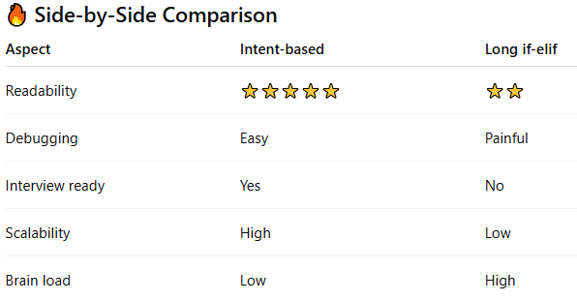
---------------------------------------------------------------------------------------------------------------------

The chatbot uses an ML-based intent classifier, so it can handle minor spelling mistakes. TF-IDF captures textual similarity, and Logistic Regression predicts the most probable intent instead of relying on exact keyword matching
✔ It worked because of ML
❌ A pure rule-based bot would fail
✔ This is why industry moves from rules → ML
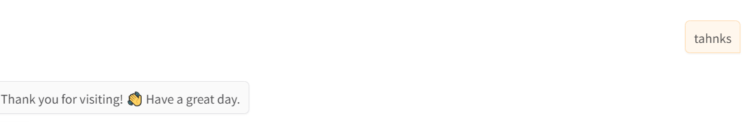

“Rule-based chatbots work for limited scenarios, but ML-based intent classification allows the system to generalize across unseen user inputs, scale better, and reduce manual rule maintenance.”

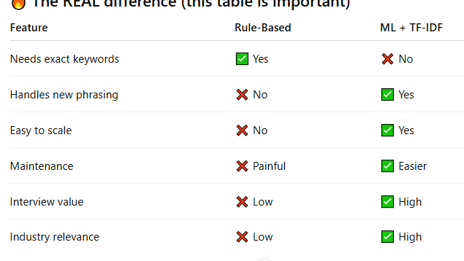

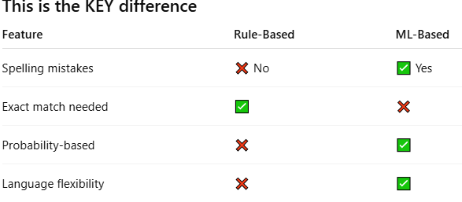

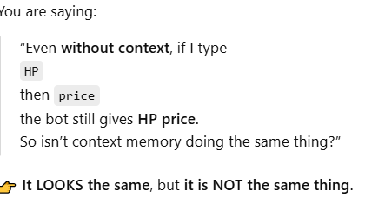

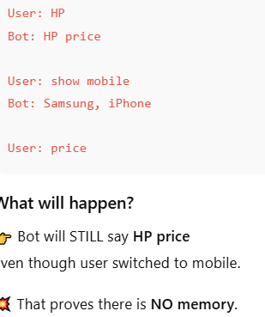
A real context bot would say:
Samsung mobile price…

Yes its happening with my code- see snapshot
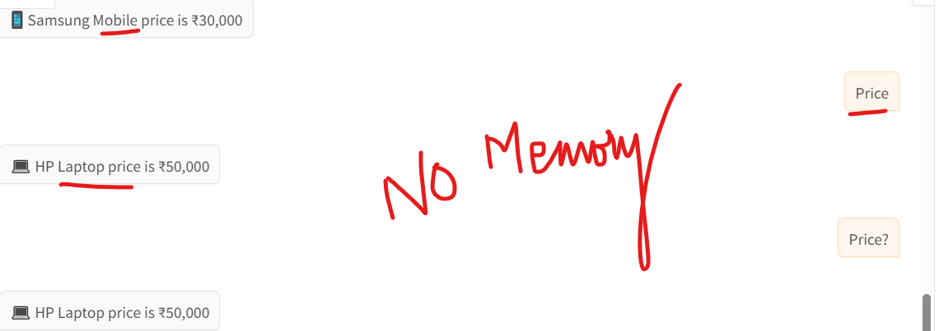

If the bot answers correctly even after the topic changes, it’s memory.
If it keeps guessing the old answer, it’s not memory.

A context-based (memory) chatbot that remembers the selected product and brand and answers follow-up questions
When user says:
mobile
Bot stores:
context["product"] = "mobile"

Bot uses memory to answer follow-up questions
User:
price
Bot checks memory:
product = context["product"] # mobile
brand = context["brand"] # Samsung
Bot replies:
Samsung mobile price is ₹30,000
✔️ This is multi-turn conversation

🔹 1. Single-Turn Conversational Chatbot
(No Context Memory)
Scenario: Product Support
User: I want to buy a laptop
Bot: We sell laptops.
User: Dell
Bot: ❌ Please specify what you want to know.
User: Price?
Bot: ❌ Which product are you asking about?
🔴 Problem
Bot forgot the topic (laptop)
Every message is treated as new. User must repeat everything

🔹 2. Multi-Turn Conversational Chatbot
(Context-Aware Chatbot)
A multi-turn chatbot remembers previous messages and uses them to reply meaningfully.
User: I want to buy a laptop
Bot: Sure! Which brand?
User: Dell
Bot: Dell laptops start at ₹55,000.
User: Price?
Bot: ✅ The Dell laptop costs ₹55,000.

🟢 Benefit
Bot remembers product = laptop
Uses earlier answers
Conversation flows naturally
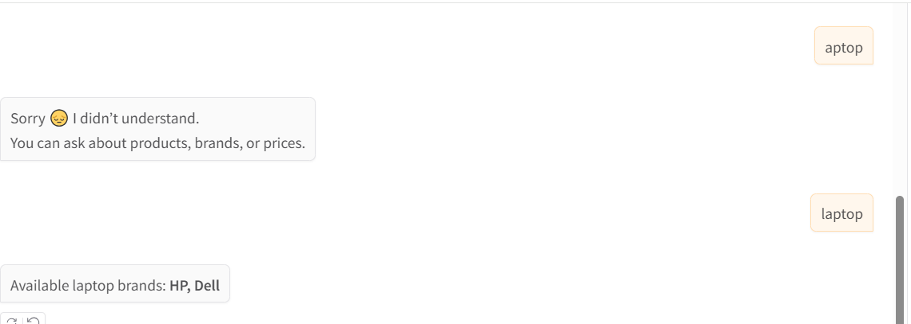
It remembers that I selected Products already , so does not ask Products brands or price again, instead upon typing its showing Laptops brands it is showing memory.

