Internal Raw Draft (Rough Notes) – Prepared by Jolly Gupta
How the Hybrid Approach — combining your DS skills with AI-assisted coding — lets you build and deploy full ML products without being a software engineer
Vibe Coding for Data Scientists: Let Claude Write Your Frontend & Backend While You Focus on the Model

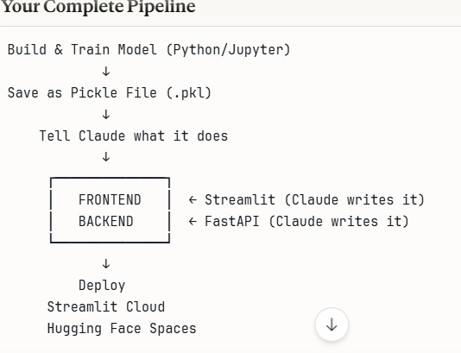
Your Complete ML Deployment Pipeline From raw idea to deployed MVP — step by step

Step 1 — Build & Train Model Open Jupyter Notebook → Write Python code → Train your ML model using Scikit-learn, Pandas, NumPy
⬇
Step 2 — Save as Pickle File After training → Run: import pickle → pickle.dump(model, open('model.pkl','wb')) → Your model is now saved as model.pkl
⬇
Step 3 — Tell Claude What It Does Share with Claude: What does your model predict? → What are the input features? → What is the output? → Claude writes your app code!
⬇
Step 4 — Frontend — Streamlit Claude generates complete Streamlit app.py → User interface with input fields, sliders, dropdowns → Loads your pickle file → Shows predictions instantly
Step 5 — Backend — FastAPI (Optional) Only needed for production/scale → Claude writes FastAPI code → Creates REST API endpoints → Connects to your pickle model
⬇
Step 6 — Deploy — Streamlit Cloud Push code to GitHub → Go to share.streamlit.io → Connect your repo → Click Deploy → Your app is LIVE in 2 minutes!
Step 7 — Deploy — Hugging Face Spaces Go to huggingface.co/spaces → Create new Space → Choose Streamlit → Upload your files → App is live with shareable link
⬇
Step 8 — Add to LinkedIn Featured Copy your live app URL → Go to LinkedIn → Featured section → Add link → Write 2-3 line project description → Done!
Pro Tip: For LinkedIn projects — Steps 1 → 4 → 6 is all you need right now. FastAPI (Step 5) comes later when you're ready to scale!
Claude_Ai__2026/pipeline.xlsx at main · JollyGupta/Claude_Ai__2026
Claude Code writes the CODE for scalable apps. But scalability itself depends on your infrastructure — not the code.
Scalability needs:
- ☁️ Proper cloud setup (AWS/Azure/GCP)
- 🐳 Docker + Kubernetes
- ⚖️ Load balancers
- 🗄️ Proper databases
- 📊 Monitoring tools
Claude Code can write all the above configs — but YOU need to set up and manage the infrastructure.
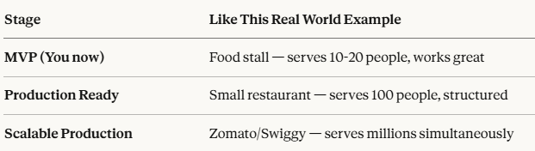
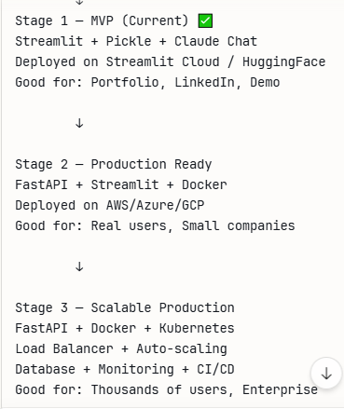
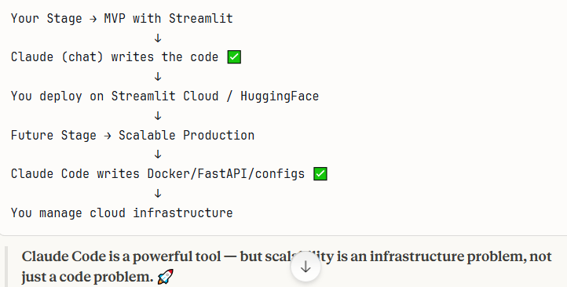
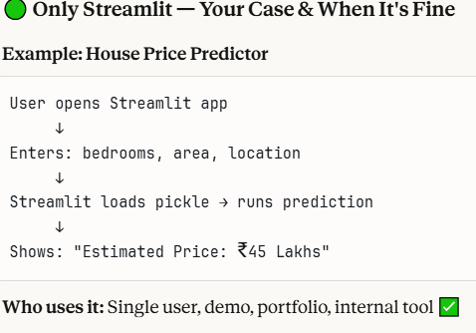
Examples
Project | Streamlit Only?
Sentiment Analysis app | ✅
Resume screener | ✅
Sales forecasting dashboard | ✅
Spam classifier | ✅
Your GenAI/RAG apps | ✅

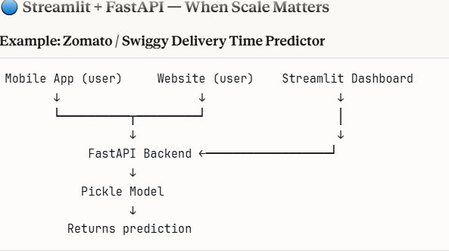
Why FastAPI here:
- Multiple apps use same model
- Mobile can't run Streamlit
- Handles thousands of users simultaneously
Real Examples
Company | Why FastAPI Needed
Swiggy delivery time | Mobile app + website + dashboard all need same model ✅
Bank fraud detection | Core banking system calls the API ✅
Netflix recommendations | Millions of users simultaneously ✅
Hospital diagnosis tool | Integrates with existing hospital software ✅
Simple Rule
Situation | Use
Portfolio / demo / single app | ✅ Streamlit only
Multiple apps need same model | ✅ FastAPI + Streamlit
Mobile integration needed | ✅ FastAPI + Streamlit
Production at scale | ✅ FastAPI + Streamlit

