**DEFINITION**

Neural Networks are a branch of machine learning and specifically a type of deep learning algorithm that makes use of layers of connected nodes that pass information along the architecture

It is typically made of an input layer, one or more hidden layers and an output layer which outputs prediction probabilities to classify the input.

Each layer is made up of connected nodes that have an associated threshold and weight, the nodes selectively pass on data to the next layer if their activation threshold is met.

There are several types of neural networks which are used for different applications and datatypes, recurrent neural networks (RNN) for example are commonly used for sequential data such as written text, but for this project we focus specifically on Convolutional Neural Networks (CNN) which are more commonly used for image classification and computer vision tasks.

Before convolutional neural networks, complex and time-consuming feature extraction methods were used to highlight and classify patterns in images, CNNs provide a much more efficient and scalable method of feature extraction from image data by using mathematical techniques specifically the matrix-vector multiplication also known as a convolution operation. This technique though more efficient than previous feature extractors is computationally intensive and will often require a General Processing or Tensor Processing Unit (GPU or TPU) chip

The Image below shows the feature extraction process, using convolution operations to extract features from the pixel matrix of an input image

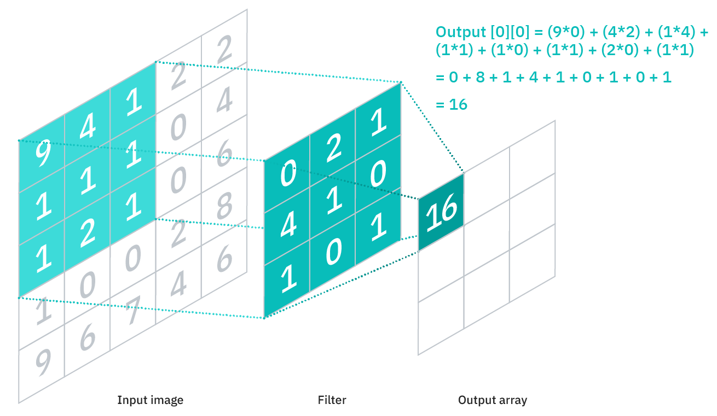

*img-source: https://www.ibm.com/cloud/learn/convolutional-neural-networks*

**HOW IT WORKS**

Convolutional neural networks generally perform better than other types of neural networks with image, video, and audio data.

They are made up of three main types of layers:

Convolutional layer

Pooling layer

Fully connected layer

The convolutional layer is the first layer of the neural network, and it uses the matrix multiplication algorithm to extract features from the input image, which it then passes to the pooling layer where these features are further condensed into the most important characteristics. Earlier layers in the network identify simple features in the image such as the colour and edges, as the image passes through the layers it starts to identify more general patterns in the image, finally when the features have been sufficiently extracted the fully connected or dense layers can be used to classify the image

The Figure below shows an image of a cat passing through several convolutional layers

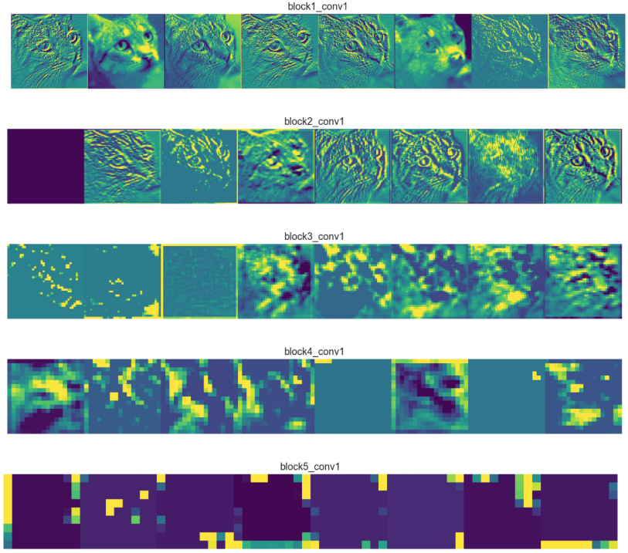

img-source: https://towardsdatascience.com/applied-deep-learning-part-4-convolutional-neural-networks-584bc134c1e2

**APPLICATIONS IN REINFORCEMENT LEARNING**

Reinforcement Learning is based on four concepts, agent, environment, state, and action

The agent represents the actor in an example game environment, it takes initially random actions in the environment to produce a state, which can be defined as a snapshot of the current environment. The agent’s actions slowly converge over several iterations called timesteps from being random to being deliberate and productive in the environment based on the training policy which associates a weighted reward for each action taken by the agent

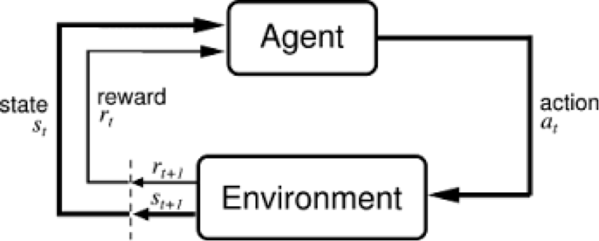

img-source: https://wiki.pathmind.com/deep-reinforcement-learning

Neural networks can be trained on image samples showing the environments state from actions taken in the environment,

Convolutional neural networks can be used in reinforcement learning, to identify an agents state based on the visual input from the game snapshot.

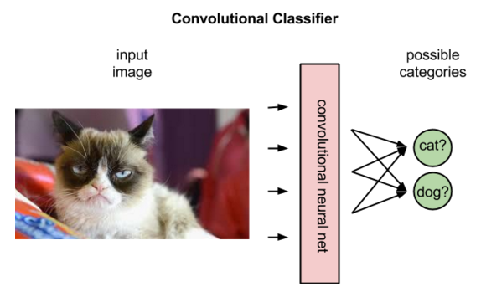

img-source: https://wiki.pathmind.com/deep-reinforcement-learning

In supervised learning, CNNs are used to label or classify images by assigning a weighted probability to the most likely label, based on labelled data it has seen before, as shown in the image above

In reinforcement learning, convolutional neural networks are used to assign a weighted probability to the best possible action to take given an input of the current state based on samples it has seen from previous states in the current environment as shown below

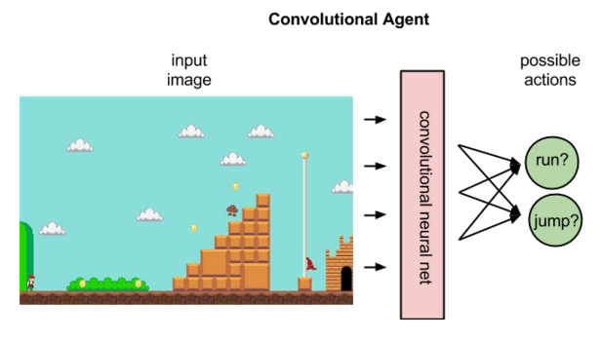

img-source: https://wiki.pathmind.com/deep-reinforcement-learning

**REFERENCES**

Chris Nicholson 2022. [online] Available at: <https://wiki.pathmind.com/deep-reinforcement-learning> [Accessed 19 April 2022].

IBM Education, 2022. *What are Convolutional Neural Networks?*. [online] Ibm.com. Available at: <https://www.ibm.com/cloud/learn/convolutional-neural-networks> [Accessed 19 April 2022].