**MY**

**PORTFOLIO**



**CALMATEO, MARKJOMAR SANJUAN.**

**BS IN INFORMATION TECHNOLOGY 1ST YEAR**

**CC102-C++**

**STEPS ON HOW TO INSTALL AND COMPILE IN NOTEPAD++ (C++)**

1 First of all download the notepad++ from below link.

2 Now install and open notepad++.

3 We require NppExec plugin that will help us to run programs. You can skip 3rd and 4th steps if the NppExec plugin is already present in notepad++. Go to Plugins > Plugin Manager > Show Plugin Manager.

4 Make sure you have internet connection because we are going to download plugin. In the new window you will get a list of all available plugins. Scroll down and select NppExec plugin from the list and install it.

5. Go to Plugins > NppExec > Execute. Now we have to create a script. In the new window enter following commands and then save it with any name.

For C and C++

Npp_save

Cd $(CURRENT_DIRECTORY)

C:\Program Files (x86)\Dev-Cpp\MinGW64\bin\g++.exe “$(FILE_NAME)”

Cmd /c “$(CURRENT_DIRECTORY)\a.exe”

6. Then go to Plugins > NppExec > Advance Options. In the bottom left corner you will get a list of Associated script. Select the script that you have just created from the drop down list.

7. Click on Add/Modify button. Now you can see the script in the Menu items box at the top.

8. Click OK button, you have to restart the notepad++.

9. After that go to Settings > Shortcut Mapper. Click on Plugin commands tab, there you will get the list of all the commands. Scroll down until you see the command with the name with which you have saved the script.

10. Click on Modify button to choose a shortcut according to you. Make sure the shortcut is unique. Now close the window.

11. Just write your program and run it using the shortcut key you created in previous step. And its done.

**C++ PROGRAMS ACTIVITIES CC102.**

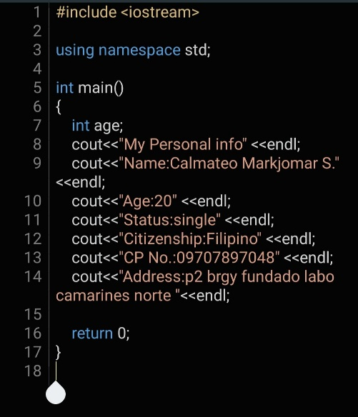

This programs printout MY PERSONAL INFORMATION.

*******************************************************************

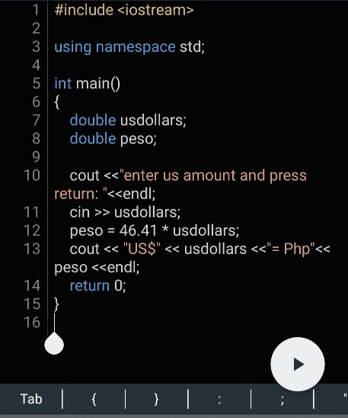This program convert the Us amount to Peso amount.

*******************************************************************

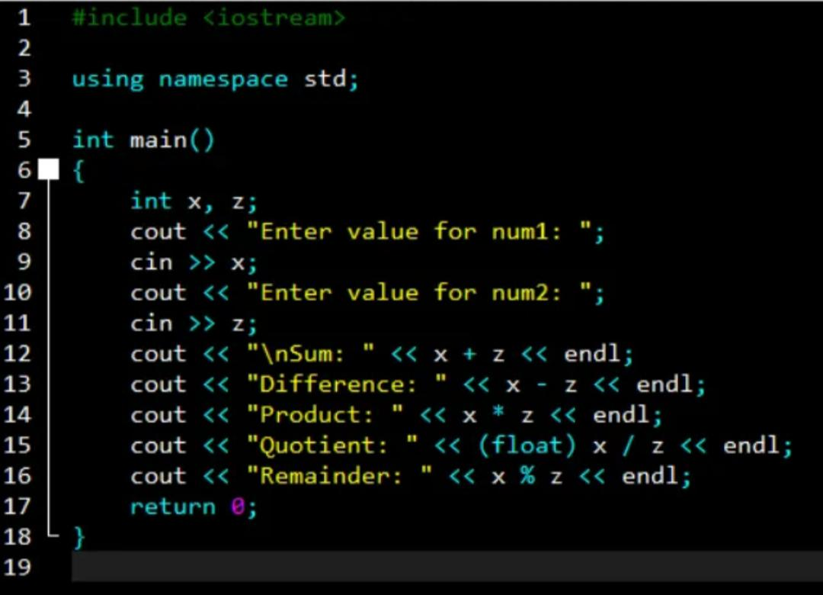This is a Simple calculator program that can print out the Sum , difference, product ,quotient and the remainder of two Value Numbers.

*******************************************************************

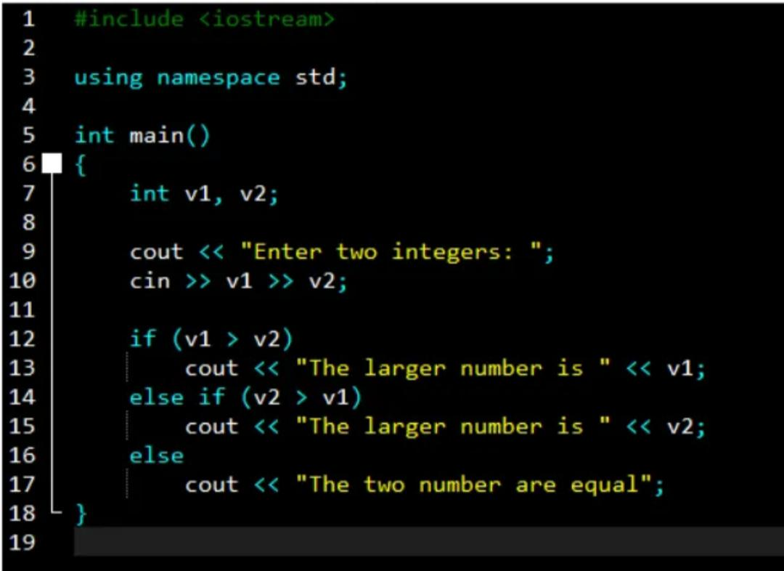

Else if program that can print the largest value number.

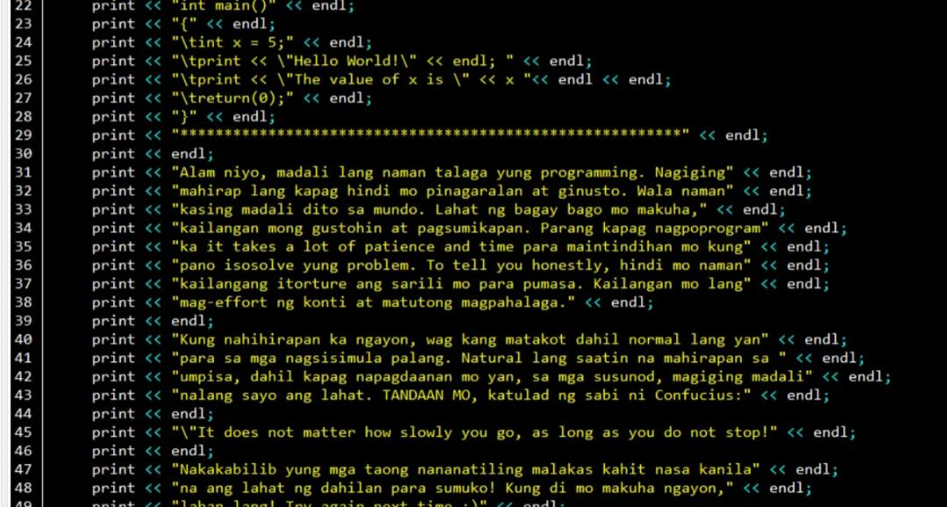*******************************************************************

Debugging program it test how fast we can solve it.

*******************************************************************

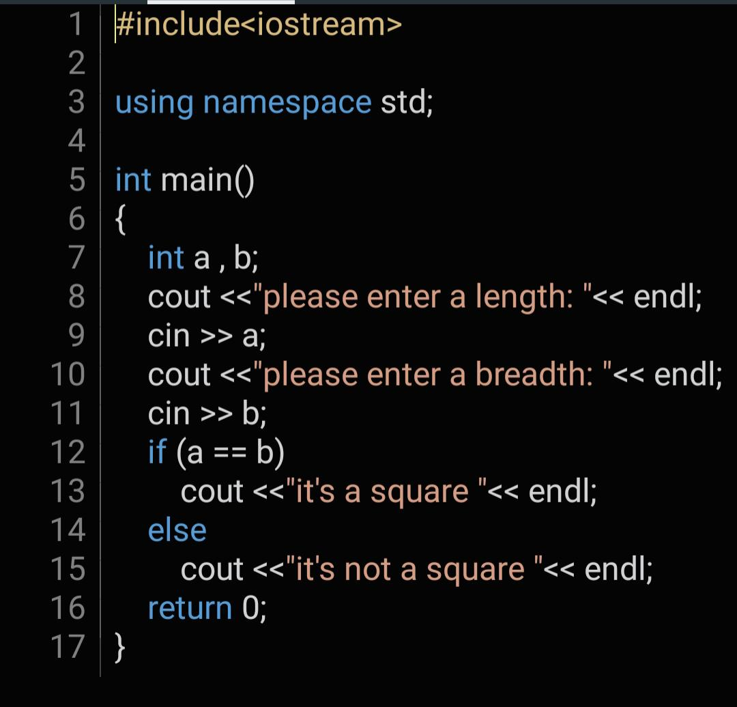**LEVEL 1 TO 3 PROBLEM SOLVING PROGRAM it tests to what extent we can solve it using an else if statement, these are the sample program that I solved.**

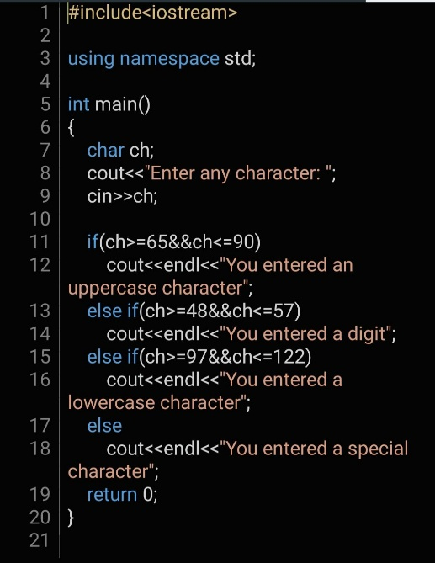This is on Level 1 when it run the program the program ask the user the length and breadth the when the two values are equal it will print “it’s a square” if not equal it will print “its not a square”.

This is level 2 program… the program ask to enter any Character, when you entered a small letter it will print “ you entered a lowercase character” and if not and you entered a big letters it will print “you entered an uppercase character “.

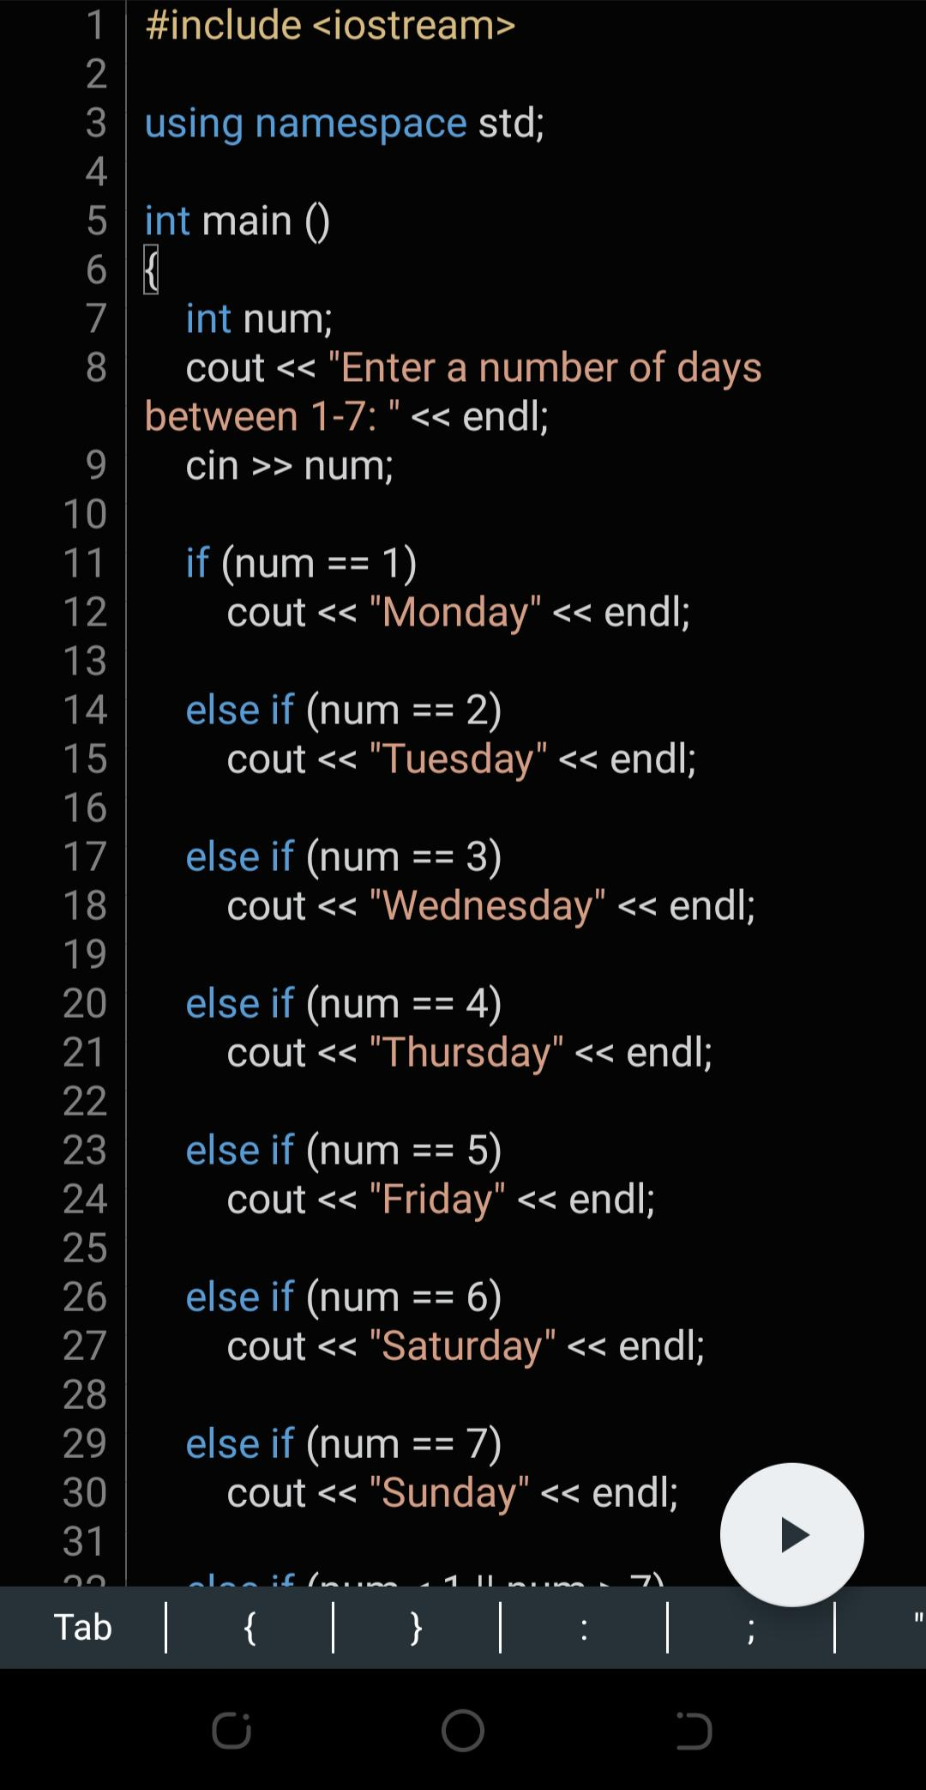

This is a Level 3 program when you run it the program will ask the user to enter a number 1 to 7 and when you entered a number it will print the weekdays… number 1 is Monday 2 is Tuesday and so on to reach the Sunday.

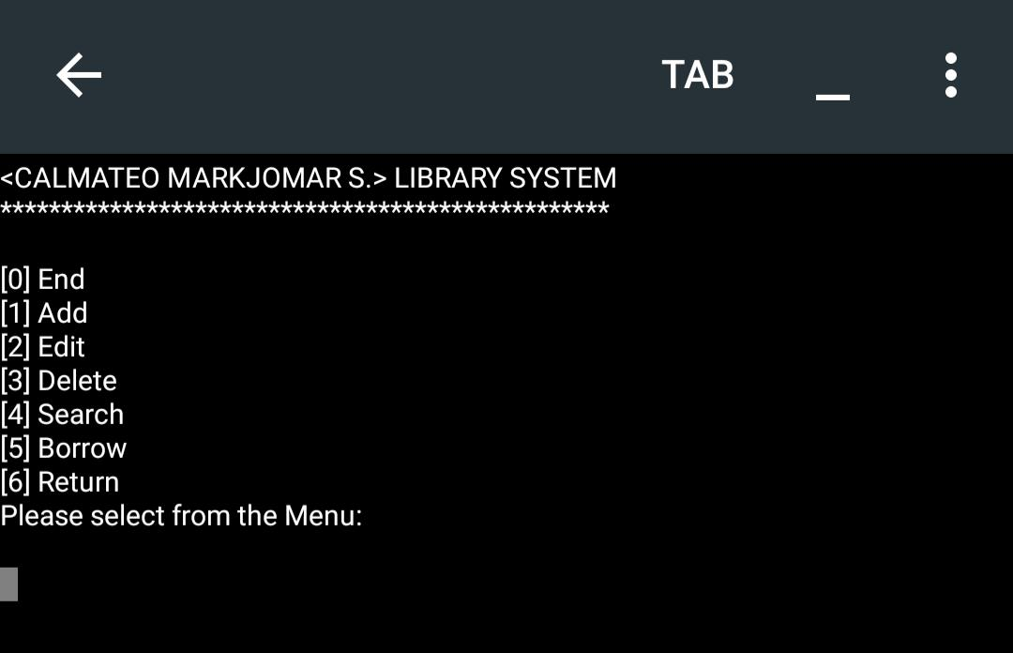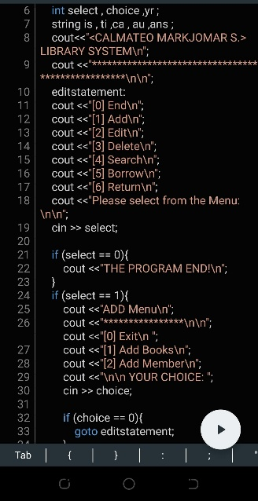**LIBRARY SYSTEM**

This program is my Library System level 4, the process of this program when you compile it is the program will ask you to which number you will choose 1 is the add book 2 is to edit books next is the delete books ,search books, borrow and the return books. This program is not finish yet but I tried all my best to program and to run this… I know I have so much more to learn about programming not only by using else if statement.. I want to learn more and more to upgrade or level up my skills for programming.

**That’s all of my programs and learnings**

**Thankyou.**