Employee Management Dashboard using Angular and TypeScript
Submitted By:
Team Members: Sangnya S Prenav, Jeremiah Christiano Pereira,
Sacchit Kallara Viju, Ciena Sunil
Roll Numbers: 2462359, 2462330, 2462345, 2462322
Course: Advanced JavaScript Frontend Frameworks (Angular)
Institution: Christ University
Date of Submission: 23/01/2026

Abstract
This project focuses on the design and development of a full-featured Employee Management Dashboard using Angular and TypeScript. The application provides a structured and interactive interface to manage employee records, including creation, viewing, updating, and status tracking. It leverages Angular’s component-based architecture, routing, services, and reactive forms to ensure scalability and maintainability. Angular Material is used to deliver a professional and responsive user interface, while RxJS facilitates real-time data updates. Employee data is handled through browser-based storage or a simulated backend API to mimic real-world enterprise workflows. The project serves as a practical implementation of modern front-end development concepts aligned with industry standards.

Objectives
- Design a modern and user-friendly Employee Management system using Angular Material.
- Implement CRUD operations for employee records using Angular components and services.
- Apply Angular routing for seamless navigation between dashboard, list, and detail views.
- Utilize TypeScript features such as interfaces, classes, and strong typing for reliability.
- Implement form validation using Angular reactive forms for accurate data entry.
- Demonstrate real-time UI updates using RxJS and Angular data binding techniques.

Scope of the Project
- The project is limited to front-end development using Angular and TypeScript.
- Employee data management is simulated using browser storage or mock REST APIs.
- Supports employee creation, listing, viewing, editing, and status management.
- The application is responsive across desktops and tablets.
- Backend authentication and production deployment are outside the project scope.

Tools & Technologies Used
- Angular (v17+) – Single Page Application development
- TypeScript – Type safety and object-oriented design
- Angular Material – UI components and theming
- RxJS – Asynchronous data handling
- Angular CLI – Project scaffolding
- Node.js – Runtime environment
- Visual Studio Code – Development environment

Key Features
- Employee Dashboard with overview and navigation controls.
- Add New Employee form with validation.
- Employee listing in tabular format.
- Employee detail view with edit functionality.
- Active and inactive status management.
- Responsive layout using Angular Material.

Challenges Faced & Solutions
Challenges such as data sharing between components, form validation, and dynamic routing were addressed using Angular services, reactive forms, and router configurations. Angular Material ensured UI consistency, while RxJS enabled efficient real-time updates.

Outcome
- Developed a fully functional employee management application.
- Implemented Angular best practices including services, routing, and reactive forms.
- Created a responsive and professional UI.
- Strengthened understanding of enterprise-level frontend development.

Future Enhancements
- Integration with backend services and authentication.
- Advanced filtering and search features.
- Export employee data to PDF or Excel.
- Role-based access control.
- Analytics dashboards for HR insights.

Sample Code
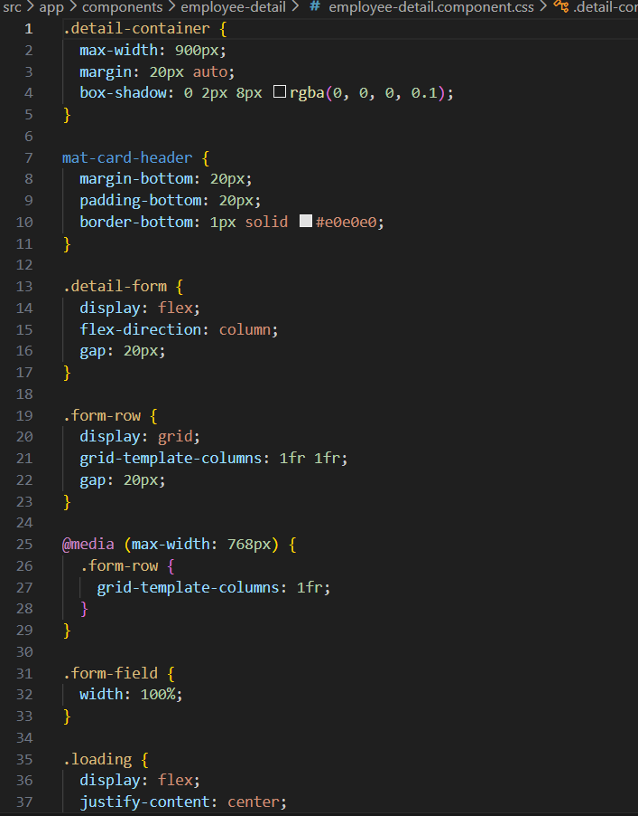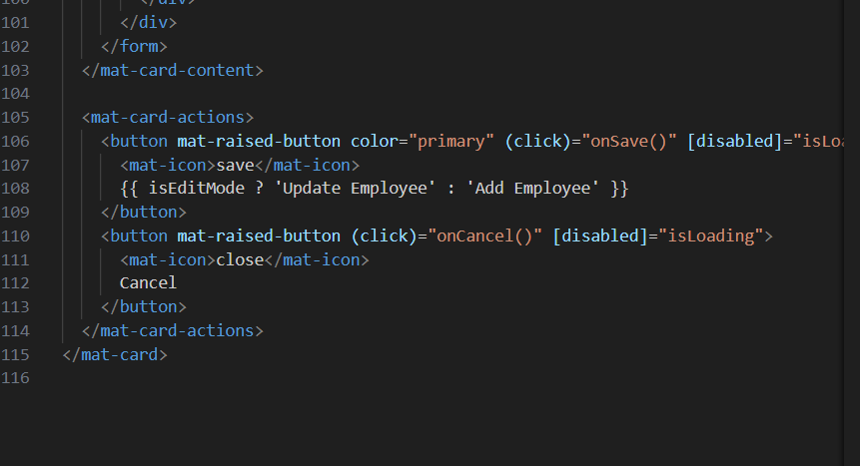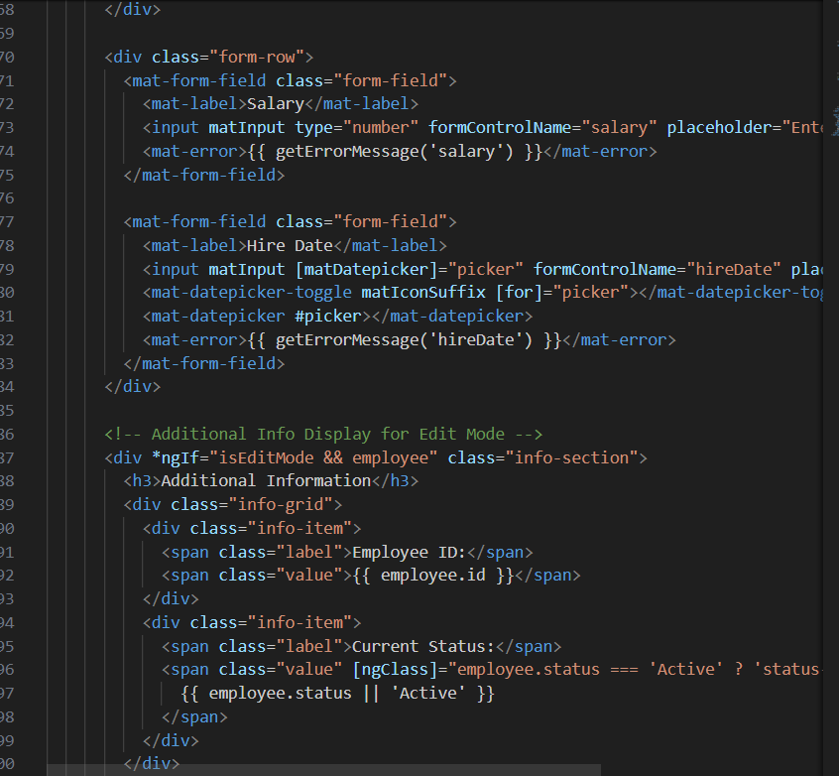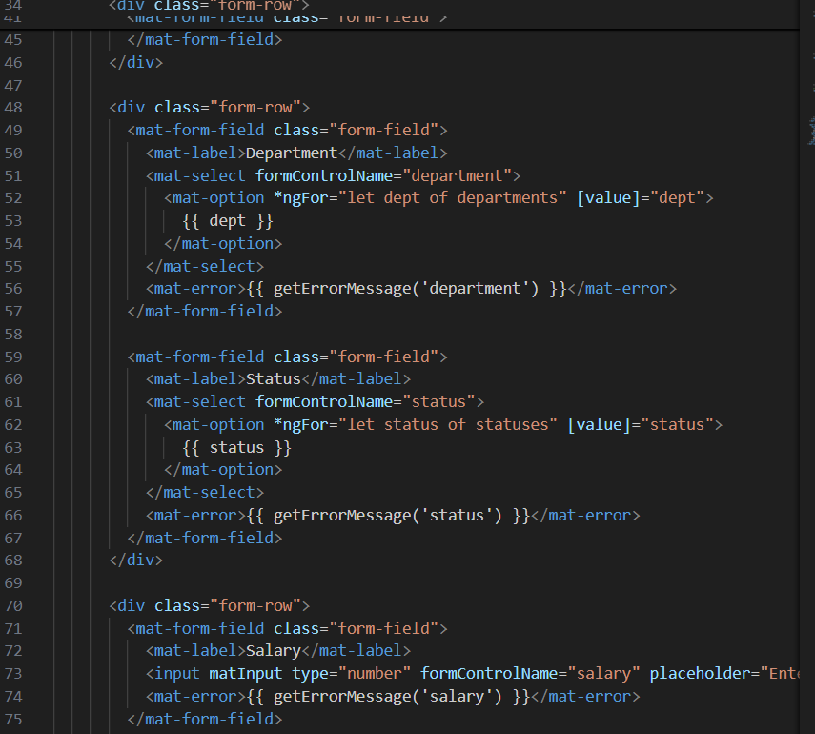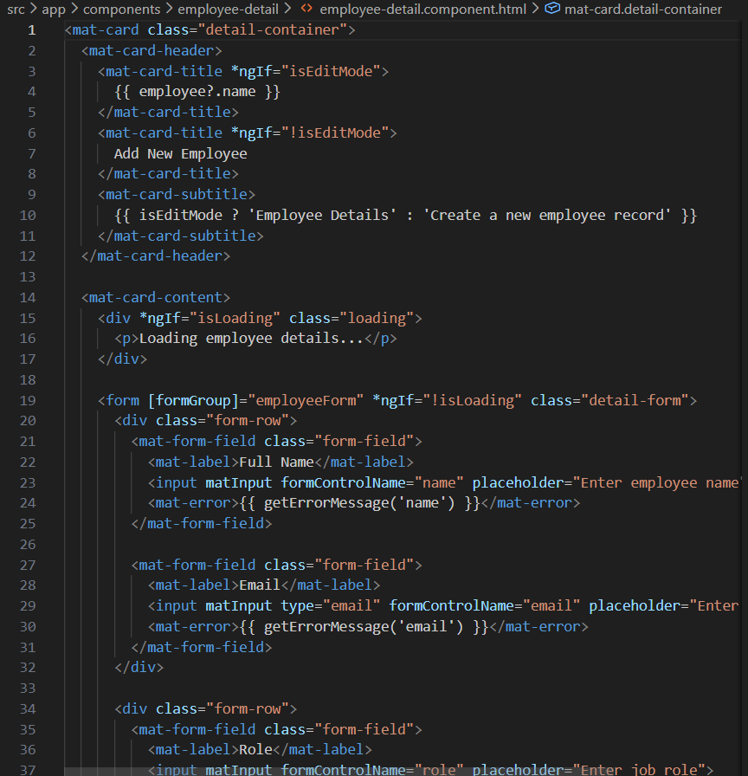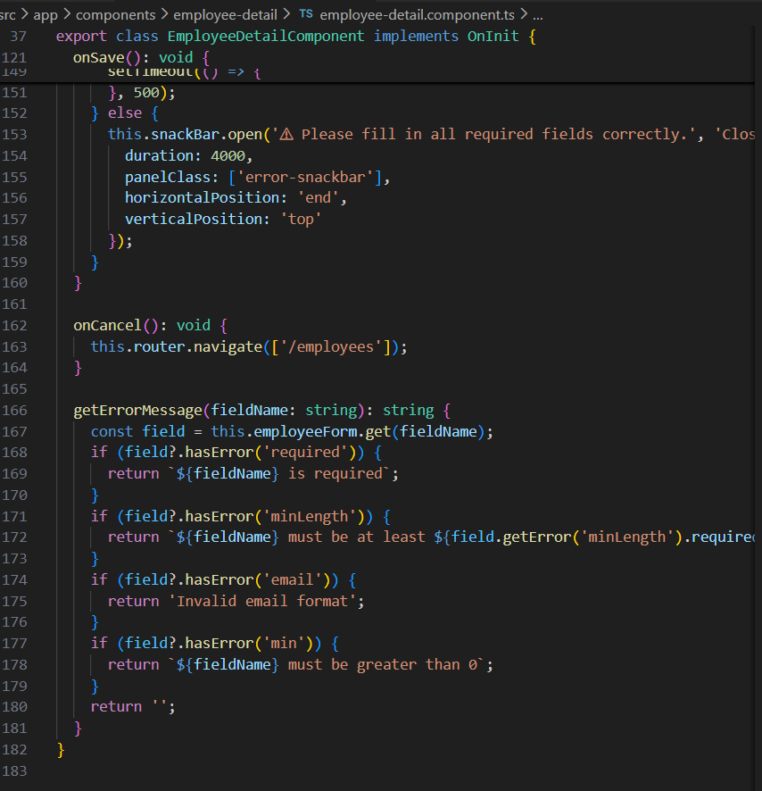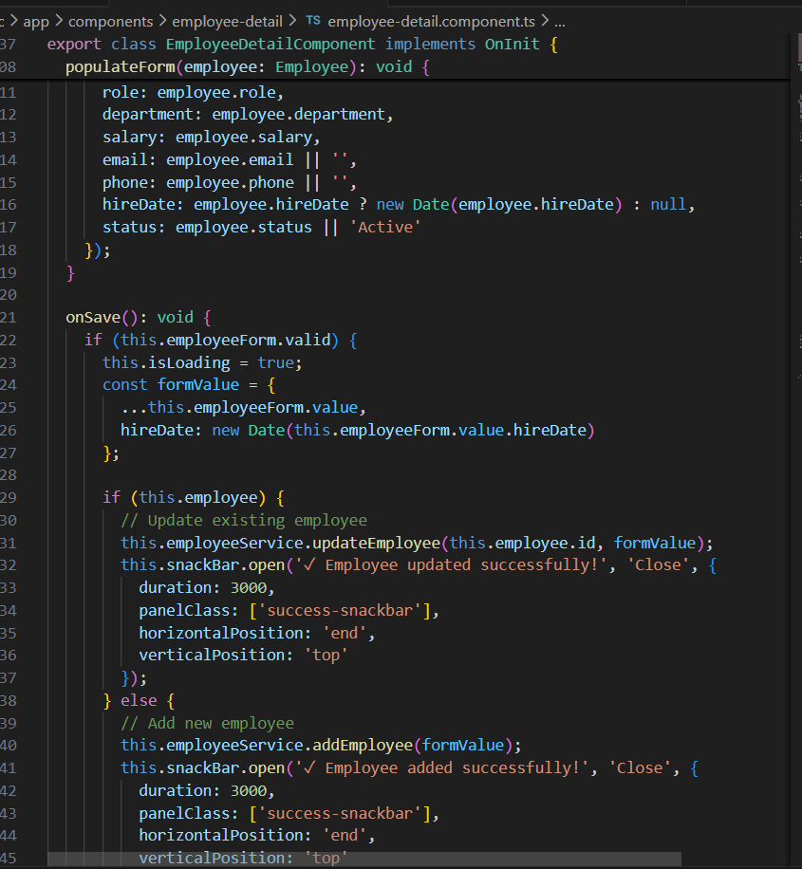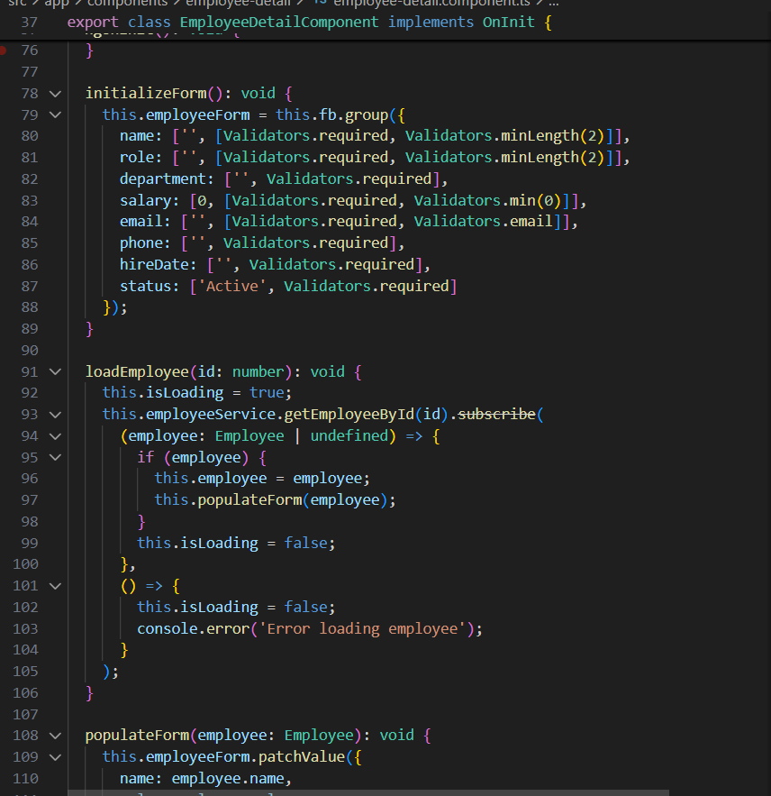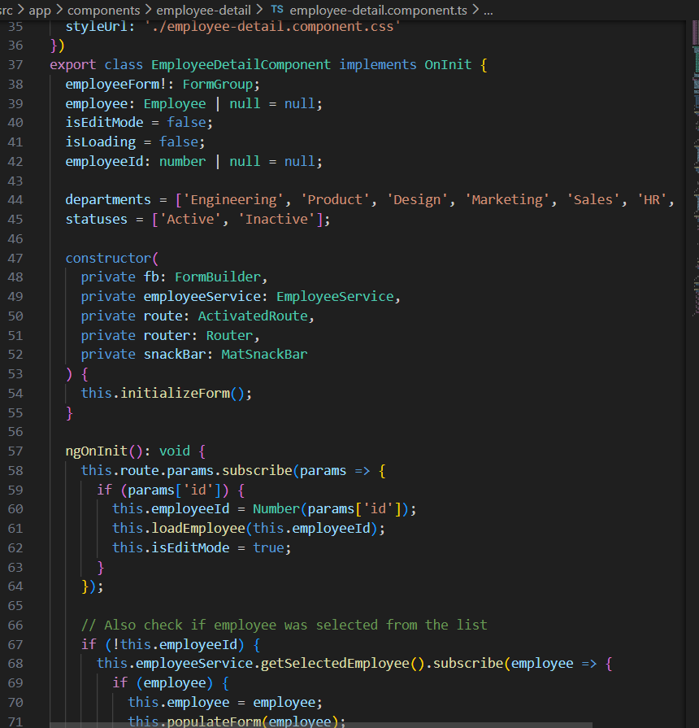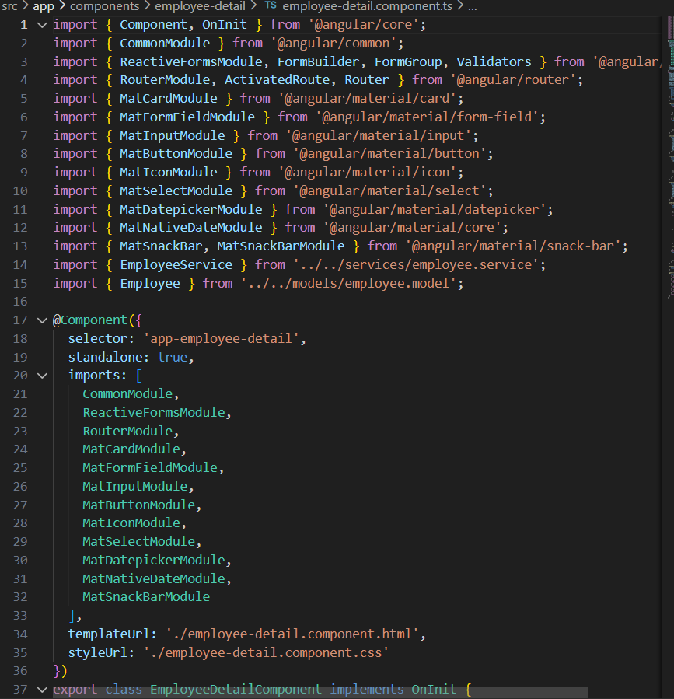
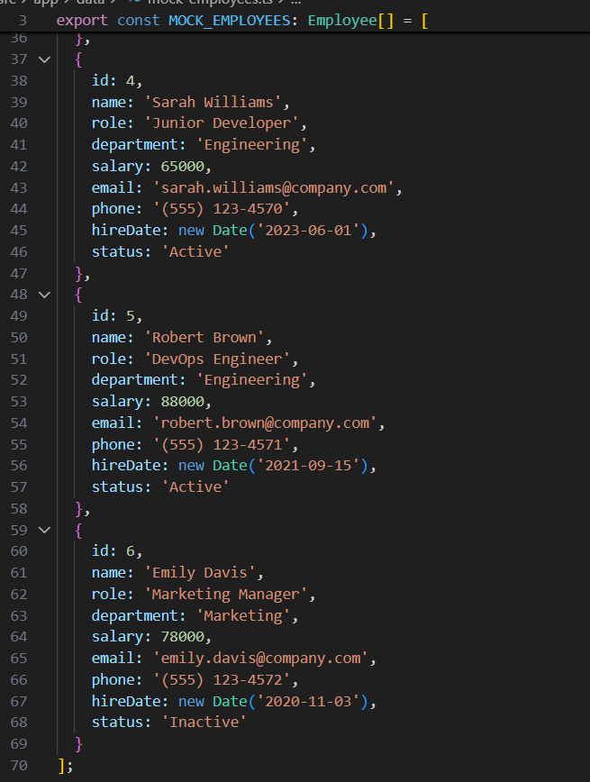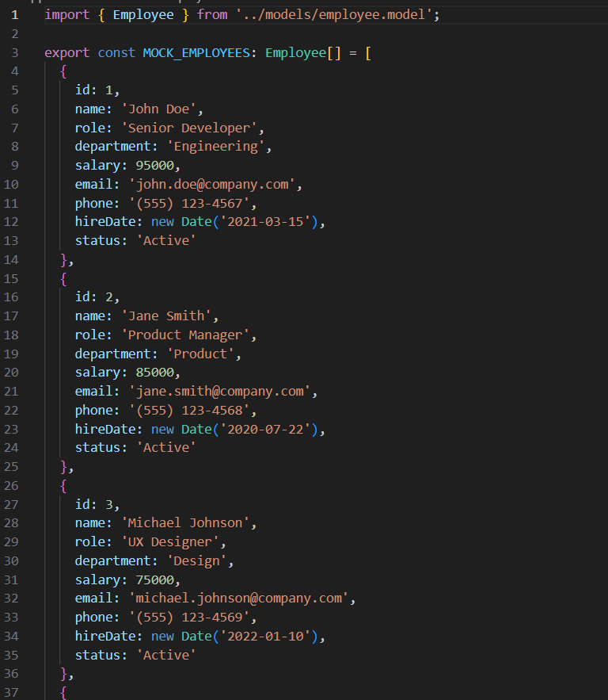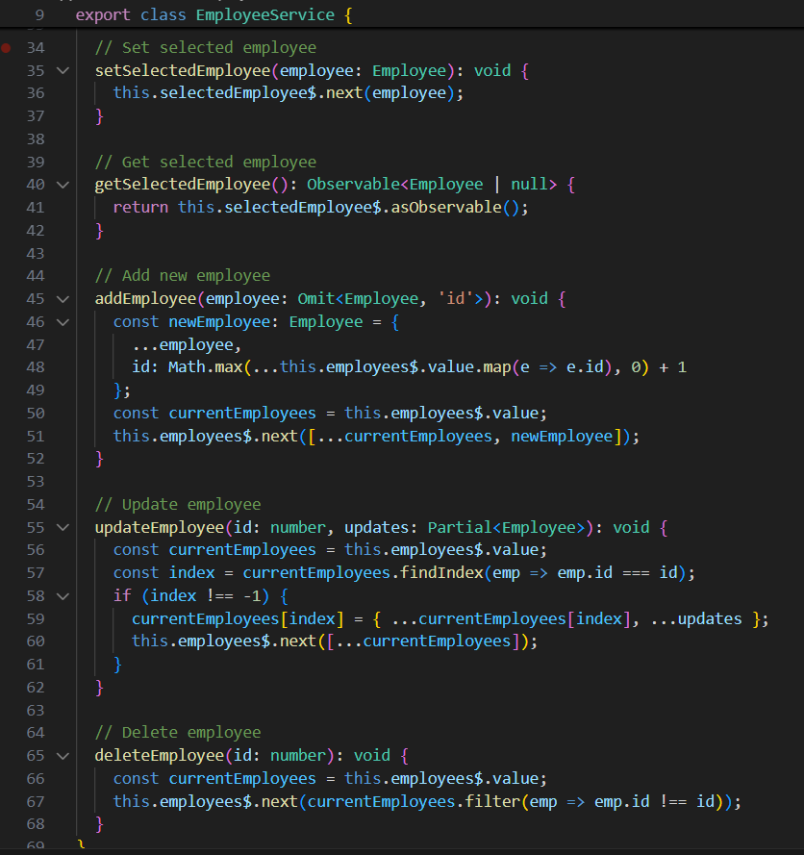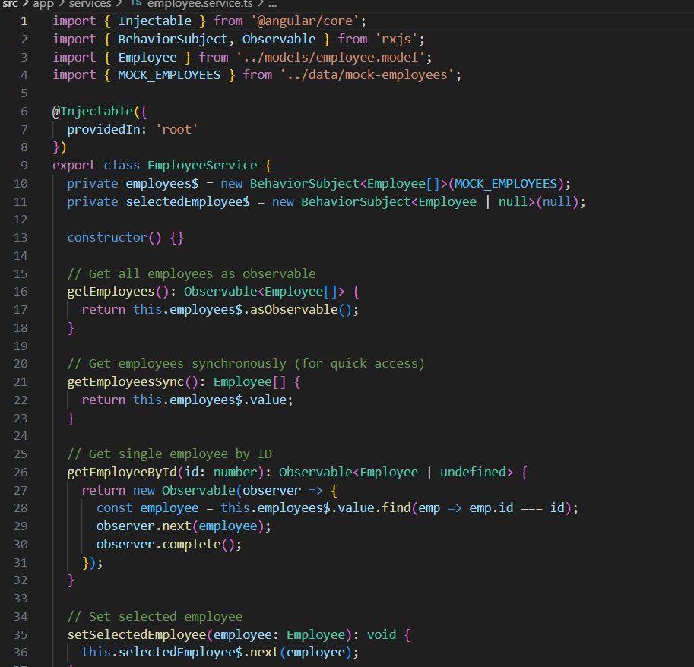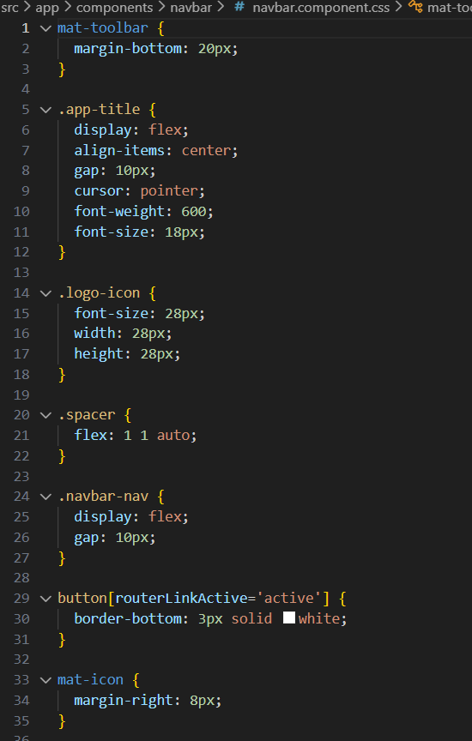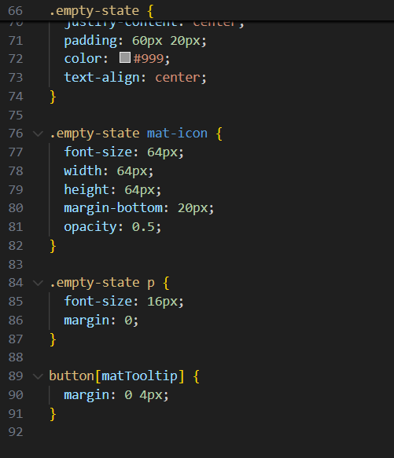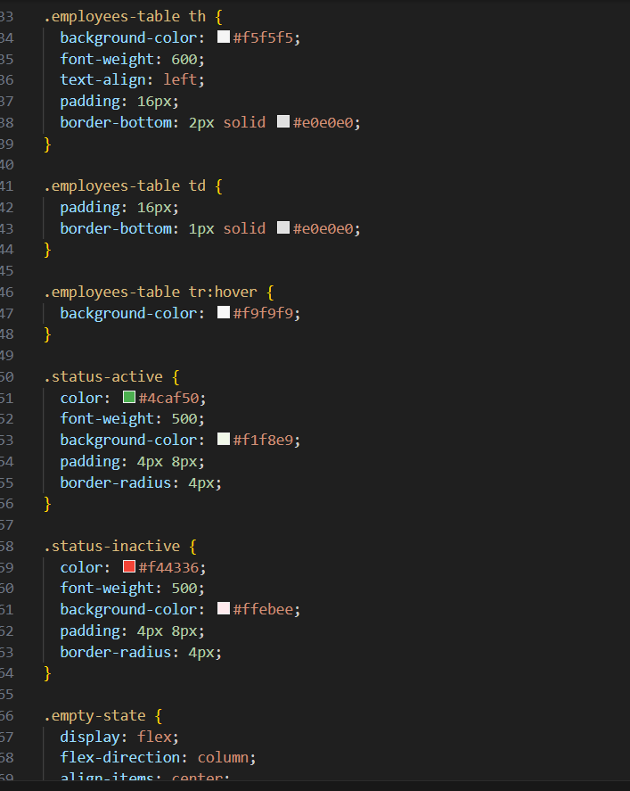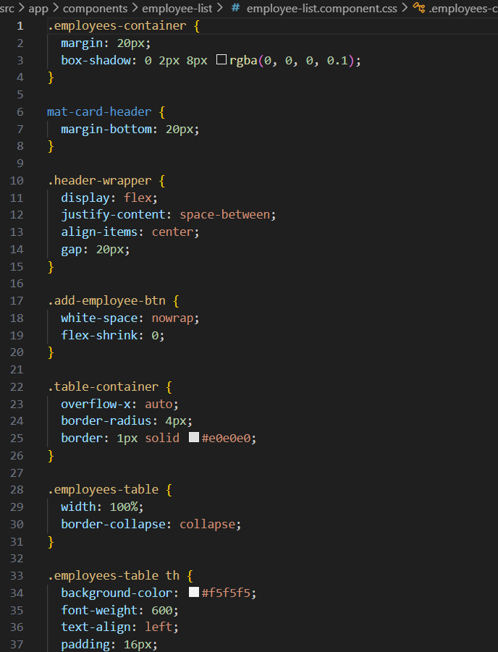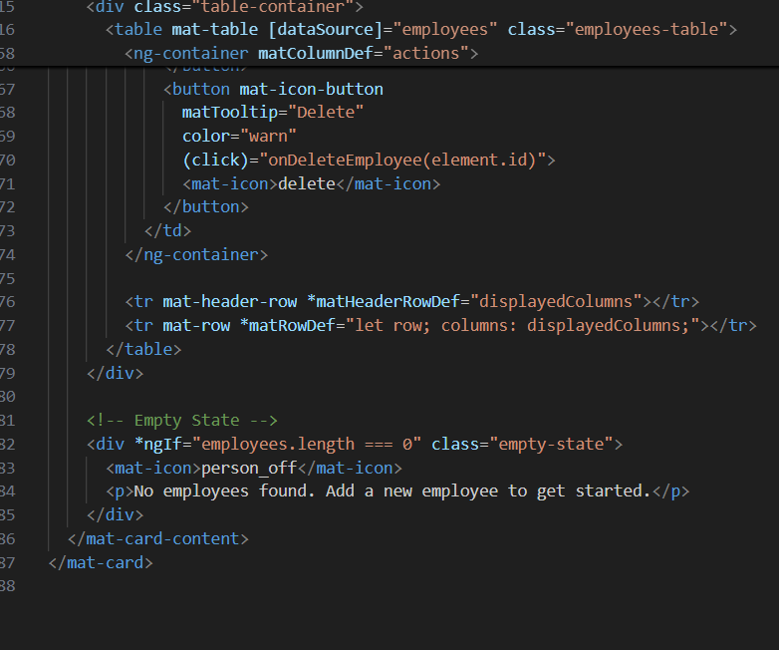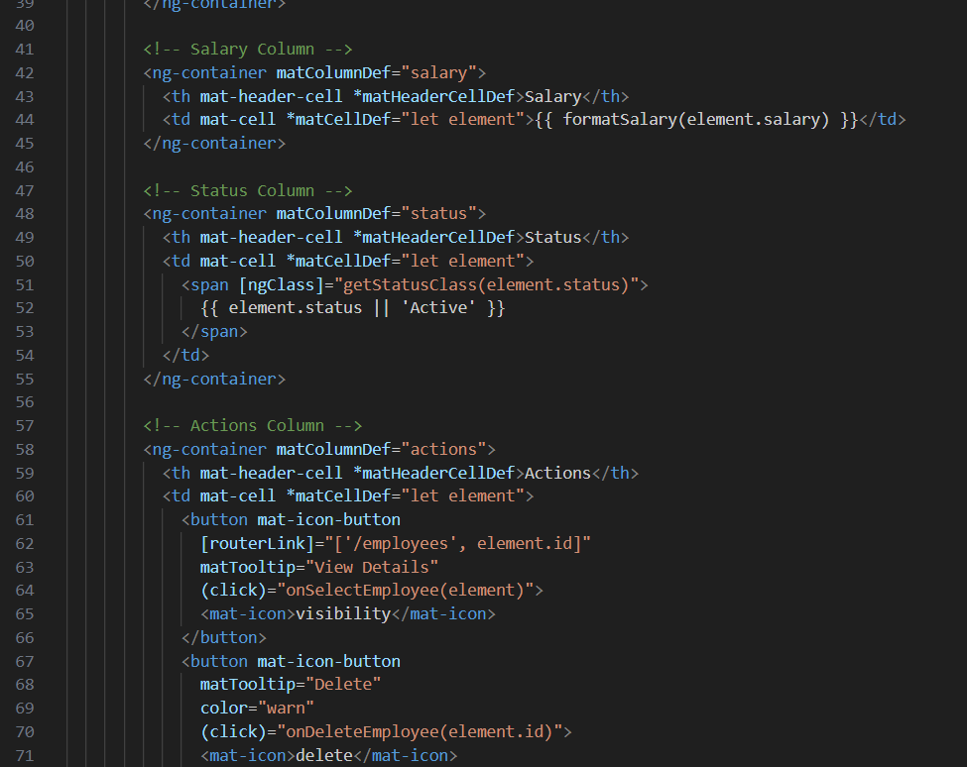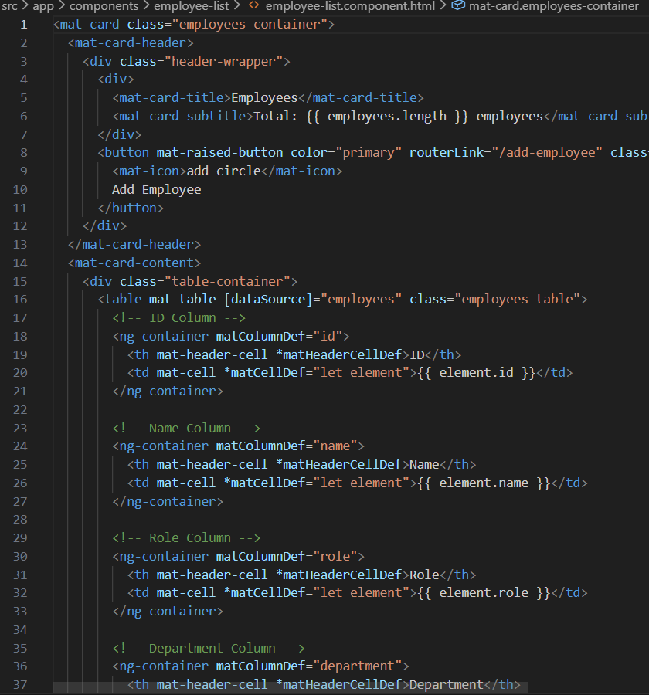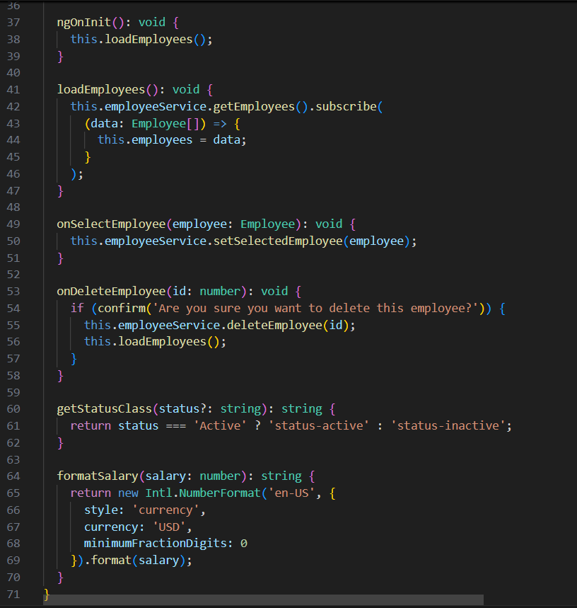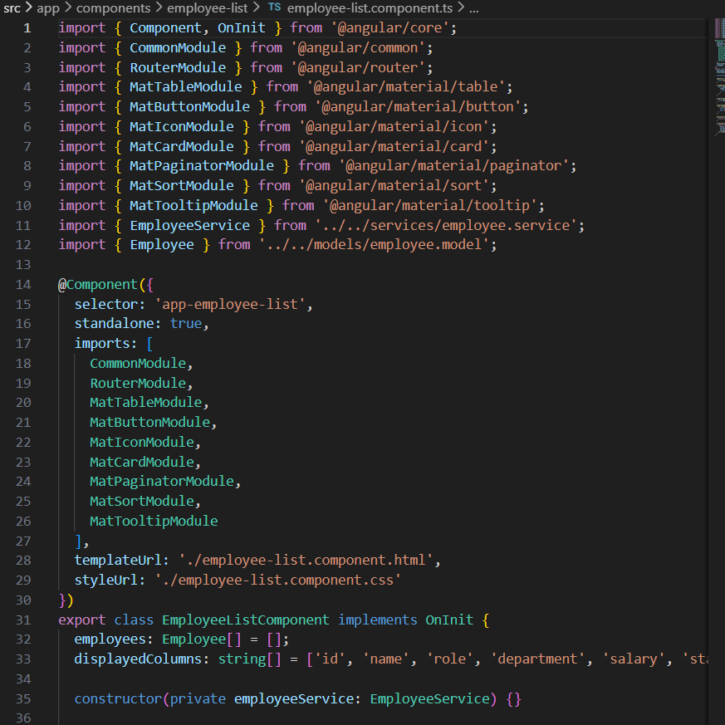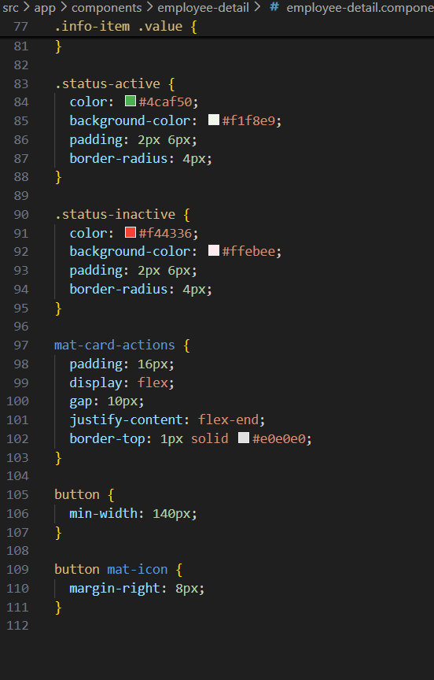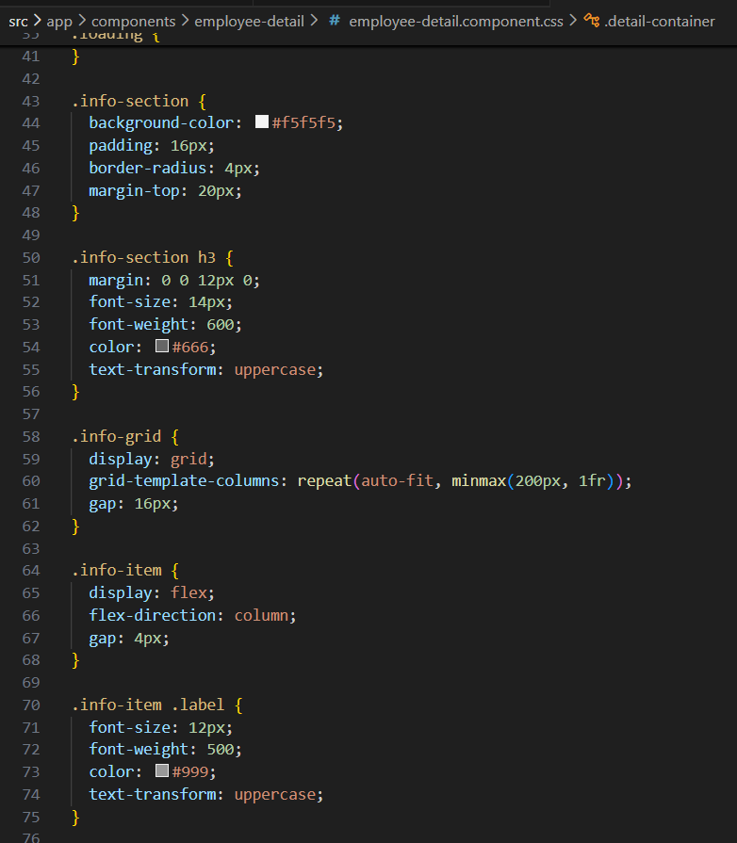

Output
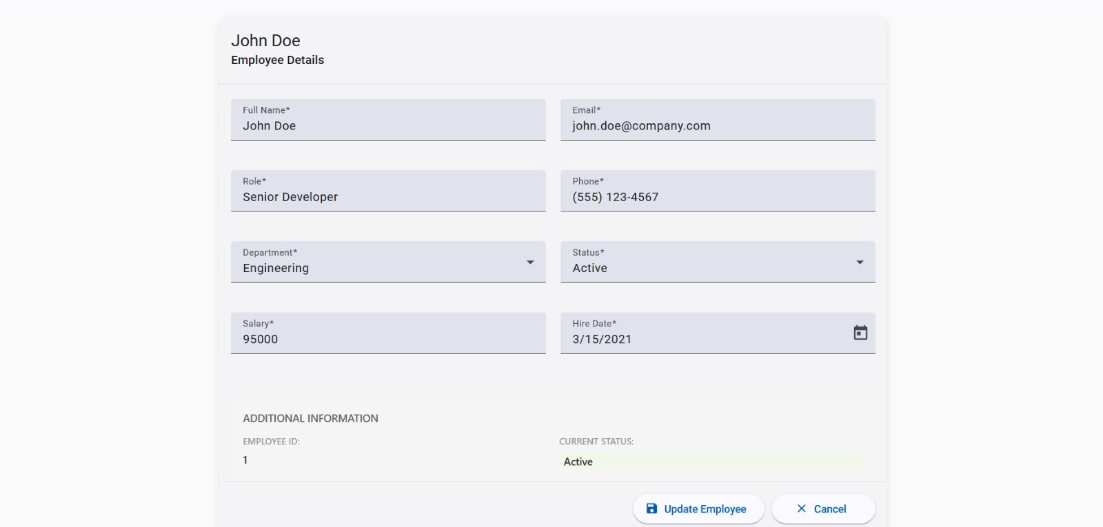
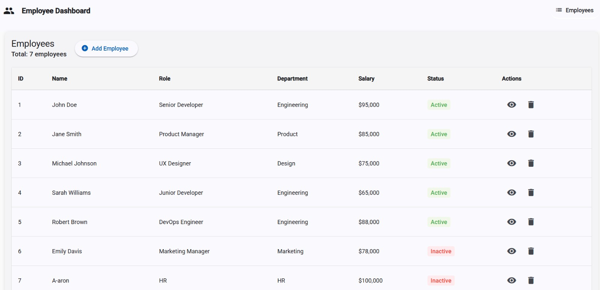

Conclusion
The Employee Management Dashboard project demonstrates the effective use of Angular and TypeScript to build a scalable and responsive web application. By adopting component-based design, service-oriented architecture, and Angular Material UI elements, the project reflects real-world enterprise development practices. This project provides a strong foundation for further enhancements and professional Angular development.

References
- Angular Official Documentation
- TypeScript Handbook
- Angular Material Documentation
- L&T LMS – Advanced JavaScript Frontend Frameworks

