**PART 2.** Study the attached code, which shows a rough scheduling system portrayed as a bank teller activity scenario.

1. Answer the following questions (5 points each):
   1. Which teller will have the most customers at the end of the program execution?

TellerA has the most customers which is 21 in total and those are A, D, E, F, G, H, J, K, L, M, N, P, Q, R, S, T, V, W, X, Y, and Z.

* 1. Which teller will have the LEAST customers at the end of the program execution?

TellerC has the least customer which is only 1 and it is C.

* 1. What made the difference between the questions above (a and b)?

The reason why TellerA has the most customer while TellerC has the least customer is because of the value of variables timeItTakesA, timeItTakesB, and timeItTakesC used in the if statement;

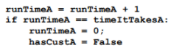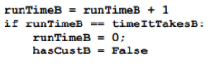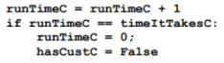

* 1. Will there be a significant difference if there were more customers (as represented by the list)? Why?

No, it is almost the same. The only difference is that the number of customers increased. Unless, we change the value of these three variables; timeItTakesA, timeItTakesB and timeItTakesC. Then, the customers will be distributed differently among the tellers.

1. Modify the code so that it takes into consideration the length of transactions each customer might have. Hint: at the current example, note that ONE CUSTOMER enters the loop each time, which means it gets distributed immediately to an open teller. Because of the complication brought about by having a time component to the customer, additional checks may be done. The modified code shall be graded using the rubrics specified below

