Republika ng Pilipinas
BARANGAY TATALON
Distrito IV, Lungsod Quezon
TANGGAPAN NG PUNONG BARANGAY
0977-203-0336 - Email Add: brgy.tatalon@quezoncity.gov.ph




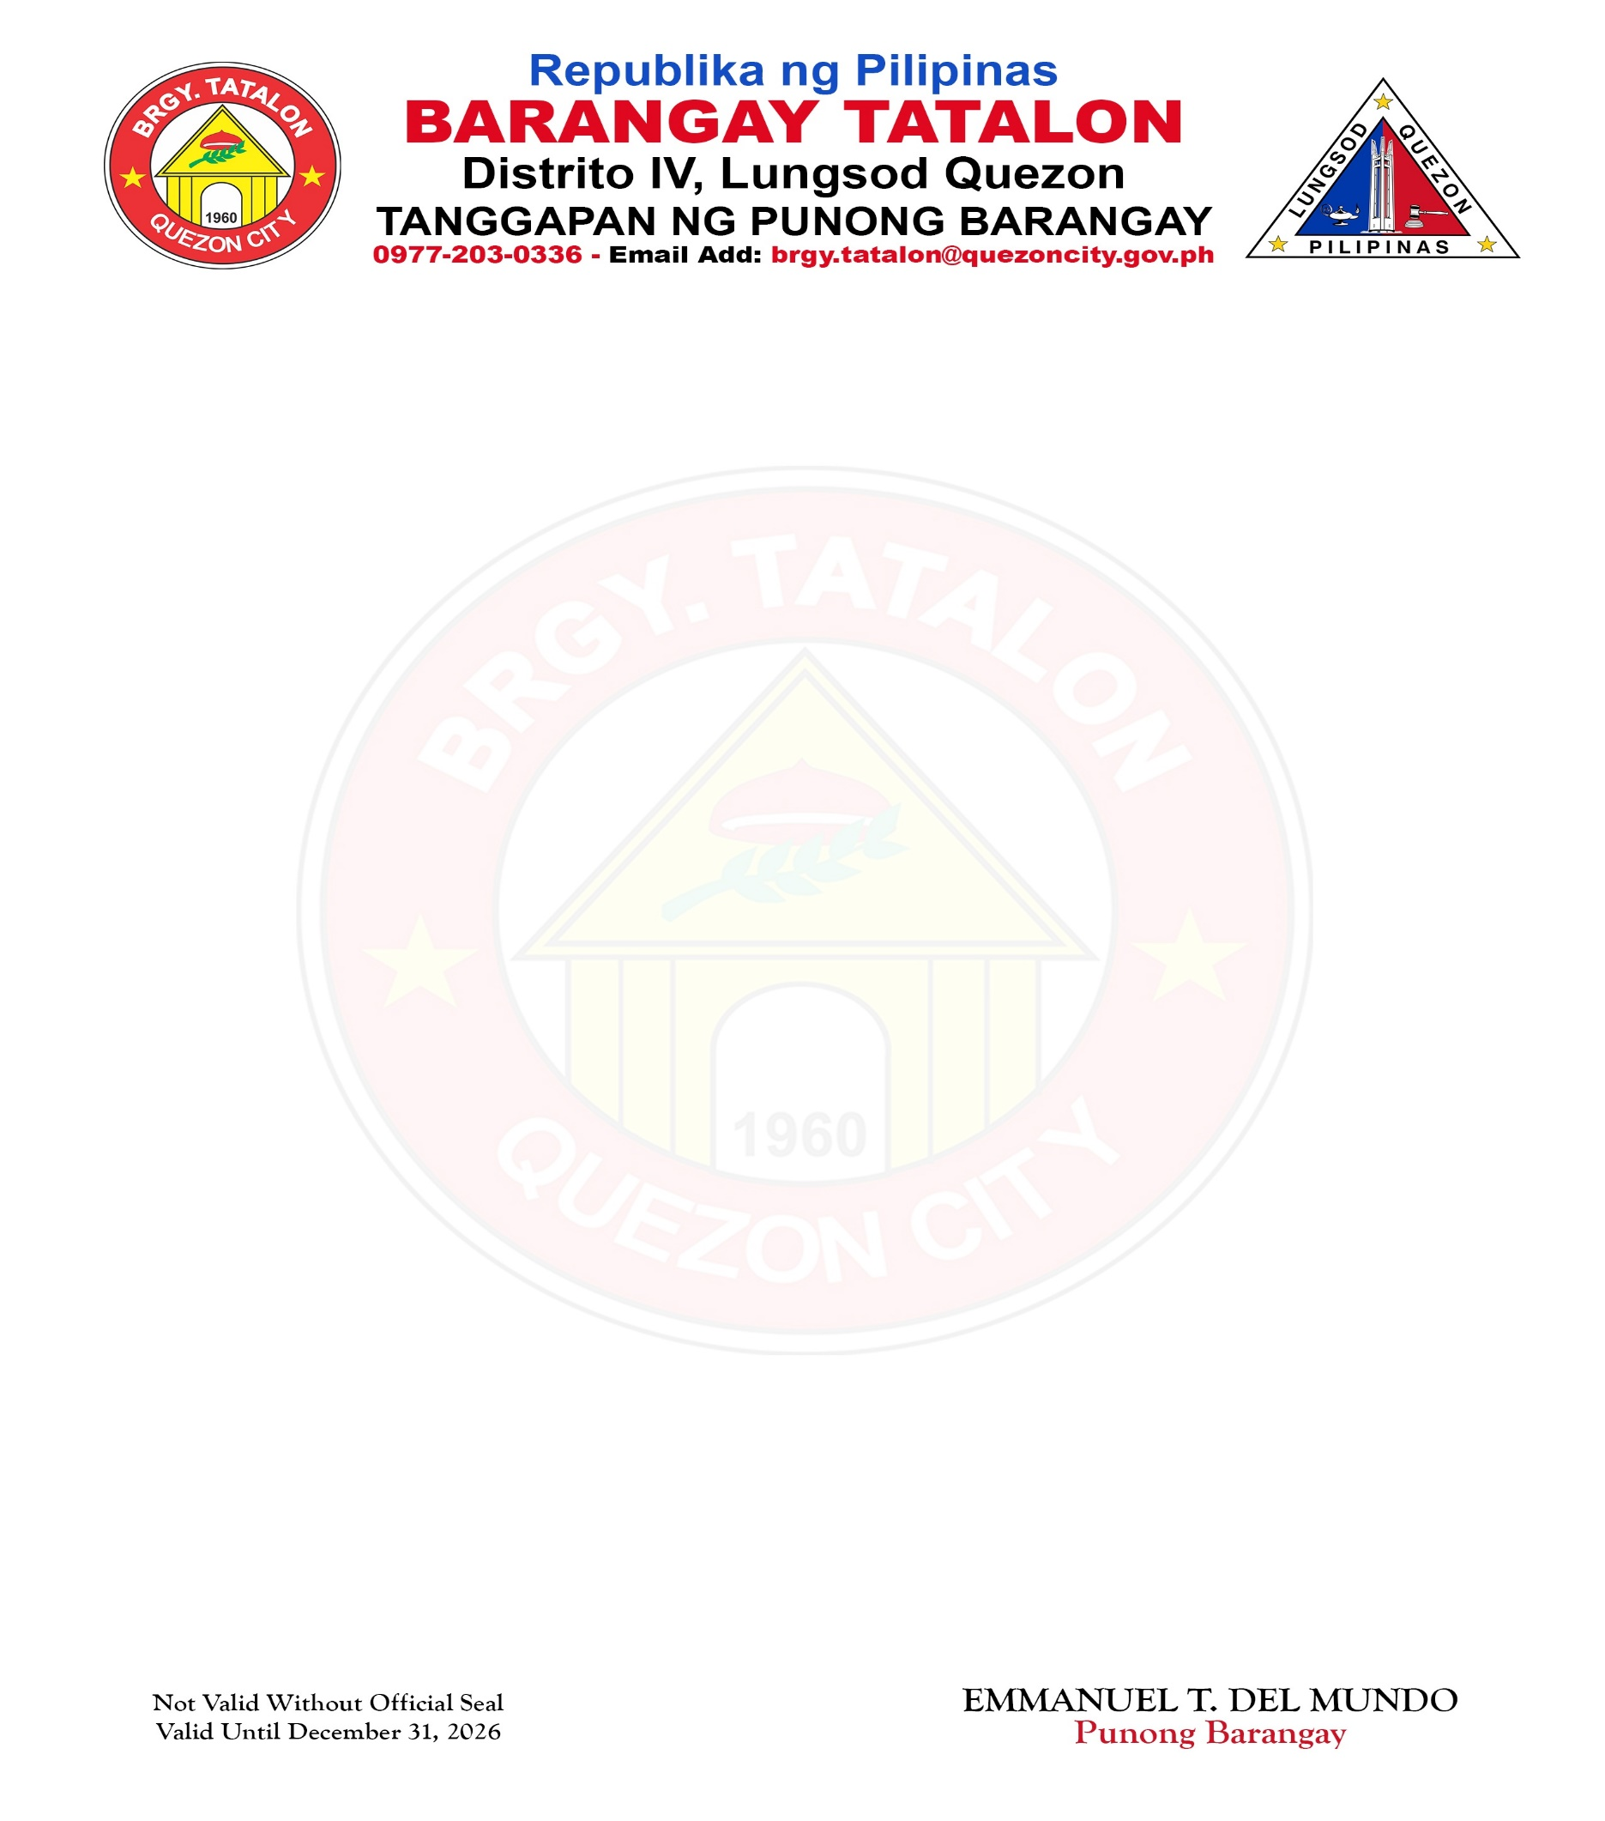

CERTIFICATE OF GOOD MORAL CHARACTER

TO WHOM IT MAY CONCERN:

This is to certify that MHELINDA LARDIZABAL AGUILAN, of legal age and Filipino, is a bona fide resident of No. 119 ROTC HUNTERS C-2, Barangay Tatalon, Quezon City, Metro Manila. Further certify that he/she is a person with good moral character and has no derogatory record in this office since December 2024 up to present based upon verification of our Purok Jonathan Quiñonez.

This certification is being issued to the above-named person upon request for whatever legal purpose it may serve.

Issued this 10th day of July, 2026 at Barangay Tatalon, Quezon City, Metro Manila.
EMMANUEL T. DEL MUNDO
Punong Barangay

Not Valid Without Official Seal
Valid Until December 31, 2026

