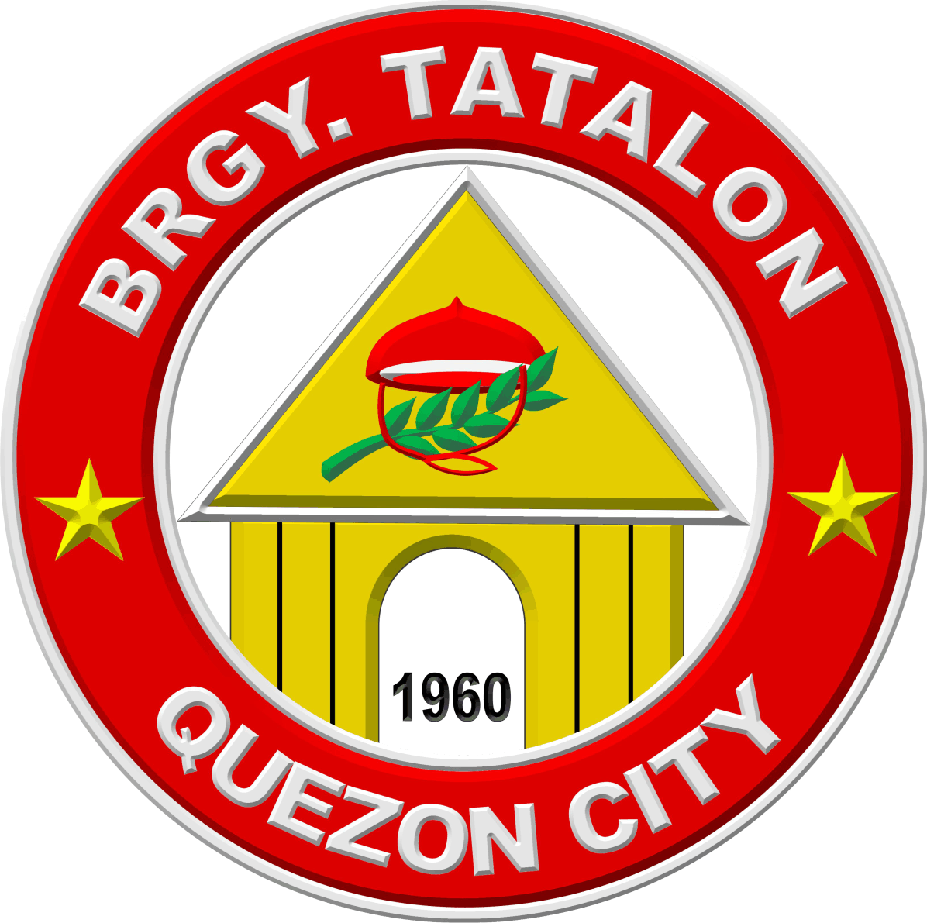

Republika ng Pilipinas
BARANGAY TATALON
Distrito IV, Lungsod Quezon
TANGGAPAN NG PUNONG BARANGAY
0977-203-0336 - Email Add: brgy.tatalon@quezoncity.gov.ph

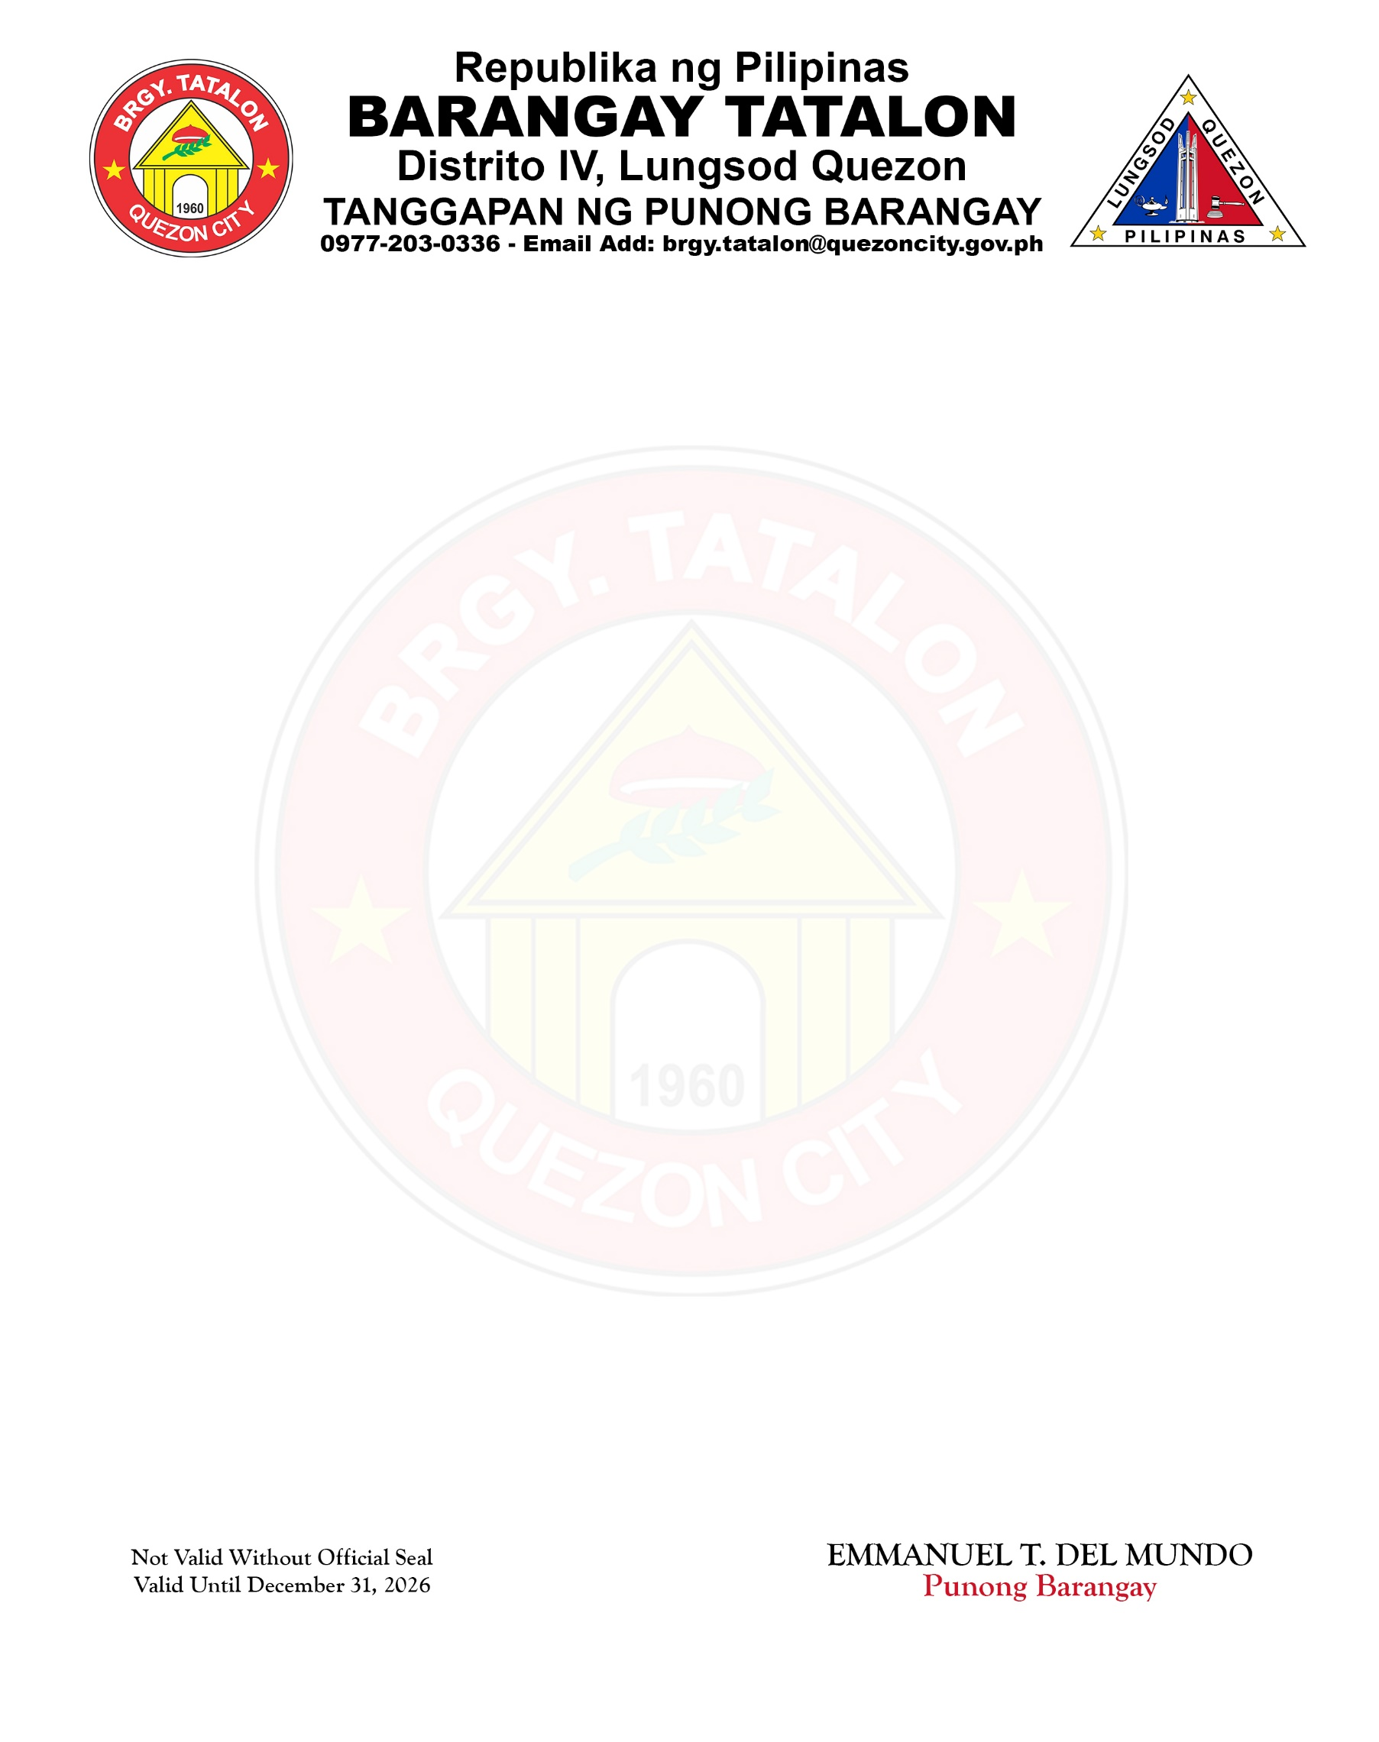
Ñ

CERTIFICATE OF INDIGENCY

TO WHOM IT MAY CONCERN:

This is to certify that NILDA SARMIENTO LIGBOS, of legal age and Filipino, is a bona fide resident of No. 534 LOT 11 BLK 8 ESPADA ST., Barangay Tatalon, Quezon City, Metro Manila. Further certify that he/she belongs to the indigent family of this barangay.
This certification is being issued to the above-named person upon request for QC ID APPLICATION of her grandchild ANIELEYA LIGBOS SUNGA (DOB: JULY 18, 2008).

Issued this 14th day of July, 2026 at Barangay Tatalon, Quezon City, Metro Manila.

EMMANUEL T. DEL MUNDO Punong Barangay

Not Valid Without Official Seal
Valid Until December 31, 2026

