

Republika ng Pilipinas
BARANGAY TATALON
Distrito IV, Lungsod Quezon
TANGGAPAN NG PUNONG BARANGAY
0977-203-0336 - Email Add: brgy.tatalon@quezoncity.gov.ph

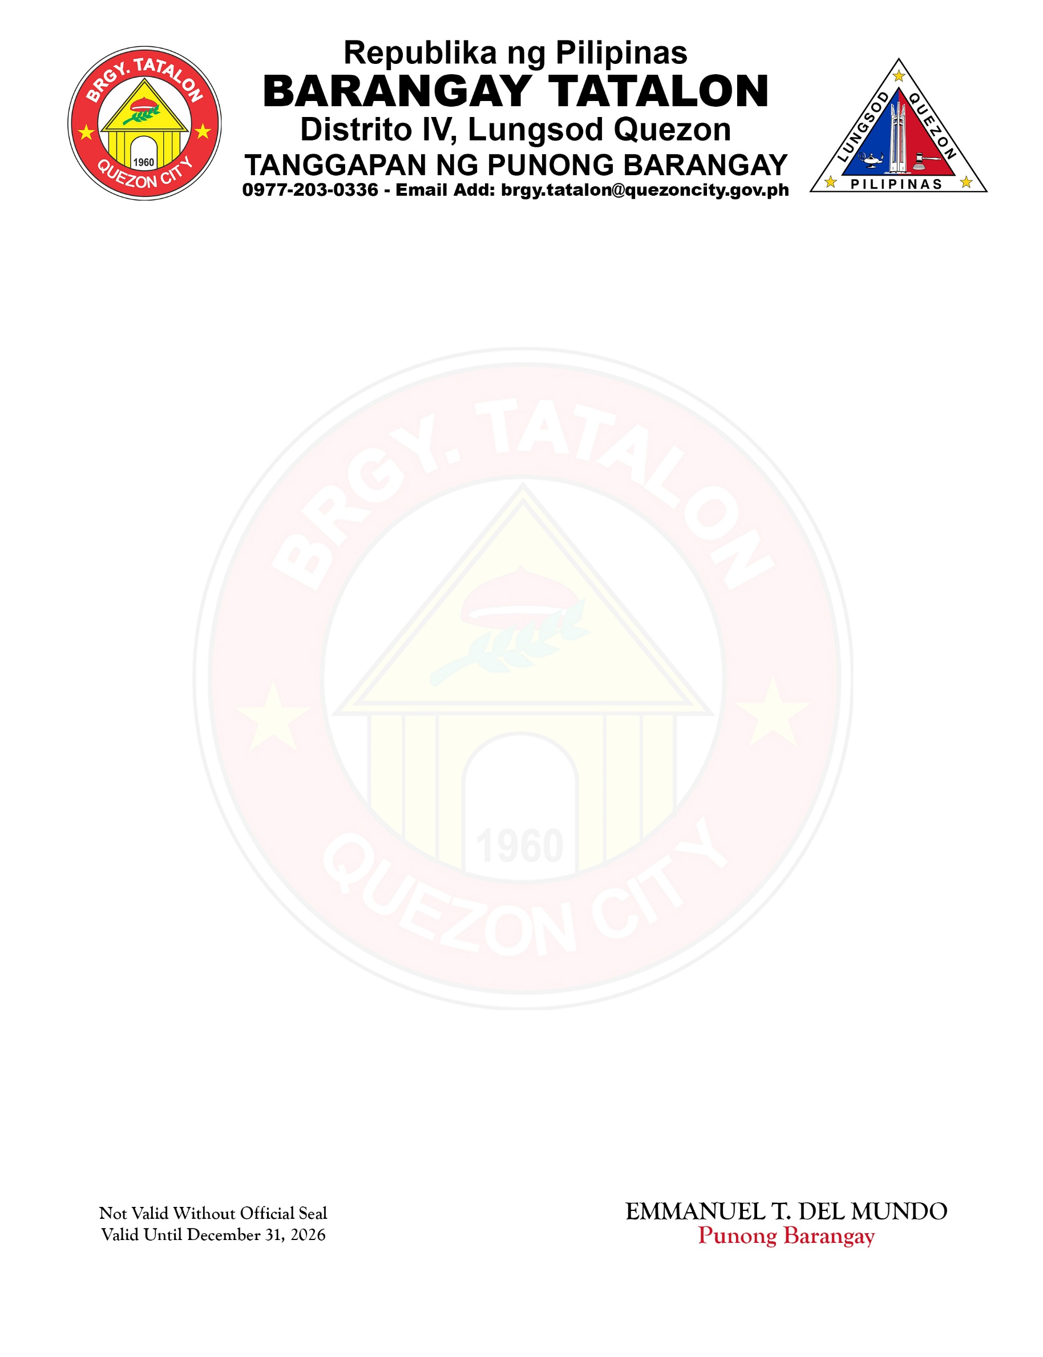

BARANGAY BUSINESS PERMIT

To Whom It May Concern:

This is to certify that : IRENE E. GABRIEL
NAME OF BUSINESS : IG PICTURE TAKING PRINTING SERVICES
ADDRESS/LOCATION : No. 96 KALIRAYA ST.,
BRGY. TATALON, QUEZON CITY
NATURE OF BUSINESS : PRINTING SERVICES

Is doing business in Barangay Tatalon, Quezon City
This certification is issued under the requirement of the New Local Government Code of Republic Act No. 7160, Article IV, Section 152 and paragraph C, for the purpose of securing business permit/license from Quezon City.
Issued this 14th day of July, 2026 at Barangay Tatalon, Quezon City, Metro Manila.

EMMANUEL T. DEL MUNDO Punong Barangay

X
NEW

RENEW
Note: Not valid without official seal to be posted prominently within
The business area and may be subject to inspection by an authorized
Barangay Business Inspector. Valid Until December 31, 2026.

