

Republika ng Pilipinas
BARANGAY TATALON
Distrito IV, Lungsod Quezon
TANGGAPAN NG PUNONG BARANGAY
0977-203-0336 - Email Add: brgy.tatalon@quezoncity.gov.ph

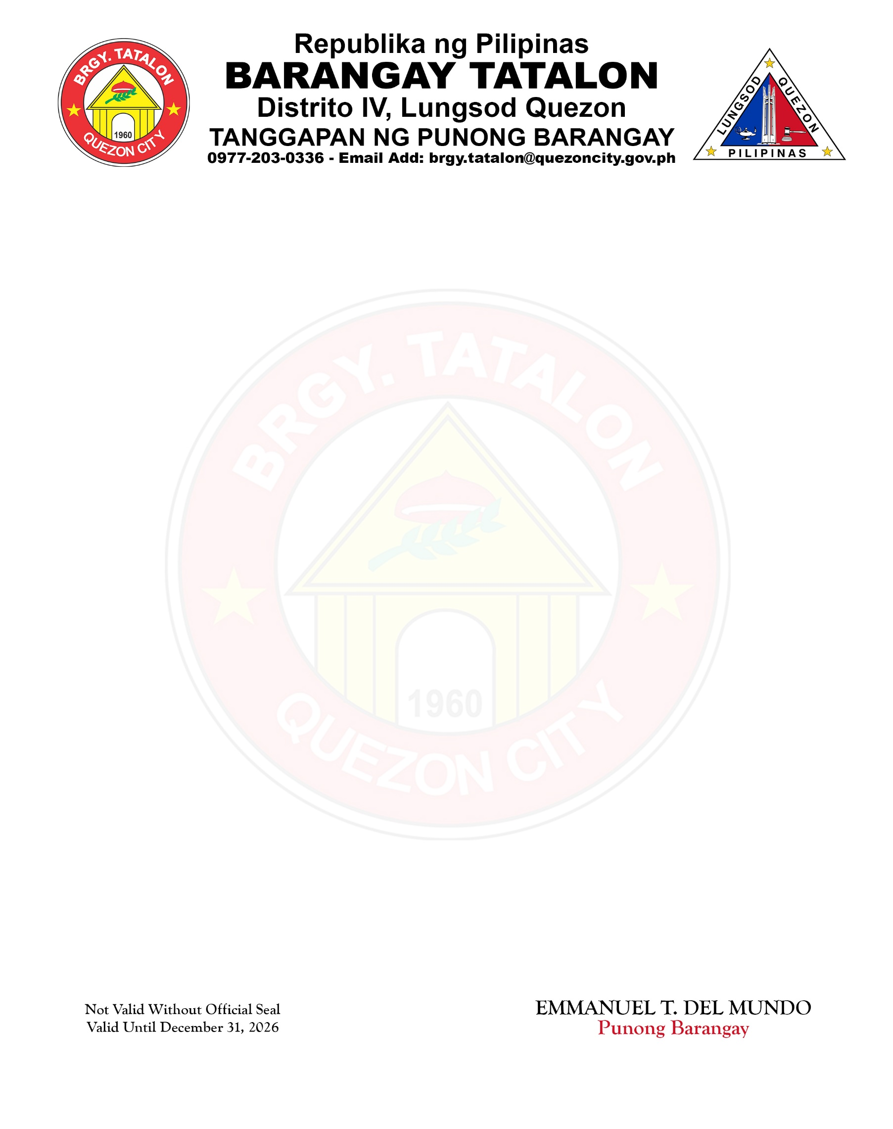

CERTIFICATE OF RESIDENCY

TO WHOM IT MAY CONCERN:

This is to certify that ANA LIZA MONTILLA ALLI, of legal age and Filipino, is a bona fide resident of CL 10 ROTC HUNTERS, Barangay Tatalon, Quezon City, Metro Manila.
This certification is being issued to the above-named person upon request for RESIDENCE IDENTIFICATION.

Issued this 14th day of July, 2026 at Barangay Tatalon, Quezon City, Metro Manila.

EMMANUEL T. DEL MUNDO Punong Barangay

Not Valid Without Official Seal
Valid Until December 31, 2026

