SparkContext
先看一个简单的spark操作,
val sc = new SparkContext(……)
val textFile = sc.textFile("README.md")
textFile.filter(line => line.contains("Spark")).count()

SparkContext
这是Spark的入口, 任何需要使用Spark的地方都需要先创建SparkContext
在SparkContext中, 最主要的初始化工作就是start TaskScheduler（具体有TaskSchedulerImpl实现）和DAGScheduler, 这两个就是Spark的核心所在，主要完成任务调度；
Spark的设计非常的干净, 把整个DAG抽象层从实际的task执行中剥离了出来，交由DAGScheduler完成；
DAGScheduler, 负责解析spark命令, 生成stage, 形成DAG, 最终划分成tasks, 提交给TaskScheduler, 他只完成静态分析 ；
TaskScheduler, 专门负责task执行, 他只负责资源管理, task分配, 执行情况的报告 ；
这样的好处, 就是Spark可以通过提供不同的TaskScheduler简单的支持各种资源调度和执行平台, 现在Spark支持, local, standalone, mesos, Yarn...
class SparkContext(config: SparkConf) extends Logging
{
....
def this(
master: String,
appName: String,
sparkHome: String = null,
jars: Seq[String] = Nil,
environment: Map[String, String] = Map(),
preferrendNodeLocationData: Map[String, Set[SplitInfo]] = Map()) =
{
this(SparkContext.updatedConf(new SparkConf(), master, appName, sparkHome, jars, environment))
this.preferredNodeLocationData = preferredNodeLocationData
}
....
}
SparkContext类在1.1.0版本的实现中共有七个构造函数，上面列出的是参数最全面的一个，其他构造函数的参数均以上的部分内容，这些参数均是由用户编写的Driver传入。

sc.textFile
然后当然要载入被处理的数据, 最常用的textFile, 其实就是生成HadoopRDD, 作为起始的RDD
/**
* Read a text file from HDFS, a local file system (available on all nodes), or any
* Hadoop-supported file system URI, and return it as an RDD of Strings.
*/ def textFile(path: String, minSplits: Int = defaultMinSplits): RDD[String] = {
hadoopFile(path, classOf[TextInputFormat], classOf[LongWritable], classOf[Text], minSplits)
.map(pair => pair._2.toString)
}
/** Get an RDD for a Hadoop file with an arbitrary InputFormat */
def hadoopFile[K, V](
path: String,
inputFormatClass: Class[_ <: InputFormat[K, V]],
keyClass: Class[K],
valueClass: Class[V],
minSplits: Int = defaultMinSplits
) : RDD[(K, V)] = {
val conf = new JobConf(hadoopConfiguration)
FileInputFormat.setInputPaths(conf, path) new HadoopRDD(this, conf, inputFormatClass, keyClass, valueClass, minSplits)
}

Transform and Action
这里调用的filter transform很简单, 可以参考前面的blog
关键调用count action, action的不同在于, 会调用runjob
所以在调用action之前, job都是没有被真正执行的
def count(): Long = {// 只有在action中才会真正调用runJob, 所以transform都是lazy的 sc.runJob(this, (iter: Iterator[T]) => { // count调用的是简化版的runJob, 只传入rdd和func, 其他的会用默认值补全，SparkContext共有7重载runJob。
var result = 0L while (iter.hasNext) {
result += 1L
iter.next()
}
result
}).sum
}
4. sc.runJob
关键在于调用了dagScheduler.runJob，且只有在这个runJob中才会调用这个函数。
/**
* Run a function on a given set of partitions in an RDD and pass the results to the given handler function. This is the main entry point for all actions in Spark. The allowLocal * flag specifies whether the scheduler can run the computation on the driver(创建SparkContext的进程) rather than * shipping it out to the cluster, for short actions like first().
*/
def runJob[T, U: ClassTag](
rdd: RDD[T],
func: (TaskContext, Iterator[T]) => U,
partitions: Seq[Int],
allowLocal: Boolean,
resultHandler: (Int, U) => Unit) {
if (dagScheduler == null) {
throw new SparkException("SparkContext has been shutdown")
}
val callSite = getCallSite
val cleanedFunc = clean(func)
logInfo("Starting job: " + callSite.shortForm)
val start = System.nanoTime
dagScheduler.runJob(rdd, cleanedFunc, partitions, callSite, allowLocal,
resultHandler, localProperties.get)
logInfo(
"Job finished: " + callSite.shortForm + ", took " + (System.nanoTime - start) / 1e9 + " s")
rdd.doCheckpoint()
}

PairRDD
和一般RDD最大的不同就是有两个泛型参数, [K, V]表示pair的概念
关键的function是, combineByKey, 所有pair相关操作的抽象
combine是这样的操作, Turns an RDD[(K, V)] into a result of type RDD[(K, C)]
其中C有可能只是简单类型, 但经常是seq, 比如(Int, Int) to (Int, Seq[Int])
下面来看看combineByKey的参数,
首先需要用户自定义一些操作,
createCombiner: V => C, C不存在的情况下, 比如通过V创建seq C
mergeValue: (C, V) => C, 当C已经存在的情况下, 需要merge, 比如把item V加到seq C中, 或者叠加
mergeCombiners: (C, C) => C, 合并两个C
partitioner: Partitioner, Shuffle时需要的Partitioner
mapSideCombine: Boolean = true, 为了减小传输量, 很多combine可以在map端先做, 比如叠加, 可以先在一个partition中把所有相同的key的value叠加, 再shuffle
serializerClass: String = null, 传输需要序列化, 用户可以自定义序列化类
/**
* Extra functions available on RDDs of (key, value) pairs through an implicit conversion.
* Import `org.apache.spark.SparkContext._` at the top of your program to use these functions.
*/
class PairRDDFunctions[K: ClassManifest, V: ClassManifest](self: RDD[(K, V)])
extends Logging
with SparkHadoopMapReduceUtil
with Serializable {
/**
* Generic function to combine the elements for each key using a custom set of aggregation
* functions. Turns an RDD[(K, V)] into a result of type RDD[(K, C)], for a "combined type" C
* Note that V and C can be different -- for example, one might group an RDD of type
* (Int, Int) into an RDD of type (Int, Seq[Int]). Users provide three functions:
*
* - `createCombiner`, which turns a V into a C (e.g., creates a one-element list)
* - `mergeValue`, to merge a V into a C (e.g., adds it to the end of a list)
* - `mergeCombiners`, to combine two C's into a single one.
*
* In addition, users can control the partitioning of the output RDD, and whether to perform
* map-side aggregation (if a mapper can produce multiple items with the same key).
*/
def combineByKey[C](createCombiner: V => C,
mergVealue: (C, V) => C,
mergeCombiners: (C, C) => C,
partitioner: Partitioner,
mapSideCombine: Boolean = true, //如果需要mapSideCombine，默认是需要的
serializer: Serializer = null): RDD[(K, C)] = {
require(mergeCombiners != null, "mergeCombiners must be defined") // required as of Spark 0.9.0
if (keyClass.isArray) {
if (mapSideCombine) {
throw new SparkException("Cannot use map-side combining with array keys.")
}
if (partitioner.isInstanceOf[HashPartitioner]) {
throw new SparkException("Default partitioner cannot partition array keys.")
}
} //1.Aggregator
val aggregator = new Aggregator[K, V, C](createCombiner, mergeValue, mergeCombiners)
if (self.partitioner == Some(partitioner)) { // RDD本身的partitioner和传入的partitioner相等时, 即不需要重新shuffle, 直接map即可
self.mapPartitionsWithContext((context, iter) => { //2. mapPartitions, map端直接调用combineValuesByKey
new InterruptibleIterator(context, aggregator.combineValuesByKey(iter, context))
}, preservesPartitioning = true)
} else {
new ShuffledRDD[K, V, C](self, partitioner)
.setSerializer(serializer) //3. ShuffledRDD, 进行shuffle
.setAggregator(aggregator)
.setMapSideCombine(mapSideCombine) //Shuffle完后, 在reduce端再做一次combine, 使用combineCombinersByKey
}
}

Aggregator
在combineByKey中, 首先创建Aggregator, 其实在Aggregator中封装了两个函数,
combineValuesByKey, 用于处理将V加入到C的case, 比如加入一个item到一个seq里面, 用于map端
combineCombinersByKey, 用于处理两个C合并, 比如两个seq合并, 用于reduce端
case class Aggregator[K, V, C] (
createCombiner: V => C,
mergeValue: (C, V) => C,
mergeCombiners: (C, C) => C) {

def combineValuesByKey(iter: Iterator[_ <: Product2[K, V]]) : Iterator[(K, C)] = {
val combiners = new JHashMap[K, C]
for (kv <- iter) {
val oldC = combiners.get(kv._1)
if (oldC == null) {
combiners.put(kv._1, createCombiner(kv._2))
} else {
combiners.put(kv._1, mergeValue(oldC, kv._2))
}
}
combiners.iterator
}

def combineCombinersByKey(iter: Iterator[(K, C)]) : Iterator[(K, C)] = {
val combiners = new JHashMap[K, C]
iter.foreach { case(k, c) =>
val oldC = combiners.get(k)
if (oldC == null) {
combiners.put(k, c)
} else {
combiners.put(k, mergeCombiners(oldC, c))
}
}
combiners.iterator
}
}

mapPartitions
mapPartitions其实就是使用MapPartitionsRDD
做的事情就是对当前partition执行map函数f, Iterator[T] => Iterator[U]
比如, 执行combineValuesByKey: Iterator[_ <: Product2[K, V]] to Iterator[(K, C)]
/**
* Return a new RDD by applying a function to each partition of this RDD.
*/
def mapPartitions[U: ClassManifest](f: Iterator[T] => Iterator[U],
preservesPartitioning: Boolean = false): RDD[U] =
new MapPartitionsRDD(this, sc.clean(f), preservesPartitioning)

private[spark]
class MapPartitionsRDD[U: ClassManifest, T: ClassManifest](
prev: RDD[T],
f: Iterator[T] => Iterator[U],
preservesPartitioning: Boolean = false)
extends RDD[U](prev) {

override val partitioner =
if (preservesPartitioning) firstParent[T].partitioner else None

override def getPartitions: Array[Partition] = firstParent[T].partitions

override def compute(split: Partition, context: TaskContext) =
f(firstParent[T].iterator(split, context)) // 对于map,就是调用f

ShuffledRDD
Shuffle实际上是由系统的shuffleFetcher完成的, Spark的抽象封装非常的好
所以在这里看不到Shuffle具体是怎么样做的, 这个需要分析到shuffleFetcher时候才能看到
因为每个shuffle是有一个全局的shuffleid的
所以在compute里面, 你只是看到用BlockStoreShuffleFetcher根据shuffleid和partitionid直接fetch到shuffle过后的数据
/**
* The resulting RDD from a shuffle (e.g. repartitioning of data).
* @param prev the parent RDD.
* @param part the partitioner used to partition the RDD
* @tparam K the key class.
* @tparam V the value class.
*/
class ShuffledRDD[K, V, P <: Product2[K, V] : ClassManifest](
@transient var prev: RDD[P],
part: Partitioner)
extends RDD[P](prev.context, Nil) {
override val partitioner = Some(part)
//ShuffleRDD会进行repartition, 所以从Partitioner中取出新的part数目
//并用Array.tabulate动态创建相应个数的ShuffledRDDPartition
override def getPartitions: Array[Partition] = {
Array.tabulate[Partition](part.numPartitions)(i => new ShuffledRDDPartition(i))
}

override def compute(split: Partition, context: TaskContext): Iterator[P] = {
val shuffledId = dependencies.head.asInstanceOf[ShuffleDependency[K, V]].shuffleId
SparkEnv.get.shuffleFetcher.fetch[P](shuffledId, split.index, context.taskMetrics,
SparkEnv.get.serializerManager.get(serializerClass))
}
}
ShuffledRDDPartition没啥区别, 一样只是记录id
private[spark] class ShuffledRDDPartition(val idx: Int) extends Partition {
override val index = idx
override def hashCode(): Int = idx
}

下面再来看一下, 如果使用combineByKey来实现其他的操作的,

group
group是比较典型的例子, (Int, Int) to (Int, Seq[Int])
由于groupByKey不使用map side combine, 因为这样也无法减少传输空间, 所以不需要实现mergeCombiners
/**
* Group the values for each key in the RDD into a single sequence. Allows controlling the
* partitioning of the resulting key-value pair RDD by passing a Partitioner.
*/
def groupByKey(partitioner: Partitioner): RDD[(K, Seq[V])] = {
// groupByKey shouldn't use map side combine because map side combine does not
// reduce the amount of data shuffled and requires all map side data be inserted
// into a hash table, leading to more objects in the old gen.
def createCombiner(v: V) = ArrayBuffer(v) //创建seq
def mergeValue(buf: ArrayBuffer[V], v: V) = buf += v //添加item到seq
val bufs = combineByKey[ArrayBuffer[V]](
createCombiner _, mergeValue _, null, partitioner, mapSideCombine=false)
bufs.asInstanceOf[RDD[(K, Seq[V])]]
}

reduce
reduce是更简单的一种情况, 只是两个值合并成一个值, (Int, Int V) to (Int, Int C), 比如叠加
所以createCombiner很简单, 就是直接返回v
而mergeValue和mergeCombiners逻辑是相同的, 没有区别
/**
* Merge the values for each key using an associative reduce function. This will also perform
* the merging locally on each mapper before sending results to a reducer, similarly to a
* "combiner" in MapReduce.
*/
def reduceByKey(partitioner: Partitioner, func: (V, V) => V): RDD[(K, V)] = {
combineByKey[V]((v: V) => v, func, func, partitioner)
}

Stage系列

Stage
理解stage, 关键就是理解Narrow Dependency和Wide Dependency, 可能还是觉得比较难理解 ，关键在于是否需要shuffle, 不需要shuffle是可以随意并发的, 所以stage的边界就是需要shuffle的地方。下面是Stage类的部分核心源码：
private[spark] class Stage(
val id: Int,
val rdd: RDD[_],
val numTasks: Int,
val shuffleDep: Option[ShuffleDependency[_, _, _]], // Output shuffle if stage is a map stage
val parents: List[Stage],
val jobId: Int,
val callSite: CallSite)
extends Logging {
val isShuffleMap = shuffleDep.isDefined
val numPartitions = rdd.partitions.size
val outputLocs = Array.fill[List[MapStatus]](numPartitions)(Nil)
var numAvailableOutputs = 0
/** Set of jobs that this stage belongs to. */
val jobIds = new HashSet[Int]
/** For stages that are the final (consists of only ResultTasks), link to the ActiveJob. */
var resultOfJob: Option[ActiveJob] = None
var pendingTasks = new HashSet[Task[_]]
private var nextAttemptId = 0
val name = callSite.shortForm
val details = callSite.longForm
/** Pointer to the latest [StageInfo] object, set by DAGScheduler. */
var latestInfo: StageInfo = StageInfo.fromStage(this)
def isAvailable: Boolean = {…}
def addOutputLoc(partition: Int, status: MapStatus) {…}
def removeOutputLoc(partition: Int, bmAddress: BlockManagerId) {…}
def removeOutputsOnExecutor(execId: String) {…}
/** Return a new attempt id, starting with 0. */
def newAttemptId(): Int = {…}
def attemptId: Int = nextAttemptId
}
从shuffleDep和val isShuffleMap = shuffleDep.isDefined两个成员变量可以看出，Stage分为shuffle map stage 和result stage两种类型，前者表示非最终stage，它的输出需要shuffle后作为下一个stage的输入，后者为最终的stage，直接产生结果或者存储，如count()。
由类的输入参数可知stage的RDD只是一个RDD，而非一列列的RDD，这是由于在一个stage中的所有RDD都是map，partition不会有任何改变，仅仅在data依次执行不同的map函数。因此，对于TasgScheduler而言，一个rdd的状况就可以代表这个stage。

newStage
如果是shuffle map stage, 需要在这里向mapOutputTracker注册shuffle

getMissingParentStages
可以根据final stage的deps找出所有的parent stage

Task系列
Task是介于DAGScheduler和TaskScheduler中间的接口。DAGScheduler需要把DAG中的每个stage的每个partitions转化成task ，然后把task封装成taskSet提交给TaskScheduler，Task的具体类图实现如4-1：
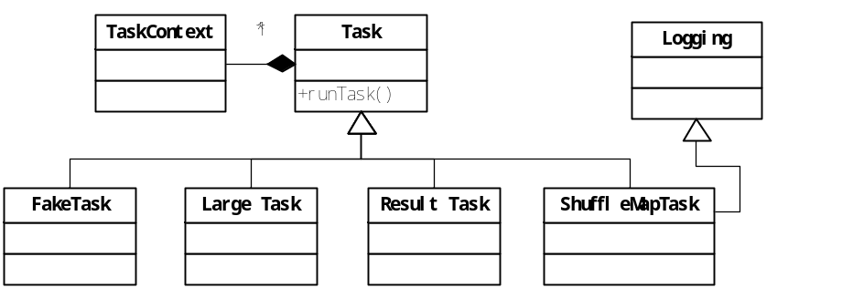
图 4-1 Task 类图概要
Task的子类主要实现runTask方法，根据具体Task类型执行不同步骤。

Task
在spark中有两种类型的Task：shuffleMapTask、ResultTask。
/**
*
* A Spark job consists of one or more stages. The very last stage in a job consists of multiple
* ResultTasks, while earlier stages consist of ShuffleMapTasks. A ResultTask executes the task
* and sends the task output back to the driver application. A ShuffleMapTask executes the task
* and divides the task output to multiple buckets (based on the task's partitioner).
*
* @param stageId id of the stage this task belongs to
* @param partitionId index of the number in the RDD
*/
private[spark] abstract class Task[T](val stageId: Int, var partitionId: Int) extends Serializable {
final def run(attemptId: Long): T = {
context =
new TaskContext(stageId, partitionId, attemptId, runningLocally = false)
context.taskMetrics.hostname = Utils.localHostName()
taskThread = Thread.currentThread()
if (_killed) {
kill(interruptThread = false)
}
runTask(context)
}
def runTask(context: TaskContext): T
def preferredLocations: Seq[TaskLocation] = Nil ////Spark关注locality,可以选择该task运行的location
// Map output tracker epoch. Will be set by TaskScheduler.
var epoch: Long = -1
var metrics: Option[TaskMetrics] = None
// Task context, to be initialized in run().
@transient protected var context: TaskContext = _
// The actual Thread on which the task is running, if any. Initialized in run().
@volatile @transient private var taskThread: Thread = _
// A flag to indicate whether the task is killed. This is used in case context is not yet
// initialized when kill() is invoked.
@volatile @transient private var _killed = false
/**
* Whether the task has been killed.
*/
def killed: Boolean = _killed
/**
* Kills a task by setting the interrupted flag to true. This relies on the upper level Spark
* code and user code to properly handle the flag. This function should be idempotent so it can
* be called multiple times.
* If interruptThread is true, we will also call Thread.interrupt() on the Task's executor thread.
*/
def kill(interruptThread: Boolean) {
_killed = true
if (context != null) {
context.markInterrupted()
}
if (interruptThread && taskThread != null) {
taskThread.interrupt()
}
}
}

TaskContext
永远记录task在执行时的上下文环境，以及task的状态。
/**
* :: DeveloperApi ::
* Contextual information about a task which can be read or mutated during execution.
*
* @param stageId stage id
* @param partitionId index of the partition
* @param attemptId the number of attempts to execute this task
* @param runningLocally whether the task is running locally in the driver JVM
* @param taskMetrics performance metrics of the task
*/
@DeveloperApi
class TaskContext(
val stageId: Int,
val partitionId: Int,
val attemptId: Long,
val runningLocally: Boolean = false,
private[spark] val taskMetrics: TaskMetrics = TaskMetrics.empty) TaskMetrics封装了task执行时一些指标和数据
extends Serializable {
@deprecated("use partitionId", "0.8.1")
def splitId = partitionId
// List of callback functions to execute when the task completes.
@transient private val onCompleteCallbacks = new ArrayBuffer[TaskCompletionListener]
// Whether the corresponding task has been killed.
@volatile private var interrupted: Boolean = false
// Whether the task has completed.
@volatile private var completed: Boolean = false
/** Checks whether the task has completed. */
def isCompleted: Boolean = completed
/** Checks whether the task has been killed. */
def isInterrupted: Boolean = interrupted
// TODO: Also track whether the task has completed successfully or with exception.
/**
* Add a (Java friendly) listener to be executed on task completion.
* This will be called in all situation - success, failure, or cancellation.
*
* An example use is for HadoopRDD to register a callback to close the input stream.
*/
def addTaskCompletionListener(listener: TaskCompletionListener): this.type = {
onCompleteCallbacks += listener
this
}
/**
* Add a listener in the form of a Scala closure to be executed on task completion.
* This will be called in all situation - success, failure, or cancellation.
*
* An example use is for HadoopRDD to register a callback to close the input stream.
*/
def addTaskCompletionListener(f: TaskContext => Unit): this.type = {
onCompleteCallbacks += new TaskCompletionListener {
override def onTaskCompletion(context: TaskContext): Unit = f(context)
}
this
}
/**
* Add a callback function to be executed on task completion. An example use
* is for HadoopRDD to register a callback to close the input stream.
* Will be called in any situation - success, failure, or cancellation.
* @param f Callback function.
*/
@deprecated("use addTaskCompletionListener", "1.1.0")
def addOnCompleteCallback(f: () => Unit) {
onCompleteCallbacks += new TaskCompletionListener {
override def onTaskCompletion(context: TaskContext): Unit = f()
}
}
/** Marks the task as completed and triggers the listeners. */
private[spark] def markTaskCompleted(): Unit = {
completed = true
// Process complete callbacks in the reverse order of registration
onCompleteCallbacks.reverse.foreach { _.onTaskCompletion(this) }
}
/** Marks the task for interruption, i.e. cancellation. */
private[spark] def markInterrupted(): Unit = {
interrupted = true
}
}

ResultTask
对应于Result Stage直接产生结果
/**
* A task that sends back the output to the driver application.
*
* See [[Task]] for more information.
*
* @param stageId id of the stage this task belongs to
* @param taskBinary broadcasted version of the serialized RDD and the function to apply on each
* partition of the given RDD. Once deserialized, the type should be
* (RDD[T], (TaskContext, Iterator[T]) => U) .
* @param partition partition of the RDD this task is associated with
* @param locs preferred task execution locations for locality scheduling
* @param outputId index of the task in this job (a job can launch tasks on only a subset of the
* input RDD's partitions).
*/
private[spark] class ResultTask[T, U](
stageId: Int,
taskBinary: Broadcast[Array[Byte]],
partition: Partition,
@transient locs: Seq[TaskLocation],
val outputId: Int)
extends Task[U](stageId, partition.index) with Serializable {
@transient private[this] val preferredLocs: Seq[TaskLocation] = {
if (locs == null) Nil else locs.toSet.toSeq
}
// 对于resultTask, run就是返回执行的结果, 比如count值
override def runTask(context: TaskContext): U = {
// Deserialize the RDD and the func using the broadcast variables.
val ser = SparkEnv.get.closureSerializer.newInstance()
val (rdd, func) = ser.deserialize[(RDD[T], (TaskContext, Iterator[T]) => U)](
ByteBuffer.wrap(taskBinary.value), Thread.currentThread.getContextClassLoader)
metrics = Some(context.taskMetrics)
try {
func(context, rdd.iterator(partition, context)) // 直接就是对RDD的iterator调用func, 比如count函数
} finally {
context.markTaskCompleted()
}
}
// This is only callable on the driver side.
override def preferredLocations: Seq[TaskLocation] = preferredLocs
override def toString = "ResultTask(" + stageId + ", " + partitionId + ")"
}

ShuffleMapTask
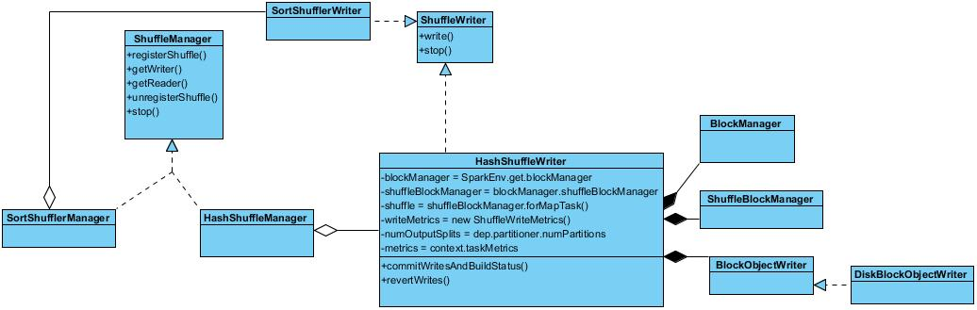
对应于ShuffleMap Stage, 产生的结果作为其他stage的输入。最关键的runTask方法中对ShuffleWriter的派生类HashShuffleWriter实例的调用或者SortShuffleWriter实例的调用（变量为writer），起着用hash方法进行Shuffle，后者对结果排序后再shuffle。两者由SparkEnv单例对象的shuffleManager属性管理，ShuffleManager的类图如下：

/**
* A ShuffleMapTask divides the elements of an RDD into multiple buckets (based on a partitioner
* specified in the ShuffleDependency).
*
* See [[org.apache.spark.scheduler.Task]] for more information.
*
* @param stageId id of the stage this task belongs to
* @param taskBinary broadcast version of of the RDD and the ShuffleDependency. Once deserialized, the type should be (RDD[_], ShuffleDependency[_, _, _]).
* @param partition partition of the RDD this task is associated with
* @param locs preferred task execution locations for locality scheduling
*/
private[spark] class ShuffleMapTask(
stageId: Int,
taskBinary: Broadcast[Array[Byte]],
partition: Partition,
@transient private var locs: Seq[TaskLocation])
extends Task[MapStatus](stageId, partition.index) with Logging {
/** A constructor used only in test suites. This does not require passing in an RDD. */
def this(partitionId: Int) {
this(0, null, new Partition { override def index = 0 }, null)
}
@transient private val preferredLocs: Seq[TaskLocation] = {
if (locs == null) Nil else locs.toSet.toSeq
}
override def runTask(context: TaskContext): MapStatus = {
// Deserialize the RDD using the broadcast variable.
val ser = SparkEnv.get.closureSerializer.newInstance()
val (rdd, dep) = ser.deserialize[(RDD[_], ShuffleDependency[_, _, _])](
ByteBuffer.wrap(taskBinary.value), Thread.currentThread.getContextClassLoader)
metrics = Some(context.taskMetrics)
var writer: ShuffleWriter[Any, Any] = null
try {
val manager = SparkEnv.get.shuffleManager
// writer是一个HashShuffleWriter实例，主要做以下几个工作：
- 通过参数获取从ShuffleDependency的partitioner中获取到shuffle目标partition的个数；
- shuffle需要的blockManager；
- 创建shuffleBlockManager；
- 从ShuffleDependency的partition中获取到shuffle的partition数目；
writer = manager.getWriter[Any, Any](dep.shuffleHandle, partitionId, context)
//writer的write方法的功能：
- 从RDD中取出每个elem数据；
- 根据elem得到buckId；
- 将elem数据写入bucket.
writer.write(rdd.iterator(partition, context).asInstanceOf[Iterator[_ <: Product2[Any, Any]]])
return writer.stop(success = true).get
} catch {
case e: Exception =>
if (writer != null) {
writer.stop(success = false)
}
throw e
} finally {
context.markTaskCompleted()
}
}
override def preferredLocations: Seq[TaskLocation] = preferredLocs
override def toString = "ShuffleMapTask(%d, %d)".format(stageId, partitionId)
}
runTask方法中，val manager = SparkEnv.get.shuffleManager返回一个HashShuffleManager或者SortShuffleManager的实例，而后通过manager对象的getWriter方法获取一个HashShuffleWriter或者SortShuffleWriter实例对象，两者是对ShuffleWriter类的泛化。
HashShuffleWriter对象初始化时，会创建ShuffleBlockManager，并通过调用forMapTask方法分配、管理bucket，同时ShuffleBlockManager为每一个bucket分配一个DiskBlockObjectWriter，即得到一个DiskBlockObjectWriter对象数组，每个write handler拥有默认100KB的缓存，使用这个write handler将Map output写入文件中。
最后，通过buckets.writers(bucketId).write(pair)，也就是说Map output的key-value pair是逐个写入到磁盘而不是预先把所有数据存储在内存中在整体flush到磁盘中去。
具体调用时序图如下所示：
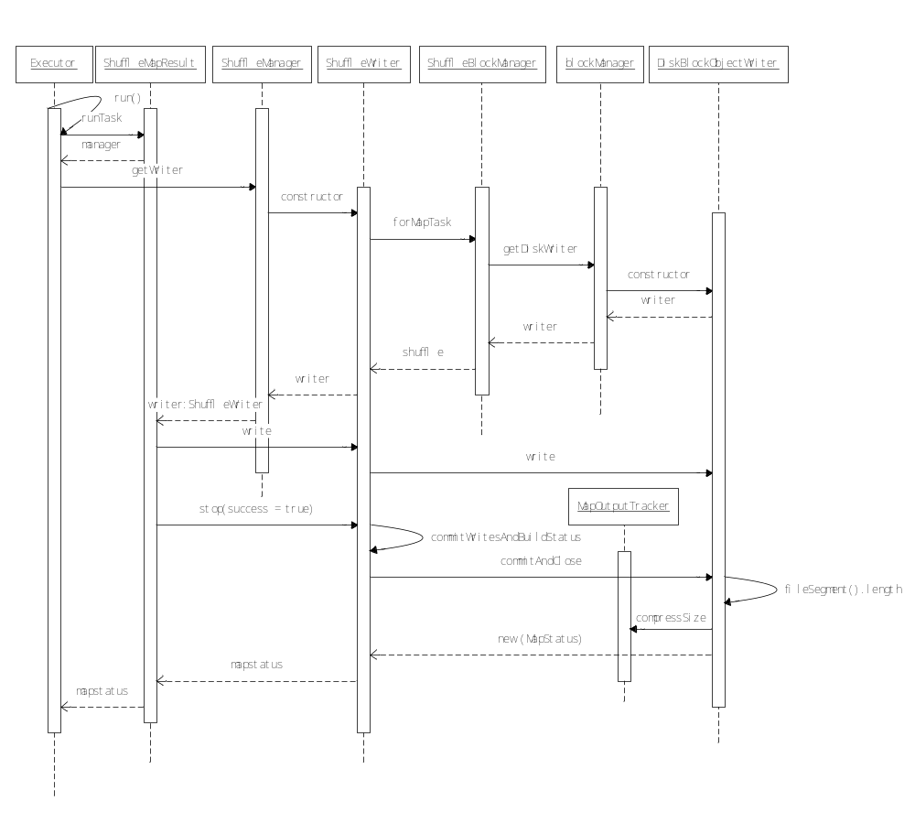

TaskSet
用于封装一个stage的所有的tasks, 以提交给TaskScheduler
package org.apache.spark.scheduler
/**
* A set of tasks submitted together to the low-level TaskScheduler, usually representing
* missing partitions of a particular stage.
*/
private[spark] class TaskSet(
val tasks: Array[Task[_]],
val stageId: Int,
val attempt: Int,
val priority: Int,
val properties: Properties) {
val id: String = stageId + "." + attempt

override def toString: String = "TaskSet " + id
}

Task执行流程
那么最终是怎么执行的? 通过DAGScheduler切分成Stage, 封装成taskset, 提交给TaskScheduler, 然后等待调度, 最终到Executor上执行
val sc = new SparkContext(……)
val textFile = sc.textFile("README.md")
textFile.filter(line => line.contains("Spark")).count()
这是一个比较简单的没有shuffle的例子, 看看在Executor上是如何被执行的。
首先这个job只有一个stage, 所以只会产生resultTask
最关键的执行语句,
func(context, rdd.iterator(split, context))
对于这个例子, func就是最终产生结果的count(), 而rdd就是count前最后一个rdd, 即filter产生的rdd
可以看到Spark中rdd的执行, 不是从前往后, 而是从后往前推的, 为什么? 因为需要考虑cache和checkpoint
所以对于stage只会保留最后一个rdd, 其他的rdd通过dep去反推, 这里调用rdd.iterator来读取最后一个rdd

我可以说iterator是spark中最为核心的一个function吗:-)
final def iterator(split: Partition, context: TaskContext): Iterator[T] = {
if (storageLevel != StorageLevel.NONE) {
SparkEnv.get.cacheManager.getOrCompute(this, split, context, storageLevel)
} else {
computeOrReadCheckpoint(split, context)
}
}
如果结果被cache在memory或disk中, 则调用cacheManager.getOrCompute来读取, 否则直接从checkpoint读或compute
通过CacheManager来完成从cache中读取数据, 或重新compute数据并且完成cache的过程
private[spark] class CacheManager(blockManager: BlockManager) extends Logging {
private val loading = new HashSet[String]

/** Gets or computes an RDD partition. Used by RDD.iterator() when an RDD is cached. */
def getOrCompute[T](
rdd: RDD[T],
partition: Partition,
context: TaskContext,
storageLevel: StorageLevel): Iterator[T] = {

val key = RDDBlockId(rdd.id, partition.index)
logDebug(s"Looking for partition $key")
blockManager.get(key) match { // 从blockManager中获取cached值
case Some(blockResult) =>
// Partition is already materialized, so just return its values
context.taskMetrics.inputMetrics = Some(blockResult.inputMetrics)
new InterruptibleIterator(context, blockResult.data.asInstanceOf[Iterator[T]])

case None =>
// Acquire a lock for loading this partition
// If another thread already holds the lock, wait for it to finish return its results
val storedValues = acquireLockForPartition[T](key)
if (storedValues.isDefined) {
return new InterruptibleIterator[T](context, storedValues.get)
}

// Otherwise, we have to load the partition ourselves
try {
logInfo(s"Partition $key not found, computing it") / /loading的过程,就是读cp或重新compute
val computedValues = rdd.computeOrReadCheckpoint(partition, context) / /compute的结果是iterator, 何处遍历产生真实数据?

// If the task is running locally, do not persist the result
if (context.runningLocally) {
return computedValues
}

// Otherwise, cache the values and keep track of any updates in block statuses
val updatedBlocks = new ArrayBuffer[(BlockId, BlockStatus)]
val cachedValues = putInBlockManager(key, computedValues, storageLevel, updatedBlocks)
val metrics = context.taskMetrics
val lastUpdatedBlocks = metrics.updatedBlocks.getOrElse(Seq[(BlockId, BlockStatus)]())
metrics.updatedBlocks = Some(lastUpdatedBlocks ++ updatedBlocks.toSeq)
new InterruptibleIterator(context, cachedValues)

} finally {
loading.synchronized {
loading.remove(key)
loading.notifyAll()
}
}
}
}

Task执行的结果, 如何传到DAGScheduler（插入时序图）
task执行的结果value, 参考Spark 源码分析 -- Task
对于ResultTask是计算的值,比如count值,
对于ShuffleTask为MapStatus(blockManager.blockManagerId, compressedSizes), 其中compressedSizes所有shuffle buckets写到文件中的data size
//TaskRunner
val value = task.run(taskId.toInt)
val result = new TaskResult(value, accumUpdates, task.metrics.getOrElse(null))
context.statusUpdate(taskId, TaskState.FINISHED, serializedResult) //context,StandaloneExecutorBackend

//StandaloneExecutorBackend.statusUpdate
driver ! StatusUpdate(executorId, taskId, state, data)

//DriverActor.StatusUpdate
scheduler.statusUpdate(taskId, state, data.value)

//ClusterScheduler.statusUpdate
var taskSetToUpdate: Option[TaskSetManager] = None
taskSetToUpdate.get.statusUpdate(tid, state, serializedData)

//ClusterTaskSetManager.statusUpdate
case TaskState.FINISHED =>
taskFinished(tid, state, serializedData)

//ClusterTaskSetManager.taskFinished
val result = ser.deserialize[TaskResult[_]](serializedData)
result.metrics.resultSize = serializedData.limit()
sched.listener.taskEnded(tasks(index), Success, result.value, result.accumUpdates, info, result.metrics)
//tasks = taskSet.tasks
//info为TaskInfo
class TaskInfo(
val taskId: Long,
val index: Int,
val launchTime: Long,
val executorId: String,
val host: String,
val taskLocality: TaskLocality.TaskLocality)

//DAGScheduler.taskEnded
override def taskEnded(
task: Task[_],
reason: TaskEndReason,
result: Any,
accumUpdates: Map[Long, Any],
taskInfo: TaskInfo,
taskMetrics: TaskMetrics) {
eventQueue.put(CompletionEvent(task, reason, result, accumUpdates, taskInfo, taskMetrics))
}

//DAGScheduler.processEvent
handleTaskCompletion(completion)

//DAGScheduler.handleTaskCompletion
......

Schedule系列
在spark的部署中有两种类型的调度：资源调度和任务调度。
spark在资源管理和调度上采用了类似于与Hadoop YARN方式，在最上层分配资源和调度注册到spark中的所有应用，在目前的spark-1.1版本中，可以选在Mesos或者Yarn等作为其资源调度框架。在每一个应用内部，spark又实现了任务调度，类似于Mapreduce。所以，外层的资源调度和spark内层的任务调度是相互独立的，各司其职。

spark在设计上将DAGScheduler和TaskScheduler完全解耦。所以在资源管理和

Storage系列
在写Spark程序的时候我们常常和RDD ( Resilient Distributed Dataset ) 打交道，通过RDD为我们提供的各种transformation和action接口实现我们的应用，RDD的引入提高了抽象层次，在接口和实现上进行有效地隔离，使用户无需关心底层的实现。但是RDD提供给我们的仅仅是一个“形”, 我们所操作的数据究竟放在哪里，如何存取？它的“体”是怎么样的？这是由storage模块来实现和管理的。

整体架构
Storage模块主要分为两层：
通信层：storage模块采用的是master-slave结构来实现通信层，master和slave之间传输控制信息、状态信息，这些都是通过通信层来实现的。
存储层：storage模块需要把数据存储到disk或是memory上面，有可能还需replicate到远端，这都是由存储层来实现和提供相应接口。
而其他模块若要和storage模块进行交互，storage模块提供了统一的操作类BlockManager，外部类与storage模块打交道都需要通过调用BlockManager相应接口来实现。
Storage模块通信层的UML类图如下：
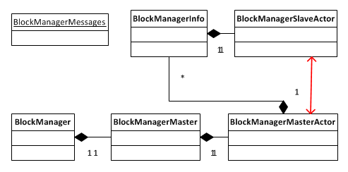
各个类在master和slave上所扮演的不同角色：
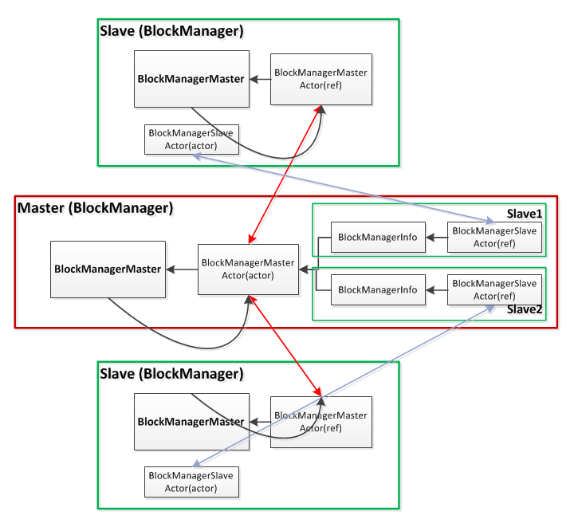
对于master和slave，BlockManager的创建有所不同：
- Master (client driver)
BlockManagerMaster拥有BlockManagerMasterActor的actor和所有BlockManagerSlaveActor的ref。
- Slave (executor)
对于slave，BlockManagerMaster则拥有BlockManagerMasterActor的ref和自身BlockManagerSlaveActor的actor。
BlockManagerMasterActor在ref和actor之间进行通信；BlockManagerSlaveActor在ref和actor之间通信。
actor和ref:
actor和ref是Akka中的两个不同的actor reference，分别由actorOf和actorFor所创建。actor类似于网络服务中的server端，它保存所有的状态信息，接收client端的请求执行并返回给客户端；ref类似于网络服务中的client端，通过向server端发起请求获取结果。
BlockManager 包含了BlockManagerMaster，通过BlockManagerMaster进行通信。Spark会在client driver和executor端创建各自的BlockManager，通过BlockManager对storage模块进行操作。

Deploy系列

Standalone模式
standalone模式下启动和任务提交执行主要是通过master、worker、SparkDeploySchedulerBackend：：AppClient、CoarseGrainedExecutorBackend以及executor共5个对象完成，主要的消息类型包括：RequestSubmitDrive()，RegisterDriver(), RegisterApplication(), LaunchExecutor(), RegisterExecutor()。具体的流程7-1所示：
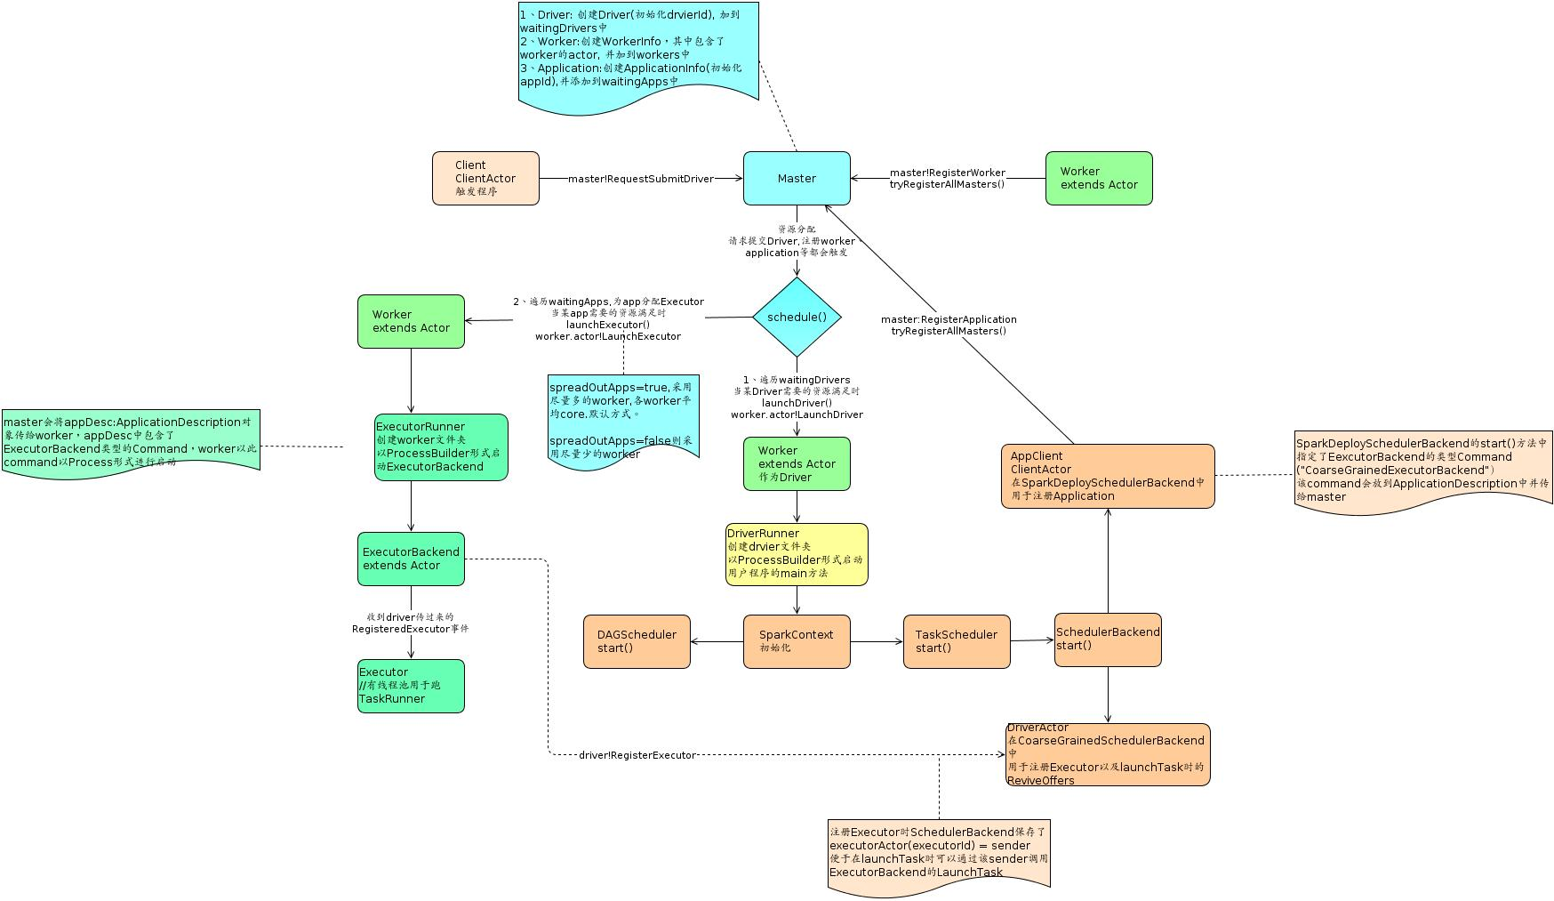
图 7-1 standalone 模式启动流程
流程说明：
- 首先启动master和worker，worker通过调用preStart()注册自己；
- Client发送RequestSubmitDriver消息提交任务；
- mater将请求的Driver放入waitingDrivers中，将application放入waitingApps中，然后调用schedule()。如果收到的是RegisterDriver请求，会操作worker.actor!LaunchDriver()给worker，让worker运行DriverRunner创建Driver文件夹，并已ProcessBuilder形式启动用户程序的main方法---初始化SparkContext，初始化TaskScheduler，通过SparkDeploySchedulerBackend：：AppClient注册application到master中。如果master收到的是RegisterApplication消息，则会操作worker.actor!LaunchExecutor消息给worker节点，worker节点会已ProcessBuilder形式启动CoarseGrainedExecutorBackend进程，该进程会创建一个包含线程池的Executor对象，其中每个线程执行一个task任务。
附录：spark组件说明：
spark组件说明：
- master: 资源管理，分配driver到哪个Worker，分配Executor等。standalone时是设置的7077端口的那台机器, yarn模式时是yarn的resource manager.
- worker: 相当于slave，其作为driver或executor的机器。standalone是注册的worker，yarn时是动态分配的nodemanager。
- driver: 用户写的main函数。spark-submit提交jar时，1.0版本时master会找到一台符合要求的worker(或nodemanager)作为driver，然后这台Worker创建DriverRunner对象来启动一个jvm进程来运行main函数对应的object，1.1版本则是由启动sparkSubmit的机器作为driver，SparkSubmit会通过反射机制来调用应用程序的main方法。
- 在yarn-cluster时是appmaster,yarn-client时是执行spark-submit的机器。
- drvier负责注册application，提交task到相应的executor等，与各executor进行通信。
- application: 每new一个SparkContext就会产生一个application。初始化SparkContext(真实是在SchedulerBackend.start()中)时driver会向master注册application。master会为该application找到符合要求的worker，然后这些worker会创建ExecutorRunner对象来启动ExecutorBackend的jvm进程。
- ExecutorBackend: 具体实现是CoarseGrainedExecutorBackend。主要是创建Executor对象并且与driver进行通信来获得driver提交的任务信息给Executor执行。一个application在相应的worker上只有一个Executor。
- Executor: Task的真正执行者，其维护一个线程池用于跑相应的Task。
- Job: ActiveJob，每个action都会生成一个Job。
- Stage: 一个Job/action中每遇到ShuffleDependency就会有一个stage(ShuffleMapStage)以及finalStage(ResultStage，每个action都会有一个finalStage)。
- Task: 每个分区Partition对应一个task。
下面是主要的代码细节：
sparkcontext（给应用程序员提供的api）中有一个scheduler的属性，在createTaskScheduler() 中根据硬件资源的管理方式创建不同的scheduler实例。在standalone模式中，创建scheduler的代码片段如下：
case SPARK_REGEX(sparkUrl) =>
val scheduler = new TaskSchedulerImpl(sc)
val masterUrls = sparkUrl.split(",").map("spark:// + _)
val backend = new SparkDeploySchedulerBackend(scheduler, sc, masterUrls)
scheduler.initialize(backend)
scheduler

可以看出，在应用程序中实例化SparkDeploySchedulerBackend一个包含AppClient对象的实例，即会同时启动AppClient对象。通过向appclient传递启动参数和application有关信息，appclient向master发送请求注册application，通过调用master的schedule()向worker发送LaunchExecutor消息，worker在收到该消息后则启动ExecutorRunner。
private[spark] class Master(
host: String,
port: Int,
webUiPort: Int,
val securityMgr: SecurityManager)
extends Actor with ActorLogReceive with Logging {
{
/**
* Schedule the currently available resources among waiting apps. This method will be called
* every time a new app joins or resource availability changes.
*/
private def schedule() {
if (state != RecoveryState.ALIVE) { return }
// First schedule drivers, they take strict precedence over applications
val shuffledWorkers = Random.shuffle(workers) // Randomization helps balance drivers
for (worker <- shuffledWorkers if worker.state == WorkerState.ALIVE) {
for (driver <- List(waitingDrivers: _*)) { // iterate over a copy of waitingDrivers
if (worker.memoryFree >= driver.desc.mem && worker.coresFree >= driver.desc.cores) {
launchDriver(worker, driver)
waitingDrivers -= driver
}
}
}
// Right now this is a very simple FIFO scheduler. We keep trying to fit in the first app
// in the queue, then the second app, etc.
if (spreadOutApps) {
// Try to spread out each app among all the nodes, until it has all its cores
for (app <- waitingApps if app.coresLeft > 0) {
val usableWorkers = workers.toArray.filter(_.state == WorkerState.ALIVE)
.filter(canUse(app, _)).sortBy(_.coresFree).reverse
val numUsable = usableWorkers.length
val assigned = new Array[Int](numUsable) // Number of cores to give on each node
var toAssign = math.min(app.coresLeft, usableWorkers.map(_.coresFree).sum)
var pos = 0
while (toAssign > 0) {
if (usableWorkers(pos).coresFree - assigned(pos) > 0) {
toAssign -= 1
assigned(pos) += 1
}
pos = (pos + 1) % numUsable
}
// Now that we've decided how many cores to give on each node, let's actually give them
for (pos <- 0 until numUsable) {
if (assigned(pos) > 0) {
val exec = app.addExecutor(usableWorkers(pos), assigned(pos))
launchExecutor(usableWorkers(pos), exec)
app.state = ApplicationState.RUNNING
}
}
}
} else {
// Pack each app into as few nodes as possible until we've assigned all its cores
此处，master会根据app所需要的core数量在worker节点上创建相应数量的CoarseGrainedExecutorBackend进程。其中，coresLeft为ApplicationInfo的方法。
for (worker <- workers if worker.coresFree > 0 && worker.state == WorkerState.ALIVE) { //选择
for (app <- waitingApps if app.coresLeft > 0) {
if (canUse(app, worker)) {
val coresToUse = math.min(worker.coresFree, app.coresLeft)
if (coresToUse > 0) {
val exec = app.addExecutor(worker, coresToUse)
launchExecutor(worker, exec)
app.state = ApplicationState.RUNNING
}
}
}
}
}
}
//省略代码
} // end of master.
master节点发送LaunchExecutor消息给worker节点时会在消息中具体指明worker节点要启动的进程主函数，具体包含在ExecutorInfo::ApplicaitonInfo:: ApplicationDescription: : command:: mainClass ，

运行时，worker会运行多个包含Executor对象的CoarseGrainedExecutorBackend进程（LaunchExecutor消息中的mainClass属性指定为CoarseGrainedExecutorBackend），在executor中会创建一个sparkEnv实例来保存相应的环境，executor包含一个线程池来执行某个任务的部分task。在每个executor实例中 都会创建一个SparkEnv实例，该实例组合了底层storage模块和通信模块功能。
* Spark executor used with Mesos, YARN, and the standalone scheduler.
*/
private[spark] class Executor(
executorId: String,
slaveHostname: String,
properties: Seq[(String, String)],
isLocal: Boolean = false)
extends Logging
{
...
// Initialize Spark environment (using system properties read above)
private val env = {
if (!isLocal) {
val _env = SparkEnv.create(conf, executorId, slaveHostname, 0,
isDriver = false, isLocal = false)
SparkEnv.set(_env)
_env.metricsSystem.registerSource(executorSource)
_env
} else {
SparkEnv.get
}
}
...
}
worker节点中启动CoarseGrainedExecutorBackend进程的代码如下：
private[spark] class Worker(
host: String,
port: Int,
webUiPort: Int,
cores: Int,
memory: Int,
masterUrls: Array[String],
actorSystemName: String,
actorName: String,
workDirPath: String = null,
val conf: SparkConf,
val securityMgr: SecurityManager)
extends Actor with ActorLogReceive with Logging {
... //部分代码省略
override def receiveWithLogging = {
... //部分代码省略
case LaunchExecutor(masterUrl, appId, execId, appDesc, cores_, memory_) =>
if (masterUrl != activeMasterUrl) {
logWarning("Invalid Master (" + masterUrl + ") attempted to launch executor.")
} else {
try {
logInfo("Asked to launch executor %s/%d for %s".format(appId, execId, appDesc.name))
val manager = new ExecutorRunner(appId, execId, appDesc, cores_, memory_,
self, workerId, host, sparkHome, workDir, akkaUrl, conf, ExecutorState.RUNNING)
executors(appId + "/" + execId) = manager
manager.start()
coresUsed += cores_
memoryUsed += memory_
masterLock.synchronized {
master ! ExecutorStateChanged(appId, execId, manager.state, None, None)
}
} catch {
case e: Exception => {
logError("Failed to launch executor %s/%d for %s".format(appId, execId, appDesc.name))
if (executors.contains(appId + "/" + execId)) {
executors(appId + "/" + execId).kill()
executors -= appId + "/" + execId
}
masterLock.synchronized {
master ! ExecutorStateChanged(appId, execId, ExecutorState.FAILED, None, None)
}
}
}
}
...
}
}// end of Worker Class.
... //部分代码省略
private[spark] class ExecutorRunner(
val appId: String,
val execId: Int,
val appDesc: ApplicationDescription,
val cores: Int,
val memory: Int,
val worker: ActorRef,
val workerId: String,
val host: String,
val sparkHome: File,
val workDir: File,
val workerUrl: String,
val conf: SparkConf,
var state: ExecutorState.Value)
extends Logging {
... //部分代码省略
def start() {
workerThread = new Thread("ExecutorRunner for " + fullId) {
override def run() { fetchAndRunExecutor() }
}
workerThread.start()
// Shutdown hook that kills actors on shutdown.
shutdownHook = new Thread() {
override def run() {
killProcess(Some("Worker shutting down"))
}
}
Runtime.getRuntime.addShutdownHook(shutdownHook)
}
... //部分代码省略
def fetchAndRunExecutor() {
try {
// Create the executor's working directory
val executorDir = new File(workDir, appId + "/" + execId)
if (!executorDir.mkdirs()) {
throw new IOException("Failed to create directory " + executorDir)
}
// Launch the process
val command = getCommandSeq
logInfo("Launch command: " + command.mkString("\"", "\" \"", "\""))
//此处为根据master所发消息LaunchExecutor（WorkInfo, ExecutorInfo)消息中ExecutorInfo::ApplicaitonInfo:: ApplicationDescription: : command:: mainClass来启动CoarseGrainedExecutorBackend新进程。其中ProcessBuilder类为java类，根据具体的进程环境属性创建进程实例，参考http://docs.oracle.com/javase/7/docs/api/java/lang/ProcessBuilder.html。
val builder = new ProcessBuilder(command: _*).directory(executorDir)
val env = builder.environment()
for ((key, value) <- appDesc.command.environment) {
env.put(key, value)
}
// In case we are running this from within the Spark Shell, avoid creating a "scala"
// parent process for the executor command
env.put("SPARK_LAUNCH_WITH_SCALA", "0")
process = builder.start()
val header = "Spark Executor Command: %s\n%s\n\n".format(
command.mkString("\"", "\" \"", "\""), "=" * 40)
// Redirect its stdout and stderr to files
val stdout = new File(executorDir, "stdout")
stdoutAppender = FileAppender(process.getInputStream, stdout, conf)
val stderr = new File(executorDir, "stderr")
Files.write(header, stderr, Charsets.UTF_8)
stderrAppender = FileAppender(process.getErrorStream, stderr, conf)
// Wait for it to exit; executor may exit with code 0 (when driver instructs it to shutdown)
// or with nonzero exit code
val exitCode = process.waitFor()
state = ExecutorState.EXITED
val message = "Command exited with code " + exitCode
worker ! ExecutorStateChanged(appId, execId, state, Some(message), Some(exitCode))
} catch {
case interrupted: InterruptedException => {
logInfo("Runner thread for executor " + fullId + " interrupted")
state = ExecutorState.KILLED
killProcess(None)
}
case e: Exception => {
logError("Error running executor", e)
state = ExecutorState.FAILED
killProcess(Some(e.toString))
}
}
}

