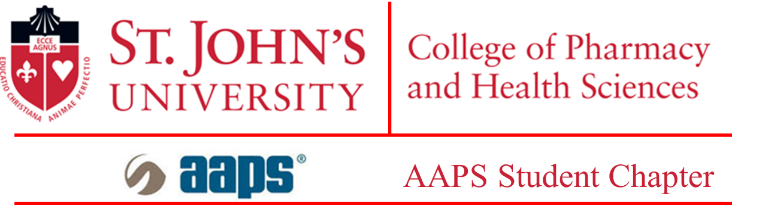

**Three-minute Thesis (3MT) Competition**

The 3MT is an exciting annual competition for graduate students to showcase their communication skills and present their research to a general audience. It helps students condense their data and focus on important aspects of their research without much deviation.

Please submit this form to Nitesh Kunda, Ph.D., at [kundan@stjohns.edu](mailto:kundan@stjohns.edu) as one single file, by April 5, 2024.

Please note: The word limit for the abstract is 300 words. The file should be saved as a .pdf file with your full name as the file name so that the saved file would say, i.e. ‘John Doe.pdf’. There is a section to write your abstract and title. Please fill the necessary details in this document itself.

**Applicant Details**

|  |  |
| --- | --- |
| **Student Name:** | |
| **Program of study (Please mark one): M.S.:  Ph.D.:** | |
| **Major:** | |
| **St. John’s email address:** | |
| **Telephone number: +1 ( )-( )-( )** | |
| **Semester of comprehensive exam completion (Please include the year) (Ph.D. only):** |  |
| **Year and semester of enrollment (M.S. only):** |  |

**Title of thesis**

|  |
| --- |
|  |

**Abstract (not more than 300 words):**

|  |
| --- |
|  |

**Please read the following and sign:**

***The 3MT competition will be held on the April 19, 2024, in-person at St. John’s University.***

***I have informed my mentor of my intention to present and apply to the 3MT competition and I have his/her full support with the same. The 3MT committee will notify me of my selection and provide me with the guidelines and judging criteria.***

