Documenting DEI efforts in the PAF

**Consider engaging in the many opportunities to develop and enhance your pedagogical skills at St. John’s Diversity, Equity, and Inclusion workshops/learning opportunities given by:** [**Equity and Inclusion Council**](https://www.stjohns.edu/equity-and-inclusion/equity-and-inclusion-council)**,** [**Human Resources**](https://www.stjohns.edu/who-we-are/leadership-and-administration/administrative-offices/human-resources/training-and-development) **(HR),** [**Academic Center for Equity and Inclusion**](https://www.stjohns.edu/equity-and-inclusion/academic-center-equity-and-inclusion) **(ACEI,** [**Institute for Critical Race and Ethnic Studies**](https://www.stjohns.edu/academics/centers-institutes/institute-critical-race-and-ethnic-studies) **( (CRES),** [**Inclusivity Resource Center**](https://www.stjohns.edu/academics/centers-institutes/inclusivity-resource-center) **(IRC),** [**Office of Multicultural Affairs**](https://www.stjohns.edu/equity-and-inclusion/office-multicultural-affairs) **(OMA),** [**LGBTQ+ Center,**](https://www.stjohns.edu/equity-and-inclusion/university-lgbtq-resources)[**Center for Teaching and Learning**](https://www.stjohns.edu/academics/centers-institutes/center-teaching-and-learning) **(CTL) etc. Below are some examples**

# Opportunities for DEI in Teaching

## Obtaining Equity and Inclusion Teaching Education and Training

### Inclusive Teaching Insitute Certification

[Academic Center for Equity and Inclusion’s](https://www.stjohns.edu/equity-and-inclusion/academic-center-equity-and-inclusion) (ACEI) Inclusive Teaching Institute (ITI’s): The ITI is a 3-part training and certification for educators who are interested in inclusive teaching and want to grow in community. Modules will be covering topics including social justice curriculum for faculty, providing opportunities for faculty to develop inclusive teaching pedagogical content and practices as well as, developing other sustained practices within our institution to support equity and inclusion. **These modules should be taken in sequence. Program participants earn a certificate at the completion of the modules.**

Module 1: Social Justice Framework for the Educator

1. Equip faculty with foundational knowledge and skills related to social justice frameworks, inclusive and culturally responsive pedagogy
2. Explore how Social Identity, Power, and Privilege operate in the classroom
3. Gain a deeper awareness of your own social identities, locations, and positions of power in relation to students, content, and classroom dynamics.

**Thursday, September 14th: 1-3 pm** [**Register here**](https://stjohns.libcal.com/event/11130291)**!**

**Thursday, October 12th: 1-3 pm** [**Register here!**](https://stjohns.libcal.com/event/11192754)

Module 2: Building an Inclusive Syllabus

1. Developing, practicing, and strengthening inclusive habits of mind
2. Providing paths for student success by leveraging the syllabus as an educational tool
3. Setting the stage for co-creating an inclusive learning environment

**Thursday, September 21st: 1-3 pm** [**Register here**](https://stjohns.libcal.com/event/11130305)**!**

**Thursday, October 19th: 1-3 pm** [**Register here!**](https://stjohns.libcal.com/event/11192756)

Module 3: Creating an Inclusive Learning Environment

1. Establishing an inclusive and welcoming learning community
2. Addressing microaggressions and bias in learning environments
3. Facilitating discussion of hot issues

**Thursday, September 28th: 1-3 pm** [**Register here!**](https://stjohns.libcal.com/event/11130361)

**Thursday, October 26th: 1-3 pm** [**Register here!**](https://stjohns.libcal.com/event/11192759)

Become an ACEI Teaching Fellow (this qualifies as a research endeavor as well):

* The ACEI Inclusive Teaching Fellowships has 4 central goals:

1. Build our collective capacity to support inclusive teaching on campus
2. Create excellent faculty-led professional development on inclusive teaching
3. Strengthen faculty relationships by building community
4. Build faculty leadership

* Some notable mentions of our efforts include:
  + Awarded fellowships to 6 groups (total of 16 faculty fellows) in 2022-2023 and 8 faculty groups (total of 24 faculty fellows) in 2023-2024. Fellows have come from 4 of the 5 colleges.
  + Each faculty group created professional development programming to solve a local equity challenge and promote effective inclusive teaching strategies.
  + They created brown bag lunch series, reading groups, workshops with internal and external faculty leaders, revised syllabi, created reading lists, reaching colleagues in their departments, programs, and colleges with this range of events.
  + Impacted course design and sequence, built instructor skills and knowledge, developed and revised curricula, collected and learned from student feedback.
  + Established an annual poster session and community share about the work created by each group of ACEI Fellows (see attached appendix 1)
  + See section 3 for more information on attending a workshop for faculty development opportunity

## Incorporating inclusive teaching practices into learning spaces

Documenting how inclusive teaching practices have been incorporated in teaching from attending sessions offered by ACEI, CRES, OMA etc... or other faculty development opportunities (both internal and/or external), see below.

### Obtaining E&I training for personal and professional development to enhance teaching

#### Faculty Development Workshop to enhance teaching skills

* 2023-2024 Teaching Fellow Events: **Attendance in workshops discussing inclusive teaching**
  + [**Building Tech Equity and Accessibility: Faculty Development on AI and Inclusion**](https://mystjohns-my.sharepoint.com/:i:/g/personal/jialalk_stjohns_edu/EcflEjbLT2tOg69C-NBHPTgBZ_yVhcnTf-n3Lkm0coAJRw?e=eRKJOQ) **Thursday, September 14th: 1:50 pm** [**Register here!**](https://stjohns.libcal.com/event/11233692)
  + [**Gender Affirming Voice Training**](https://mystjohns-my.sharepoint.com/:w:/g/personal/jialalk_stjohns_edu/EW46b7HU8rhOs0qVrsnRkmEB5wsHbucvciYGCdOSDDhF_A?e=mpK2Wq)

**Thursday, October 5th: 5-6 pm** [**Register here!**](https://stjohns.libcal.com/event/11284681)

### Additional resources for faculty development for teaching practices (external)

* Universal Design for Learning (UDL)
  + St. John’s University [Office of Online Learning and Services](https://www.stjohns.edu/academics/academic-resources-and-programs/office-online-learning-and-services) (OLS) [UDL guide](https://campusguides.stjohns.edu/c.php?g=1294618&p=9663979&preview=88ffb74554ddca557bd4aae752e40588)
  + Harvard University: [Universal Design for Learning course](https://pll.harvard.edu/course/universal-design-learning-apply)
* Intergroup Dialogue
  + <https://igr.umich.edu/courses/training-intergroup-dialogue-facilitation>

#### Personal & Professional Development

* [Safe Zone](https://sjuit.formstack.com/forms/safezonersvp) Training hosted by the [Office of Multicultural Affairs](https://www.stjohns.edu/equity-and-inclusion/office-multicultural-affairs) and the [LGBTQ+ Center](https://www.stjohns.edu/equity-and-inclusion/university-lgbtq-resources)
* [RESPECT](https://www.stjohns.edu/equity-and-inclusion/respect) Circles hosted by the [Office of Multicultural Affairs](https://www.stjohns.edu/equity-and-inclusion/office-multicultural-affairs)
* [Equity and Inclusion](https://www.stjohns.edu/equity-and-inclusion/equity-and-inclusion-council) Workshops hosted by Human Resources (HR)
  + [HR Training and Development](https://www.stjohns.edu/who-we-are/leadership-and-administration/administrative-offices/human-resources/training-and-development) (Certification)
* [St. John’s College of Liberal Arts and Sciences](https://www.stjohns.edu/academics/schools/st-johns-college-liberal-arts-and-sciences) partners with the [ACEI](https://www.stjohns.edu/equity-and-inclusion/academic-center-equity-and-inclusion) to host the Cultural Rhetoric Series, organized by [Dr. LaToya Sawyer](https://www.stjohns.edu/academics/faculty/latoya-sawyer). These events will bring timely and leading-edge presentations from dynamic and nationally recognized scholars of cultural rhetoric to our campus community. Please see below for posters of previous sessions. Announcements about future sessions forthcoming

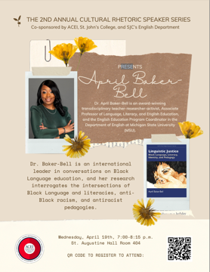

* Caribbean Writers Series organized by [Dr. Raj Chetty](https://www.stjohns.edu/academics/faculty/raj-chetty) (announcement forthcoming)
* ACEI Book Club (announcement for Fall 2023 forthcoming)
  + In the ACEI Book Club, we will be reading and discussing important and timely work that is sure to raise awareness and provide us with tools to combat the deleterious effects of implicit bias in our classrooms and in our campus community.
  + The latest book was, “Do the Work! An Antiracist Activity Book” by W. Kamau Bell & Kate Schatz

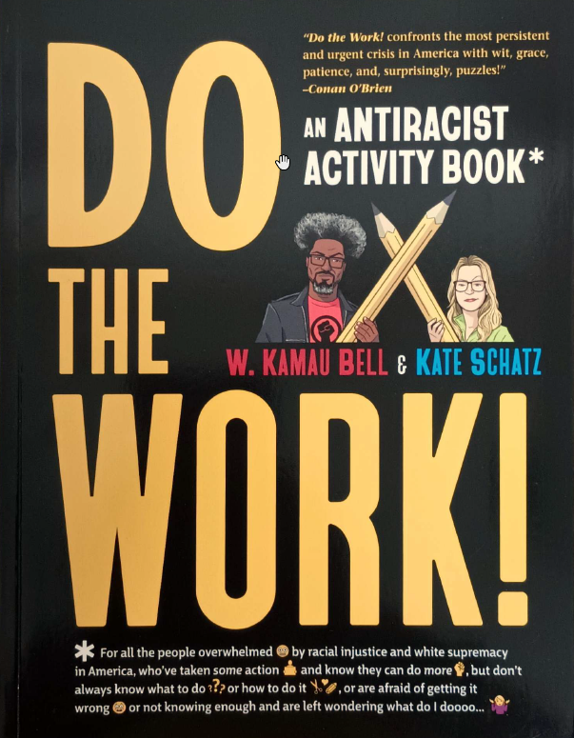

#### Conferences that you can attend to develop teaching practices:

* [American College Personnel Association ACPA](https://myacpa.org/)
* [National Conference on Race and Ethnicity in Higher Education (NCORE)](https://ncore.ou.edu/)
* [American Association of Colleges and Universities (AACU) Diversity & Student Success](https://www.aacu.org/event/2024-conference-on-diversity-equity-and-student-success)
* [Social Justice Training Institute](https://sjti.org)
* Attending Institute for Critical Race and Ethnic Studies forums on Culturally Responsive-Sustaining Education Programs (CR-SE). ([E.G.](https://drive.google.com/drive/u/2/folders/1OHuDfc_fx7zX5yfEEomNb3QIxV4nhVjH). Announcement forthcoming)

## Recognition of DEI teaching efforts and curricular development

### Awards

* St. John’s University Faculty Equity and Inclusion Teaching Award (Faculty Convocation)
* External teaching awards that center DEI in teaching

### Curriculum Development

* Participant in the Institute for Critical Race and Ethnic Studies Curriculum Development Initiative (announcements forthcoming)
* Creating new courses for DEI/Social Justice themed courses to be offered in your school or College. or changing course content/learning objectives to include DEI/social justice themes (see appropriate curriculum committee)
* HHMI Inclusive Excellence in STEM education initiative, please contact [Dr. Srividhya Swaminathan](mailto:swaminas@stjohns.edu)

# Opportunities for DEI in Research

## ACEI Teaching Fellows

* See above section

## CRES Research and Scholarship Opportunities

### Community Research Partnerships

* [The Institute for Critical Race and Ethnic Studies Community Research Partnerships](https://www.stjohns.edu/academics/centers-institutes/institute-critical-race-and-ethnic-studies) (CRP) is an Institute-based funding program that fosters community-based collaborative research designed to create redresses to systemic racism. Funded projects must be a collaboration between members of the St. John’s University community (staff, administrators, faculty, or graduate students) and individuals and organizations outside the university. The research in this space must 1) re-center the voices of individuals/communities that have historically experienced racial and ethnic minoritization and marginalization; and 2) use innovative methods central to critical race and ethnic studies.

### Publishing and Presentation Opportunities

* Publishing in the Institute’s *Journal of Critical Race and Ethnic Studies (JCRES).* Volume 1 is currently being curated.
* Proposing/organizing a panel presentation on your research on racial justice issues for the CRES Institute

If interested in learning more about these opportunities, please contact [Dr. Natalie Byfield](mailto:byfieldn@stjohns.edu).

## Writing Across Communities and ACEI

* Join the Faculty of Color Writing group organized by [Dr. Raj Chetty](https://www.stjohns.edu/academics/faculty/raj-chetty). Organized to provide faculty support on campus for their writing endeavors. For more information, please reach out to Dr. Chetty

## Awards and Recognition

* St. John’s University Faculty Equity and Inclusion Research award

## Grants

* DEI funding opportunities see link: <https://research.fas.harvard.edu/diversity-funding>

# Opportunities for DEI in Service

## Opportunities within the ACEI

* Participate as a workgroup member within the ACEI (Workgroups: “Education and Programming” or “Equity-minded” Assessment”)
* Contributing to the ACEI PULSE – a blog to chronicle faculty efforts in DEI
* Participating in ACEI communities of practice
* Running or participating RESPECT circles
* Become a trainer!
  + Facilitating workshops for the ACEI including the ITI

## Opportunities within the Institute for CRES

* Editorial Advisory Boad of the *Journal of Critical Race and Ethnic Studies (JCRES) (by invitation)*
* Institute for Critical Race and Ethnic Studies Advisory Board (
* Participating on any of the planning committees for Institute for CRES programming

## Additional Opportunities

* Nomination or becoming a recipient Values and Inclusion Program award (announcements and calls for nominations distributed by HR)
* Participate on social justice / anti racists / DEI Committees at any level both internally and/or externally
* Facilitating workshops for E&I Training for HR

# Additional Faculty Resources

Joining and participating in [National Center for Faculty Development and Diversity](https://www.facultydiversity.org/) (NCFDD) Workshops that center teaching

The ACEI has partnered with the National Center for Faculty Development and Diversity (NCFDD) and encourages all faculty to take advantage of this resource. The NCFDD is an independent faculty development center dedicated to supporting academics in making successful transitions throughout their careers. By becoming an institutional member, ***all faculty, postdocs,* *and graduate students*** at the University have access to the following member resources at no additional cost:

* + Weekly **Monday Motivator**
  + Monthly **Core Curriculum Webinars**
  + Monthly **Guest Expert Webinars**
  + Access to **Multiweek Courses**
  + Private **Discussion Forum** for peer-mentoring, problem-solving, and moderated writing challenges
  + Monthly accountability “buddy” matches
  + Access to **14-Day Writing Challenges**
  + Access to the **Member Library** that includes past webinars materials and readings

**To take advantage of this opportunity, you can activate your confidential, personal membership by visiting** [**https://www.facultydiversity.org/Join**](https://www.facultydiversity.org/Join)

For more information on these opportunities, if you are not already involved, please email [acei@stjohns.edu](mailto:acei@stjohns.edu)