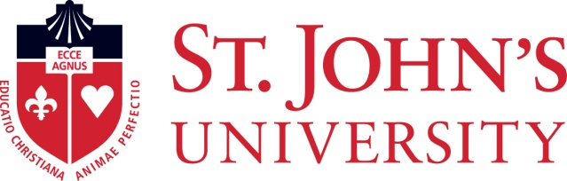

**2022 ST. JOHN’S CHILDREN’S SUMMER CAMP PROGRAM**

**EMERGENCY CONTACT and EMERGENCY CONSENT FORM**

**Please print clearly:**

Child’s Name: ________________________________________________________________

Summer Program Organization: _______________________________________________

Dates Attending: _____________________________________________________________

**EMERGENCY CONTACT (up to three adults can be provided):**

**Provide the information requested for the person to be notified in the event of emergency:**

Name _____________________________________Relationship to Child ______________

Age ______________ Telephone # ______________________

Name _____________________________________Relationship to Child ______________

Age ______________ Telephone # ______________________

Name _____________________________________Relationship to Child ______________

Age ______________ Telephone # ______________________

**EMERGENCY CONSENT**

I, (print full name) _____________________________________, as parent or legal guardian of the above minor:

Authorize __________________ through its designated representatives/chaperones, and St. John’s Summer Programs to take such emergency measures as deemed appropriate in the event of the program’s inability to locate promptly a person designated to be notified in case of emergency. St. John’s Summer Programs shall notify the parent or legal guardian as soon as possible

____________________________________

Signature of Parent or Guardian Date

*St. John’s Summer Programs 2022 (Revised 11/9/2020)*