1) Prime Number

#!/bin/bash
echo " enter the number "
read n
for ((i=2;i<$n;i++))
do
if(( $n % $i == 0 ))
then
echo " it is not prime "
exit
fi
done
echo " its prime "

output

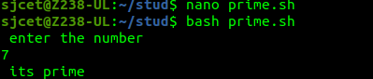

2) Add Two Numbers

#!/bin/bash
echo " enter the 1st number "
read n1
echo " enter the 2nd number "
read n2
n3=$((n1+n2))
echo "sum is: $n3"

output
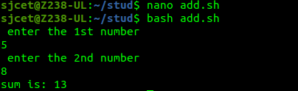

3) Swapping of two numbers

#!/bin/bash
echo " enter the number "
read f
echo " enter the number "
read s
temp=$f
f=$s
s=$temp
echo " after swapping,numbers are: "
echo " f = $f s = $s "

output
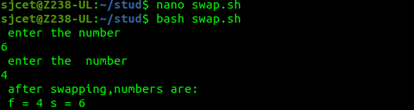

4) Radius and Circumference of a circle

echo "enter the radius"
read r
echo "the radius is"
echo " 3.14 * $r * $r " | bc
echo "the circumference is"
echo "2 * 3.14 * $r" | bc

output

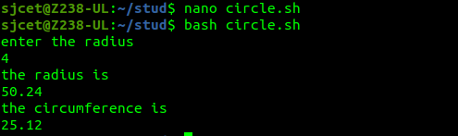

5) odd or even

#!/bin/bash
echo "enter the number"
read n
if [ `expr $n % 2` == 0 ]
then
echo "even number"
else
echo "odd number"
fi

output
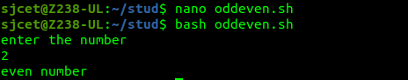

6) 1 to 10 print

#!/bin/bash
for (( counter=10; counter>0; counter-- ))
do
echo -n "$counter "
done
printf "\n"

output

