**3rd-Year-Project**

This is my 3rd year project for college. It incorporates material and topics from all the modules I studied in college. There was no specification provided as it was up to the student to choose the project.

#### Introduction

Since my first attempt at the messaging project was unsuccessful, the reason being…I could not get the WhatsApp API working, as everyone online was running into the same problem when I searched for a solution. So I had to change my app around slightly.

I set my goal to make a chatting app on visual studios 2015 using c#. First step I took was creating 3 projects in 1 containing a Client, Server and Interface using WPF (Windows Presentation Foundation) application.

Inside this project the client is going to be communicating with server and the server is going to be communicating with the clients, to create an instant messaging app. Also when a client goes offline other clients will pick up on this and see the client has gone offline at a certain time.

I done all of my projects design in Visual Studio “Blend”.

#### How to run the project

GitHub

Project link: <https://github.com/Jomzi/3rdYearProjectWhatsApp>

1. Import the project from github into visual studios.
2. Run the project.
3. When the project is running a client window will pop up and also a the console server.
4. Insert a username into the client.
5. Run another client by right clicking the “ChattingClient” or press f5 (I think also works).
6. Insert a different username into second client as a username that has already being used wont work!
7. Once all this is done the app is very easy to use. (Screenshot below should help you)

#### ScreenShots

First step run the app…

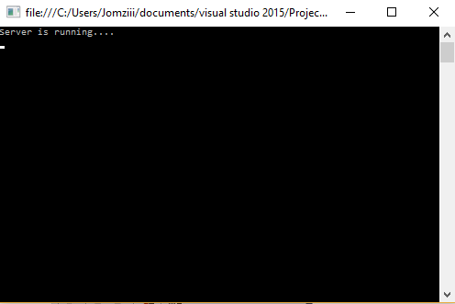

1. Presented with a console window say “Server is running…”

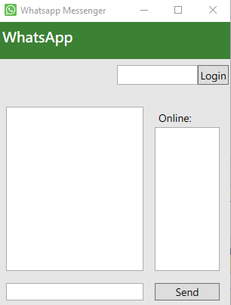

2. Messaging app is displayed one you run it

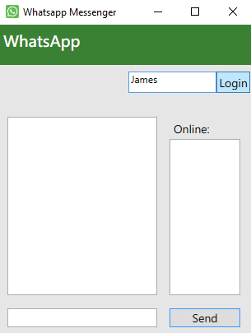

3. Type in a username(James) and click login

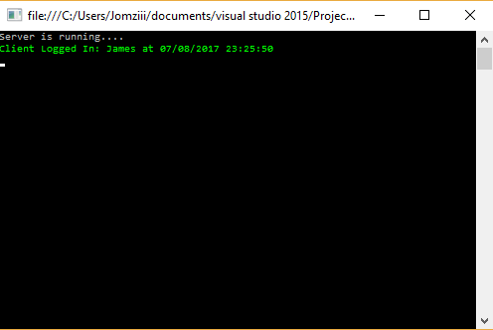

4. The server console will display details of the login

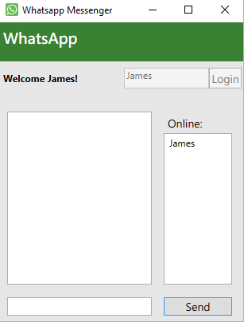

5. Once the login button is click…a welcome sign with username will appear, also it will show the username is online.

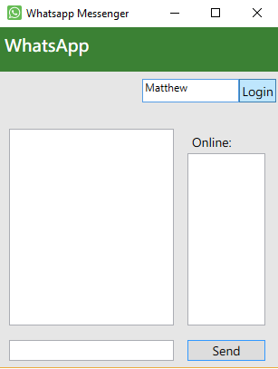

6. Here is a client 2 login, so they can chat to client 1.

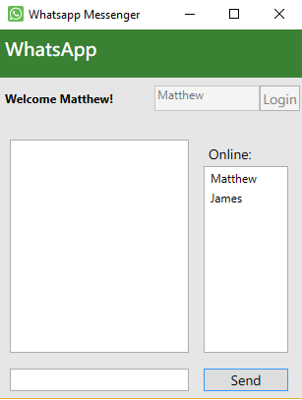

7. Client 2 is logged in showing he’s online and also shows client 1 is online also.

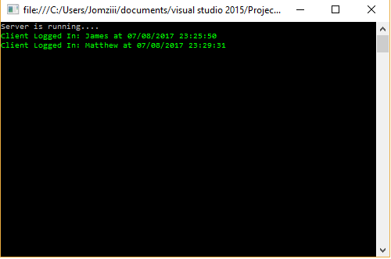

8. Detail of both clients login.

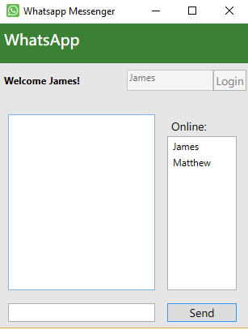

9. Now since client 2 has logged in, it will show he’s online on client 1’s.

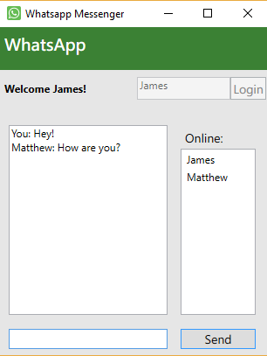

10. Here client 1 is sending a message to client 2, then client 2 responds.

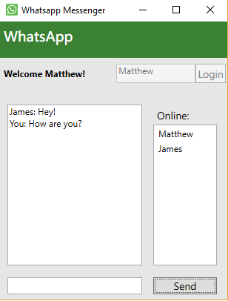

11. Client 2.

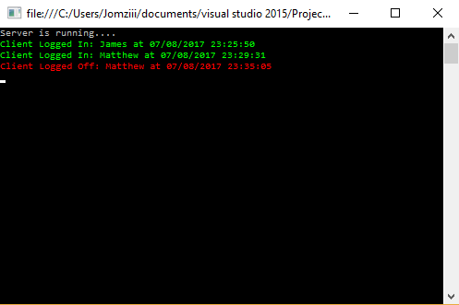

12. If client 2 closes his window it will show on the console that he has logged off. (There can be as many clients as you want to use the app)