Final Year Project

WhatsApp Messenger

James O’Hanlon

Student Id: G00318662

Lecturer: Martin

Introduction

As part of my subject in mobile application 2 we were required to create a UWP mobile phone application in Visual Studios Community 2015. The project instructions were to create a project that demonstrate the use of Isolated storage and at least one other sensor out of 6 that include: Accelerometer or GyroScope, GPS, Sound, Network services, Camera, Touch gesture Management.

My final mobile phone application idea that I went ahead with was a selfie location application that allows you to take a photo if you’re out having a coffee with a friend, write a little text about what you’re up to or what you’ve seen. Once you’ve taking the photo you will have the option to keep or discard it…If you are happy with it a map in the application will show where you were, plus the time and date when the photo was taking and you can then send all that information to a friend or families by email address. Then sensors in the application I used are Camera, GPS and Isolated storage.

My project: How I created my UWP application.

Brainstorming

The first step I took for my project was thinking of ideas for my app and searching existing apps to see could I find anything interesting that I could use for mine.

Github

Once I knew what I was going to final do for my application, I created a Github repository so I could save and keep track of my work.

Repository name: SelfieLocation

Visual Studios

Getting the project started I downloaded Visual Studios community 2015. Then I created a UWP project and called it SelfieLocation. Once I had the UWP template in front of me I got out a piece of paper to draw what I wanted my application design to look like. After I had a rough idea of my design, I then started dragging in buttons and textboxes from the toolbar and then started coding the functions in C#.

Testing

Testing my project I used local device in visual studios to test and run my project to see if I would get errors. Towards the end of my project I downloaded the windows phone emulator to make sure my app would run on a phone if someone on the windows store downloaded it.

Windows Store

Finally when I was happy with my application and everything was working I uploaded it up to windows store.

Why I chose this app.

I had many app ideas but my final choice stud out to me because of the learning factor. Also I thought it would be fun and interesting to see the finished project running and working compared to other ideas I had.

Why the user would come back to use this app?

I think people would come back to use my application because it’s a good way of engaging with friends, very fun, informational and also easy to use.

References

To get ideas for my project I looked up a site that has 100 app ideas.

I used mainly the following sites to help me with c# coding:

Youtube

microsoft.com

StackoverFlow

LearnOnline

Running my app!

(touchscreen on my windows phone decided not to work today)

Here the app is open and the front camera opens.

Click the capture button to take the picture!

Once the picture is taking the photo will freeze on the window and the capture button will change to discard, if you want to delete the photo.

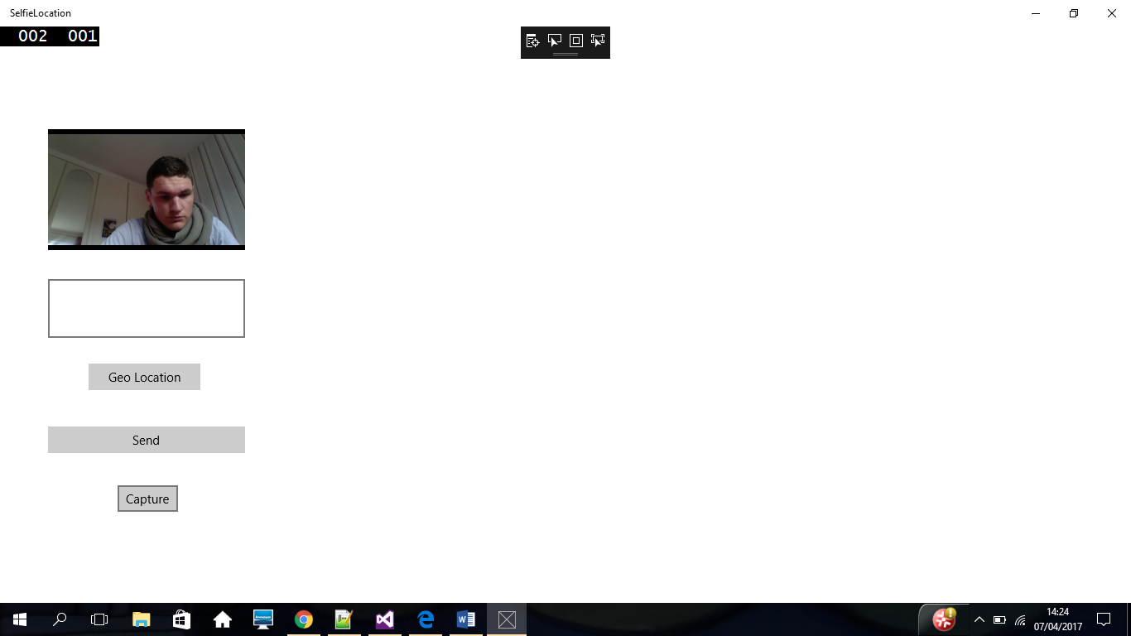

Next you can write a little message in the textbox!

After hit the Geo location button to get your location, it will bring you to a large map showing your location.

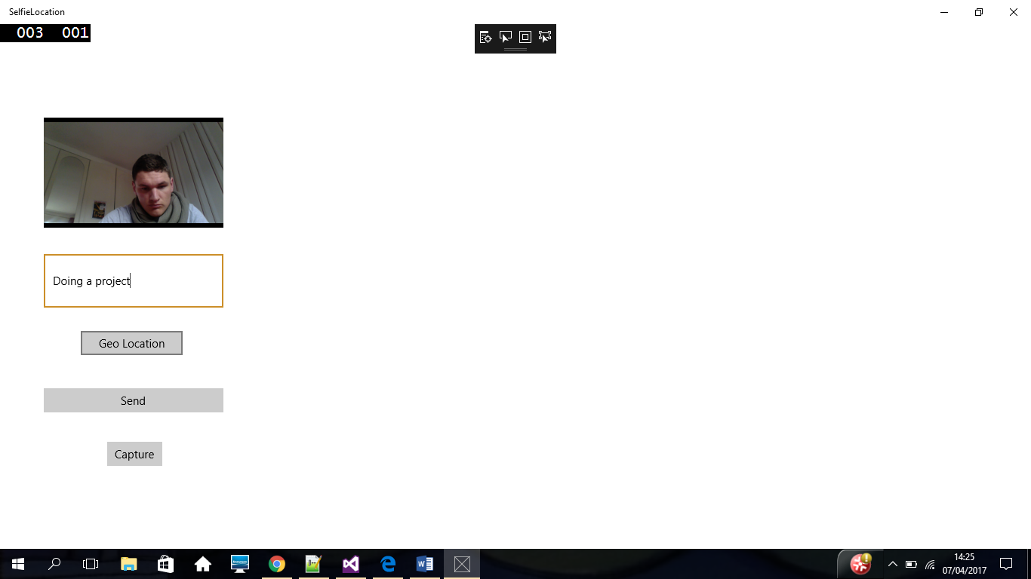

Hit the Link buttom left of the map and you will be brought back to the app with the link of the location in the textbox!

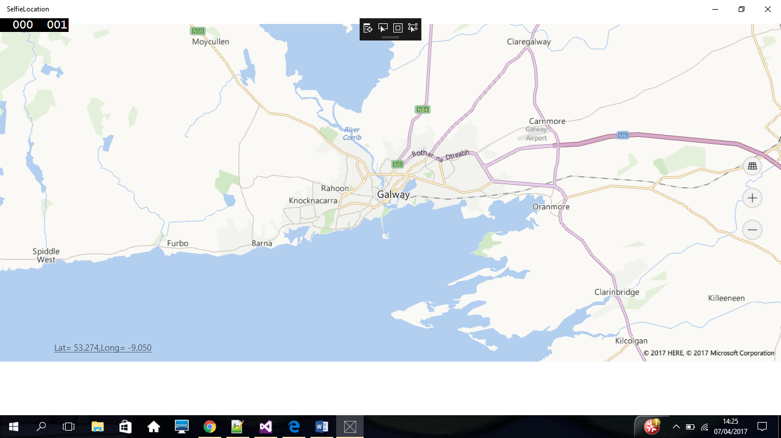

Here shows the location in the textbox…

Once you are happy you can send all the information by hitting the send button…and you will be giving a list of email contacts you can then choose who you wish to send to.

