Volatility analysis

John S. Smith

2024-01-01

## Data

We are analysing SP-500 returns from 2003-01-03 to 2022-12-30, 5034 observations. If you like thousand commas in your numbers, then 5,034 observations.

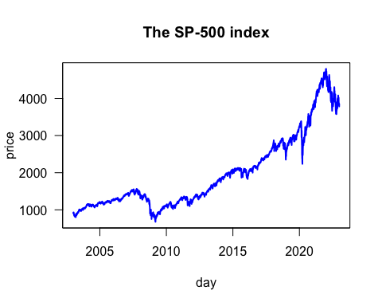

## Analysis of SP-500 volatility

When we estimate a GARCH(1,1), we get these parameters

|  | Estimate | Std. Error | t value | Pr(>|t|) |
| --- | --- | --- | --- | --- |
| omega | 0.0000024 | 0.0000008 | 3.140765 | 0.0016851 |
| alpha1 | 0.1202890 | 0.0097730 | 12.308242 | 0.0000000 |
| beta1 | 0.8594914 | 0.0106664 | 80.579245 | 0.0000000 |

Note that since alpha+beta=0.98<1 , the model is covariance stationary.

Note that since $α+β=0.98<1$, the model is covariance stationary.

The Log Likelihood is 16,443.07 .

### Returns with 2 times volatility

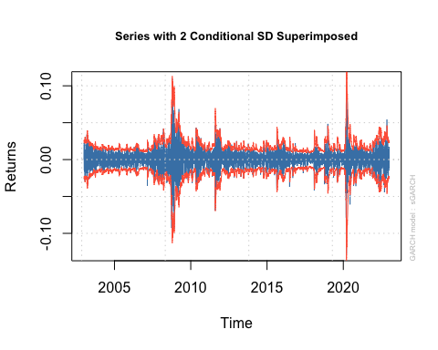

## Some VaR analysis

Portfolio = 1000  
sigma = 0.01  
p = 0.05  
VaR = -qnorm(p) * Portfolio * sigma

Risk is $16.4 according to the VaR.