|  |
| --- |
|  |
| **MATLAB Project** |
| **Quantitative Analysis of the Interdisciplinarity of Applied Mathematics** |

|  |
| --- |
| Jon Peppinck |

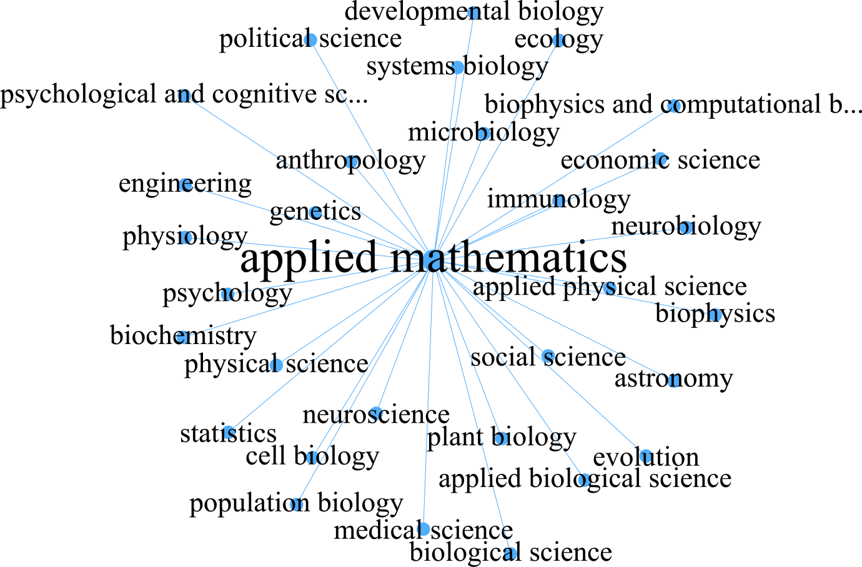  
*Figure 1: Neighbours of Applied Mathematics in the Discipline Network (PLOS One)*

Table of Contents

Part 1: Identification of a Study Topic 3

Background 4

Part 2: Program Planning 7

Initial Pseudo Code and Flow Chart 8

Example of User Interaction 11

Description and Justification of Results 14

Summary of Results 15

References 16

Appendix A - 'discipline.txt' 17

Appendix B - Annotated MATLAB code 'Final_Project.m' 18

Appendix C - Annotated MATLAB Code - 'KMNSC_values.m' 24

# Part 1: Identification of a Study Topic

This project is inspired from the peer-reviewed journal article "Quantitative Analysis of the Interdisciplinarity of Applied Mathematics" (Xie Z, Duan X, Ouyang Z, Zhang P (2015). PLoS ONE 10(9): e0137424). Available from: <https://doi.org/10.1371/journal.pone.0137424>  
The Public Library of Science (PLOS) is a highly reputable database, containing only the highest quality, peer-reviewed journal articles. The findings in these academic journals therefore have credibility and reliability. Therefore, it seems appropriate to base the project on the data and analysis provided in the article. The scientific data and literature provided revolves around the key research question "How interdisciplinary is applied mathematics?"   
  
**Abstract**  
*"The increasing use of mathematical techniques in scientific research leads to the interdisciplinarity of applied mathematics. This viewpoint is validated quantitatively here by statistical and network analysis on the corpus PNAS 1999–2013. A network describing the interdisciplinary relationships between disciplines in a panoramic view is built based on the corpus. Specific network indicators show the hub role of applied mathematics in interdisciplinary research. The statistical analysis on the corpus content finds that algorithms, a primary topic of applied mathematics, positively correlates, increasingly co-occurs, and has an equilibrium relationship in the long-run with certain typical research paradigms and methodologies. The finding can be understood as an intrinsic cause of the interdisciplinarity of applied mathematics" (Xie Z, Duan X, Ouyang Z, Zhang P (2015)).*

## Background

The journal article selected acquired its information from another highly reputable database,

Proceedings of the National Academy of Sciences of the United States of America (2013),

PNAS - vol. 110 no.18. Available from: http://www.pnas.org/content/110/18

The corpus analysed here consists of 52,803 scientific papers published in PNAS in 1999-2013.

Each of the papers has been categorised as a particular discipline and sub discipline.

The three main categories that the scientific papers fall under are:

**1.** Physical Sciences

**2.** Social Sciences

**3.** Biological Sciences

Within these three main categories 39 subcategories levels exist. Figure 2 depicts how PNAS has

classified the following categories and subcategories.   
  
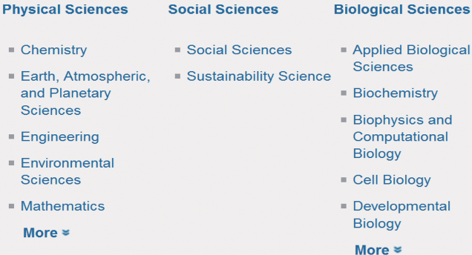*Figure 2: Classification of Main Categories in Science (PNAS)*

Most of the papers have been classified by the first and second level disciplines, however, some

have only been classified by the first level discipline. There is 3007 papers belonging to more than

one sub discipline.

Figure 3 depicts a network describing the connections based on the information of the corpus. The   
  
illustration is indicative of the interdisciplinary nature that exists across the fields in science. This will  
  
be explored in detail with the help of some programming in Matlab.

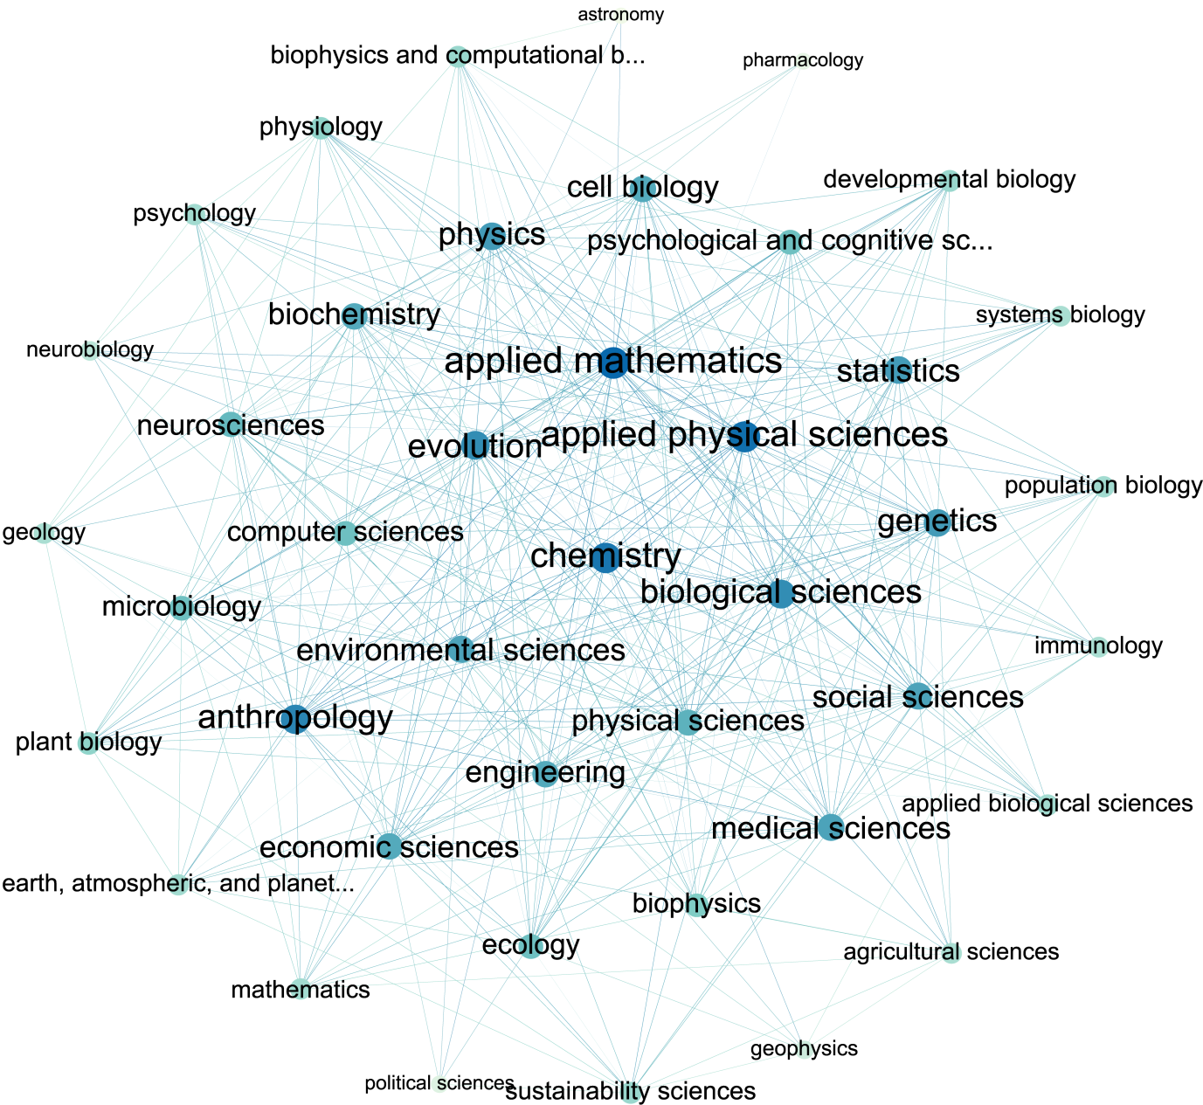*Figure 3: The Discipline Network(PNAS)*

Figure 4 summarises all of the key data of interest for this project. Please refer to Appendix A -

'discipline.txt', to see the relevant data of interest for this project. The data is the numeric entries

from column 'K', 'M', and 'N'. This is sufficient to make calculations and draw conclusions based off

the users discipline of choice.

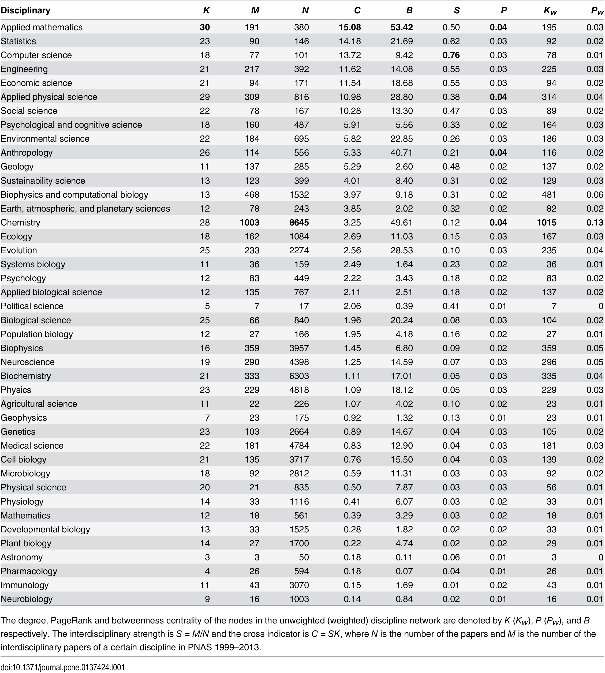*Figure 4: Certain Quantitative Indicators for the interdisciplinarity of disciplines*

# Part 2: Program Planning

The focus of this assignment will be based around the research question "How interdisciplinary is

your discipline?" This research question is simply a generalised version from "Quantitative Analysis

of the Interdisciplinarity of Applied Mathematics" research question ", "How interdisciplinary is

applied mathematics?"  
  
From Figure 4:  
  
We will calculate the relative interdisciplinary strength (S):  
  
Si = Mi/Ni  
  
Where;  
  
S: Relative interdisciplinary strength

M: Number of interdisciplinary papers in discipline

N: Number of papers in discipline

i: Discipline of interest

We will also take into consideration interdisciplinarity strength and breadth with the cross indicator:  
  
Ci = SiKi

Where;  
  
C: Cross indicator   
  
S: Relative interdisciplinary strength

K: Degree of discipline in the discipline network (i.e. a factor to take into account various number of   
  
journal articles for each discipline)  
  
i: Discipline of interest

# Initial Pseudo Code and Flow Chart

Figure 5 depicts the initial planning for the interdisciplinary strength of discipline program.  
  
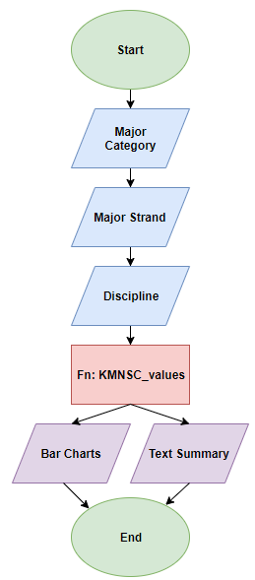  
*Figure 5: Initial Flow Chart of Interdisciplinary Strength of Discipline Program*

**Start:** The main program is written in 'Final_Project.m'. The focus of this project has been discussed

in both the program planning and Matlab comment annotations. Please ensure 'Final_Project.m',

'KMNSC_values.m', and 'discipline.txt', are all in the same working directory.  
  
**Major Category:** Input will be required from the user. The user will be presented a menu and will be

required to choose between 'Physical Sciences', 'Social Sciences', or 'Biological Sciences'. Their

major discipline choice will be stored as it is of interest for later. An error message will occur if the

user exits the window.  
  
**Major Strand:** Since there is 42 disciplines to choose from in total, the disciplines have been further

categorised into their major strands. Depending on the users major category choice, a secondary

menu will be created based on the following scenarios;

Physical sciences has been categorised into two main strands:

1. Math, Physics, Engineering, and Computer Science.

2. Chemistry, Earth, and Environmental Science  
  
The social science had the least amount of disciplines and was able to fit into one window.

Biological sciences has been categorised into two main strands:  
  
1. Predominantly Biology

2. Biology Relating to Chemistry, Physics, Health, or Neuroscience The chosen strand is stored as it is of interest for later. An error message will occur if the user exits

the window. **Discipline:** There is 42 disciplines that the use could possibly be interested in (Please see figure 4).   
  
These disciplines have been categorised as outlined above. The chosen discipline is stored as it is of

interest for later. An error message will occur if the user exits the window

**Fn: KMNSC_values:** The function KMNSC_values has been saved in a separate script

'KMNSC_values.m'. KMNSC_values opens data from 'discipline.txt' (Appendix A). If there is any

reason why 'discipline.txt' does not open, an error message will be displayed. KMNSC_values then

creates three vectors for the K, M, and N values. It then closes 'discipline.txt' as all of the information

required has been retrieved. If there is a problem closing the file an error message will be displayed.

Additionally, if the data from 'discipline.txt' has a different number of entries for either K, M, or N,

this would influence the data, this the user will be prompted to check/adjust the input. The function

also takes into consideration if the file has an invalid entry. Specifically, If M > N, this would result in  
  
an error since the number of interdisciplinary papers in the discipline cannot exceed that of the

total number of papers in the discipline. The average interdisciplinary strength (S) and the average

cross indicator (C) will be calculated for: The average overall for all disciplines, and the average for

physical sciences, social sciences, and biological sciences. The S and C value will also be calculated

for the discipline the user has selected.  
  
**Bar Charts:** The user will be presented with two bar charts related to the discipline they have   
  
selected. The first will display the comparison of all of the S values, and the second displays a

comparison of all of the C values. The window size and legend has been adjusted to suit the

output.  
  
**Text Summary:** The user will be presented with all of the relevant data for their selections. Once  
  
the program has been executed, it will output all of their selections and the corresponding S and C  
  
values.  
  
**End:** The user can view the relative interdisciplinary strength (S), the cross indicator (C), for the

discipline they have selected. The user can then compare this to the bar charts and text summary  
  
to draw conclusions relating to the research question of "How interdisciplinary is your discipline?"

# Example of User Interaction

This example will be consistent with the main aim of the journal article with a focus of the research

question, "How Interdisciplinary is Applied Mathematics?" It is to be noted that this procedure can

be replicated for any of the disciplines that the user is interested in.

**Step One:** Select major category for the discipline of interest  
  
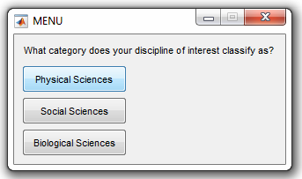  
*Figure 6: Menu Selection for Major Category*  
  
In this example we will select 'Physical Sciences'.  
  
**Step Two:** Select subcategory strand the discipline of interest classifies as  
  
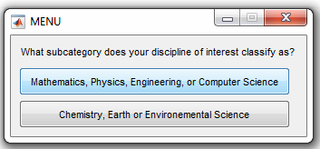  
*Figure 7: Menu Selection for Subcategory Strand*

**Step Three:** Select discipline of interest  
  
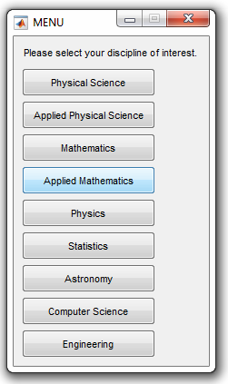   
*Figure 8: Menu Selection for Discipline of Interest*

**Step Four:** Interpret Results  
  
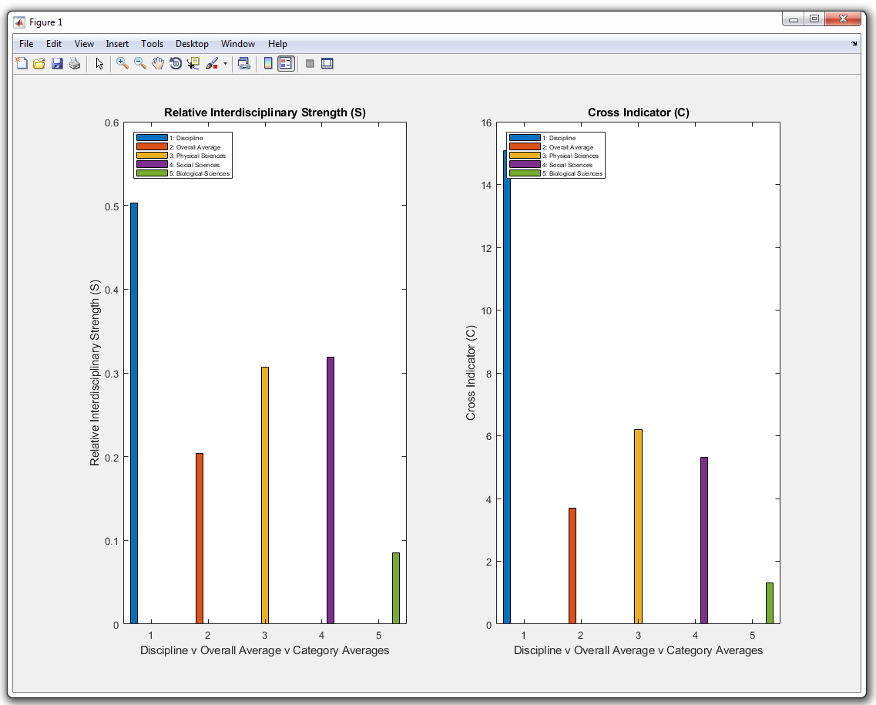 *Figure 9: Bar Charts Comparing the Relative Interdisciplinary Strength (S) and the Cross Indicator (C) for the Selected Discipline to the Averages Overall and from the Physical Sciences, Social Sciences, and Biological Sciences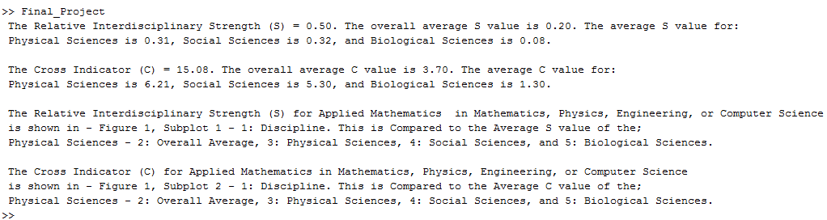 Figure 10: MATLAB Output for the Selected Discipline and Comparative Information*

# Description and Justification of Results

Figure 9 depicts two bar plots that both contain important information in determining how

interdisciplinary applied mathematics is. It should be noted that whilst the study focuses on  
  
the interdisciplinary of applied mathematics, this procedure can be replicated for any of the

disciplines shown in Figure 4.  
  
The first sub plot focusing on the Relative Interdisciplinary Strength (S) for various observations.  
  
The first bar shows the S value for the discipline selected. In this case, it is showing the relative

interdisciplinary strength for applied mathematics. The second bar shows the average S value  
  
for all 42 disciplines. The third, fourth, and fifth, bars show the S value corresponding to the

average of the defined major strands, corresponding to the average S value for: Physical Sciences,

Social Sciences, and Biological Sciences, respectively. The second possesses features similar to the

the first sub plot. This bar plot focusing on the Cross Indicator (C) value instead of the Relative

Interdisciplinary Strength (S). It is observed that the two plots typically show similar features,

however the second gives a more accurate visual representation of the interdisciplinary strength

that the chosen discipline (Applied Mathematics in this case). This is because it takes into

consideration that different disciplines have different number of journals and also that the degree of

the discipline in the discipline network differs (i.e. a factor to take into account various numbers).

Figure 10 summarises all of the critical information into various print statements. The program will

return to the user the relative interdisciplinary strength (S) and cross indicator (C) for the discipline

they selected, the overall average, and the three major categories. It will also inform the user which

selections they have made from the menus depicted in Steps 1-3. It is then up to the user how they  
  
would like to interpret the information and what conclusions they can draw.

# Summary of Results

Since there are so many different combinations the user can enter we will focus on interpreting the

results from our user interaction example given above; applied mathematics. Consideration will also

be given to disciplines that have particularly noteworthy results.

From Figure 9 and 10 it is clear to see that both the Relative Interdisciplinary Strength (S) and the

Cross Ratio (C) far exceeds that of the overall average, and the averages from the three major

categories - Physical Science, Social Science, and Biological Science. This can be interpreted as

Applied mathematics has a significantly larger interdisciplinary nature compared to that of the

overall and major category averages.

The top three disciplines that have the most interdisciplinary strength, after considering the cross

indicator are:  
  
1. Applied Mathematics

2. Statistics

3. Computer Science

The lowest ranking three are:

1. Neurobiology

2. Immunology

3. Pharmacology

These results may not be overly surprising, and be consistent with our current understanding of

scientific research. Applied mathematics, statistics, and computer science (particular algorithms),

show up in a multitude of disciplinary research in the sciences. Neurobiology, immunology, and

pharmacology, are particularly specialised, and are a lot less likely to show up in the other scientific   
  
disciplines.

# References

Xie Z, Duan X, Ouyang Z, Zhang P (2015). Quantitative Analysis of the Interdisciplinarity of Applied Mathematics. PLoS ONE 10(9): e0137424. Retrieved 16 May , 2018, from: https://doi.org/10.1371/journal.pone.0137424  
  
Proceedings of the National Academy of Sciences of the United States of America (PNAS). Discipline Information Corpus given by PNAS (2013). PNAS - vol. 110 no.18. Retrieved 16 May, 2018, from: http://www.pnas.org/content/110/18

Appendix A - 'discipline.txt'  
  
30 191 380

23 90 146

18 77 101

21 217 392

21 94 171

29 309 816

22 78 167

18 160 487

22 184 695

26 114 556

11 137 285

13 123 399

13 468 1532

12 78 243

28 1003 8645

18 162 1084

25 233 2274

11 36 159

12 83 449

12 135 767

5 7 17

25 66 840

12 27 166

16 359 3957

19 290 4398

21 333 6303

23 229 4818

11 22 226

7 23 175

23 103 2664

22 181 4784

21 135 3717

18 92 2812

20 21 835

14 33 1116

12 18 561

13 33 1525

14 27 1700

3 3 50

4 26 594

11 43 3070

9 16 1

# Appendix B - Annotated MATLAB code 'Final_Project.m'

% Quantitative Analysis of the Interdisciplinarity of Applied Mathematics

% MATLAB - Jon Peppinck

% _________________________________________________

% This program will allow the user to select which scientific discipline

% they are interested in and plot the interdisciplinary strength (S) and

% the cross indicator (C) in comparison to the average of all the data and

% also the average of the three major disciplines. This will give the user

% an indication of how much their selected discipline depends on others.

% The data is based on a corpus of journal articles that have been analysed

% in the peer-reviewed journal article "Quantitative Analysis of the

% Interdisciplinarity of Applied Mathematics" (Xie Z, Duan X, Ouyang Z,

% Zhang P (2015). PLoS ONE 10(9): e0137424).

% Available from: https://doi.org/10.1371/journal.pone.0137424

% Key information has been recorded in the file 'discipline.txt'

% The three major disciplines the user has to choose from are:

% 1. Physical Sciences, 2. Social Sciences, and 3. Biological Sciences.

% Their major discipline choice will be stored as it is of interest for later.

% An error message will occur if the user exits the window

choices = {'Physical Sciences', 'Social Sciences', 'Biological Sciences'};

discipline = menu('What category does your discipline of interest classify as?', choices);

if discipline ~= 0

major_discipline_choice = choices{discipline};

elseif discipline == 0

error('Major discipline not selected. Please start again.\n');

end

% There are many choices within Physical Sciences, so the field has been

% categorised further into two main strands:

% 1. Math, Physics, Engineering, CS, 2. Chemistry, Earth, Environmental

% The chosen strand is stored as it is of interest for later.

% An error message will occur if the user exits the window

if discipline == 1

physical_sci_choices = {'Mathematics, Physics, Engineering, or Computer Science', 'Chemistry, Earth or Environemental Science'};

physical_sci_discipline = menu('What subcategory does your discipline of interest classify as?', physical_sci_choices);

if physical_sci_discipline ~= 0

major_discipline_strand_choice = physical_sci_choices{physical_sci_discipline};

elseif physical_sci_discipline == 0

error('Major discipline strand not selected. Please start again.\n');

end

% A specific discipline is chosen from the first main strand in the physical science

% 1. Math, Physics, Engineering, CS

% The chosen discipline is stored as it is of interest for later.

% An error message will occur if the user exits the window

if physical_sci_discipline == 1

ps_choice1 = {'Physical Science', 'Applied Physical Science', 'Mathematics', 'Applied Mathematics', 'Physics', 'Statistics', 'Astronomy', 'Computer Science', 'Engineering'};

ps_choice1_discipline = menu('Please select your discipline of interest.', ps_choice1);

if ps_choice1_discipline ~= 0

discipline_selected = ps_choice1{ps_choice1_discipline};

elseif ps_choice1_discipline == 0

error('Discipline of interest not selected. Please start again.\n');

end

% The data has been written in the file 'discipline.txt'. This text file

% contains values for all of the different disciplines. Of interest is:

% K: Degree of Discipline in Network (Factor)

% M: Number of interdisciplinary papers in discipline

% N: Total number of papers in Discipline

% The function KMNSC_values has been created to avoid the tedious task of

% repetitive data entry. This function also calculates:

% S: Relative Disciplinary Strength (M/N)

% C: Cross Indicator (S*K)

% The K, M, N, S, C values for the selected discipline choice will be

% utilised later.

if ps_choice1_discipline == 1

KMNSC_values(34);

elseif ps_choice1_discipline == 2

KMNSC_values(6);

elseif ps_choice1_discipline == 3

KMNSC_values(36);

elseif ps_choice1_discipline == 4

KMNSC_values(1);

elseif ps_choice1_discipline == 5

KMNSC_values(27);

elseif ps_choice1_discipline == 6

KMNSC_values(2);

elseif ps_choice1_discipline == 7

KMNSC_values(39);

elseif ps_choice1_discipline == 8

KMNSC_values(3);

elseif ps_choice1_discipline == 9

KMNSC_values(4);

end

% A specific discipline is chosen from the second strand in the physical science

% 2. Chemistry, Earth, Environmental

% The chosen discipline is stored as it is of interest for later.

% An error message will occur if the user exits the window

elseif physical_sci_discipline == 2

ps_choice2 = {'Chemistry', 'Earth, Atmospheric and Planetary Sciences', 'Geology', 'Geophysics', 'Environmental Science'};

ps_choice2_discipline = menu('Please select your discipline of interest.', ps_choice2);

if ps_choice2_discipline ~= 0

discipline_selected = ps_choice2{ps_choice2_discipline};

elseif ps_choice2_discipline == 0

error('Discipline of interest not selected. Please start again.\n');

end

% The K, M, N, S, C values for the selected discipline choice will be

% utilised later.

if ps_choice2_discipline == 1

KMNSC_values(15);

elseif ps_choice2_discipline == 2

KMNSC_values(14);

elseif ps_choice2_discipline == 3

KMNSC_values(11);

elseif ps_choice2_discipline == 4

KMNSC_values(29);

elseif ps_choice2_discipline == 5

KMNSC_values(9);

end

end

% The major strand of Social Sciences can fit its specific disciplines of

% choice into one menu.

% The chosen discipline and major strand is stored as it is of interest for later.

% An error message will occur if the user exits the window

elseif discipline == 2

social_sci_choices = {'Social Science', 'Sustainability Science', 'Economic Science', 'Political Science', 'Psychological and Cognitive Science', 'Anthropology', 'Psychology', 'Agricultural Science'};

social_sci_discipline = menu('What subcategory does your discipline of interest classify as?', social_sci_choices);

if social_sci_discipline ~= 0

major_discipline_strand_choice = choices{discipline};

discipline_selected = social_sci_choices{social_sci_discipline};

elseif social_sci_discipline == 0

error('Discipline of interest not selected. Please start again.\n');

end

% The K, M, N, S, C values for the selected discipline choice will be

% utilised later.

if social_sci_discipline == 1

KMNSC_values(7);

elseif social_sci_discipline == 2

KMNSC_values(12);

elseif social_sci_discipline == 3

KMNSC_values(5);

elseif social_sci_discipline == 4

KMNSC_values(21);

elseif social_sci_discipline == 5

KMNSC_values(8);

elseif social_sci_discipline == 6

KMNSC_values(10);

elseif social_sci_discipline == 7

KMNSC_values(19);

elseif social_sci_discipline == 8

KMNSC_values(28);

end

% There are many choices within Biological Sciences, so the field has been

% categorised further into two main strands:

% 1. Predominately Biology 2. Biology Relating to Chemistry, Physics,

% Health, or Neuroscience.

% The chosen strand and discipline is stored as it is of interest for later.

% An error message will occur if the user exits the window

elseif discipline == 3

bio_sci_choices = {'Predominantly Biology', 'Biology Relating to Chemistry, Physics, Health, or Neuroscience'};

bio_sci_discipline = menu('What subcategory does your discipline of interest classify as?', bio_sci_choices);

if bio_sci_discipline ~= 0

major_discipline_strand_choice = bio_sci_choices{bio_sci_discipline};

elseif bio_sci_discipline == 0

error('Major discipline strand not selected. Please start again.\n');

end

% A specific discipline is chosen from the first main strand in biological science

% 1. Predominantly Biology

% The chosen discipline is stored as it is of interest for later.

% An error message will occur if the user exits the window

if bio_sci_discipline == 1

bio_choice1 = {'Biological Science', 'Applied Biological Science', 'Genetics', 'Evolution', 'Cell Biology', 'Microbiology', 'Plant Biology', 'Ecology', 'Systems Biology', 'Population Biology', 'Developmental Biology', 'Physiology'};

bio_choice1_discipline = menu('Please select your discipline of interest.', bio_choice1);

if bio_choice1_discipline ~= 0

discipline_selected = bio_choice1{bio_choice1_discipline};

elseif bio_choice1_discipline == 0

error('Discipline of interest not selected. Please start again.\n');

end

% The K, M, N, S, C values for the selected discipline choice will be

% utilised later.

if bio_choice1_discipline == 1

KMNSC_values(22);

elseif bio_choice1_discipline == 2

KMNSC_values(20);

elseif bio_choice1_discipline == 3

KMNSC_values(30);

elseif bio_choice1_discipline == 4

KMNSC_values(17);

elseif bio_choice1_discipline == 5

KMNSC_values(32);

elseif bio_choice1_discipline == 6

KMNSC_values(33);

elseif bio_choice1_discipline == 7

KMNSC_values(38);

elseif bio_choice1_discipline == 8

KMNSC_values(16);

elseif bio_choice1_discipline == 9

KMNSC_values(18);

elseif bio_choice1_discipline == 10

KMNSC_values(23);

elseif bio_choice1_discipline == 11

KMNSC_values(37);

elseif bio_choice1_discipline == 12

KMNSC_values(35);

end

elseif bio_sci_discipline == 2

bio_choice2 = {'Biochemistry', 'Biophysics', 'Biophysics and Computational Biology', 'Neuroscience', 'Neurobiology', 'Medical Science', 'Pharmacology', 'Immunology'};

bio_choice2_discipline = menu('Please select your discipline of interest.', bio_choice2);

if bio_choice2_discipline ~= 0

discipline_selected = bio_choice2{bio_choice2_discipline};

elseif bio_choice2_discipline == 0

error('Discipline of interest not selected. Please start again.\n');

end

% The K, M, N, S, C values for the selected discipline choice will be

% utilised later.

if bio_choice2_discipline == 1

KMNSC_values(26);

elseif bio_choice2_discipline == 2

KMNSC_values(24);

elseif bio_choice2_discipline == 3

KMNSC_values(13);

elseif bio_choice2_discipline == 4

KMNSC_values(25);

elseif bio_choice2_discipline == 5

KMNSC_values(42);

elseif bio_choice2_discipline == 6

KMNSC_values(31);

elseif bio_choice2_discipline == 7

KMNSC_values(40);

elseif bio_choice2_discipline == 8

KMNSC_values(41);

end

end

end

% Prints summary message for selected choices

fprintf(' The Relative Interdisciplinary Strength (S) for %s in %s\n is shown in - Figure 1, Subplot 1 - 1: Discipline.', discipline_selected, major_discipline_strand_choice);

fprintf(' This is Compared to the Average S value of the;\n %s - 2: Overall Average, 3: Physical Sciences, 4: Social Sciences, and 5: Biological Sciences.\n\n', major_discipline_choice);

fprintf(' The Cross Indicator (C) for %s in %s\n is shown in - Figure 1, Subplot 2 - 1: Discipline.', discipline_selected, major_discipline_strand_choice);

fprintf(' This is Compared to the Average C value of the;\n %s - 2: Overall Average, 3: Physical Sciences, 4: Social Sciences, and 5: Biological Sciences.\n', major_discipline_choice);

Appendix C - Annotated MATLAB Code - 'KMNSC_values.m'  
  
% Quantitative Analysis of the Interdisciplinarity of Applied Mathematics

% MATLAB - Jon Peppinck

% _________________________________________________

function [K,M,N,S,C] = KMNSC_values(line_index)

%KMNSC_values returns K, M, M, S, and C values for each discipline

% KMNSC_values reads in information from 'discipline.txt'

% It organises information by assigning each column (K, M, and N) to a variable

% KMNSC_values uses this data to perform calculations to find S and C

% This functions primary use will be used in conjunction with the main

% script 'Final_Project.m'. It is important that 'Final_Project.m',

% 'KMNSC_values.m', and 'discipline.txt' are all in the current working

% directory, as they depend on each other. KMNSC_values will return all

% of the relevent values for any partciular line corresponding the the

% discipline of interest. It also calculates the average values across

% the major disciplines, and this is used in the plot.

fid = fopen('discipline.txt', 'r');

if fid == -1

error('Failed to open discipline.txt.');

end

% Create three vectors for K, M, and N from 'discipline.txt'

data = textscan(fid, '%f %f %f');

K_all = data{1};

M_all = data{2};

N_all = data{3};

% Close the file and display error if there is a problem closing it

if fclose(fid) == -1

error('Failed to close discipline.txt.');

end

% If the data from 'discipline.txt' does not have the same amount if

% entried for K, M, and N, the outcome will not be accurately presented.

% Therefore it will be checked, and if they are not of the same dimension

% or M>N, and error will be raised

if length(K_all) ~= length(M_all) || length(M_all) ~= length(N_all)

error('Please check ''discipline.txt'' contains equal number of entries for K, M, and N');

end

if length(M_all) > length(N_all)

error('Please check ''discipline.txt'' has correct values for M and N.\nSince N is the total number of journal articles, N>=M');

end

% Average S value for all disciplines from Physical Sciences, Social

% Sciences, and Biological Sciences.

S_all = M_all./N_all;

sum_S = sum(S_all);

length_S = length(S_all);

avg_S = sum_S/length_S;

% Average C value for all disciplines from Physical Sciences, Social

% Sciences, and Biological Sciences.

C_all = S_all.*K_all;

length_C = length(C_all);

sum_C = sum(C_all);

avg_C = sum_C/length_C;

% K, M, N, S, C values for a particular disciplines line index

K = K_all(line_index);

M = M_all(line_index);

N = N_all(line_index);

S = M/N;

C = S*K;

% Finds average S and C values for Physical Sciences

S_tot_phys = S_all(34)+S_all(6)+S_all(36)+S_all(1)+S_all(27)+S_all(2)+S_all(39)+S_all(3)+S_all(4)+S_all(15)+S_all(14)+S_all(11)+S_all(29)+S_all(9);

S_avg_phys = S_tot_phys/14;

C_tot_phys = C_all(34)+C_all(6)+C_all(36)+C_all(1)+C_all(27)+C_all(2)+C_all(39)+C_all(3)+C_all(4)+C_all(15)+C_all(14)+C_all(11)+C_all(29)+C_all(9);

C_avg_phys = C_tot_phys/14;

% Finds average S and C values for Social Sciences

S_tot_soc = S_all(7)+S_all(12)+S_all(5)+S_all(21)+S_all(8)+S_all(10)+S_all(19)+S_all(28);

S_avg_soc = S_tot_soc/8;

C_tot_soc = C_all(7)+C_all(12)+C_all(5)+C_all(21)+C_all(8)+C_all(10)+C_all(19)+C_all(28);

C_avg_soc = C_tot_soc/8;

% Finds average S and C values for Biological Sciences

S_tot_bio = S_all(22)+S_all(20)+S_all(30)+S_all(17)+S_all(32)+S_all(33)+S_all(38)+S_all(16)+S_all(18)+S_all(23)+S_all(37)+S_all(35)+S_all(26)+S_all(24)+S_all(13)+S_all(25)+S_all(42)+S_all(31)+S_all(40)+S_all(41);

S_avg_bio = S_tot_bio/20;

C_tot_bio = C_all(22)+C_all(20)+C_all(30)+C_all(17)+C_all(32)+C_all(33)+C_all(38)+C_all(16)+C_all(18)+C_all(23)+C_all(37)+C_all(35)+C_all(26)+C_all(24)+C_all(13)+C_all(25)+C_all(42)+C_all(31)+C_all(40)+C_all(41);

C_avg_bio = C_tot_bio/20;

% Creates two plots to visualise the interdisciplinary strength of the

% selected discipline (S), and the cross factor (C) that takes into account

% the degree of discipline in the discipline network (i.e. various N's etc)

% The first plot shows the selected discipline's S value compared to the

% average of all the S values and the average for each of the three major

% categories.

subplot(1,2,1)

to_plot = [S, avg_S, S_avg_phys, S_avg_soc, S_avg_bio];

bar(diag(to_plot));

xlabel('Discipline v Overall Average v Category Averages');

ylabel('Relative Interdisciplinary Strength (S)');

title('Relative Interdisciplinary Strength (S)');

legend({'1: Discipline', '2: Overall Average', '3: Physical Sciences', '4: Social Sciences', '5: Biological Sciences'}, 'Location', 'northwest', 'FontSize', 6);

x0=200;

y0=100;

width=825;

height=600;

set(gcf,'units','points','position',[x0,y0,width,height]);

xticks([1 2 3 4 5]);

xticklabels({'1','2', '3', '4', '5'});

% The second plot shows the selected discipline's C value compared to the

% average of all the C values and the average for each of the three major

% categories.

subplot(1,2,2)

to_plot_C = [C, avg_C, C_avg_phys, C_avg_soc, C_avg_bio];

bar(diag(to_plot_C));

xlabel('Discipline v Overall Average v Category Averages');

ylabel('Cross Indicator (C)');

title('Cross Indicator (C)');

legend({'1: Discipline', '2: Overall Average', '3: Physical Sciences', '4: Social Sciences', '5: Biological Sciences'}, 'Location', 'northwest', 'FontSize', 6);

xticks([1 2 3 4 5]);

xticklabels({'1','2', '3', '4', '5'});

% Prints out a summary of all of the relevent information relating to the

% users selections.

fprintf(' The Relative Interdisciplinary Strength (S) = %.2f.', S)

fprintf(' The overall average S value is %.2f. The average S value for:\n Physical Sciences is %.2f, Social Sciences is %.2f, and Biological Sciences is %.2f.\n\n',avg_S, S_avg_phys, S_avg_soc, S_avg_bio);

fprintf(' The Cross Indicator (C) = %.2f.', C)

fprintf(' The overall average C value is %.2f. The average C value for:\n Physical Sciences is %.2f, Social Sciences is %.2f, and Biological Sciences is %.2f.\n\n',avg_C, C_avg_phys, C_avg_soc, C_avg_bio);

end