Tetris – Assignment DUE FRIDAY DEC 16TH at 23:55

A **Class Diagram** is a visual description of the objects and classes used in the program, and the relationships among them. The diagram doesn’t show how classes are built, but only shows: class attributes, class methods, interactions among objects. We have built the following classes:

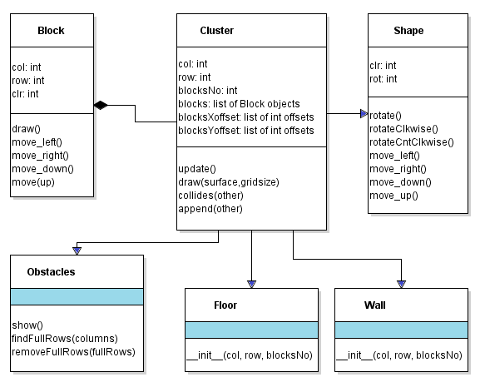

The arrows in the class diagram show all inheritance relationships we’ve created. All members from the parent class are also available in the child class.

It is your job now to finish the game, applying your knowledge about Object Oriented Programming.

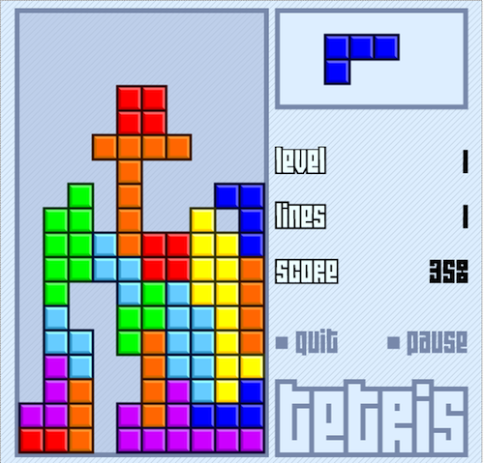

**Remember: Avoid low-level data processing in your program.  
 Tell your objects what to do, and teach them how**

**to do it in the class.**

Read the hints on the next page and think!

Have fun with the Tetris Game!

**Download from Moodle and read carefully the rubric!**

**You will have to submit the rubric back, with the self-assessment column filled.**

TETRIS Game RUBRIC DUE DATE : DEC 17

**Name:________________________________________________________________**

|  |  |  |  |
| --- | --- | --- | --- |
| **Description** | **Self** | **marks** | **Teach** |
| **KNOWLEDGE ___/ 15** | | | |
| the game field is drawn on the game window (grid can be shown) | **2** | **2** |  |
| left and right walls are correctly created and limit horizontal movement of shapes | **2** | **2** |  |
| floor is correctly created and stops the shapes from moving down | **2** | **2** |  |
| the walls and the floor are not shown on the screen | **0\*** | **1** |  |
| conflicts between rotating shape and the adjacent border are detected and processed | **3** | **3** |  |
| New shape appears at the top/middle of the game field | **1** | **1** |  |
| the game keeps a score and displays it every new line is 100 points (4 lines are 800 points) | **2** | **2** |  |
| the game is over when the current shape collides with the top (create a new object) | **1** | **1** |  |
| the game displays a background picture and not just black screen | **1 \*** | **1** |  |
| **APPLICATION ___/ 20** | | | |
| current shape moves down by itself and stops when it hits an obstacle | **4** | **4** |  |
| conflicts between rotating shape and obstacles are detected and handled properly | **3** | **3** |  |
| the scoring system follows the scheme:   * 100 for clearing a single line; * 800 for clearing four lines simultaneously (Tetris); * 1200 for back-to-back Tetris ( four lines | **4** | **4** |  |
| speed of falling shapes determines the current level, which increases with the score   * After score 500 the game moves to level 2 and medium speed, * After score 1000 the game changes to level 3 and fast speed | **3** | **3** |  |
| The current level are displayed on the screen | **1** | **1** |  |
| running time is shown on the screen | **2** | **2** |  |
| next shape is shown on the screen (beside the game field) | **3** | **3** |  |
| **THINKING ____/ 15** | | | |
| Animation is smooth and at a good speed | **2** | **2** |  |
| Sounds effects are added when dropping a shape and when clearing a line | **2** | **2** |  |
| Pictures/tiles are used to draw the blocks (not just coloured squares) | **2** | **2** |  |
| Extra Features are added choose from the following: NO EXTRA BONUS MARKS!   * **Intro & Game over screens**➋**, background music**➊**, pause button**➊, * **Shadow is added – only unique solutions will be considered! Don’t stare your code!** ➌ | **6** | **6**  **max** |  |
| The game is complete and works as per requirements - The player can't crash it | **1** | **1** |  |
| The game is completed on time. The zip files + self-assessment rubric is submitted | **2** | **2** |  |
| **COMMUNICATION ­­___/ 8** | | | |
| All variable names and method names are descriptive according to the naming conventions | **2** | **2** |  |
| Private variables and methods are protected/hidden – game template has no access | **3** | **3** |  |
| Clear and understandable comments that elaborate and explain the logic of the command | **3** | **3** |  |

**Comments:**