**Use of Terrestrial Lidar to Quantify Small Mammal Habitat**

Jonathan Batchelor1

1School of Environmental and Forest Sciences, University of Washington. [JonBatch@UW.edu](mailto:JonBatch@UW.edu)

**Abstract**

The major objective of this paper was to identify correlations between forest structure, as quantified by Terrestrial Lidar Scanner (TLS), and northern flying squirrel (*Glaucomys sabrinus*) (GLSA) populations. 144 plots at 16 sites that had small mammal trapping stations established, and were scanned with a TLS. Metrics for depth and openness of the stands were developed from the TLS data. NMDS was used to determine what sections of the TLS scans accounted for the highest amount of variation between the sites and ANOSIM was used to test if this subsection of the TLS data was correlated with GLSA population. No correlation between the depth and openness metrics and GLSA populations was detected with our methodology.

Class note: When conducting the initial analysis, I was excited because there was a clear relationship between GLSA abundance and the TLS data. Sitting down to actually write this paper, I realized the correlation was due to my cbind command in R mixed up the species data and assigned species values to the wrong sites. Once I corrected this error, all traces of a correlation disappeared. Now this is just a sad paper reporting on negative findings that I had to rush.

**1. Introduction**

**1.1 Forest Structure**

The amount and arrangement of aboveground biomass can loosely be described as the structure of a forest. This includes the horizontal and vertical layering of trees, shrubs, and herbaceous ground cover. Structure is comprised of both live and dead plant matter and is perhaps the most important element within any forested environment. There are dozens of methods to quantify forest structure (Pommerening 2002) and the method used is highly dependent on the ecological question being asked.

This structure can have an immense influence on how a forest ecosystem functions and the species composition (Beier and Drennan 1997, Shugart et al. 2010). There is a cyclical relationship as the species composition of an area influences the structure of the forest and the forest structure in turn, influences the species composition. Of particular interest for this study is how the physical structure relates to the abundance of small arboreal mammals. The arrangement of the physical biota in a forest dictates the connectivity and distance between foraging areas and micro refugia for these arboreal mammal species. Similarly, the “openness” of a stand dictates how far potential predators are able to see as well as the overall canopy closure and light levels.

* 1. **Small Mammals**

Arboreal mammals are incredibly important, not only for their own fulfilling of ecological niches and roles within an ecosystem, but they also represent important food sources for many threatened apex predators such as the spotted owl (*Strix occidentalis*) (Smith et al. 1999). One arboreal mammal of particular interest is the northern flying squirrel (*Glaucomys sabrinus*) (GLSA). Flying squirrels have been the subject of much study, and elements of their ecology such as range, diet, and behavior are becoming understood (Wilson 2010). However, one element that has yet to be quantified in a satisfactory manner is how much of an influence the physical structure of a forest impacts their abundance. Is the arrangement and openness of a forested stand related to the presence of flying squirrels? The ability to answer this question is confounded by how notoriously difficult is has been to quantify forest structure.

**1.3 Lidar**

Historical measurements of forest structure have included the use of handheld densitometers and visual assessment of tree crown diameter. Such measurements are notoriously influenced by observer bias (Vales and Bunnell 1988). Over the last several years, lidar has come to be an extremely valuable tool for quantifying element of forest structure. The most common uses of lidar include deriving biomass estimates (Seidel et al. 2013), determining leaf area index (Zhao et al. 2011), creating vegetation density profiles (Ashcroft et al. 2014), and quantifying biometrics such as tree height and tree crown size (Srinivasan et al. 2015). One element that has not been as thoroughly explored is the use of lidar to quantify forest structure as it relates to habitat preference of individual species.

Two metrics that are derivable from terrestrial lidar scans (TLS) are depth and openness. TLS produces a 3 dimensional, spherical rendering of the visible space by scanning the area with laser pulses in a scan line. Depth is a measurement of how far a laser pulse travels before being reflected back to the scanner. Openness is the percentage of pulses returned in a designated area. The two metrics can be correlated but

**1.4 Objectives**

The purpose of this study is twofold:

1. To identify which section of the vertical structure of a forest most differentiates forested stands as measured by a TLS
2. To determine if there is statistical significance between the depth and openness values derived by TLS and the abundance of northern flying squirrels (Glaucomys sabrinus) (GLSA).

**2. Methods**

**2.1 Scan Acquisition & Species Data**

Sixteen forested stands west of the Cascade mountain range in Oregon were selected for this study (Figure 1). Between 2014-2016 non-lethal small mammal trapping was conducted at each of these sites. Not all sites had trapping data from every year. GLSA, NECI, and NEFU were tagged once caught, and then released. Trapping was conducted using methods established by Todd Willson (2010). The minimum known individuals at each site was recorded and the average number of individuals caught over the 3 years was determined. A Spearman’s rank correlation test was run on the 3 years of trapping data to determine if the same sites had either a low or high population in each of the three years, or if the individual counts at each of the sites varied from relatively high one year to low the next. Each site was placed in one of five categories depending of the relative number of individuals at each site (None, Low, Mid, High, Very High).

At each site, the established 3x3 trapping grid consisted of 9 trap stations spaced 100m apart. There was a total of 144 plots with 9 plots at each of the 16 sites. A Faro Focus 3D 120 Terrestrial Lidar Scanner (TLS) was used to perform a scan at each trapping plot, resulting in 144 scans. The scanner reliably received returns for objects ≤ 60m away. Each panoramic scan captured a horizontal window from 0 to 360 degrees and a vertical window from -60 to 90 degrees. Vertical scan lines were spaced every 0.035 degrees, resulting in a 10,266 horizontal x 4267 vertical resolution per scan. Each scan required approximately 10 minutes to complete.

**2.2 Scan Processing**

Initial scan processing consisted of filtering artifacts and noise present in the scan data using preset filters in Faro Scene version 5.3.3 (Ulrich Von Zadow 2014). Dark scan points were isolated using an intensity (return signal strength) threshold of 200. Stray or isolated scan points were removed using a grid size of 3px, distance threshold of 0.02m, and allocation threshold of 33.3%.

Scans were then exported into Leica PTX format which preserved the scanning acquisition structure with fixed angular increments between scan pulses resulting in a spherical coordinate system. PTX reader (Kimball et al. n.d.) was then used to create two-dimensional intensity rasters (Figure 2) and depth (range) rasters using first-return point values. Each column of pixels represented an individual scan line. Each pixel represented an angular location where the laser pulse was fired. Each scan resulted in a 10,266 x 4,267 pixel raster.

**2.3 Depth and Openness Metric Calculation (Site Signatures)**

Below-ground pixels were visually identified and removed in each depth raster. The number of pixels above ground in each vertical scan line in the depth raster was then divided into 100 equally spaced vertical increments (from ground to vertical) using a custom MATLAB script (Figure 3). 100 increments is an arbitrary number but it is small enough to allow for easier analysis, yet large enough to maintain a relatively high level of spatial resolution. It is important to remember that these increments do not directly relate to view angle from the scanner. The 90th increment is not 90 degrees (i.e. vertical) from the scanner. This discretization process minimized potential effects of slope within and across plots. We then averaged both depth and percent of “no returns” (openness) for each increment across the entire 360º horizontal view. This produced a 1x100 table for each plot, aggregated into a 9x100 table for each site. These values will further be referred to as scan increments with 1 being the base of trees above ground level and 100 being vertically above the scanner. Structural signatures were created for each site by graphing depth and openness scan increments, using mean and standard deviation of the 9 plots surveyed within each stand (Figure 4). For more information about this method see Batchelor (2015).

**2.4 Site Differentiation (NMDS & Mantel)**

The analytical methods used for this study was a multi-step process. For the lidar data, the first step assessed how correlated our depth and openness matrices were. Due to the missing values in the depth matrix due to lidar pulses sent with no return, a Gowers distance measure was used with a Mantel test based on Pearson’s product-moment correlation, to assesses if our depth values were correlated with the openness values. The depth and openness matrices were kept as separate and discrete data tables for all tests. A Non-metric Multidimensional Scaling (NMDS) ordination (Gowers distance) was performed on the depth and open matrices to determine which of the 100 scan increments described the most variation between sites (i.e. which scan increments had the highest loadings on the 1st NMDS axis) (Oksanen 2015). Isolating the scan increments that accounted for the most variability is necessary as plots tend to be more similar in relation to openness and depth looking up and at the base of trees. For assessing canopy structure most related to arboreal mammal populations, the scan increments that capture more of a cross-section of the upper canopy and also explain the largest variation between sites is ideal.

Once the subset of scan increments for both the depth and openness matrices was determined, a second Mantel test was used to test for correlation between the subsets. A Euclidian distance was used for the second Mantel test as the subset of the depth matrix had no missing data, and given the continuous nature of the data, Euclidian distance is preferred. A second NMDS ordination was run on the subset to visually inspect the distribution and centroids of the population groupings. Scatter plots and boxplots were also produced to visualize the point distributions.

**2.5 Mammal Population Association (ANOSIM)**

An analysis of similarity test (ANOSIM) was conducted on the subset of the depth and openness matrices using Euclidian distance measure and grouping the sites by species abundance. An ANOSIM test was conducted so significance could be determined as well as assess the degree of similarity as ANOSIM results are constrained between -1 and 1.

**3. Results**

* 1. **Site Signatures**

The site signatures were produced (Figure 4) and visually examined to assess if they graphically appeared to differentiate from each other.

* 1. **NMDS & Mantel**

The Mantel test (999 permutations) using Gowers distance, with the full openness and depth matrices, returned a Mantel statistic r value of 0.06597 with significance of 0.089. There was no statistically significant correlation between the two matrices. The initial NMDS test on the openness matrix had a stress value of 13.6 on two axes. The stress value for the depth matrix with two axes was 5.8. Both NMDS plots returned a solution at 20 tries. Plotting the original dissimilarities and the Euclidean distances in the NMDS ordination, returns R2 values >0.92 for both the non-metric fit as well as the linear fit for the openness matrix, and R2 values >0.98 for both the non-metric fit as well as the linear fit for the depth NMDS. Due to the large sample size, the majority of the scan increments showed statistically significant loadings on the first two principal components for both the openness and depth NMDS. The 10 (10%) scan increments that had the largest loading on the first principle competent were identified as scan increments 53-62 for both the openness and depth matrices (Figure 5). Figure 6 illustrates this subset in two sites with very high GLSA populations compared to two sites with low GLSA populations.

A second Mantel test was conducted on the subset of the depth and openness matrices using Euclidian distance and 999 permutations. The returned Mantel statistic r value was 0.1843 with significance of 0.001. Strong statistical evidence of a correlation between the subset of the depth and openness matrices but with a relatively low r value. A second set of NMDS plots using Euclidian distance was produced with the four classes of GLSA population identified and centroids for each class added (Figure 7). The Openness subset had a stress value of 1.5 with two dimensions and a solution was derived after 20 tries. A Monte Carlo randomization test of the final stress value for the openness subset with 2 dimensions returned a p value of 0.0099. The Depth subset had a stress value of 0.5 with two dimensions and a solution was derived after 262 tries. A Monte Carlo randomization test of the final stress value for the depth subset with 2 dimensions also returned a p value of 0.0099.

* 1. **Species Data and ANOSIM**

Spearman's rank correlation test was run on the GLSA data from 2014 to 2016. There was a statistically insignificant correlation between the years 2014 and 2015 (rho=0.535, p=0.059), as well as a statistically significant correlation between the years 2015 and 2016 (rho=0.589, p=0.027). NEFU had a very high correlation but also a very large number of 0 making the data largely unusable for this analysis. NECI had no correlation between years. NEFU and NECI species data was subsequently not used for NMDS or ANOSIM analysis. The average 3 year population for all species is presented in Table 1.

The location of each scan plot along the NMDS axis 1 was recorded for both the openness and depth subsets. Box plots of the population groups for GLSA (Low, Mid, High, Very High) was created in relation to these values (Figure 8), as well as scatter plots of each site in relation the NMDS axis 1 location (Figure 9). This NMDS axis location was used for plotting as opposed to relating the species data back to the individual scan increments as the NMDS axis location was derived from all 10 scan increments that accounted for the most variation between sites, and not just one.

The ANOSIM results are summarized in Table 2. The R statistic was < 0.1 for all but one pairwise comparison with the R statistic < .02 overall for both the openness and depth matrices.

**4. Discussion**

* 1. **NMDS**

Using an NMDS test to identify the scan increments that most explained the variation between the depth and openness matrices (i.e. loading on the 1st NMDS axis) identified the same range in both matrices (scan increments 52-62). This range is highlighted in figure 6. The depth and openness matrices were not correlated in their values but the identification of the same range reinforces that the variation in the upper scan increments does capture the greatest difference in structure as a whole. In figure 6, the yellow highlighted area seems to be capturing the upper stems of trees and branch structure before the lower crown of the trees becomes more obscuring. This area represents the upper bound of the view shed available to animals in the forest. The identification of these scan segments was done without computing any values related to the small mammal populations. There is a large potential in exploring how the forest structure within these scan increments relates to many other ecological questions beyond just arboreal mammal populations.

In figure 6, the site signatures for two sites with very high GLSA abundance and two sites with low GLSA abundance are contrasted with the region of the signature relating to the identified scan segments identified within the purple box. Intensity rasters of one of the scan plots at each of the four sites was included as an example of the forest structure. When looking at the site signatures of all the sites (Figure 4), a seemingly large amount of variation exists between the sites but when the area of the scan increments is highlighted contrasting the very high and low GLSA population sites, there isn’t a large obvious difference. Looking at the NMDS plots of the subset with the centroid ellipses highlighted (Figure 7) there isn’t a clear separation between the population groups. The one exception to this is that the mid population centroid in the openness NMDS does seem to separate from the other clustering.

* 1. **ANOSIM**

The ANOSIM results indicate that overall there was no significant difference between the 4 groups of GLSA population. The only pairwise significant difference was between the openness groups of mid and low. However even this difference had a low R statistic of 0.106. The assigning of the four groups of low, mid, high, very high was fairly subjective. There were some evidence of natural breaks between the four groups as can be seen in the figure 9 but manipulating the group memberships to look for a grouping scheme that becomes significant is beyond the scope of this paper. In figure 9 in the depth scatter plot, there are a few sites that have a much higher spread in values than other. Notably, Buzzard Creek (not labeled) is a low population site with the highest spread of values. Treating this site as an outlier and removing it from the ANOSIM analysis, a statistical difference is still not observed between sites.

* 1. **Conclusions**

The failure of this paper to detect correlations is potentially due to one of three issues. First, the sampling method that was used to collect structural data via TLS may be flawed or inappropriate for addressing questions in relationship to forest structure and species habitat. The methodology is still very much experimental and was derived thorough an exploratory study looking at the possible used for TLS in forest ecology. Future study revolving around this particular methodology is required before its utility can be assessed.

Second, our statistical methods could be inappropriate. The methods employed were partially directed to fulfill class requirements and may simply be incapable of detecting the correlations that were sought. To address this issue, a fuller understanding of potential statistical methods needs to be acquired. Studies such as this that is geared toward trying to tease out relationships need to be approached with some caution to ensure methods aren’t employed that bias results toward the expected outcome of the researcher.

Third, there may simply be no quantifiable correlation between the difference in forest structure in forests that were sampled and GLSA populations. The failure to detect a correlation may simply be because the correlation doesn’t exist. There are likely metrics that can be measured that correlate with GLSA populations but looking at above ground forest structure may not be relatable to populations.

* 1. **Next Steps**

The use of TLS in ecological applications will continue to expand and increase and is a field of exciting possibility. The methodology outlined in this paper may not be appropriate for the quantification of arboreal mammal habitat but I feel it does offer a starting point for possible future research as well and answering questions about how TLS can be employed to quantify forests in an ecological manner.

**Literature Cited**

Ashcroft, M. B., J. R. Gollan, and D. Ramp. 2014. Creating vegetation density profiles for a diverse range of ecological habitats using terrestrial laser scanning. Methods in Ecology and Evolution 5:263–272.

Batchelor, J. L. 2015. Quantification of Ecological Change Using Repeat Photography and Ground Based Lidar. Master’s Thesis, Oregon State University, Oregon.

Beier, P., and J. E. Drennan. 1997. Forest structure and prey abundance in foraging areas of northern goshawks. Ecological Applications 7:564–571.

Kimball, J., M. J. Olsen, and K. Ponto. (n.d.). PTX READER.

Oksanen, J. 2015. Vegan: an introduction to ordination. URL http://cran. r-project. org/web/packages/vegan/vignettes/introvegan. pdf 8:19.

Pommerening, A. 2002. Approaches to quantifying forest structures. Forestry 75:305–324.

Seidel, D., K. Albert, C. Ammer, L. Fehrmann, and C. Kleinn. 2013. Using terrestrial laser scanning to support biomass estimation in densely stocked young tree plantations. International Journal of Remote Sensing 34:8699–8709.

Shugart, H., S. Saatchi, and F. Hall. 2010. Importance of structure and its measurement in quantifying function of forest ecosystems. Journal of Geophysical Research: Biogeosciences 115.

Smith, R. B., M. Z. Peery, R. J. Gutiérrez, and W. S. Lahaye. 1999. The Relationship between Spotted Owl Diet and Reproductive Success in the San Bernardino Mountains, California. The Wilson Bulletin 111:22–29.

Srinivasan, S., S. C. Popescu, M. Eriksson, R. D. Sheridan, and N.-W. Ku. 2015. Terrestrial Laser Scanning as an Effective Tool to Retrieve Tree Level Height, Crown Width, and Stem Diameter. Remote Sensing 7:1877–1896.

Ulrich Von Zadow. 2014. Scene. FARO http://www.faro.com.

Vales, D. J., and F. L. Bunnell. 1988. Comparison of methods for estimating forest overstory cover. I. Observer effects. Canadian Journal of Forest Research 18:606–609.

Wilson, T. M. 2010. Limiting factors for northern flying squirrels (Glaucomys sabrinus) in the Pacific Northwest: a spatio-temporal analysis. PhD Thesis, Union Institute and University.

Zhao, F., X. Yang, M. A. Schull, M. O. Román-Colón, T. Yao, Z. Wang, Q. Zhang, D. L. Jupp, J. L. Lovell, and D. S. Culvenor. 2011. Measuring effective leaf area index, foliage profile, and stand height in New England forest stands using a full-waveform ground-based lidar. Remote Sensing of Environment 115:2954–2964.

**Tables**

Table 1. A list of the 16 sites with the number of individuals captured of the three small mammals. The GLSAF column is the designation if the site was considered to have high, medium, or low population of GLSA.

|  |  |  |  |  |
| --- | --- | --- | --- | --- |
| **SITE** | **GLSA** | **GLSA GROUP** | **NECI** | **NEFU** |
| **East Ashland** | **26** | **VH** | **6** | **0** |
| **Bull Gap** | **23** | **VH** | **8** | **0** |
| **Wildcat** | **18.3** | **H** | **1** | **0** |
| **Trail Creek** | **18** | **H** | **5** | **13** |
| **Bonanza** | **16.7** | **H** | **2.7** | **0.7** |
| **Ferngully** | **16.3** | **H** | **0** | **0** |
| **Savage Bluffs** | **16** | **H** | **3.7** | **2.7** |
| **Schooner Creek** | **15** | **H** | **0.7** | **0** |
| **Beehave** | **11.3** | **M** | **3.3** | **0** |
| **Chintiminy** | **11** | **M** | **0.7** | **0** |
| **Farmer Easy** | **10** | **M** | **2.3** | **0** |
| **Three Horn** | **7.7** | **L** | **1** | **20.3** |
| **Erickson Creek** | **7.7** | **L** | **1.3** | **0** |
| **Buzzard Creek** | **3.3** | **L** | **1** | **0** |
| **Pontnu** | **3.3** | **L** | **0** | **6.7** |
| **Easy Tiger** | **1** | **L** | **0.5** | **0** |

Table 2. ANOSIM R statistics for the depth and openness matrices. The only statistically different pairwise comparison was between the mid and low population groups.

|  |  |  |  |
| --- | --- | --- | --- |
| ANOSIM R Statistic for Openness | | | |
| Overall 0.01948, P = 0.192 | | | |
|  | High | Mid | Low |
| VHigh | -0.056 | 0.029 | -0.089 |
| High |  | 0.121 | -0.007 |
| Mid |  |  | 0.106* |
|  | *p<0.05 |  |  |

|  |  |  |  |
| --- | --- | --- | --- |
| ANOSIM R Statistic for Depth | | | |
| Overall -0.03024, P = 0.939 | | | |
|  | High | Mid | Low |
| VHigh | -0.056 | -0.011 | -0.038 |
| High |  | -0.046 | -0.007 |
| Mid |  |  | -0.023 |
|  | *p<0.05 |  |  |

**Figures**

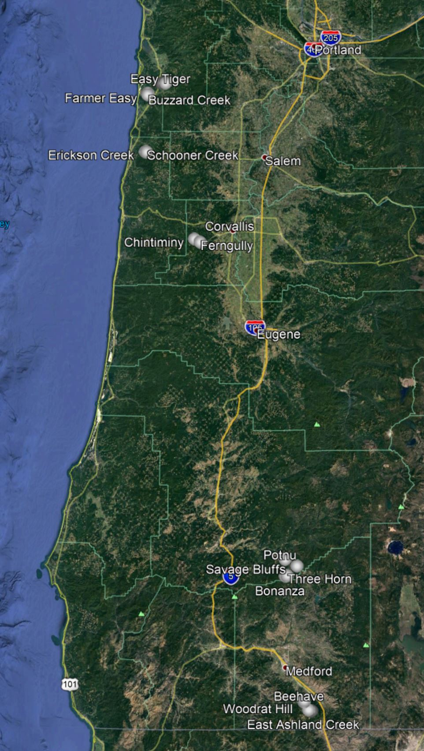

Figure 1. A map of the 16 sites used in this study. All sites were located in Western Oregon.

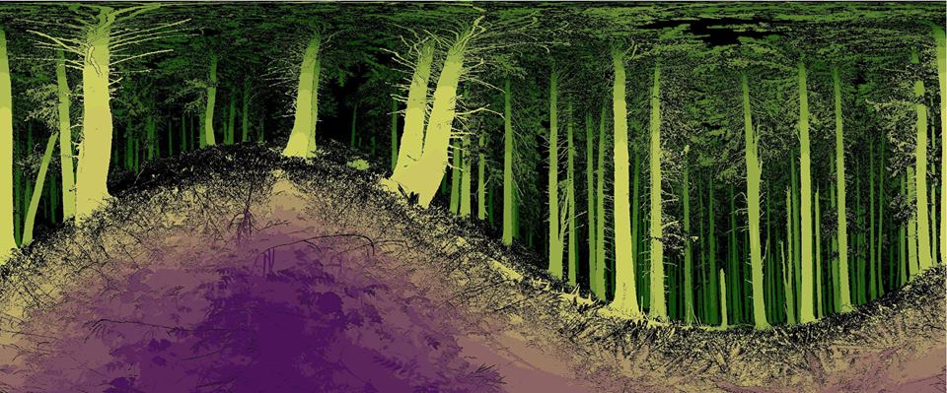

Figure 2. An example of a depth raster derived from the TLS.

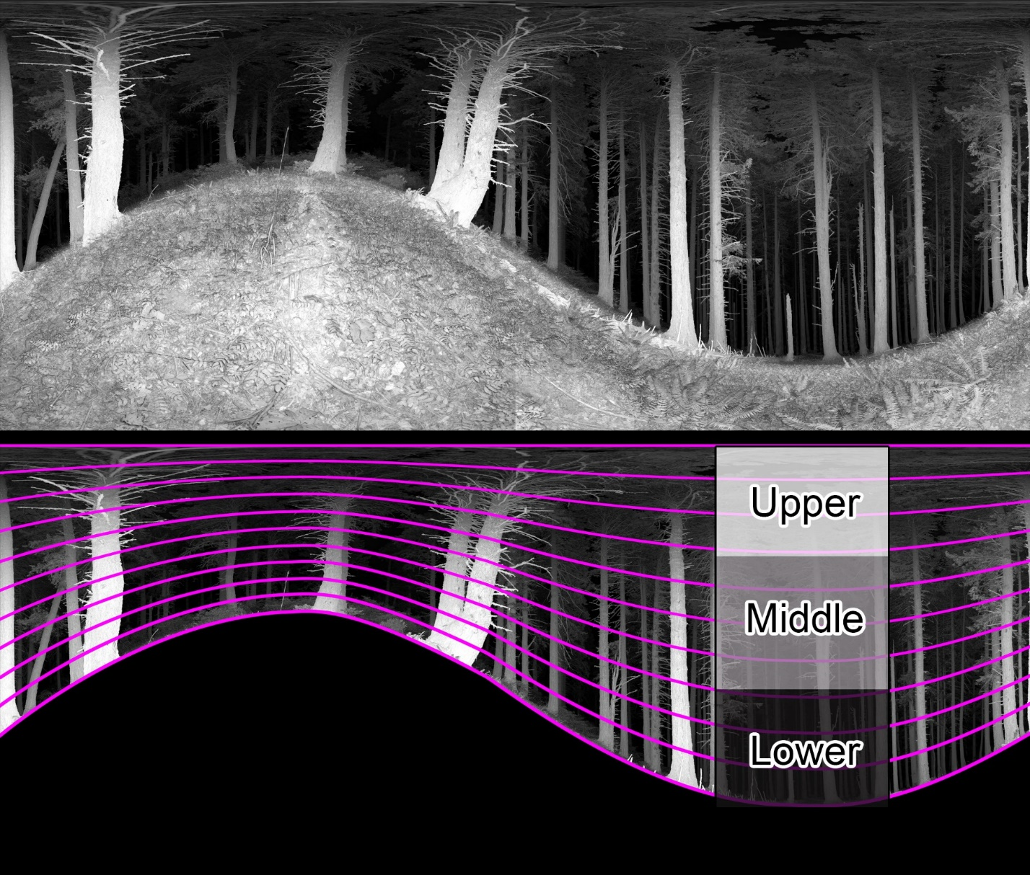

Figure 3. A conceptual figure demonstrating the process of identifying and removing the ground from a TLS scan and then segmenting the aboveground area into 100 vertical sections.

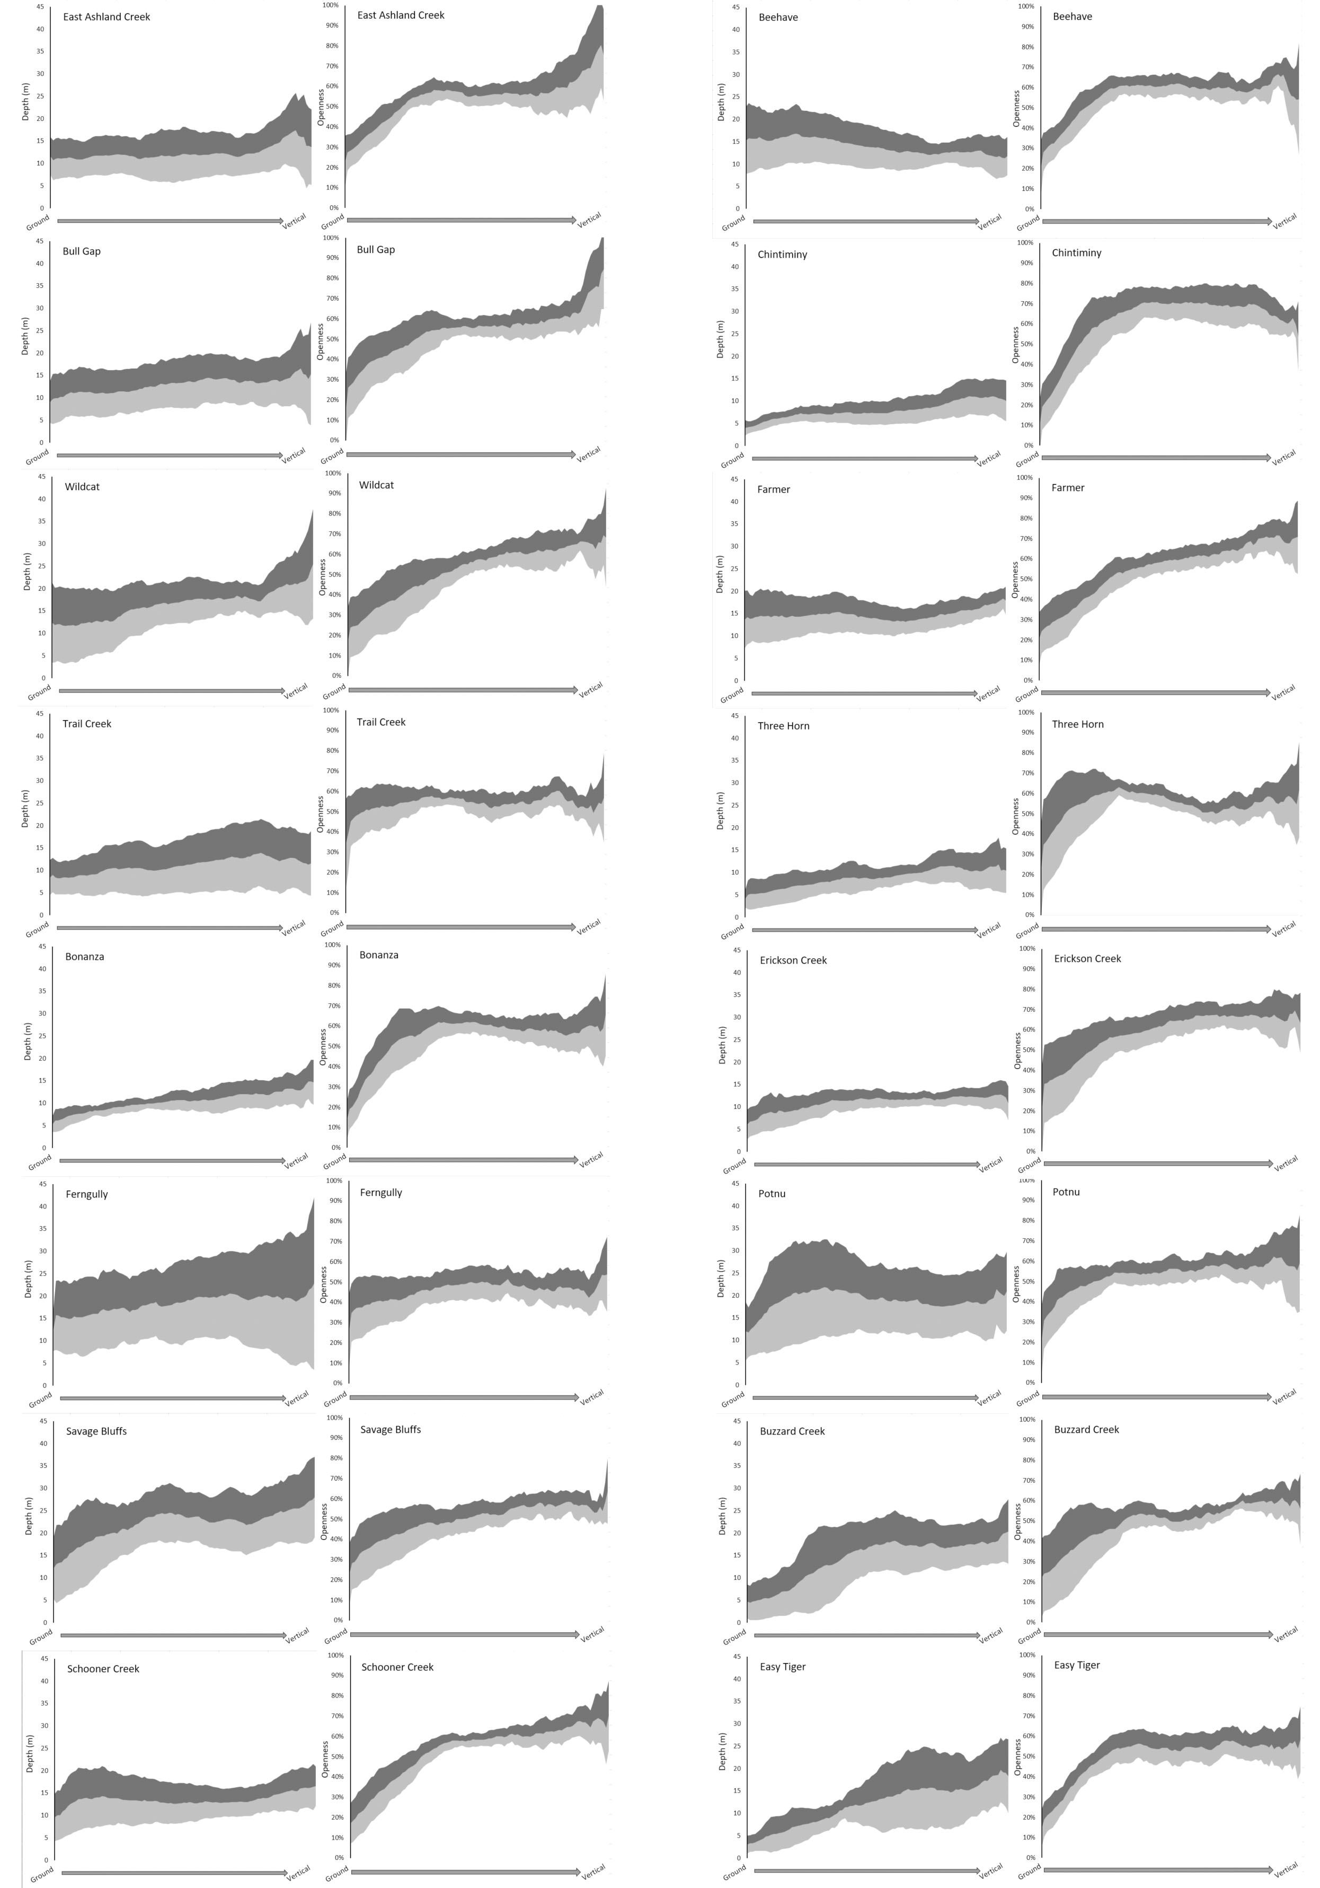

Figure 4. Site signatures the 16 sites. The shaded bands represent one standard deviation above and below the mean value of the 9 plots within each site.

**NMDS Ordination Plot of Openness values**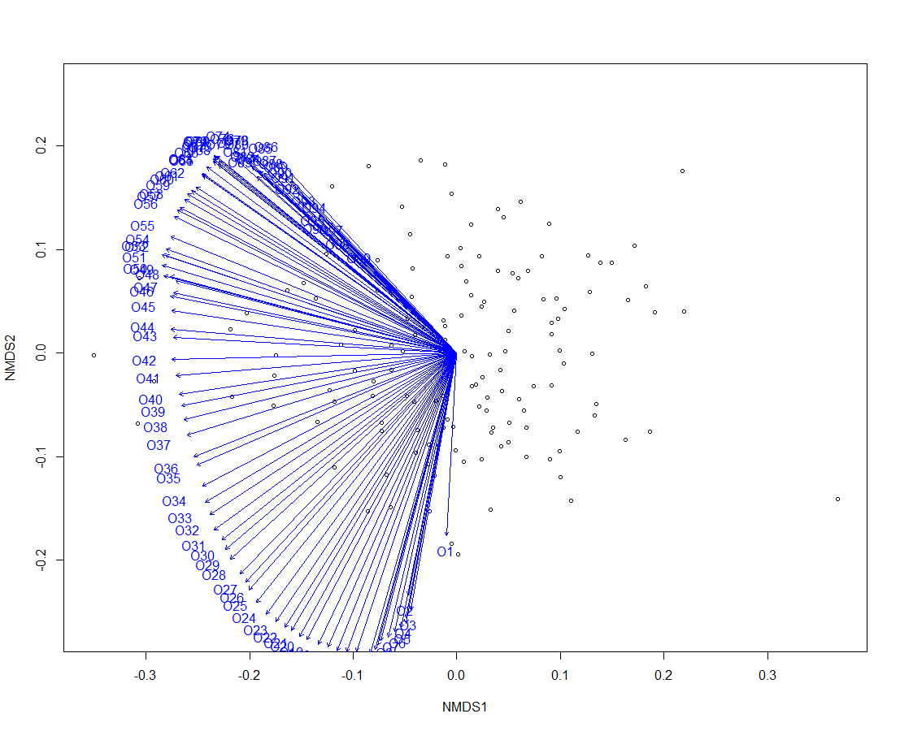

**NMDS Ordination Plot of Openness values**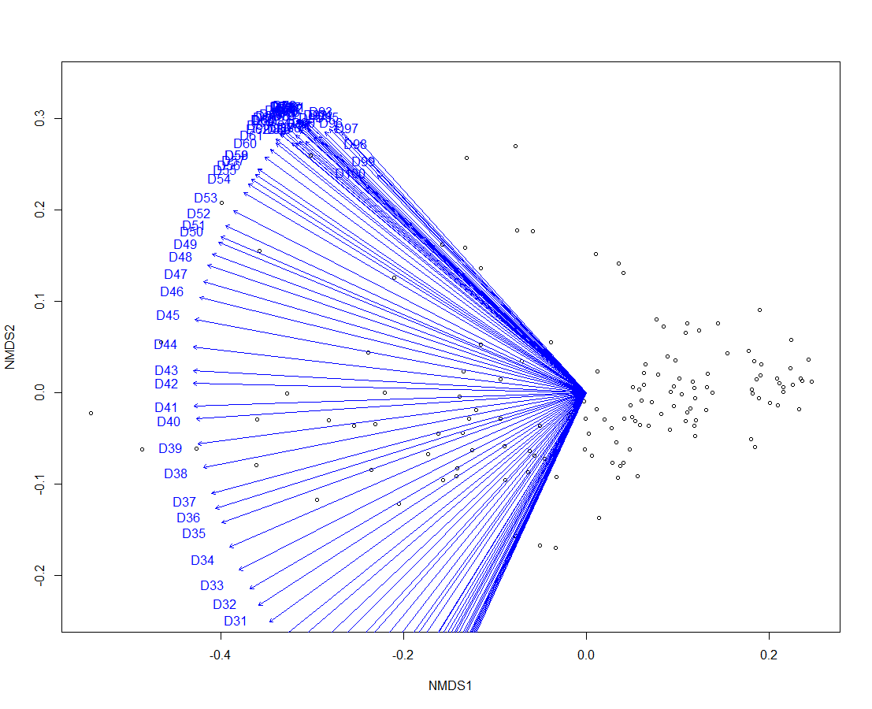

Figure 5. NMDS plots using a Gowers distance matrix for both the openness and depth values. The scan increments are included as the blue lines. The scan increments with the highest loadings on the 1st NMDS axis were 53-62.

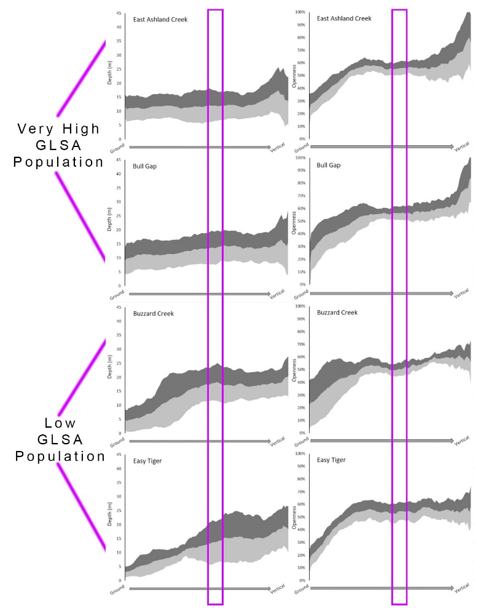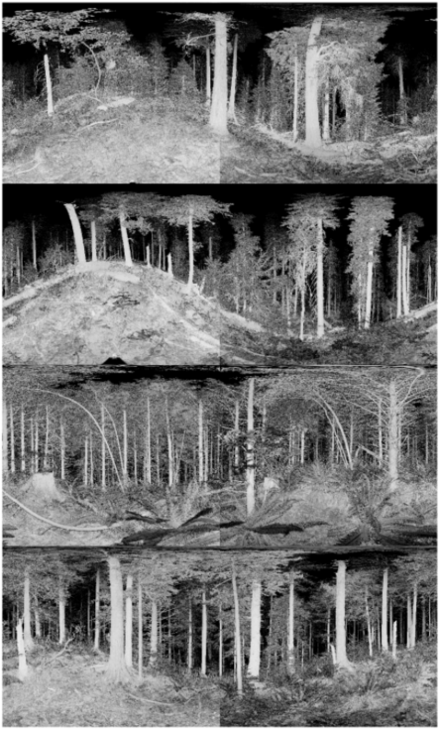

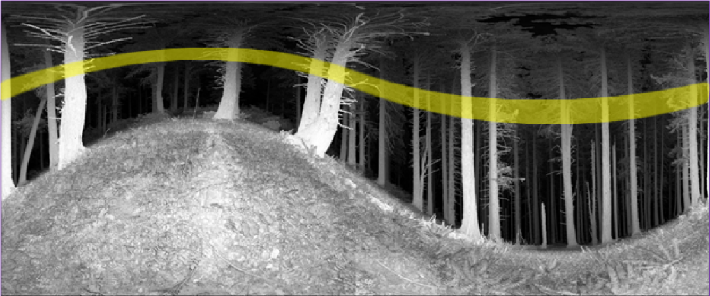

Figure 6. The site signatures of the 2 sites with the highest GLSA population and the signatures of the sites with the lowest GLSA population. The area in the purple boxes is the subsection identified by NMDS as describing the largest amount of variation between sites. A representative intensity image of each site is to the right of the signatures. The yellow band in the image below illustrates the approximate position of the subset.

**NMDS Ordination on Subset of Openness Values with GLSA Group Centroids** 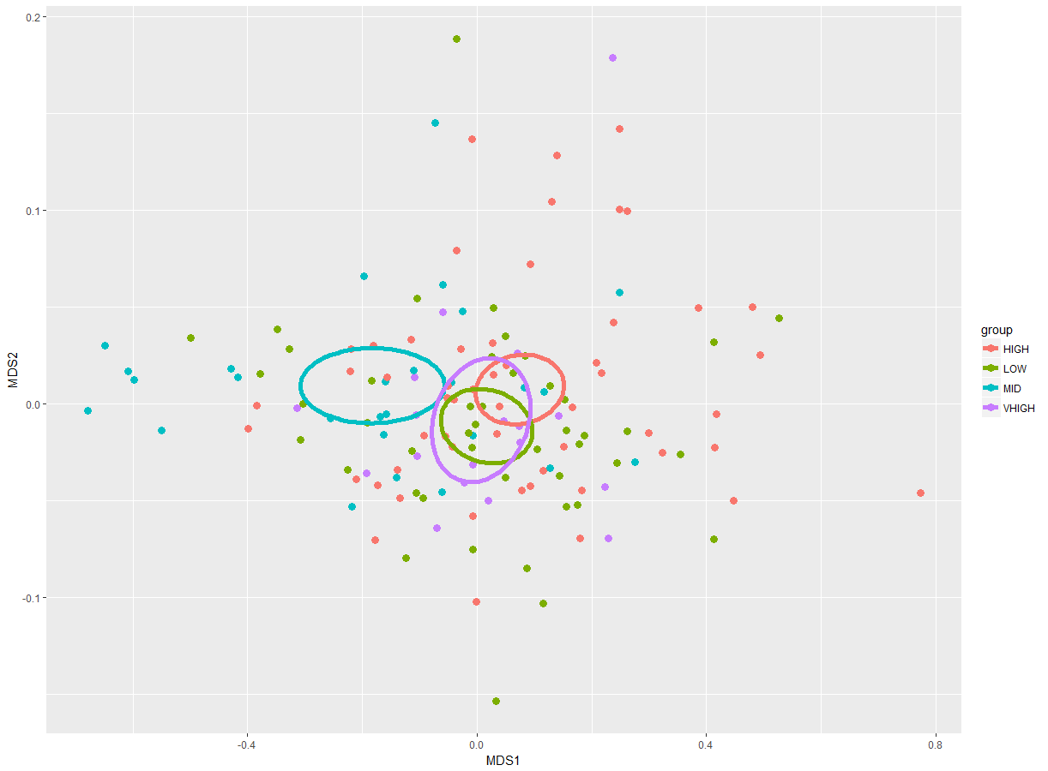

**NMDS Ordination on Subset of Depth Values with GLSA Group Centroids** 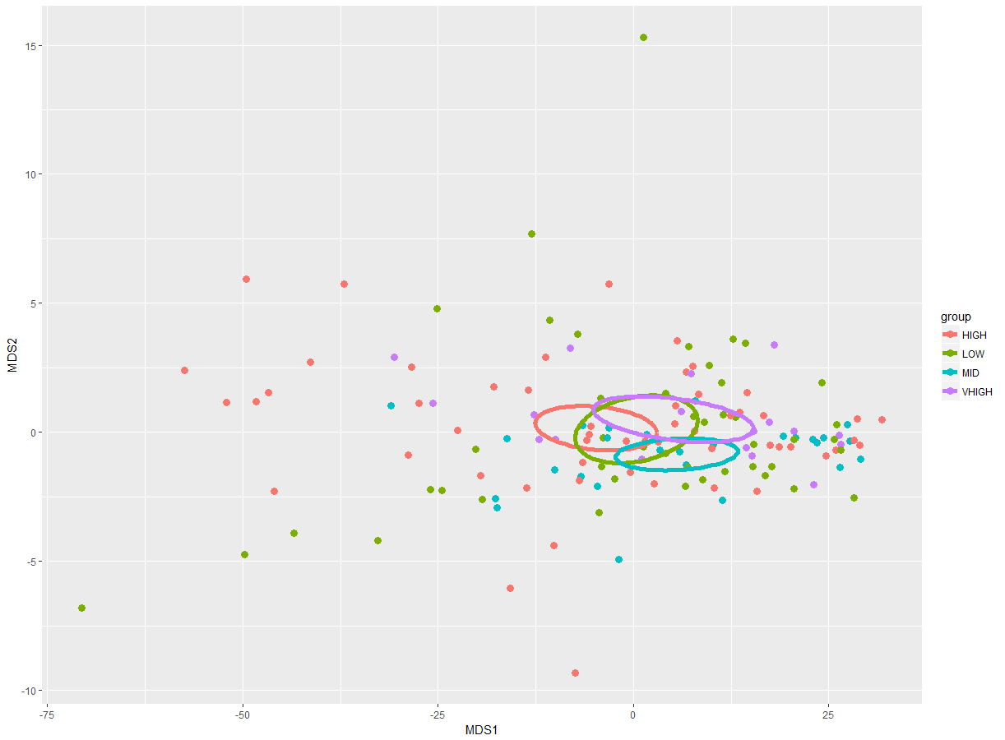

Figure 7. NMDS plots of the subset openness and depth values with the GLSA population groups identified and centroids for each group added.

**Scan Plot Location on NMDS axis 1 for Openness values (n=144). Grouped by GLSA Population.** 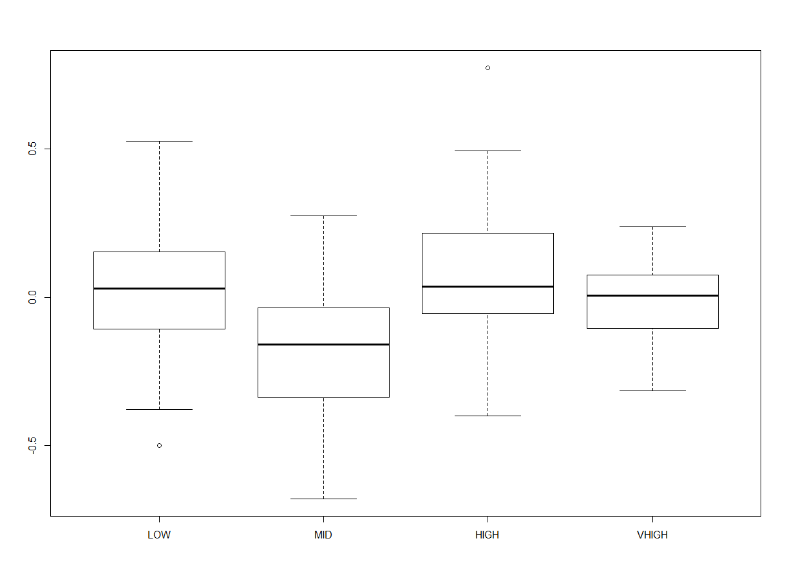

**Scan Plot Location on NMDS axis 1 for Depth values (n=144). Grouped by GLSA Population.**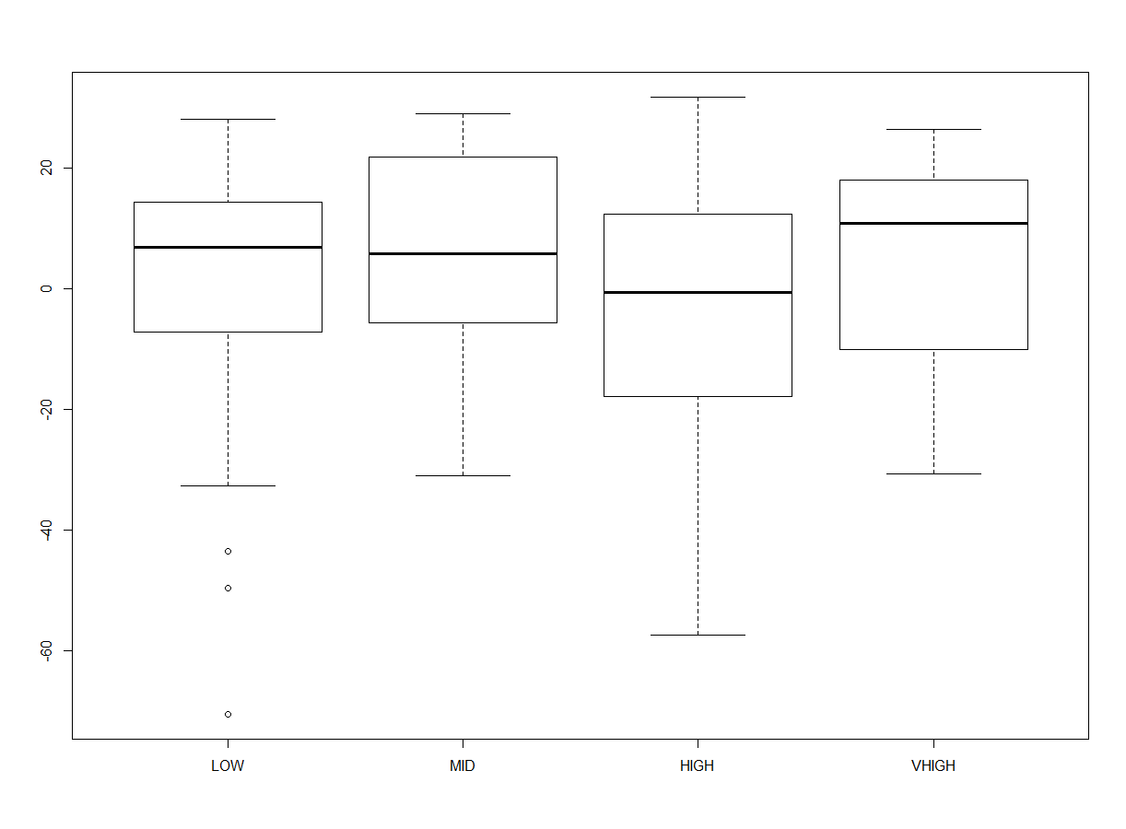

Figure 8. Boxplots of the subset openness and depth values grouped by GLSA population. The Y axis is the location of the plots on the 1st NMDS axis.

**Scan Plot Location on NMDS axis 1 for Openness values (n=144)**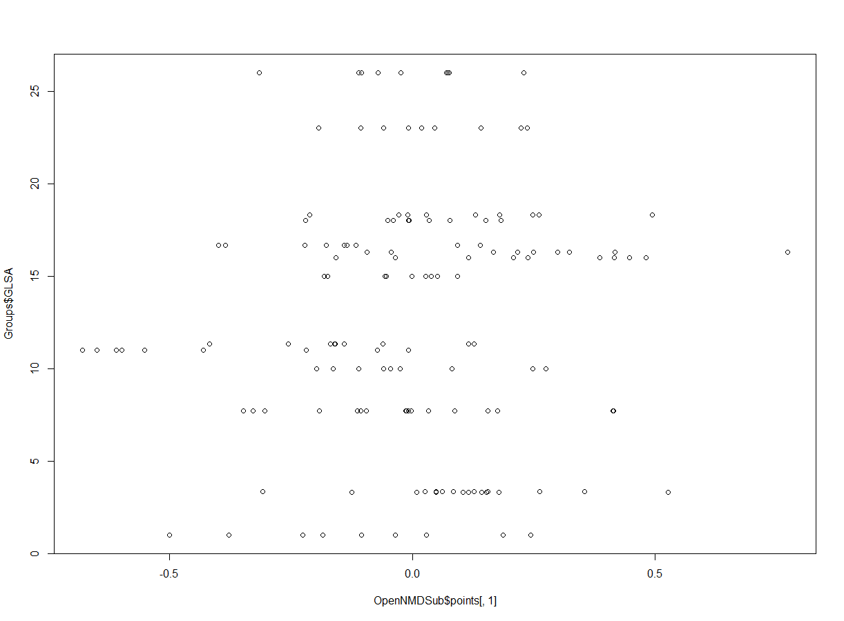

**Scan Plot Location on NMDS axis 1 for Depth values (n=144)**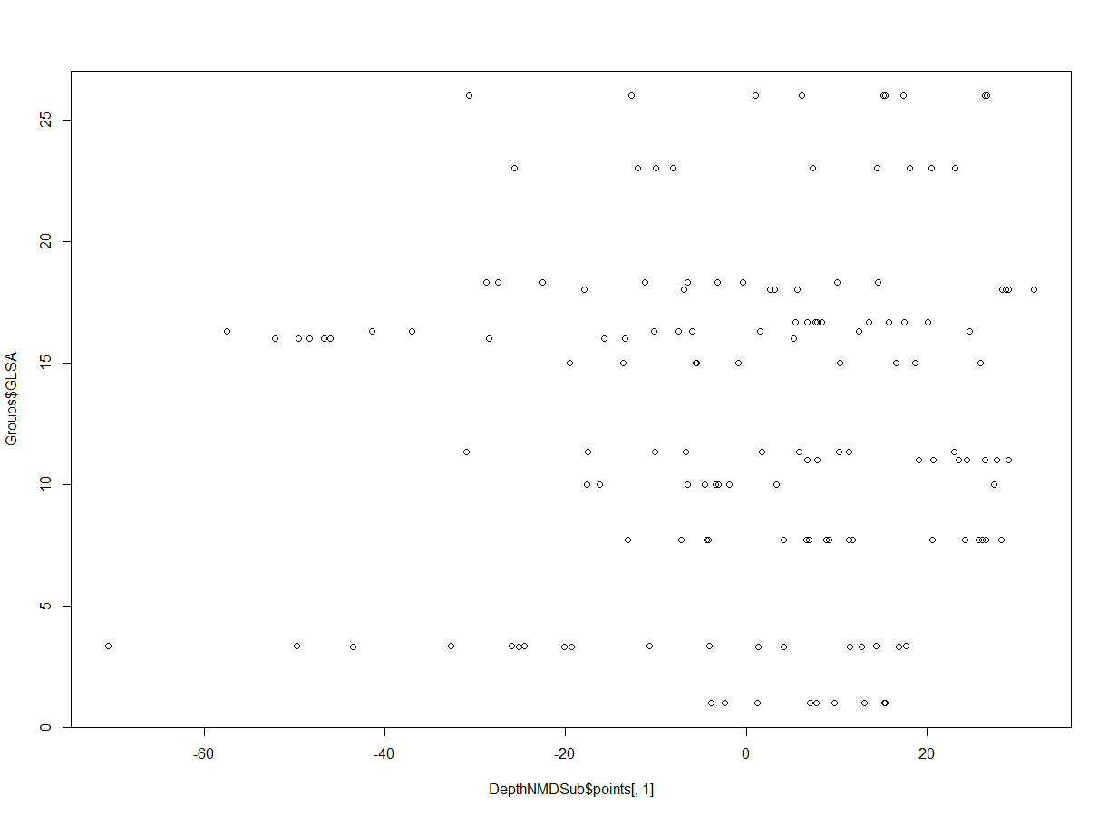

Figure 9. Scatter plots of the Depth and Openness values with the y axis being the GLSA population and the x axis being the plots location on the 1st NMDS axis.