Jonathan Boley
EEN 698 PY

Cochlear Filter Bank Comparison

Background
When we hear various sounds, sound waves are hitting our ear drums. Motion of the ear drum causes three small bones in the inner ear to move. These bones effectively act as an impedance matching device and transfer the wave energy to the oval window of the cochlea. Within the cochlea, sound waves travel through a fluid and excite small hair cells along the basilar membrane. High frequency tones excite hair cells near the oval window whereas low frequency tones affect hair cells near the end. However, a single-frequency tone does not merely enervate a small number of hair cells. A simple tone excites hair cells most at a particular point, but it also excites surrounding hair cells (to a lesser extent). An issue known as masking can arise when two or more tones, relatively close in frequency, are present simultaneously. If one tone is slightly louder than the other, the hair cells corresponding to the frequency of the softer tone may already be enervated to an equal or greater extent by the louder tone. In this case, we cannot hear the softer tone because the brain has no way of knowing that it is present.
Masking has tremendous advantages for audio compression. If we cannot hear a sound, it does not need to be encoded. Throughout the past several decades, scientists have conducted various measurements to determine masking thresholds in a variety of circumstances, but the modeling methods used by engineers are rarely true to these measurements. One common method used by engineers to model the processes that occur within the inner ear is to use cochlear filter banks. A filter bank is used to divide the spectrum into components in a fashion similar to the way the hair cells in the cochlea respond to auditory stimuli. Engineers can use this information to determine which sounds are going to be masked and which ones are going to be audible. To minimize errors, the filter bank should be as accurate as possible.
Two implementations of cochlear filter banks were identified that are commonly used in the speech and audio communities. The first is Patterson and Holdsworth’s filter bank based on ERBs (Equivalent Rectangular Bandwidths¹) and the second is known as Lyon’s Cochlear Model². In the following pages, these two models are compared to the actual ear response as measured by Schroeder³.

Schroeder’s Masking Curves
Schroeder introduced an equation that accurately describes the response of the ear to various frequencies. To calculate this response, the input frequency is first converted to the bark scale according to the equation:
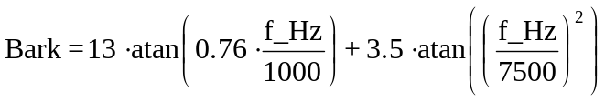
Then the following equation is used to calculate the response curves at various frequencies:
where dz is defined as the difference between the center bark frequency and the bark frequency in question.

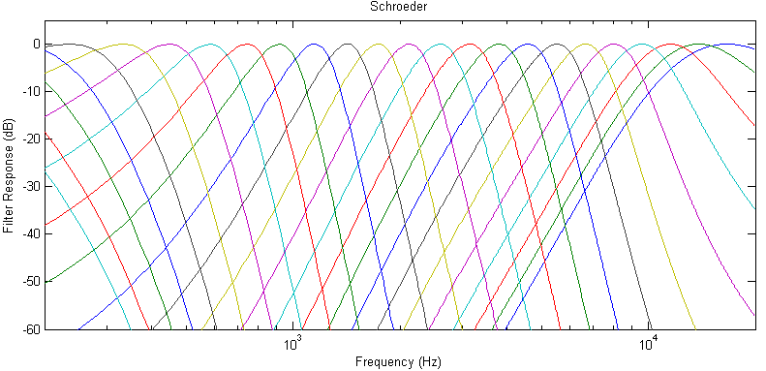
Figure 1. A series of Schroeder masking curves across the audible spectrum

However, the ear does not respond linearly to changes in level. As level increases, the slope of the curves begins to flatten out. This modified version of Schroeder’s equation accounts for level:
where I is defined as:
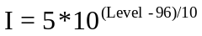

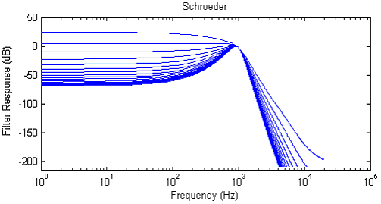
Figure 2. Schroeder curve slopes flatten out as level increases

Patterson and Holdsworth’s ERB Filter Bank
The basilar membrane can be divided into many “critical bands”, each of which can be modeled by an Equivalent Rectangular Bandwidth (ERB). Glasberg and Moore proposed the following equation to calculate the bandwidth at a particular frequency:
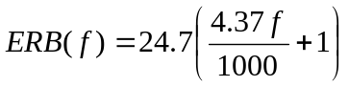
This model uses gammatone filters that are defined by the function:
The ‘b’ and ‘n’ parameters are used to control the order of the filter, thus controlling the slope of the magnitude response. The parameters are chosen such that the bandwidth is equal to 1.019 times the ERB.

For example, the filter corresponding to a center frequency of 1kHz is assigned b=125 and n=4. The impulse response of this gammatone filter is shown below.

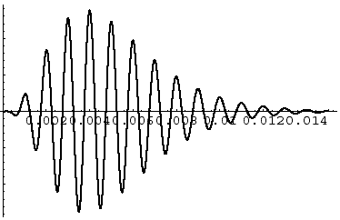
Figure 3. The impulse response of a gammatone filter

Notice the shape- it is called a gammatone function because it is the combination of a gamma distribution and a sine tone. It works well for auditory applications because the frequency response is “pseudo-resonant” and is relatively easy to match with measured responses.⁵

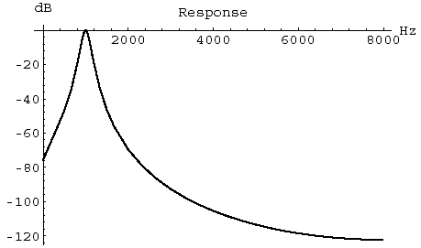
Figure 4. Magnitude response of gammatone filter

If a complex signal is passed through a bank of these filters, we can see how the basilar membrane responds by looking at the subband signals.
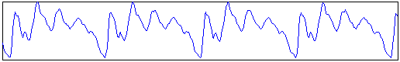
Figure 5. A complex signal (a voiced “aaa” sound)
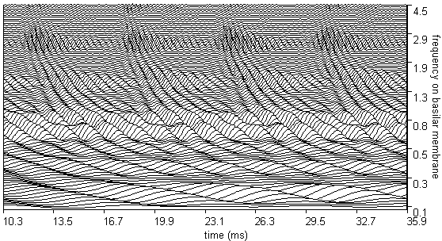
Figure 6. Resonance of the basilar membrane in response to the sound of fig. 5

When the spectrum is divided into 25 ERBs, the magnitude response of the Patterson-Holdsworth filter bank may be plotted as below.
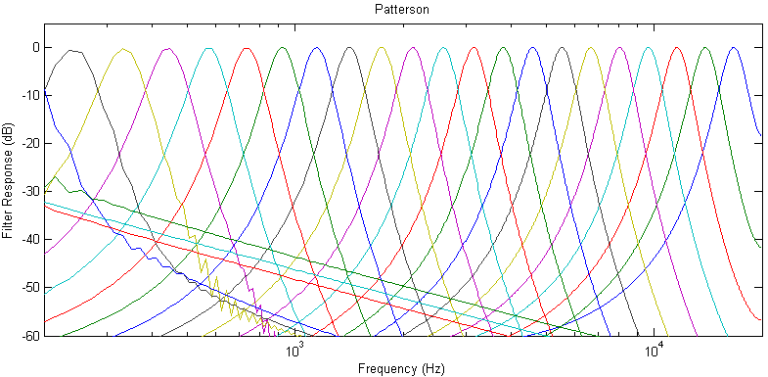
Lyon’s Cochlear Model
Lyon models the basilar membrane as a transmission line. Each of the filters is actually a cascade of second order sections, each of which can be thought of as a combination of a second order notch filter and a second order resonance filter.⁶
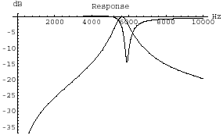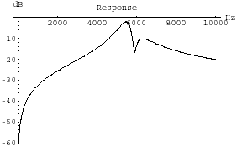
Figure 8. A notch filter and a resonance filter are combined to form each second order section

These two filters are fused by combining the zeros of the notch filter centered on the target frequency with the poles of the resonator at the same frequency and the poles of the notch filter centered at the adjacent subband’s frequency. Note that the poles of the second notch filter match the poles of the current resonator. Thus, the resulting filter remains a second order section.

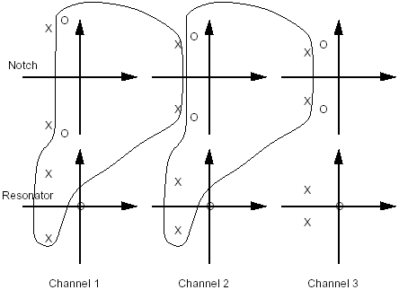
Figure 9. Poles and zeros of notch filters and resonators are combined in each 2nd order section
When designing the second order sections, the poles and zeros of each filter are chosen such that Q=8. (Recommended in [6] to most closely resemble critical bands.) If center frequencies are chosen to be the center frequency of each ERB, the magnitude response of the cascaded sections can be graphed in the following manner:
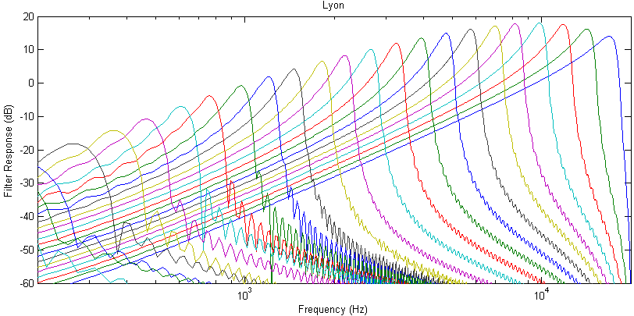
Figure 10. Magnitude response of Lyon’s cochlear filter bank

The gain of each filter can then be adjusted such that the center frequency is at 0dB. The resulting magnitude responses are shown below:
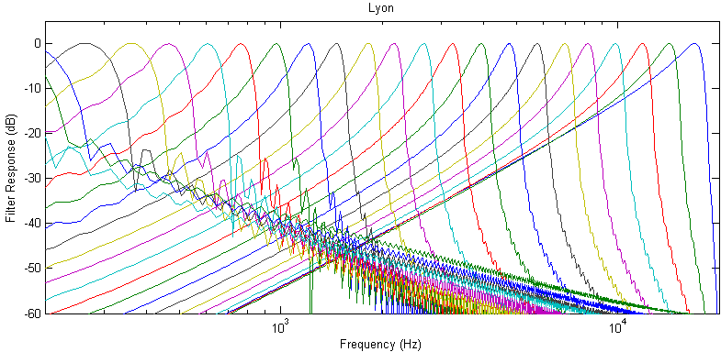
Figure 11. Magnitude response of Lyon’s cochlear filter bank (with gain adjustment)

Comparison
To compare each of the filter banks to Schroeder’s masking curves, an error was calculated for each filter. However, some of the filter responses are calculated down to
-400dB which is far below the human threshold of hearing. Before calculating error, a threshold is applied to each filter response according to the equation:
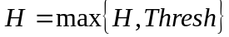
where

After applying this threshold to each filter response, it is much easier to compare the filters.
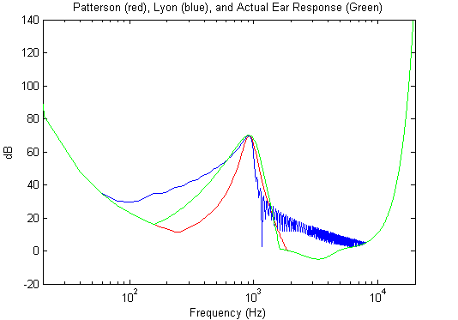
Figure 12. Magnitude response of Patterson, Lyon, and Schroeder models
The method used to calculate the error is then described by the following equation:
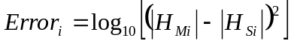
where H_{M} represents the magnitude response of the filter, H_{S} represents the magnitude response of the ear according to Schroeder, and i corresponds to the filter number. Note that the error measurements can vary significantly depending on the loudness of the simulated input signal. Figure 13 shows how the error changes when the Schroeder masking function is modified to account for level.
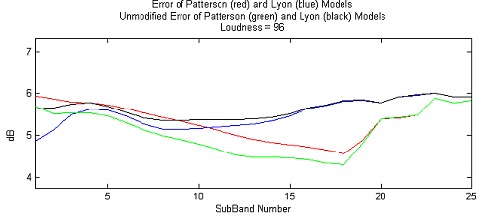
Figure 13. Error measurements with and without level modifications to Schroeder’s equation

The number of subbands was chosen to be 25 in order to coincide with the bark scale. The error is then graphed in terms of both subband number and loudness for both filter banks. Where the error is lower for a particular model, this model outperforms the other.

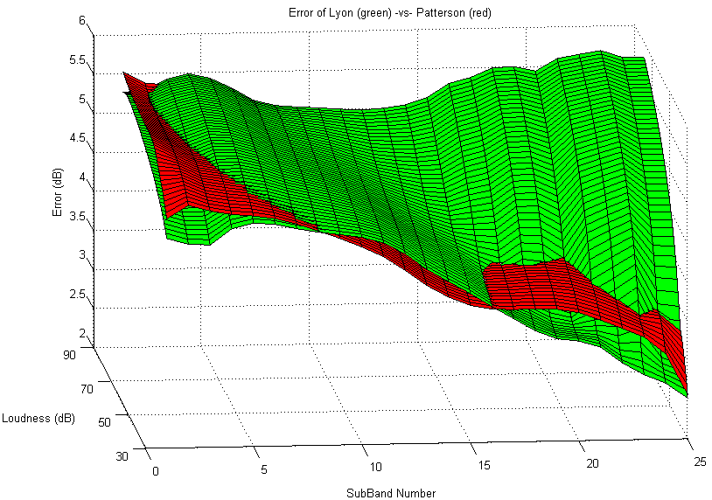
Figure 14. Error of each filter bank in terms of loudness and frequency
It is much easier to determine which model is superior when the above plot is examined in two dimensions (as if viewed from above). In the plots below, the model with less error is plotted in white.

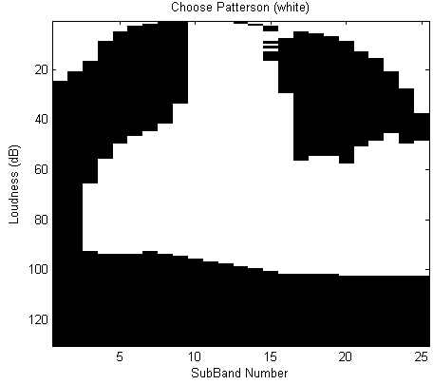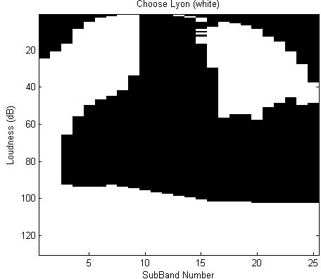
Figure 15. The white regions show the best filter for each frequency range and loudness level

If the spectrum is divided into 32 subbands, the graphs change slightly:

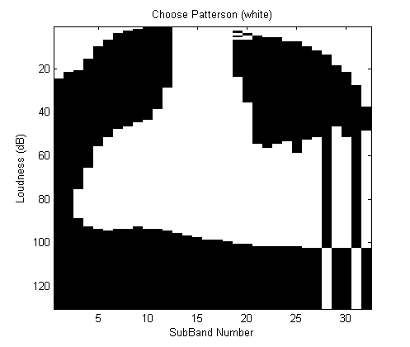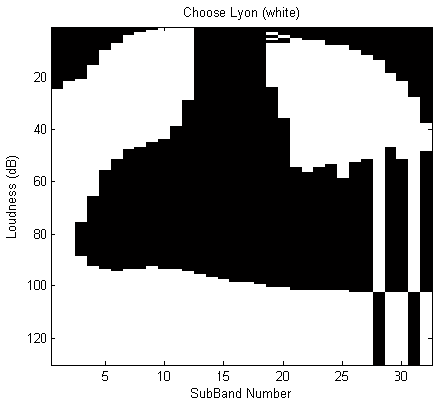
Figure 16. The white regions show the best filter when expanded to 32 subbands

From the four graphs on this page, we see that the magnitude response of Patterson and Holdsworth’s ERB filter bank more closely resembles the response of the ear in the center region of loudness versus frequency. Because a significant amount of audio occurs in this region, Patterson and Holdsworth’s model would be a better choice than Lyon’s model for most applications.

Resources

1. R. D. Patterson, K. Robinson, J. Holdsworth, D. McKeown, C.Zhang, and M. H. Allerhand, "Complex sounds and auditory images," In Auditory Physiology and Perception, (Eds.) Y. Cazals, L. Demany, K. Horner, Pergamon, Oxford, 1992, pp. 429-446.

2. R. F. Lyon, "A computational model of filtering, detection, and compression in the cochlea," Proc. of the IEEE ICASSP,1282-1285, 1982.

3. M.R. Schroeder, B.S. Atal, J.L. Hall, “Optimizing digital speech coders by exploiting masking properties of the human ear”, J. Acoust. Soc. Am. 66 (16) (December 1979) 1647-1651.

4. B. R. Glasberg and B. C. J. Moore, “Derivation of auditory filter shapes from
notched-noise data.” Hearing Research, vol. 47, 1990, pp. 103-108.

5. R.F. Lyon, “The All-Pole Gammatone Filter and Auditory Models”, Unofficial Apple Technical Report, 1996. http://www.mit.edu/people/kosuke/pdfs/Lyon96.pdf

6. M. Slaney, “”Lyon’s Cochlear Model”, Apple Technical Report #13, 1988.

Source Code
(Uses the Auditory Toolbox which can be downloaded from http://rvl4.ecn.purdue.edu/~malcolm/interval/1998-010/ )

% Final Project
% Filterbanks & Wavelets

clear all;

for Loudness = 70:70

Fs = 40000;

% Patterson
NumERBs = 25;
fcoefs = MakeERBFilters(Fs,NumERBs,1);
y = ERBFilterBank([1 zeros(1,1023)], fcoefs);
ERBresp = 20*log10(abs(fft(y',2048)));
freqScale = (0:1023)/1024*(Fs/2);
ERBvalues = max(ERBresp);
for i=1:NumERBs
ERBindices(i) = find(ERBresp(1:end/2,i)==ERBvalues(i));
ERBfreqs(i) = freqScale(ERBindices(i));
end
figure(1);
subplot(3,1,1), semilogx(freqScale,ERBresp(1:end/2,:));
axis([200 Fs/2 -60 5]);
title('Patterson');
ylabel('Filter Response (dB)');

% Lyon
[filts, freqs]=DesignLyonFilters(Fs);
resp=soscascade([1 zeros(1,511)],filts);
if abs(fft(resp(1:end,:)',2048)) == 0,
freqResp = zeros(1,2048);
else
freqResp=20*log10(abs(fft(resp(1:end,:)',2048)));
end
freqScale=(0:length(freqResp)/2-1)/(length(freqResp)/2)*(Fs/2);
filtIndex = dsearchn(freqs',ERBfreqs');
for i=1:length(freqResp(1,:)) % Normalization
freqResp(:,i) = freqResp(:,i)-max(freqResp(:,i));
end
subplot(3,1,2),semilogx(freqScale,freqResp(1:end/2,filtIndex));
axis([200 Fs/2 -60 5]);
title('Lyon');
ylabel('Filter Response (dB)');

% SCHROEDER
N = 2048;
freqs=ERBfreqs; %Test tones
f_Hz = [1:Fs/N:Fs/2];
for i=1:length(freqs)
freq=freqs(i);
bark_freq = 13*atan(0.76*freq/1000) + 3.5*atan((freq/7500).^2);
bark_f_Hz = 13*atan(0.76*f_Hz/1000) + 3.5*atan((f_Hz/7500).^2);
dz = bark_freq-bark_f_Hz;
I=(5*10^((Loudness-96)/10));
m(i,:) = ((15.81-I)+7.5*(dz+0.474)-(17.5-I)*sqrt(1+(dz+0.474).^2));
end
subplot(3,1,3), semilogx(f_Hz,m);
axis([200 Fs/2 -60 20]);
title('Schroeder');
xlabel('Frequency (Hz)');
ylabel('Filter Response (dB)');

for i=1:NumERBs
% Re-align index values
index1 = find(ERBresp(1:end/2,i)==max(ERBresp(1:end/2,i)));
index2 = find(freqResp(1:end/2,filtIndex(i))==max(freqResp(1:end/2,filtIndex(i))));
freqResp(1:end/2,filtIndex(i)) = [freqResp(1+abs(index2-index1):end/2,filtIndex(i));freqResp(end/2,filtIndex(i))*ones(abs(index2-index1),1)];

% Threshold in Quiet
f_kHz = f_Hz/1000;
A = 3.64*(f_kHz).^(-0.8) - 6.5*exp(-0.6*(f_kHz - 3.3).^2) + (10^(-3))*(f_kHz).^4;
ERBrespA = max(ERBresp(1:end/2,i) + Loudness,A');
freqRespA = max(freqResp(1:end/2,filtIndex(i)) + Loudness,A');
mA = max(m(i,:)' + Loudness,A');

% Calculate Error
Error1(Loudness,i) = log10(sum((ERBrespA - mA).^2));
Error2(Loudness,i) = log10(sum((freqRespA - mA).^2));

% Plot comparisons
figure(2), semilogx(f_Hz,ERBrespA,'r');hold on;
semilogx(f_Hz,freqRespA,'b'); semilogx(f_Hz,mA,'g'); hold off;
axis([20 Fs/2 -20 200]);
title('Patterson (red), Lyon (blue), and Actual Ear Response (Green)');
pause;
end

figure(3), plot(Error1(Loudness,:),'g'); hold on; plot(Error2(Loudness,:),'k'); hold off;
SLoudness = sprintf('\nUnmodified Error of Patterson (green) and Lyon (black) Models\nLoudness = %d',Loudness);%\nLoudness = %d',Loudness);
title(['Error of Patterson (red) and Lyon (blue) Models' SLoudness]);
xlabel('SubBand Number'); ylabel('dB');
axis([1 25 0 10]);
pause(0.01);
end

figure(4); surf(Error1(40:90,:)); hold on; surf(Error2(40:90,:));
title('Error of Lyon (green) -vs- Patterson (red)')
xlabel('SubBand Number');
ylabel('Loudness');
zlabel('Error (dB)');

for i=1:length(Error2(:,1))
for j=1:length(Error2(1,:))
Choose2(i,j) = (Error2(i,j) < Error1(i,j));
end
end
figure(5);colormap gray;
imagesc(Choose2); title('Choose Lyon (white)');
xlabel('SubBand Number');
ylabel('Loudness (dB)');

clear index1 index2

for i=1:length(Error2(:,1))
for j=1:length(Error2(1,:))
Choose1(i,j) = (Error2(i,j) >= Error1(i,j));
end
end
figure(6);colormap gray;
imagesc(Choose1); title('Choose Patterson (white)');
xlabel('SubBand Number');
ylabel('Loudness (dB)');

