AUDIO SPATIALIZER FOR HEADPHONES

By

Jonathan Boley
Paul Carlson
John Horstman

ECE 345, SENIOR DESIGN PROJECT
SPRING 2003

TA: Paul Leisher

6 May 2003

Project No. 24

ABSTRACT
Modern entertainment systems strive to create the most realistic sound environment possible. This typically requires several loudspeakers positioned at various locations within the listening space, making sound systems impractical for mobile use. However, by modeling human perception of sound localization one can create a realistic 3-dimensional sound stage using only two channels of audio. The objective of this project was to design and build a portable device that simulates surround sound in a pair of headphones. This was accomplished through use of an AC-3 decoder, a matrix decoder, and head related transfer functions (HRTFs). The audio stream was sent through an audio codec to a digital signal processor where it was enhanced before being output to headphones. The device provided a clean audio signal to the user, minimizing distortion and maintaining a high signal to noise ratio.

TABLE OF CONTENTS

- INTRODUCTION 1
1.1 Purpose 1
1.2 Project Functionality 1
1.3 Subprojects 2
- DESIGN PROCEDURE 3
2.1 Design Decisions 3
2.1.1 Codec 3
2.1.2 DSP 3
2.1.1 Microcontroller 3
2.2 Tools Used 4
- DESIGN DETAILS 5
3.1 Chip Communication 5
3.1.1 Codec / DSP 5
3.1.2 Microcontroller 5
3.2 Circuitry and Layout 6
3.2.1 Voltage Supply Circuit 6
3.2.2 Support Circuitry 7
3.2.3 Printed Circuit Board Layout 7
- DESIGN VERIFICATION 9
4.1 Functional Testing 9
4.2 Objective Testing 9
4.3 Conclusions 11
- COST 12
5.1 Parts 12
5.2 Labor 12
- CONCLUSIONS 13
6.1 Successes 13
6.2 Unresolved Challenges 13
6.3 Future Work 13

APPENDIX 1. SCHEMATICS 15

REFERENCES 17

1. INTRODUCTION
  - Purpose
Modern entertainment systems strive to create the most realistic sound environment possible. This typically requires several loudspeakers positioned at various locations within the listening space, making sound systems impractical for mobile use. However, by modeling human perception of sound localization one can create a realistic 3-dimensional sound stage using only two channels of audio. The objective of this project was to design and build a portable device that simulates surround sound in a pair of headphones. This is accomplished through use of an AC-3 decoder, a matrix decoder, and head related transfer functions (HRTFs). The audio stream is sent through an audio codec to a digital signal processor where it is enhanced before being output to headphones. The device must provide a clean audio signal to the user, minimizing distortion and maintaining a high signal to noise ratio.

  - Project Functionality
The goal of this project was to design a portable device that would allow a user to listen to “virtual surround sound” through headphones. The original audio stream could be either standard stereo (digital or analog) or AC-3 encoded surround sound. (AC-3, also known as Dolby Digital, is the industry standard for multi-channel audio.) If the incoming stream is determined to be stereo, it will pass through Dolby ProLogic II, where it will be converted to 6 discrete channels; if the stream is AC-3 encoded, it is sent to the Dolby Digital decoder to separate the 6 channels of audio. In either case, five channels (we ignore the subwoofer channel) are sent to the Dolby Headphone algorithm, which filters each channel with a head related transfer function (HRTF) before recombining the channels to create an output of two channels. These two channels - output to a pair of headphones - represent the 3D soundscape perceived by the left and right ears. Figure 1 illustrates the path that an audio signal takes through the Dolby algorithms.
The user would have access to various parameter controls for the Dolby algorithms used (Figure 2). ProLogic II employs two primary mode settings. In Movie Mode, several parameters that have been optimized for movie listening are preset. In Music Mode, the user has access to dimension, center width, and panorama controls. Dimension has five levels of increasing virtual depth of the listening space. Center Width also has five levels, each increasing the width of the listening space. When Panorama Mode is toggled on, the surround channels are used as additional left and right front channels, creating the illusion of sitting in front of a concert stage. Additionally, Dolby Headphone allows the user may choose between three varying room effects which model a small damped room, a mid-sized live room, and a large room such as a concert hall or theatre.
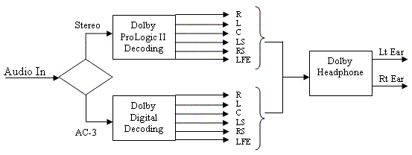
Figure 1: Audio stream running through Dolby algorithms
MicroController
DSP
Movie Music
Dimension
Center Width
Panorama
off
on
Room Effects
1 2 3
Volume
Codec
Figure 2: User interface controls

1.3 Subprojects
Most of the important functionality of our project was handled by three ICs: an audio codec, a digital signal processor (DSP), and a microcontroller. In order to ensure proper cooperation between the chips within the final device, each chip was assigned its own subproject. The goal of each subproject was to gain a complete understanding of the capabilities of the chip, to learn how to control these capabilities, and to find out how the chip properly interfaces with the rest of the device. Completion of these projects was vital to achieving inter-IC communication.
In order to ensure proper assembly of our final product, a subproject was dedicated to the creation of a successful circuit schematic and PCB layout. Our design was complicated enough to warrant a great deal of attention when compiling a final circuit from the individual circuitry needed for each chip. After creating a successful circuit, several board layout restrictions were considered, such as length of clock signal lines, space between traces, and total board size.

2. DESIGN PROCEDURE
2.1 Design decisions
At the beginning of our project, we knew we needed the following components: a DSP to process the audio in our device, an audio codec to handle the input and output of the audio signal, and a microcontroller to handle the user interface and send messages to the other two chips (Figure 3).
DSP
Motorola 56367
Microcontroller
HCS12
Audio Codec
AK4584
Stereo in
AC3 in
Headphone out
Audio stream in bold
Controls
Figure 2: User interface controls
Figure 3: Block diagram of original design

2.1.1 Codec
In order to implement all of the features we wanted to provide to the user, we needed a codec with certain capabilities. It had to be able to recognize both analog and digital signals at various values of Fs (sample rate). It had to transmit audio at studio quality (24 bits of resolution, Fs = 44.1 kHz) or higher. Additionally, it had to have a low cost to keep consumer cost down in the final product.
We chose the AKM AK4584 because it met or exceeded all of these requirements. It samples audio at 24 bits at a rate of 96 kHz, and provides stereo analog and digital inputs and outputs. It was also easy to connect this chip to other devices, as it had few communication lines and was easy control.
2.1.2 DSP
We chose the Motorola DSPD56367 because it was one of the fastest audio DSPs on the market at the time, capable of running at speeds up to 150 MIPS (Million Instructions Per Second). Dolby Headphone applies 10 FIR (Finite Impulse Response) filters, each consisting of 7000 coefficients. The DSPD56367 comes with all three of the necessary Dolby algorithms, and has the processing power to run them all in real time.
The DSP software automatically distinguishes between PCM and AC-3 encoded streams. If the data from the codec is AC-3 encoded, the stream is routed to the Dolby Digital decoder. (See Figure 1) Otherwise, the signal is assumed to be stereo PCM, and is routed to the ProLogic II algorithm. After passing through one of these two phases, the five main channels of audio are passed through Dolby Headphone, which applies HRTFs and room responses.
2.1.3 Microcontroller
Our project required a microcontroller in order to change the settings on the codec and the DSP. Our initial thought was to use a Motorola 68HC12 because it is a common microcontroller and we had been introduced to it in previous courses. Its low cost was also desirable.
As our project progressed, we ran into some problems with the HC12. The poor documentation, unnecessary complexity, and awkwardness of programming led to problems interfacing with the other chips. After much frustration, we were convinced that the HC12 was not the best fit for our project.
After shopping for different microcontrollers, the BasicX BX-24 was selected as our microcontroller since it provided for all of our needs in a simple, easy to use package. Another positive aspect of the BX-24 was that it came with its own board that included the necessary hardware, thus providing a microcontroller with only 24 pins. The BX-24 is also programmable in Basic, which reduced code complexity and programming time due to its ease of use.

2.2 Tools Used
This project incorporated many different tools that were essential for our success. Dealing with representatives at Motorola and AKM, we were able to acquire evaluation boards for the DSP and codec. These boards provided us with the necessary circuitry to test and evaluate our design. We were able to send signals from common consumer devices - such as CD and DVD players - to our circuit to verify proper performance from the chips. Windows-based control software was provided for all three chips; this meant that we needed multiple PCs to control all of the chips in real time. A PC operating on Windows 98 was required to run the software for the codec. Development software for the DSP and BX-24 worked on all Windows platforms. Orcad Capture was used to make a schematic of each chip, and these schematics were used as a reference throughout the project for each chip’s hardware needs.
For the PCB fabrication process, our preliminary goal was to take advantage of the ECE Parts Shop to make a prototype board. This meant using Easyedit and Easyplot to do PCB layout and artwork leading to a functional PCB design. Unfortunately, the facilities in the Parts Shop limited our PCB options such that it became impossible for us to manufacture a working board on campus. This obstacle led to reworking the PCB design with additional layers that will increase performance of our device which is ready to be sent to a PCB fabrication company.

3. DESIGN DETAILS
3.1 Chip Communication
Due to the versatility and functionality of the chips we selected, the ICs make up most of our circuitry. Communication between chips was of the utmost importance for the success of our project. Miscellaneous resistors and capacitors were used in support roles, such as sending a particular voltage to an IC pin. The values of these electrical components were supplied in the documentation provided by the vendor.
3.1.1 Codec / DSP
The chips talked to each other through pin-to-pin communication over two clock lines and two serial data lines. Figure 4 illustrates the communication between the codec and the DSP.

Codec
Audio
DSP
LRCK
BICK
SDTO
SDTI
Figure 4: Codec-DSP communication lines

The left-right clock (LRCK) is generated by the codec and is used to tell the DSP whether it is sending information related to the left channel or the right channel (left = H; right = L). For a given audio signal, the LRCK will automatically operate at the sample rate of that signal. The bit clock signal (BICK) is used to tell the chips when to read a bit from the serial data line. The audio data is sent over the serial data in and out lines (SDTI and SDTO, respectively).
Each sample requires 32 bits to send across a serial line: 8 bits are for the header information, and 24 bits are for the audio sample. All samples are transmitted as 24 bit, MSB justified on both SDTI and SDTO. Since we are sending this information for two channels, the BICK must operate at 64*Fs. The DSP reads the bit on SDTO on a rising clock edge from BICK, and the codec reads the bit on SDTI on a falling clock edge.

3.1.2 Microcontroller
The microcontroller also used pin-to-pin communication to send messages to the other ICs. Figure 5 illustrates the required communication lines.

Codec
Audio
DSP
LRCK
BICK
SDTO
SDTI
MicroController
CCLK
CDTO
CSN
CCLK
CDTO
CSN
Figure 5: Microcontroller communication lines

The control clock (CCLK) is generated by the microcontroller and is used as a bit clock for the target IC. Commands are sent across the serial control data line (CDTO). The chip select pin (CSN) is used to enable the target IC.
Source code for DSP and Codec control can be found in the file entitled “Appendix” on our project page.

3.2 Circuitry and Layout
Once we established communication between chips through the evaluation boards, our goal was to create a viable schematic and board layout. This involved designing a voltage divider, implementing support circuitry for each chip, and developing a printed circuit board (PCB) layout for our final product.
3.2.1 Voltage Supply Circuit
The purpose of the voltage supply circuit was to provide the proper voltage to each of the three ICs. The microcontroller required 6V, the codec required 5V, and the DSP needed 3.3V. We achieved these values by designing a simple voltage divider (based on a 9V DC power supply), according to the following equations:
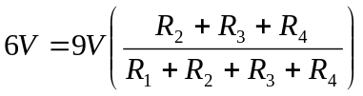 (1)
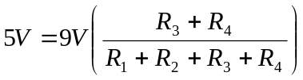 (2)
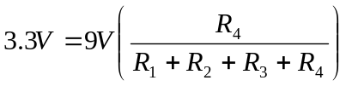 (3)

The resistor values that result from Equations (1-3) are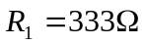, 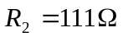, 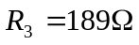, and 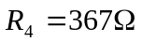. Resistors of these exact values were not readily available, so we approximated the values to 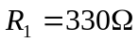, 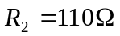, 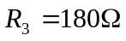, and 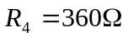. The voltages resulting from these approximated values were 5.969V, 4.959V, and 3.306V for the microcontroller, codec, and DSP respectively. We then verified that each chip would operate at these voltages, but realized that the input impedance of each IC affected our voltage divider circuit. Therefore, we used buffers to eliminate this problem. The resulting circuit is displayed in Figure 6.

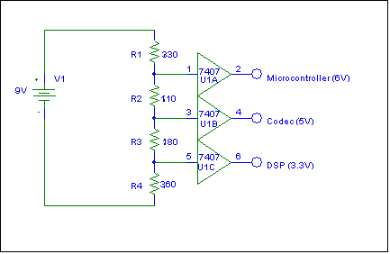
Figure 6: Voltage supply circuit

3.2.2 Support Circuitry
Each of the IC manufacturers supplied a recommended schematic for optimum chip performance. The final schematics for our device directly employed the manufacturers’ suggestions, and may be seen in Appendix 1.
3.3.3 Printed Circuit Board Layout
The PCB layout (available in a ZIP file on our project page as “File 1”) involved many aspects of hardware design that needed to be taken into consideration. The idea of this layout was to come as close as possible to creating a board that would fulfill our project’s original goals. We wanted a small device with easily accessible I/O ports that would be easy to transport and use. In addition we also had physical considerations for our circuits, such as making sure that all connections were made properly and set up in a competent manner so that our device would operate most efficiently.
After beginning work on the layout, it became evident that our original idea of having inputs on one side and outputs on the opposite side was not as feasible as having all inputs and outputs on one of the long sides of the board. This also helped minimize space as the opposite edge of the board now only needed to include the microcontroller and its communication lines with the DSP instead of sharing space with the output lines and their components .
Initially, we decided to make a 2-sided board with the idea that is would be easy to troubleshoot as well as easy and inexpensive to have fabricated. After completing the 2-sided layout, it was decided that a 4 layer board would much better suit our needs since it would provide a much smaller space for the board, which was one of our goals. The inner layers were mostly used for the memory and DSP communication. These became essential to perform this communication in such limited space. These also helped the layout in that they provided some lines in perpendicular directions to reduce coupling problems between layers. These added layers, despite adding cost and complexity, will improve the performance of the board.
One of the most important parts of the layout was that the DSP was positioned as close as possible to the memory array. This was the most complex section of the PCB since the DSP had a large number of pins, many of which were connected to the memory array as data or address lines. Although this section of the board at first appears complex, once individual lines are traced, it will be found that each line has a very minimal distance to its destination. Another potential problem was that the clock needed to be close to the DSP. Fortunately, this was easy to deliver since the crystal input pin was near a corner of the chip.
Our PCB layout eventually provided all that we had asked of it. The final layout was much more complex and had many differences than our original design, but these changes were done so that we could stay as close as possible to our design goals.

4. DESIGN VERIFICATION
During each stage of our project design, we tested the functionality by simply listening to the sound. After completing the project, we conducted objective measurements, such as signal-to-noise ratio and total harmonic distortion, to confirm that the audio quality was satisfactory.
4.1 Functional Testing
To establish that the microcontroller was properly functioning, we wrote a test program that read a clock input from an I/O pin, and turned on a green LED when the signal was high, and a red LED when the signal was low. By changing the frequency of the clock signal, we could verify that the microcontroller was working by noting how fast the LEDs changed color. However, the microcontroller stopped working midway through the semester. It would not communicate with the PC interface, and it did not properly load memory from EEPROM during start-up.
To establish that the DSP was properly functioning, we first ran the pass-thru code, and listened to a signal being passed through the DSP. After verifying that the pass-thru code was functioning, we ran a couple macros that initialized the DSP and ran the Dolby Headphone algorithm. (Dolby Digital is automatically turned on when an AC-3 stream is detected, and ProLogic II is the default for PCM material.) We first sent a PCM stream to the DSP evaluation board, and listened to the output through a pair of headphones. To verify that ProLogic II was working properly, we listened to the channels that had not been processed by Dolby Headphone. After verifying that this worked, we connected the digital output of a DVD player, which outputs AC-3 encoded audio, to the DSP evaluation board and listened to a test DVD. The test DVD sent signals to each of the five channels separately and allowed us to determine that both Dolby Digital and Dolby Headphone were working properly.
To establish that the codec was properly functioning, we performed a variety of listening tests. We first sent an analog signal to the codec ADC, then to the codec DAC, and finally to a pair of speakers. When we heard this working, we sent a PCM audio stream to the codec, and simply passed it through the DAC to a pair of speakers. Next, we sent an AC-3 stream from the DVD player to the codec. From the TX port on the codec evaluation board, we sent the signal to the DSP evaluation board. The signal was then processed and sent back to the codec DAC via a digital coax line. The codec then sent the signal to a pair of headphones, to which we listened in order to verify that the codec would pass through AC-3 signals as desired. We then attempted to send a signal from the I²S output on the codec to the ESAI input on the DSP. However, this did not work, as discussed in the next section.

4.2 Objective Testing
Our first objective test was conducted to determine if the I²S output on the codec was working or not. We first examined the SDTI and SDTO signals, and noticed that the SDTO (data output) was not sending a proper signal, as shown in Figure 7. The TX output (optical or coax) can be seen in Figure 8.
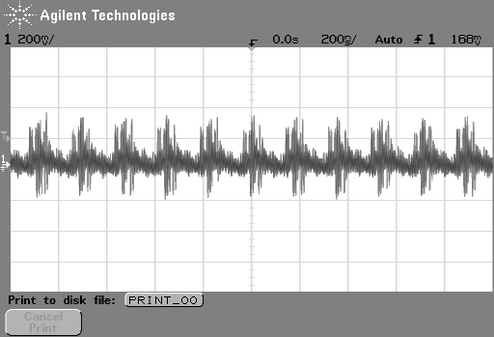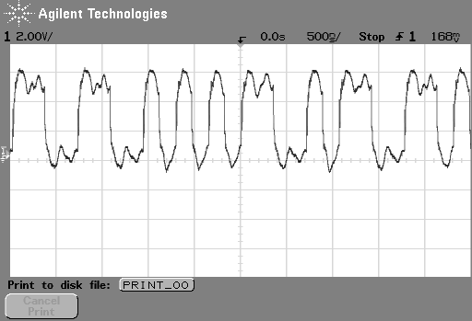
Figure 7: Codec Serial Data Out (SDTO)
Figure 8: Codec TX (Coax Output)

We then probed the codec clock signals to determine if they were working properly. The bit clock can be seen in Figure 9, and the L/R clock can be seen in Figure 10.

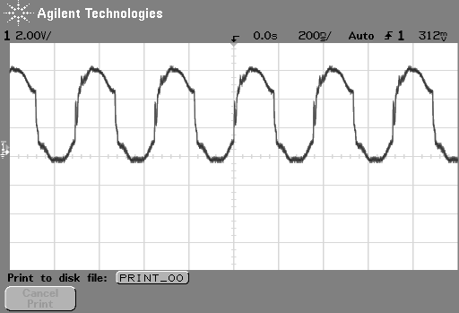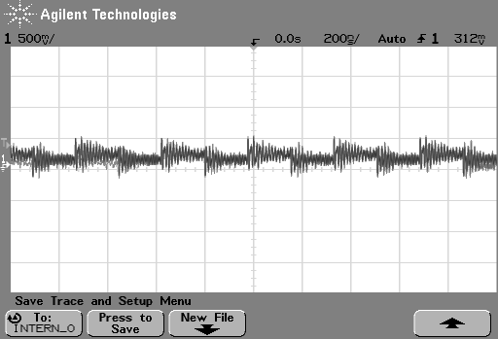
Figure 9: Codec Bit Clock (BICK)
Figure 10: Codec Left / Right Clock (LRCK)

Because direct communication between the codec and DSP was not possible, we conducted objective tests on the codec and DSP separately. For each of these ICs, we passed a 1kHz sine tone through the IC, and recorded the output. The output sound from the codec is shown in Figure 11, and the output from the DSP is shown in Figure 12.
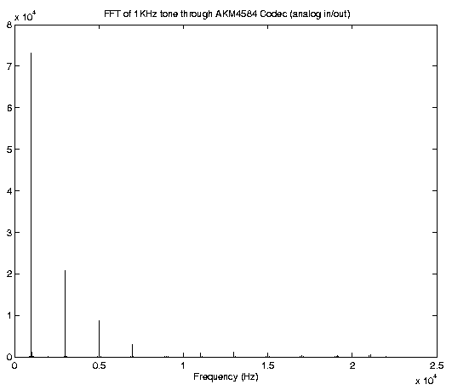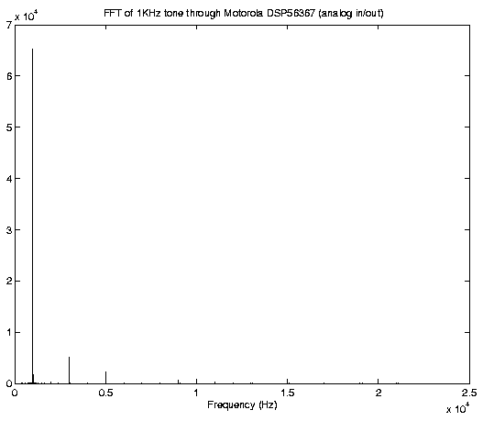
Figure 11: Codec Output
Figure 12: DSP Output

From these recordings, we were able to calculate signal-to-noise ratio (SNR) and total harmonic distortion (THD). The equations used for these calculations are shown below:
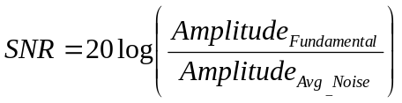 (4)
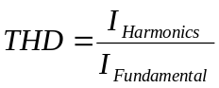 (5)
where 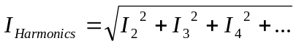
and 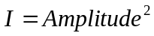
The resulting SNR for the codec was 99.8dB, and the SNR for the DSP was 98.8dB. The THD measurement for the codec was 8.17% and the THD of the DSP was calculated to be 0.61%.

4.3 Conclusions
After determining that the codec was not operating properly, we spoke with an applications engineer at AKM who was not able to determine the problem. He could only suggest a faulty codec and offered to send us a new IC. (However, by this time, it was too late in the semester to proceed with a new codec.) This may also account for the unusually high THD measurement.
SNR and THD values measured on the DSP were very good, and the DSP appears to function flawlessly.
After the microcontroller failed, we spoke with an engineer at NetMedia, who could only recommend a new chip. (Again too late to continue with this aspect.)

5. COST
Our project attempted to keep cost at a minimum since our goal was to provide the consumer with an affordable way to enjoy the technology of surround sound with headphones. Although some unexpected costs arose, our project never drastically escalated in price.
5.1 Parts
For individual prices on our chips and parameter controls, we found some expected prices that provide a rough estimate for the actual cost of one of our devices. The price for the DSP and codec was based off the price of 1000 or more while the cost of the BasicX-24 was based of the price of buying 100 or more. The price for PCB fabrication was based on the price of 20 proto boards.
DSP………………………………….….…$117.60
Codec…………………………………..…….$9.00
BX-24……………………………….……...$37.80
PCB………………………………………...$25.15
Misc hardware and connectors……………....$3.00
Parts total…………………………….........$192.55

For the donated parts that we worked with, the following costs are provided:
Donated Parts:
DSP Evaluation Motherboard………..$ 750.00
DSP Evaluation Daughterboard……...$ 250.00
HCS12 Evaluation Board…………….$ 495.30
MultiLink for HCS12………………...$ 249.40
AK4584 Evaluation Board…………...$ 400.80
BasicX-24 ……………………………...$75.23
Total Donated Value……………….$ 2,220.73

5.2 Labor
For our group’s labor cost, we agreed on a pay rate of $25 per hour per group member. The time spent on this project was approximately 10 hours per week each for 16 weeks. To calculate total cost of labor our pay rate multiplied by our number of hours.
160 h x $75/h = $12,000
When taking in a factor of 2.5:
$12,000 x 2.5 = $30,000
Cost of our project:
$30,000 + $2,230.73 = $32,230.73

6. CONCLUSIONS
This project is well on its way to production as a commercial device. There are still a few minor issues to resolve with individual components, but the life cycle of our project is nearly complete. We have formed ideas on how to improve upon this project in order to guarantee its future success.
6.1 Successes
The codec and DSP chips that we selected at the beginning of the semester ended up being a perfect fit in this system. By substituting the BX-24 for the HC12, we created a system powerful enough to accomplish everything we set out to do without being unnecessarily complex. The small number of connections between the ICs in our circuit made controlling, routing, and processing the audio signal an easy task for our hardware.
Thanks to the capabilities of the chips, we were able to create a PCB that met our design requirements. Our chip placement considerations have guaranteed maximum performance from our components on a board small enough to be conveniently portable.
The quality of the output signal meets all of our expectations. The HRTFs generate a convincing 3-dimensional aural space which is enhanced by running the effects in the DSP. Noise and distortion in the output signal are negligible, and user testing has yet to yield a single complaint about audio quality.
As a final subjective proof of our project’s success, we have received requests for a working device from several of our classmates. Effectively creating a marketable product is one of the ultimate goals of this course, and we have achieved that goal.

6.2 Unresolved Challenges

Although our design was successful, we encountered hardware problems with some of our ICs. The failure of our codec led us to question the reliability of the chip; the same was true of the BX-24. Additionally, the failure of these chips prevented us from fabricating and testing a final product before the end of the semester. Chances are that these individual malfunctions are not a good representation of the quality of these chips, but if reliability became an issue in mass production then we would have to search for alternative devices.
The facilities available to us through the ECE department were consistently helpful, but ultimately the PCB fabrication facilities offered by the Parts Shop could not handle the complexity of our board design. In order to manufacture our board in its current layout, we will have to ship it to an outside company. This may cost us extra money and time, but we would have to take this route anyway if we were to sell our product commercially.

6.3 Future Work
Our plan is to see this project through until we have a working final product. Depending on the results of this work we may pursue commercial retail of our device, in which case we would have to make some revisions.
The high price per part of the BasicX-24 as compared to other microcontrollers significantly increases the cost of our final product. To make our product more marketable we may have to switch to using the HC08. This is a scaled-down version of the HC12, and costs about 1/6th as much as the BasicX-24. This would make the project more complicated from a design standpoint, but the money saved in manufacturing cost should be worth it.
Using the HC12 would call for a redesign of our board layout, but this may be to our advantage. Now that we have already created one layout, we are aware of obstacles such as trace spacing and noisy clock signals. Drawing up a new design would result in an improved layout. Also, since PCB vendors commonly use modern drawing software, we will be able to create our new layout in a fraction of the time it took to make a layout in the outdated software used by the Parts Shop.

APPENDIX 1. SCHEMATICS

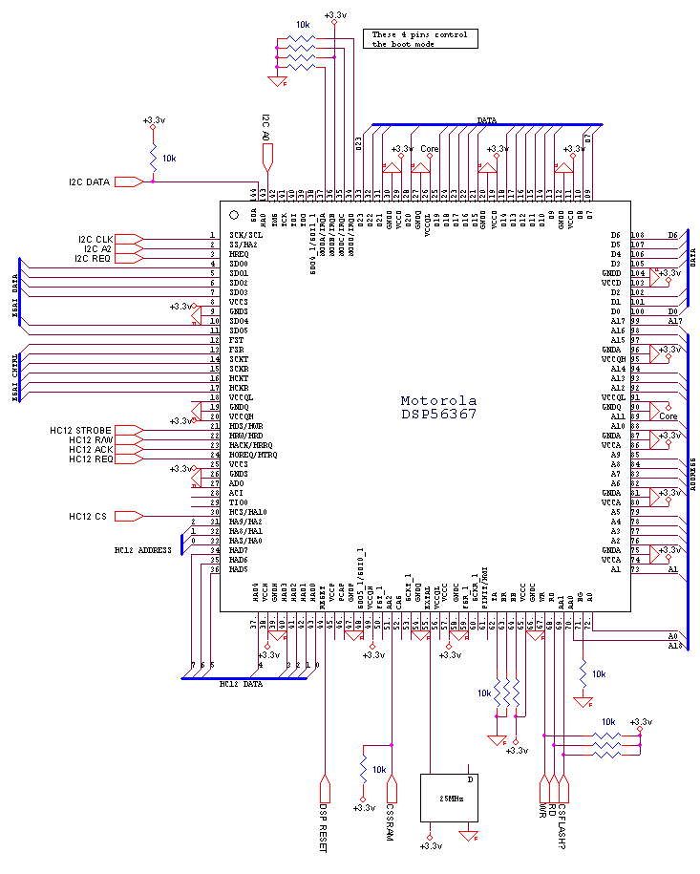
Schematic for DSP56367

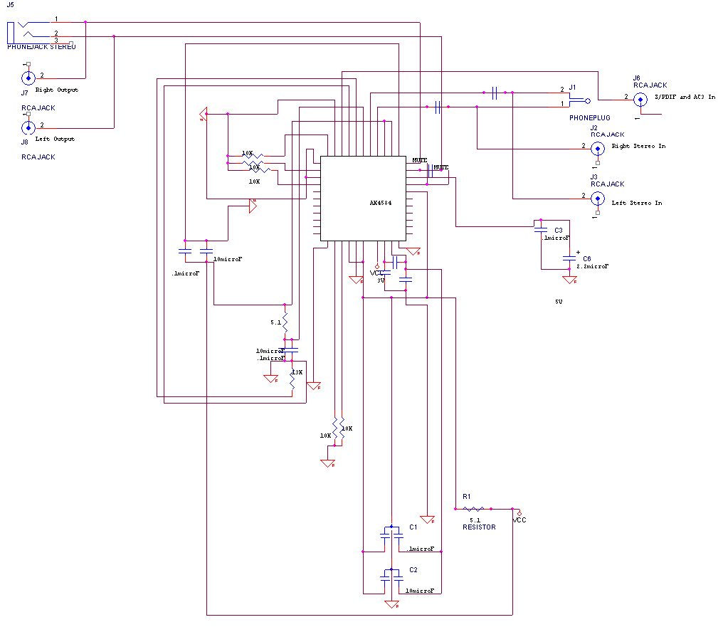
Schematic for AK4584

REFERENCES

[1] Motorola Technical Staff, A/X-6 User Manual for Audio SA Project, Motorola Inc., Apr. 2002
[2] Motorola Technical Staff, DSP56300 24-Bit Digital Signal Processor Family Manual, Motorola Inc., Oct. 2001
[3] Asahi Kasei Microsystems Technical Staff, AK4584 Data Sheet, AKM Semiconductor Inc., Nov. 2001
[4] NetMedia Technical Staff, BasicX Software Manual, NetMedia Inc., Mar. 2002

