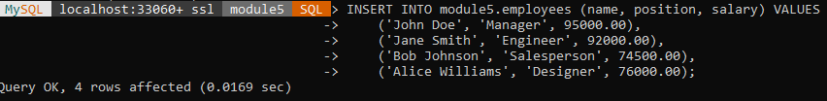

**INSERT INTO:** This statement inserts four new rows of data into the employees table, specifying values for the name, position, and salary columns. The id column is auto-incremented, so we don't need to provide values for it.

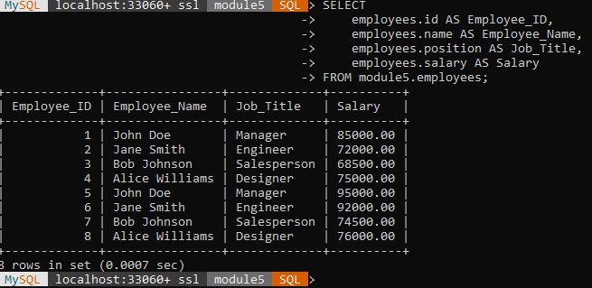

**SELECT with Aliases:** The first SELECT statement retrieves the data from the employees table, using column aliases (Employee_ID, Employee_Name, Job_Title, Salary) for better readability

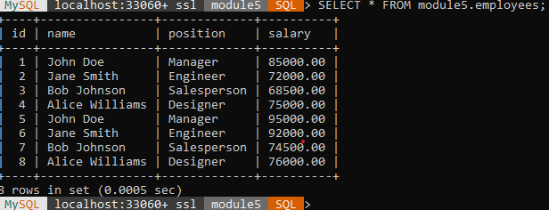

**SELECT *:** The second SELECT statement is unchanged. It simply retrieves all columns and rows from the employees table, using the default column names.

Source:

*W3schools.com*. W3Schools Online Web Tutorials. (n.d.). https://www.w3schools.com/sql/sql_ref_mysql.asp