Vscode with result:

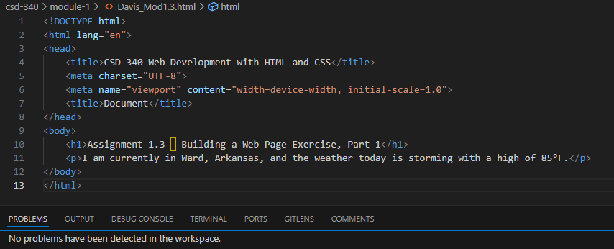

Web browser result:

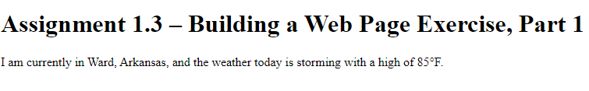

GitHub link:

https://github.com/JonDavis8712/csd-340