Browser result:

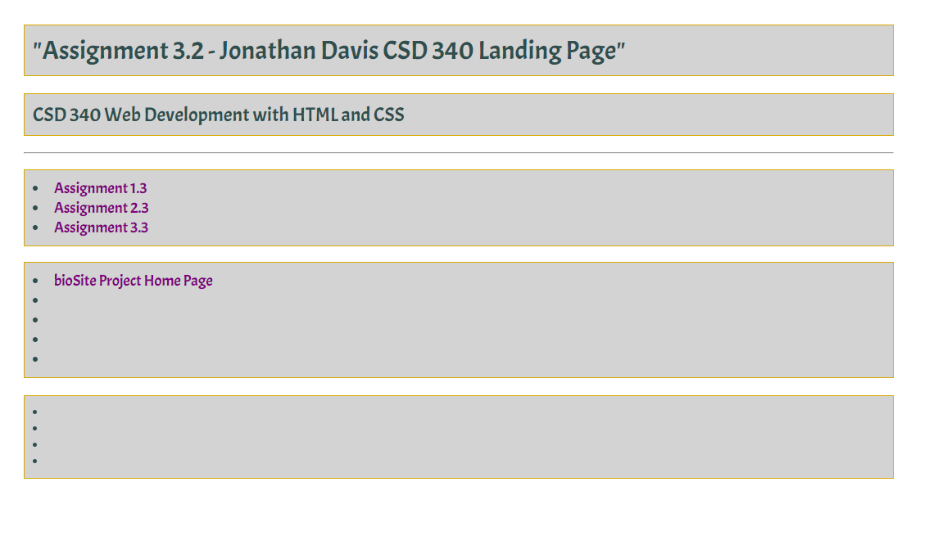

HTML validation:

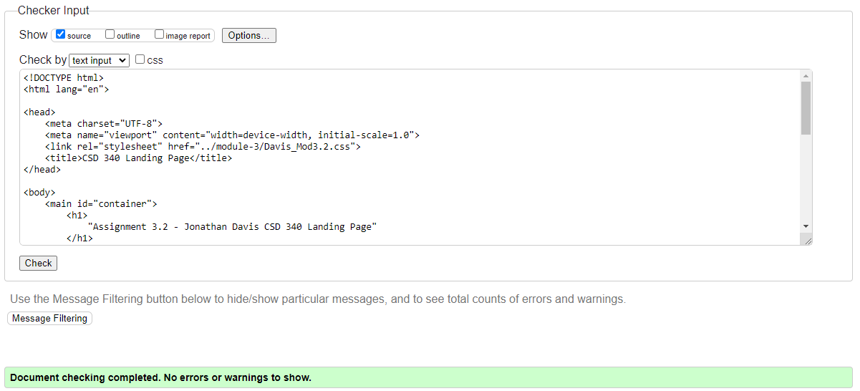

CSS validation:

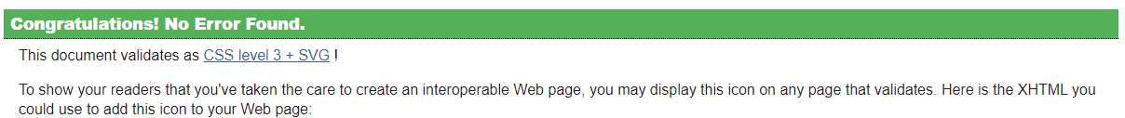

GitHub link:

https://github.com/JonDavis8712/csd-340