Query history initial database and server setup



RESULTS:

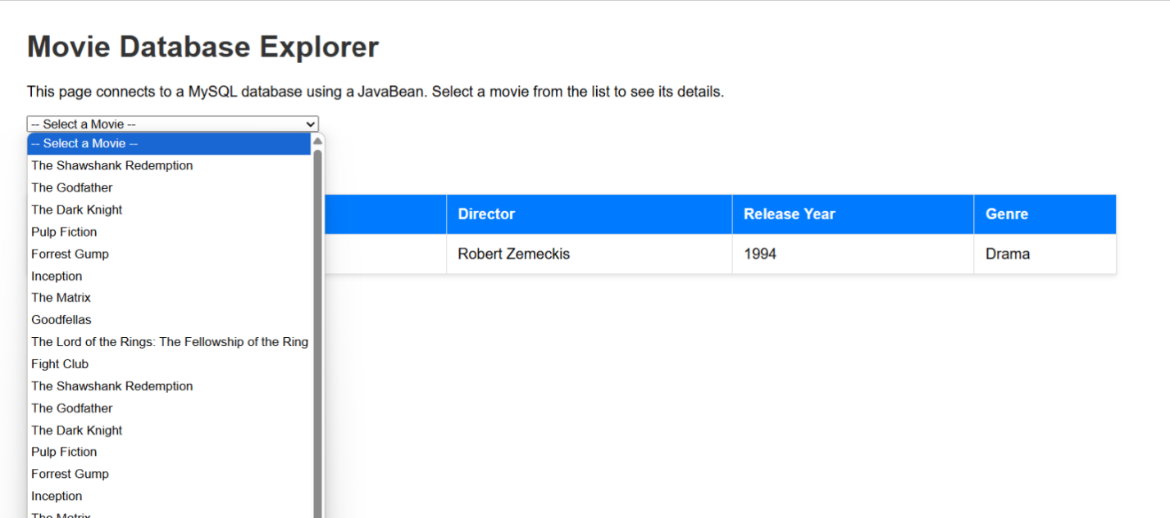Webpage dropdown:

Movie selected from drop down:

