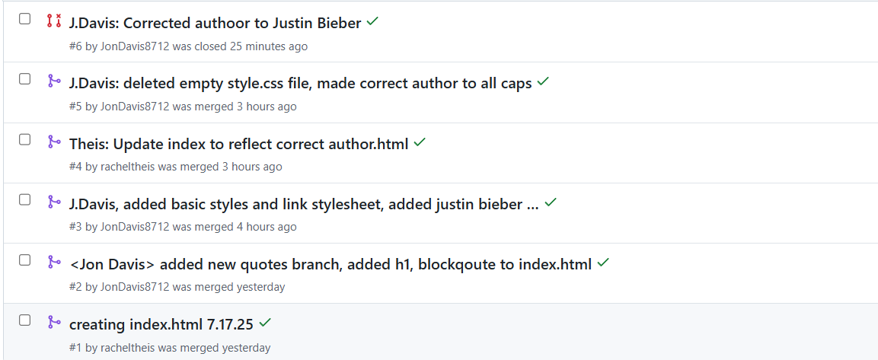4

I did do Developer 2 and 3, so that’s why the requests seem crazy.

<https://github.com/JonDavis8712/csd-380>

<https://github.com/HernandezCui/GitLab/pulls?q=is%3Apr+is%3Aclosed>