CreateTable.java:

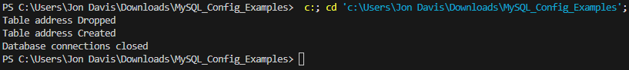

InsertData.java:

Select5.java: