**Changes in telomere length and telomerase activity during seasonal regeneration of *Parastichopus californicus***

By: Faith Hunnicutt

A Thesis Proposal

Submitted to

Walla Walla University

In Partial Fulfillment of

Requirements for the Degree of

Master of Science

**May 2018**

TABLE OF CONTENTS

**Introduction** .................................................................................................................................. 3

Invertebrate regeneration ......................................................................................................... 3

Role of telomeres and telomerase in the cell lifecycles ........................................................... 3

Role of telomeres and telomerase in echinoderm regeneration ............................................... 4

Regeneration and dormancy of *Parastichopus californicus* .................................................... 5

Telomeres and regeneration in *P. californicus*: purpose and research question ...................... 6

**Methods** ......................................................................................................................................... 7

Sample collection ..................................................................................................................... 7

Telomerase activity using a TRAP assay ................................................................................. 7

Telomerase expression through mRNA to cDNA synthesis and qPCR .................................. 9

Relative telomere lengths using qPCR .................................................................................. 11

Statistical analysis .................................................................................................................. 12

**Results** ......................................................................................................................................... 13

Telomerase activity using a TRAP assay ................................................................................ 13

Telomerase expression through mRNA to cDNA synthesis and qPCR .................................. 13

Relative telomere lengths using qPCR .................................................................................... 14

**Discussion** ................................................................................................................................... 15

**Figures** ........................................................................................................................................ 18

**Literature Cited** ......................................................................................................................... 27

**Appendices** ................................................................................................................................. 30

FIGURES

**Figure 1** ....................................................................................................................................... 18

**Figure 2** ....................................................................................................................................... 19

**Figure 3** ....................................................................................................................................... 20

**Figure 4** ....................................................................................................................................... 21

**Figure 5** ....................................................................................................................................... 22

**Figure 6** ....................................................................................................................................... 23

**Figure 7** ....................................................................................................................................... 24

**Figure 8** ....................................................................................................................................... 25 **Figure 9** ....................................................................................................................................... 26

APPENDICES

**Appendix 1 – Proposed Budget** ................................................................................................. 30

**Appendix 2 – Breakdown of Samples** ...................................................................................... 31

**Appendix 3 – TPG Formula** ...................................................................................................... 32

**Appendix 4 – Measuring Absolute Telomere Length** ............................................................. 33

INTRODUCTION

Invertebrate regeneration

The ability to regenerate tissue is vital for the survival and fitness of any multicellular organism. The degree to which tissue regenerates greatly varies between different groups, and some of the most impressive examples of these organisms belong to Phylum Echinodermata. Asteroids (sea stars) possess the ability to regenerate new individuals from a single ray, involving a high degree of regenerative complexity (Edmondson 1935, Ruppert 2004). Many species of Holothuroids (sea cucumbers) eviscerate their internal organs in a defensive response to predation and within two weeks they regrow these organs. Some holothuroids degrade their organs in an annual cycle of dormancy, regenerating the organs fully within two weeks when they come out of dormancy (Byrne 1986, Garcia-Arraras 2001). Regardless of the cause of organ loss, the volume of tissue regeneration is massive as these holothurians regenerate entire systems of internal organs at least annually, if not more frequently.

Role of telomeres and telomerase in the cell lifecycle

The nucleoprotein structures on the ends of chromosomes called telomeres are key not only to maintaining the structure, but also the functionality of chromosomes (Figure 1). Alone, the unique structure of linear DNA is detrimental to the stability of the karyotype. Unguarded, chromosomal DNA will fuse end-to-end resulting in fused sister chromatids, breakage of dicentric chromatids in anaphase, and subsequent fusion of atelomeric DNA ends with other chromatids. These processes result in karyotype chaos (Weinberg, 2014). Furthermore, the primase enzyme mechanism used during DNA replication ensures that approximately 50-200 bp (base pairs) of one of the template strands of DNA are not properly replicated (Anchelin et. al, 2011). In addition, there are exonucleases that “slowly chew” on the ends of DNA (Weinberg, 2014). To counter these detrimental events, telomeres are located on the ends of chromosomes to protect DNA from end-to-end fusion, base pair loss during replication, and exonuclease degradation (Weinberg, 2014). These events eventually result in the shortening of telomeres with each cell division (Figure 2). Over time, telomeres are no longer effective at protecting the ends of chromosomes. Cells then enter a stage of crisis; chromosomes fuse and the cells undergo widespread apoptosis (e.g., aging) or emerge spontaneously and become immortalized (e.g., cancer; Weinberg, 2014).

The enzyme telomerase is a unique reverse transcriptase which elongates telomeres through adding telomeric repeat sequences to the 3’ end of chromosomes (Nguyen, 2018). The newly discovered bilobal structure of human telomerase is unique as the holoenzyme contains not only the molecular apparatus for adding these repeats onto the chromosome, but also an integral telomerase RNA subunit which provides an internal template for repeat synthesis (Nguyen, 2018). Basically, telomerase allows the cell to continue proliferation. Research has shown that telomerase is expressed in highly proliferating tissues including: embryos, stem cells in adults, and in immortalized or cancerous cells (Weinberg 2014, Anchelin et. al. 2011). Furthermore, telomerase activity has been found to be very low in healthy adult tissues but is detectable in around 85 – 90% of human tumor cell samples (Weinberg 2014). Telomerase activity in humans seems to be lost after embryogenesis but can return during cell crisis. However, instead of continuing a regular cell cycle, telomerase assists with unchecked cell growth – one of the hallmarks of cancer (Weinberg 2014).

Role of telomeres and telomerase in echinoderm regeneration

Telomeres may be key to the regenerative abilities of echinoderms. The massive requirements for regular DNA replication in the tissue regeneration seen in echinoderms (loss and replacement of limbs, guts, etc.) may require differences in telomeres or telomerase activity than found in human cells. Varney et. al. (2017) addressed the mechanisms of the regenerative process in the sea star, *Luidia calthrata*. They found that during tissue regeneration after injury telomeres are elongated by increased telomerase expression. This elongation of telomeres may occur prior to cell crisis in *L. calthrata* which may help it avoid spontaneous immortality (cancer) or apoptosis*.* Increased telomere elongation also may explain part of the mechanism allowing for the dramatic tissue regeneration seen in other species of Phylum Echinodermata as well.

Regeneration and dormancy of *Parastichopus californicus*

*Parastichopus californicus,* or the Giant California Sea Cucumber, is one of the holothuroids that regenerates internal organs from both seasonal atrophy and from disturbance-induced evisceration (Byrne 1986, Garcia-Arraras 2001). *P. californicus* can be found all along the west coast of North America from the Gulf of Alaska to Baja California (Palzat et al., 2007) and is an important commercial food product (Mueller 2016).

The anatomy of *P. californicus* is relatively simple. *P. californicus* has a cylindrical, tube-within-a-tube, soft body with weak bilateral symmetry (Figure 3). The digestive system is looped and separated into the pharynx, esophagus, intestine, and cloaca. The cucumber also has an esophageal nerve ring, respiratory trees, and gonads. The internal organs of the holothuroid slowly atrophy each fall until only a few filaments remain during the winter (Figure 4) and then completely regrow in the spring (Figure 5). During these winter months, the cucumber also displays signs of dormancy as it ceases to move and feed (Byrne 1986, Garcia-Arraras 2001).

Telomeres and regeneration in *P. californicus*: purpose and research question

The purpose of this study is to examine telomere length, telomerase expression, and telomerase activity in the echinoderm *Parastichopus californicus* in order to determine if the seasonal regeneration of this sea cucumber’s internal organs is accompanied by unique telomeric responses. I predict that in the spring, when *P. californicus* regenerates its internal organs, the telomeres of the regenerating internal organs (respiratory trees and gut) will be elongated by increased telomerase expression and activity while the telomeres of non-regenerating tissues (muscle, skin, body wall, tube feet) will shorten as is typically seen after cell division. This study will help elucidate the mechanisms of seemingly unlimited regeneration in *P. californicus*. *P. californicus* is particularly adept for this studybecause of its yearly regeneration of internal organs which I hypothesize should impact cell viability even more than the occasional limb regeneration of other organisms such as *L. calthrata*, as well as discovering if the mechanism of telomere elongation is conserved across different species.

METHODS

Sample collection

Mature *Parastichopus. californicus* (> 30 cm in length) will be collected by WWU Scientific SCUBA Divers from subtidal areas near the Rosario Beach Marine Laboratory in Anacortes, WA (48°25’22’’N 122°40’21W). Organisms will be collected in November 2017, February 2018, and July 2018. These dates correspond to the absence of internal organs due to atrophy (November), organs in the process of regrowth (February), and fully active cucumbers with all organs present (July). Eight individual cucumbers will be collected during each period, brought in seawater buckets to the RBML, and immediately dissected for tissue samples.

Samples of five different types of tissue will be collected from each animal: respiratory tree, gut, tube feet, body wall, and muscle. Respiratory tree and gut tissues experience seasonal atrophy and regeneration, while tube feet, body wall, and muscle experience minimal if any seasonal atrophy and regeneration (Garcia-Arraras 2001). Three samples of each tissue type will be taken from each cucumber, one for each assay, and one placed in 95% ethanol and the other two placed in TriPure (Anchelin et. al. 2017) and stored at -80 °C at RBML and assayed at RBML or at the College Place campus.

Telomerase activity using a TRAP assay

The TRAP assay (Telomeric Repeat Amplification Protocol) is a PCR-based method to determine telomerase activity. Protocols for tissue homogenization found in Tan (2015) have been adapted for this study. Around 25 mg of tissue will be pulverized with liquid nitrogen using a sterile mortar and pestle until a smooth consistency is reached. Tissue will then be put into a 1.5 mL microcentrifuge tube and resuspended in 1x CHAPS lysis buffer (approximately 200 µL of lysis buffer per 40-100 mg of tissue). Tubes will be shaken by hand, then briefly opened to allow any N2 to escape. The tubes will be incubated on ice for 30 minutes with periodic shaking then centrifuged at 12,000 x g for 20 minutes at 4 °C. The supernatant (expected to be about 160 µL) will be put in a fresh tube and protein concentration will be measured by Bradford assay. It is expected that there will be 10-500 ng/µL per <1.5 µL of tissue samples. The supernatant will be aliquoted in 1.5 mL microcentrifuge tubes and stored at -80 °C.

The TRAP assay will be performed using the TRAPeze Telomerase Detection kit (Millipore). The protocol for this was followed by Schumpert et. al. (2015) to study *Daphnia* telomerase activity and by Ebert et. al. (2008) to study *Echinometra lucunter* telomerase activity. A 25 µL PCR reaction will be performed for all samples and controls. Each reaction contains 23 µL of master mix (0.5 µL TRAPeze RT Reaction mix, 0.4 µL Taq Polymerase, 17.6 µL nuclease free water) and 2 µL of control or tissue sample. The samples will then placed in the thermocycler and heated to 30 °C for 30 minutes for one cycle, 95 °C for 2 minutes for one cycle, and then 45 cycles of heating to 94 °C for 15 seconds, 59 °C for 60 seconds, and 45 °C for 10 seconds. The heat inactivated control samples will be incubated at 85 °C for 10 minutes. Following this PCR amplification, samples will be mixed with 5 µL of loading dye and zylene cyanol. Samples will be loaded on a 10% non-denaturing polyacrylamide gel and run at 400 V for 1.5 hours in 0.5 S TBE Buffer and stained using Sybr Green for 30 minutes before scanning in a fluorometer. Gel analysis and calculations to determine Total Product Generated will follow Shumpert et al. (2015) and the TRAPeze Telomerase Detection kit manual.

Telomerase expression through mRNA to cDNA synthesis and qPCR

Methods from Varney et. al. (2017), Tan (2015), and the protocol for TriPure Isolation Reagent (Roche) will be followed to isolate telomerase mRNA from tissue samples for qPCR. Samples within 50-100 mg will be pulverized with liquid nitrogen using a mortar and pestle until a smooth consistency is reached. Pulverized tissues will be put into a 1.5 mL microcentrifuge tube and mixed with 1mL TriPure Isolation Reagent (Roche). The tube will be quickly shaken by hand, and then opened briefly to allow remaining N2 to escape. Tubes will then be vortexed at room temperature for 5 minutes to ensure thorough homogenization, lysis, and inactivation of RNAses. Homogenized samples will then be centrifuged at 12,000 x g for 10 minutes at 4 °C. The supernatant will then be transferred to another 1.5 mL centrifuge tube and stored at -80 °C.

RNA will be isolated from the supernatant according to the manufacturer protocols for the Direct-zol RNA MiniPrep kit (Zymo). Equal parts of the homogenized sample and 95% ethanol will be transferred to another 1.5 mL centrifuge tube and mixed thoroughly by vortexing. The mixture will be transferred to a spin column, centrifuged, and the flow through discarded. Twice, 400 µL of RNA PreWash will be added to the column, column centrifuged, and the flow through discarded. 700 µL of RNA Wash Buffer will be added to the column, the column centrifuged for 2 minutes, and thee column transferred to a new 1.5 mL microcentrifuge tube. RNA will then be eluted into the collection tube and centrifuged to ensure complete elution. RNA remaining will be quantified via a NanoDrop (Thermo) and A260/A280 ratios will be recorded. Extracted RNA will be stored at -80 °C.

First-strand cDNA will be synthesized from the RNA samples with the Transcriptor First Strand cDNA Synthesis (Roche) according to manufacturer protocols. 1 µg total RNA, random hexagonal primers, and water to make total volume 13 µL will be thawed on ice, centrifuged briefly, and put into a 1.5 mL microcentrifuge tube on ice. Tube will be inverted to mix and picofuged to collect samples at the bottom again. The remaining components will be added in the following order: 4 µL Transcriptor Reverse Transcriptase Reaction Buffer, 0.5 µL Protector RNase Inhibitor, 2 µL Deoxynucleotide Mix, 0.5 µL Transcriptor Reverse transcriptase. Reagents will be mixed by inversion of tube. RT reaction will be incubated in a thermal block cycler with the following cycles: 10 minutes at 25 °C, 30 minutes at 55 °C, five minutes at 85 °C, then chilled on ice and stored at -80 °C.

cDNA samples will then be analyzed through qPCR. Mastermix will be prepared for each cDNA sample containing: 2 µL forward primer, 4 µL reverse primer, 10 µL SYBR Green MasterMix, and 3 µL dH2O. cDNA will be thawed on ice and 1 µL will be taken from the sample and added to the Mastermix for a total volume of 20 µL. Negative controls will substitute an additional 1 µL of dH2O instead of cDNA. Each mixture will be pipetted into a 96 qPCR well plate, and will be run with 4 replicates, to ensure accuracy and replicability. The thermocycler program will consist of the following cycles: preinoculation – 10 minutes at 95 °C; amplification – 40 cycles of 95 °C for 15 seconds (denaturing), 56 °C for 1 minute (annealing); melting – 95 °C for 10 seconds, 65 °C for 1 minute, and holding the reaction at 97 °C for the melt curve. Fluorescence data from the amplification curve and melt curve will be collected by the fluorometer (Light Cycler 96 – Roche) and used for statistical analysis.

Relative telomere lengths using qPCR

Relative telomere length will be measured in this study as in Varney et. al. (2017) because until the specific telomeric repeat sequence for *P. californicus* is determined, telomere length cannot be measured absolutely. See Appendix 4 for possible methods to ascertain absolute telomere length providing additional time and resources.

Tissue samples will be homogenized, and DNA will be extracted from all five tissue types via Qiagen DNeasy Tissue Kit protocol as done in Varney et. al. (2017). Approximately 25 mg of tissue will be ground with a mortar and pestle with liquid N2 until a smooth consistency is reached. Pulverized tissues will be put into a 1.5 mL microcentrifuge tube, shaken, and opened briefly to allow the remaining N2 to escape. 180 µL of Buffer ATL (tissue lysis buffer) will be added to the tube, then 10 µL proteinase K will be added, mixed thoroughly by vortexing, and incubated at 56 °C for 1-3 h on a rocking platform until the tissue is completely lysed. 4 µL RNase A (100 mg/mL) will be added to remove RNA, each tube will be vortexed, and incubated for 2 minutes at room temperature.

The tube will be vortexed again, a mixture of 200 µL Buffer AL (lysis buffer) and 200 µL 98% ethanol will be added and mixed thoroughly by vortexting. Each mixture will be placed into a DNeasy Mini spin column with a collection tube and centrifuged at 6,000 x g for 1 minute, and the flow-through discarded. 500 µL Buffer AW1 (wash buffer) will be added, centrifuged for 1 minute at 6,000 x g, and the flow-through discarded. 500 µL Buffer AW2 (wash buffer) will be added, centrifuged for 3 minutes at 20,000 x g to dry to the spin column membrane. To elute, 200 µL of Buffer AE (elution buffer) will be pipetted directly onto the membrane, the tube incubated at room temperature for 1 minute, and centrifuged for 1 minute at 6,000 x g. To ensure maximum DNA yield, elution will be done twice. Actual yield will be determined by NanoDrop (Thermo) and A260 measurements will be recorded. Expected yields provided with kit protocol for 25 mg of organ tissue can be between 5-30 µg of DNA, but none of the examples are from echinoderms so it may vary. Samples will be stored at -80 °C.

DNA samples will then be analyzed through qPCR. Telomeres in *P. californicus* have not been sequenced yet, so primers used will be for telomeric repeats that are conserved across deuterostomes [F 5’CGGTTTGTTTGGGTTTGGGTTTGGGTTTGGGTTTGGGTT3’, R 5’GCGTTGCCTTACCCTTACCCTTACCCTTACCCTTACCCT3’] (Varney et. al. 2017). Mastermix will be prepared for each tissue’s DNA sample containing: 2 µL forward primer, 4 µL reverse primer, 10 µL SYBR Green MasterMix, and 3 µL dH2O. cDNA will be thawed on ice and 1 µL will be added to the Mastermix for a total volume of 20 µL. Negative controls will substitute additional 1 µL of dH2O instead of DNA. The thermocycler program will consist of the following cycles: preinoculation – 10 minutes at 95 °C; amplification – 40 cycles of 95 °C for 15 seconds (denaturing), 56 °C for 1 minute (annealing); melting – 95 °C for 10 seconds, 65 °C for 1 minute, and holding reaction at 97 °C for the melt curve. Fluorescence data from the amplification curve and melt curve will be collected by the fluorometer (Light Cycler 96 – Roche) and used for statistical analysis.

RESULTS

Telomerase activity using a TRAP assay

Figure 6 exhibits the means of results from the five tissue types (muscle, respiratory tree, body wall, guts, and tube feet) in different seasons (Fall – degeneration, Summer – complete compliment, and Spring – regeneration). Results will be measured in TPG (Total Product Generated) which is the number of TS primers extended by at least 4 telomeric repeats in 30 minutes at 30 °C (see Appendix 3 for formula). Based on my hypothesis, I expect to see low telomerase activity (low TPG values) for all tissues in all seasons except for significantly higher telomerase activity (high TPG values) in guts and respiratory tree tissue harvested in the Spring.

Telomerase expression through mRNA to cDNA synthesis and qPCR

Figure 8 shows the means of telomerase expression in five tissue types (muscle, respiratory tree, body wall, guts, and tube feet) in different seasons (Fall – degeneration, Summer – complete compliment, and Spring – regeneration). The unit of measurement is Ct (cycle threshold) which is the number of qPCR cycles required for the fluorescent signal of the sample to exceed the background level fluorescence. Ct levels are inversely proportional to the amount of target nucleic acid in the sample, so high Ct levels correspond with low amounts of target nucleic acid in the sample. In this case, a high Ct level indicates low expression, and a low Ct level indicates high expression. Based on my hypothesis, I expect to see low telomerase expression (high Ct levels) in all tissues from all seasons except for significantly higher expression (low Ct levels) in the respiratory tree and gut tissue harvested in the Spring.

Relative telomere lengths using qPCR

Figure 9 shows the means of relative telomere lengths in five tissue types (muscle, respiratory tree, body wall, guts, and tube feet) in different seasons (Fall – degeneration, Summer – complete compliment, and Spring – regeneration) . The unit of measurement is Ct (cycle threshold), which is the number of qPCR cycles required for the fluorescence of a given sample to exceed the background level fluorescence. In terms of telomere length, high Ct levels indicate low levels of nucleic acid (telomerase has not elongated the telomeres) and low Ct levels indicate high levels of nucleic acid (telomerase has elongated the telomeres). Based on my hypothesis, I expect to see shorter telomere lengths (higher Ct values) in all tissues from all seasons except for significantly longer telomeres (lower Ct values) in the respiratory tree and gut tissue harvested in the Spring.

DISCUSSION

My hypothesis is that in Spring, when *Parastichopus californicus* regenerates its internal organs, the telomeres of the holothuroids’ regenerating internal organs (guts, respiratory tree) will be elongated by increased telomerase expression and activity while the telomeres of non-regenerating tissues (muscle, body wall, tube feet) will shorten as is typically seen after cell division. As such, I expect to find that telomere length, telomerase expression, and telomerase activity will be significantly higher in tissues taken from Spring cucumbers (regenerating) compared to Fall (atrophying), or Summer (full complement) cucumbers.

The significantly higher levels of telomerase activity predicted in Figure 6 indicate that there are more functional telomerases in Spring respiratory and gut tissues and not in other tissues and seasons. Thus, more telomerase is activated (functional and working) in the respiratory and gut tissue that degenerates in Fall and regenerates in Spring. In cell division telomeres protect the ends of chromosomes from base pair loss and damage caused by incomplete replication, essentially protecting the karyotype from age related degradation and allowing for these massive, annual regeneration events. If telomerase activity levels are not significantly different between regenerating and non-regenerating tissues that would indicate that telomerase does not appear to be more active during the regenerative cycle.

The significantly lower Ct levels predicted in Figure 8 indicate that telomerase is being expressed more in Spring respiratory and gut tissues compared to other tissues and seasons. This means that there are more copies of telomerase mRNA which assists in the production of the holoenzyme telomerase, but it does not indicate if the telomerase enzyme is functioning. In a real time PCR (qPCR) assay a positive reaction is detected by accumulation of a fluorescent signal. The Ct (cycle threshold) is number of cycles required for the fluorescent signal to cross the threshold (ie: exceeds background level). As Ct levels are inversely proportional to the amount of target nucleic acid in the sample, the lower the Ct level is the greater the amount of target nucleic acid is present in the sample. I will be comparing relative Ct levels within this study because there are no other studies done on telomerase expression and relative telomere length in *P. californicus.*

The significantly lower Ct levels predicted in Figure 9 would indicate that telomeres are longer in Spring respiratory and gut tissues compared to all other tissues which appear to experience normal levels of cell division.

Varney et. al. (2017) found in the starfish *Luidia calthrata* that telomeres were elongated in regenerated tissues than in non-regenerated tissues. They concluded that this ability may be a mechanism to allow for large amounts of tissue regeneration without the detrimental effects of shortened telomeres, so the whole body “ages” at the same rate regardless of sustained injuries. Varney et al. (2017) proposed that the ability to elongate telomeres may be common to many echinoderms, and data from my study could support that proposal.

The seasonal dormancy observed in *P. californicus*, indicated by organ atrophy, is a period of reduced metabolic activity that has been observed in several holothuroids (Byrne 1986, Garcia-Arraras 2001, Tan 2016). It is possible that a dormant state in Winter months, during which cooler temperatures and food scarcity may be more common, is an advantage to the cucumber. Although degenerating and regenerating entire systems of internal organs on an annual basis seems extreme, elongation of telomeres by active telomerase could counteract that risk.

Telomerase has been described as the guardian of the chromosome, but it also acts as the guardian of immortal cells (Weinberg, 2014). Theoretically, it could allow indefinite additions to telomeres, ensuring infinite cell division. Active telomerase is prominent in cancer cells and is an key part of what makes cancer cells so dangerous – immortality (Weinberg, 2014). If telomerase could be activated in adult humans there could be novel aging prevention treatments, and if it could be deactivated there could be novel anti-cancer therapeutic agents (Nguyen 2018). This is even more exciting as recently the structure of telomerase has been fully characterized, and treatments could now be designed to target the molecule (Nguyen, 2018).

In *Parastichopus californicus* I predict that more telomerase is made in gut and respiratory tissues in the regenerative period in Spring (qPCR for telomerase expression), it is functioning (TRAP for telomerase activity), and it is performing the expected job – elongating telomeres (qPCR for telomere length).

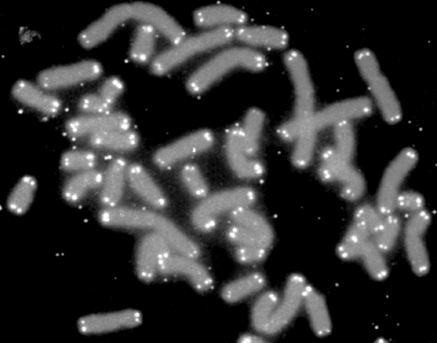

**Figure 1.** Human chromosomes (grey), capped by telomeres (white). By U.S. Department of Energy Human Genome Program, Public Domain.

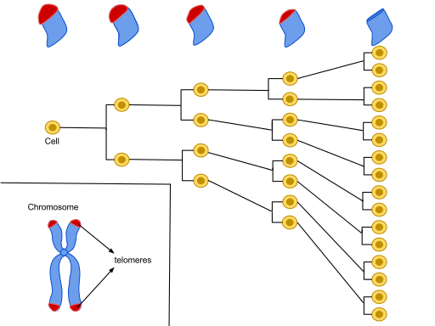

**Figure 2.** Nucleoprotein structures called telomeres (in red) are located on the ends of chromosomes to protect DNA from end-to-end fusion, base pair loss during replication, and exonuclease degradation. Each cell division event (in yellow) will result in gradual shortening of telomeres and over time, this process is no longer effective at protecting the ends of chromosomes. Cells then enter a stage of crisis (Weinberg, 2014). From Wikimedia Commons, Free Domain.

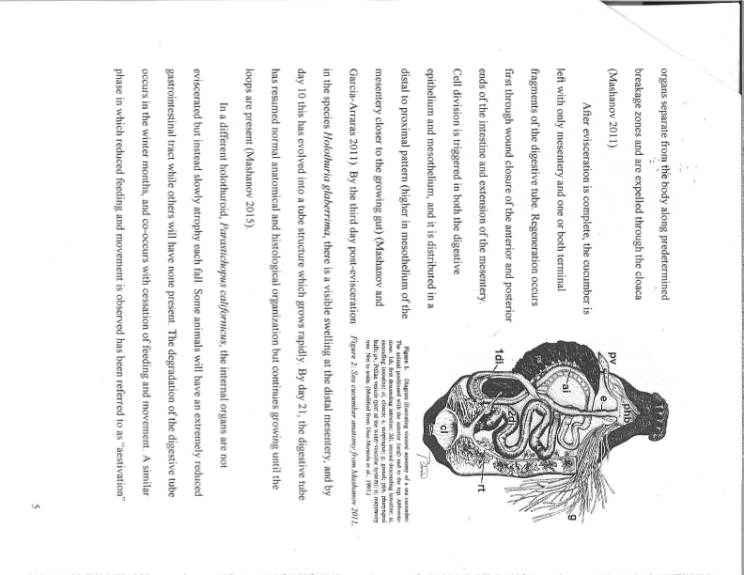

**Figure 3.** Basic sea cucumber anatomy from Mashanov (2011). Structures include: (1di) first descending intestine, (2di) second descending intestine, (ai) ascending intestine, (cl) cloaca, (e) esophagus, (g) gonad, (phb) pharyngeal bulb, (pv) Polian vesicle, and (rt) respiratory tree.

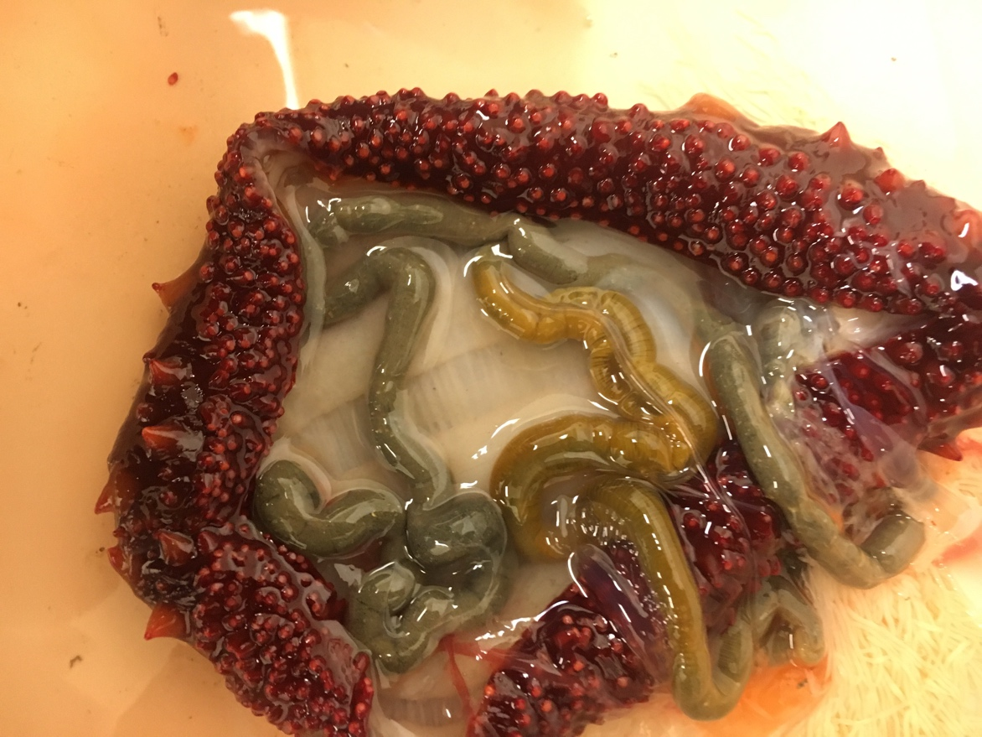

**C**

**A**

**B**

**D**

**F**

**E**

**Figure 4.** *Parastichopus californicus* caught near RBML November 2017. Cucumber has yet to undergo seasonal atrophy, and the internal organs can be seen including: A) muscle band, B) gonads, C) intestines, D) tube feet, E) respiratory tree, F) Polian vesicle. Picture by Dr. Jim Nestler.

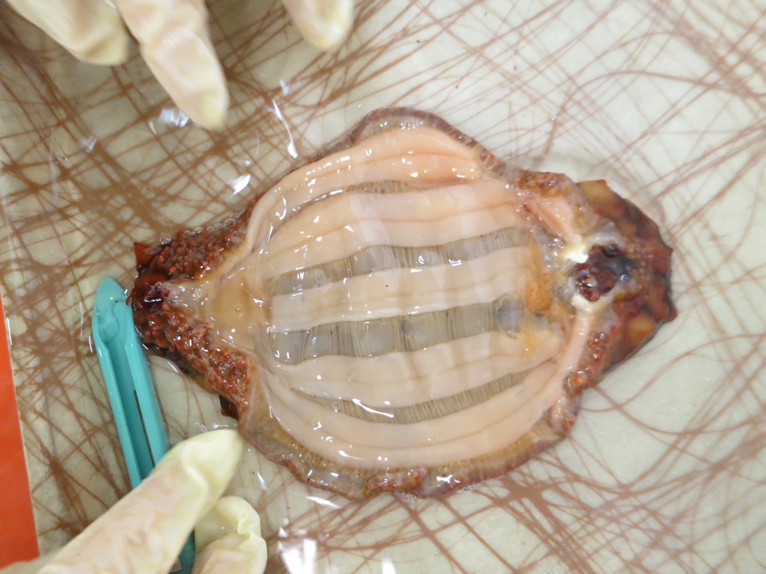

**D**

**C**

**A**

**B**

**Figure 5.** *Parastichopus californicus* caught near RBML in February 2018. The cucumber’s internal organs have undergone seasonal atrophy, and only a few filaments. Visible tissues include: A) tube feet, B) muscle band, C) respiratory filaments, D) nerve ring (cut). Picture by Dr. Jim Nestler.

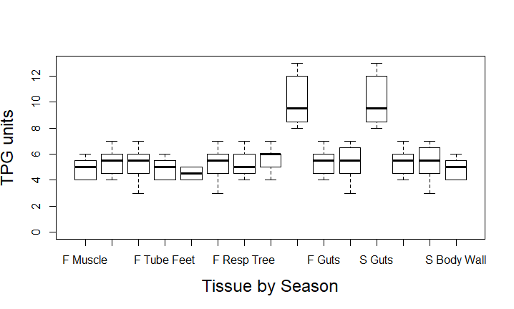

*

*

Su F Sp Su F Sp Su F Sp Su F Sp Su F Sp

Muscle Tube Feet Resp Tree Guts Body Wall

**Figure 6.** Predictedtelomerase activity (TPG = Total Product Generated) in *P. californicus*, by tissue and season. Seasons include Su (Summer), F (Fall), and Sp (Spring). This is a quantification of data that will be obtained from TRAP products, and an example of a real TRAP assay is shown in Figure 7. I predict that telomerase activity will be highest in Respiratory Trees and Guts during Spring (two-factor ANOVA and Tukey multiple comparisons test, * indicates p < 0.05).

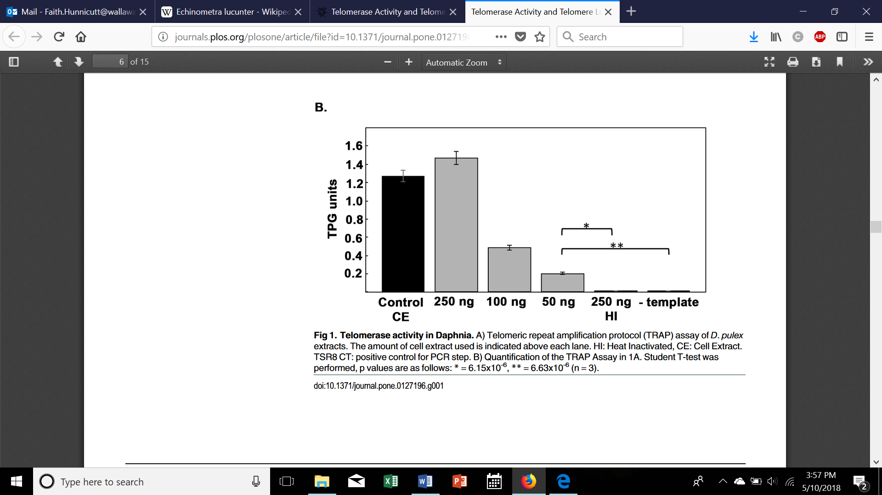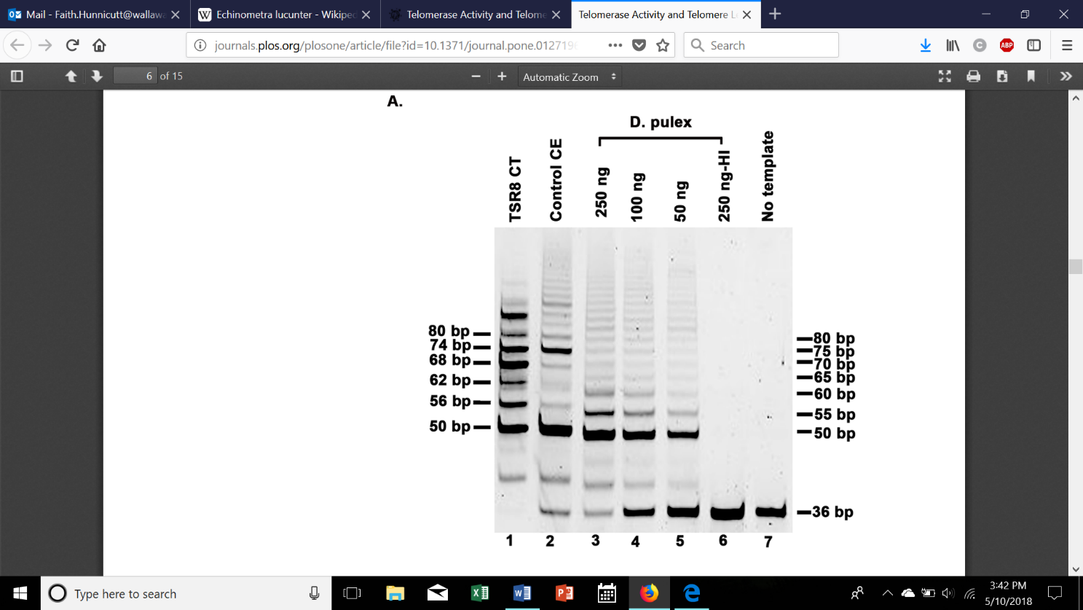

**Figure 7.** Figure taken from Schumpert et. al. (2015): “**Telomerase activity in *Daphnia*.** A) Telomeric repeat amplification protocol (TRAP) assay of *D. pulex* extracts. The amount of cell extract used is indicated above each lane. HI: Heat Inactivated, CE: Cell Extract. TSR8 CT: positive control for PCR step. B) Quantification of the TRAP Assay in 1A. Student T-test was performed, p values are as follows: *=6.15x10-6, **=6.63x10-6(n=3).”

**Lane 1** – Telomerase positive human cell line acts as a positive control (could be compared to a ladder) for hTERT (human telomerase) adding the human 6 nucleotide repeat sequence (TTAGGG).

**Lane 2** – Positive control to determine presence of inhibition of telomerase activity in *Daphnia* extracts (positive control provided by kit).

**Lanes 3-5** –Shows dose-dependence with amount of protein in extracts and *Daphnia* telomerase adding a 5 nucleotide sequence (TTAGG).

**Lane 6** – *Daphnia* extract was heat treated to inactivate telomerase. Shows the dependence of band ladder on telomerase activity and confirms the presence of telomerase activity in *Daphnia* extract.

**Lane 7** – Absence of bands with no template added indicates no contamination incurred in PCR step and further confirms presence of telomerase activity in *Daphnia* extract.

**Bottom rows** – 36 bp internal control determine false negative results due to the presence of a telomerase inhibitor in the extracts.

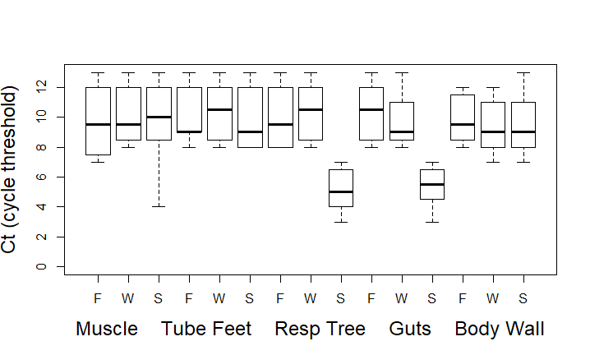

Su F Sp Su F Sp Su F Sp Su F Sp Su F Sp

Muscle Tube Feet Resp Tree Guts Body Wall

*

*

**Figure 8.** Predicted telomerase expression in *P. californicus,* by tissue and season. Seasons include Su (Summer), F (Fall), and Sp (Spring). Telomerase expression is inversely related to Ct. I predict that telomerase expression will be highest (lowest Ct) in Respiratory Trees and Guts during Spring (two-factor ANOVA and Tukey multiple comparisons test, * indicates p < 0.05).



Su F Sp Su F Sp Su F Sp Su F Sp Su F Sp

Muscle Tube Feet Resp Tree Guts Body Wall

*

*

**Figure 9.** Predicted relative telomere length of *P. californicus*, by tissue and season. Seasons include Su (Summer), F (Fall), and Sp (Spring). Quantification of raw qPCR data in table X. Relative telomere length is inversely proportional to Ct. I predict that relative telomere length will be highest (lowest Ct) in Respiratory Trees and Guts during Spring (two-factor ANOVA and Tukey multiple comparisons test, * indicates p < 0.05).

Literature Cited

Anchelin, M., Murcia L., Alcaraz-Perez F., Garcia-Navarro E.M., and Cayuela M.L. (2011). Behavior of Telomere and Telomerase during Aging and Regeneration in Zebrafish. PLoS ONE *6*, 1-14.

Ebert, T.A., Russel, M.P., Gamba, G., and Bodnar, A. (2008). Growth, survival, and longevity estimates for the rock-boring sea urchin *Echinometra lucunter lucunter* (Echinodermata, echinoidea) in Bermuda. Bulliten of Marine Science *82*, 381-403.

Edmonson, C.H. (1935). Autotomy and Regeneration of Hawaiian Starfishes. Bishop Museum Occasional Papers *11,* 3-20.

Garcia-Arraras, J.E., and Greenberg, M.J. (2001). Visceral Regeneration in Holothurians. Microscopy Research and Technique *55*, 438-451.

Garcia-Cisneros, A., Perez-Portela R., Almroth B.C., Degerman, S., Palacin, C., and Skold H.N. (2015). Long telomeres are associated with clonality in wild populations of the fissiparous starfish *Coscinasterias tenuispina*. Heredity *115*, 1-7.

Latorre E., Birar V.C., Sheerin A.N., Jeynes C.C., Hooper A., Dawe H.R., Melzer D., Cox L.S., Faragher R.G., Ostler E.L., Harries L.W. (2017). Small molecule modulation of splicing factor expression is associated with rescue from cellular senescence. BMC Cell Biology *18*, 1-15.

Millipore Sigma. TRAPeze Telomerase Detection Kit Protocol Catalog No S7700.

Mueller, K.W. (2016) Fishery biology of the sea cucumber *Parastichopus californicus* (Stimpson, 1857) from the San Juan Islands, Washington. Lummi Natural Resources Department 2013-2015 Sea Cucumber Study. 1-112.

Nguyen, T.H.D., Tam, J., Wu, R.A., Greber, B.J., Toso, D., Nogales, E., and Collins, K. (2018). Cryo-EM structure of substrate-bound human telomerase holoenzyme. Nature *557*, 190–195.

O’Callaaghan, N.J., and Fenech M. (2011) A quantitative PCR method for measuring absolute telomere length. Biological Procedures Online. *13*, 1-10.

Ohuchida, K., Mizumoto, K., Yashiro, O., Ishikawa, N., Nagai, E., Yamaguchi, K., and Tanak, M. (2005). Quantitative Assessment of Telomerase Activity and Human Telomerase Reverse Transcriptase messenger RNA Levels in Pancreatic Juice Samples for the Diagnosis of Pancreatic Cancer. Clinical Cancer Research *11*, 2285-2292.

Paltzat, D.L., Pearce, C.M., Barnes, P.A., and McKinley R.S., (2008). Growth and production of California sea cucumbers (*Parastichopus californicus* Stimpson) co-cultured with suspended Pacific oysters (*Crassostrea gigas* Thunberg). Aquaculture *67*, 124-137.

Podlevesky, J.D., Li, Y., Chen J.J. (2018). Structure and function of echinoderm telomerase RNA. RNA Society *22,* 204-215.

Roche. (2013) TriPure Isolation Reagent Protocol version 07.

Ruppert, E.E., Fox, R.S., and Barnes R.D. Invertebrate Zoology: A Functional Evolutionary Approach, Eighth Edition. YEAR? (United States of America: Brooks Cole).

Schumpert, C., Nelson, J., Kim, E., Dudycha, J., and Patel, R. (2015). Telomerase Activity and Telomere Length in *Daphnia.* PLoS ONE *10*, 1-15.

Stocum, D.L. (2017). Mechanisms of urodele limb regeneration. Regeneration *4,* 159-200.

Tan, A. L. (2015). Expression of survivin and mortalin during the annual cycle of visceral regeneration in *Parastichopus californicus* (Master’s thesis). Walla Walla University, College Place, WA.

Varney, R.M., Pomory C.M., Janosik A.M. (2017). Telomere elongation and telomerase expression in regenerating arms of the starfish *Ludia clathrata* (Asteroidea: Echinodermata). Marine Biology *164*, 1-6.

Weinberg, R.A. (2014) The Biology of Cancer, Second Edition. (United States of America: Garland Science).

APPENDICES

Appendix 1 - Proposed Budget

|  |  |  |
| --- | --- | --- |
| Product | Cost | Justification |
| Qiagen DNeasy Blood & Tissue Kit (250) | $700.00 | Extract DNA from cucumber tissues |
| Millipore TRAPeze Telomerase Detection Kit (S770) | $653.00 | Measure functional telomerase |
| Zymo Direct-zol RNA Miniprep Kit (R2053) | $770 | Extract total RNA from tissue samples |
| Roche Transcriptor First Strand cDNA Synthesis Kit, 1 x 50 rxn, 1 x 100 rxn | $1,000 | Synthesize cDNA from RNA to perform qPCR |
| Roche FastStart Essential DNA Green Master (06402712001) | $468 | Reaction mixture for qPCR |
| Total Expenses: | $3,591 |  |

Modified Budget – eliminated body wall tissue samples

|  |  |  |
| --- | --- | --- |
| Product | Cost | Justification |
| Qiagen DNeasy Blood & Tissue Kit (2 x 50 rxn) ID: 69504 | $326 | Extract DNA from cucumber tissues |
| Millipore TRAPeze Telomerase Detection Kit (112 assays - S770) | $653.00 | Measure functional telomerase |
| Zymo Direct-zol RNA Miniprep Kit (2 x 50 rxn) | $500 | Extract total RNA from tissue samples |
| Roche Transcriptor First Strand cDNA Synthesis Kit, 100 rxns (04896866001) | $659 | Synthesize cDNA from RNA to perform qPCR |
| Roche FastStart Essential DNA Green Master (06402712001) | $468 | Reaction mixture for qPCR |
| Total Expenses: | $2,606 |  |

Appendix 2 - Breakdown of Samples

**TRAP assay for telomerase activity:**

3 seasons x 8 animals x 5 tissue types = 120 samples

**qPCR for telomerase expression:**

3 seasons x 8 animals x 5 tissue types = 120 samples

**qPCR for relative telomere length:**

3 seasons x 8 animals x 5 tissue types = 120 samples

**Seasons:** Spring, Summer, Fall

**Tissue Types:** Respiratory Tree, Gut, Tube Feet, Body Wall, Muscle

Modified Breakdown of Samples – eliminated body wall tissue samples

**TRAP assay for telomerase activity:**

3 seasons x 8 animals x 4 tissue types = 96 samples

**qPCR for telomerase expression:**

3 seasons x 8 animals x 4 tissue types = 96 samples

**qPCR for relative telomere length:**

3 seasons x 8 animals x 4 tissue types = 96 samples

**Seasons:** Spring, Summer, Fall

**Tissue Types:** Respiratory Tree, Gut, Tube Feet, Muscle

Appendix 3 - Formulas

(x-xo)/c

TPG = x 100

(r-ro)/cr

x – signal measured in each reaction/lane

xo – heat inactivated control

ro – no-template control

r – TSR8 quantication control

c – 38 bp band internal standard

cr – 38 bp band internal standard for TSR8 control

Appendix 4 – Measuring absolute telomere length

As reported in Elmore et. al. (2008) the telomeric repeat sequence for the sea cucumber *Cucumaria fondosa* is TTAGGG. To confirm that the telomeric repeat sequence TTAGGG is conserved in *P. californicus*, the product from a TRAP assay reaction that contained a strong positive result could be sequenced as in Schumpert et. al. (2015). The reaction product will be purified using a Qiagen PCR purification kit, ligated into the vector pGEMT Easy (Promega), and sequenced. Then the results can be compared across tissues and seasons. However, the sequencing of TRAP product may require more time and expense than is available for this study. So, for the rest of the methods, it will be assumed that this will not be possible and relative telomere length will be measured instead.