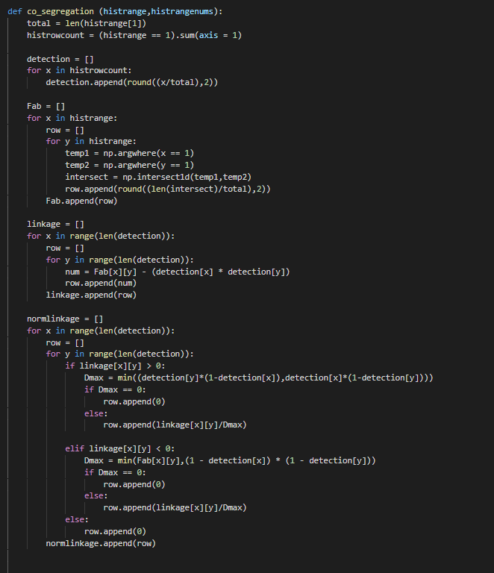

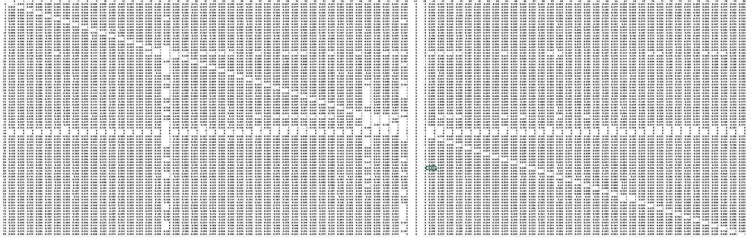

Full Table

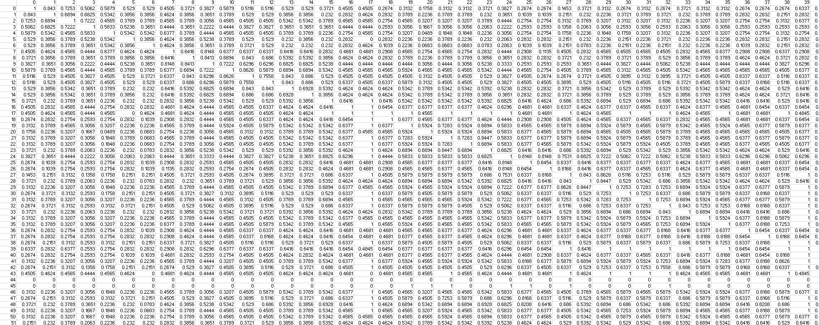

Top left of table

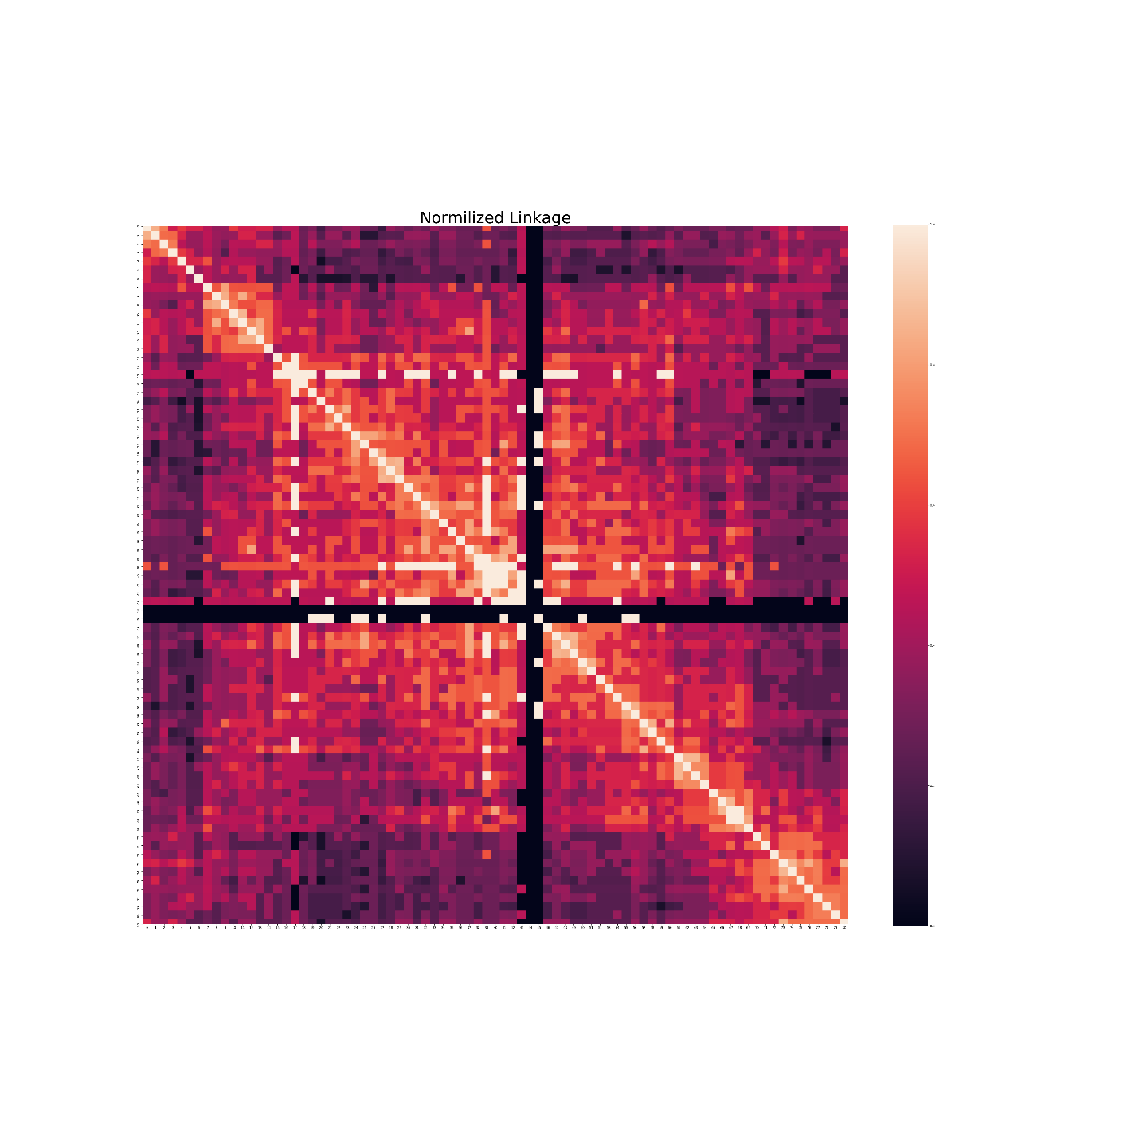

As shown in the heatmap (White = High interaction, Purple = low), The closer we get to the center of the center of the Hist1 region (17 - 57), there is a higher rate of interaction between the loci. This is the case throughout most of the heatmap with a few exceptions. In general. The closer the loci are to the origin line (where the location is [X,X]). The more interaction there is with that particular loci.