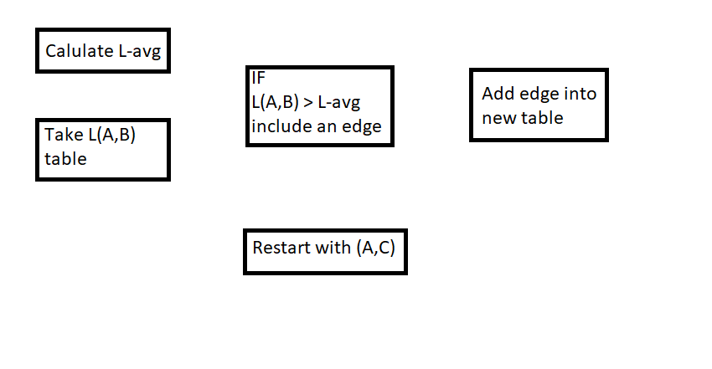

To calculate L-avg you take the average value of the L table. The L table come from the previous assignment. If the value of L(A,B) is grater the L-Avg then you will create an edge form A to B and B to A. If not, it will move to the next index. This repeats until the table is complete. From the new table you can calculate the average, min, max, and produced a list of all edges created.