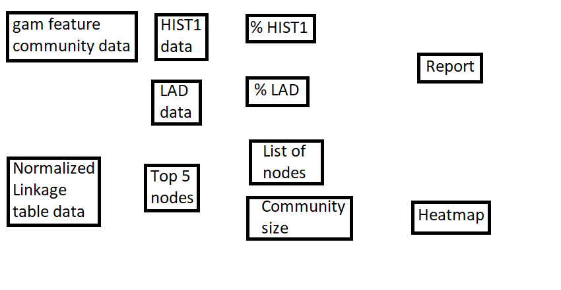

Taking the data from the normalized linkage table, this table already shows in order the greatest 5 hubs. From the game feature community table retrieve the HIST1 and LAD columns for comparison. Match each node to either HIST1 or LAD. Then take the percentage of HIST1 / hub total and LAD / hub total. The list of nodes and size of community should both already be included in the hub data from the linkage table. All previous calculations go into the report, and a heatmap is created based on the present nodes.