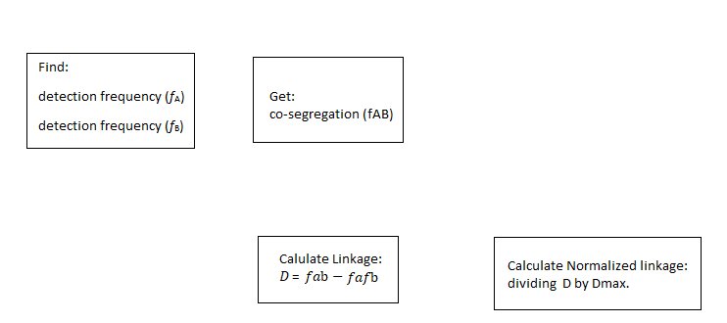

First you have to find detection frequency Fa of a given locus “a” is the number of nuclear profiles in which A is detected divided number of nuclear profiles. This is the same for b. The co-segregation Fab of a pair of loci “a” and “b” is the number of nuclear profiles in which both A and B are detected divided by the number of nuclear profiles. To find linkage you calculate D = Fab – FaFb. Finally, to calculate. Normalized linkage disequilibrium You take D divided by Dmax. After all calculations are made produce a heatmap of the results.