Mushroom Analysis

Jonathon Farzanfar
Towson University
Towson, USA
Jfarzanfar1@gmail.com

Abstract—To be able to find uniqueness between mushrooms that are poisonous and ones that are not. This correlation will help dearly if stranded with nothing to eat.

Introduction
This dataset contains physical attributes of mushroom species. The specific attributes contained are as follows: Poisionous_Or_Not,CapShape,Cap-Surface,cap-color,bruises,odor,gill-attachment,gill-spacing,gill-size,gill-color,stalk-shape,stalk-root,stalk-surface-above-ring,stalk-surface-below-ring,stalk-color-above-ring,stalk-color-below-ring,veil-type,veil-color,ring-number,ring-type,spore-print-color,population,habitat. All of these objects were analyzed for frequency to see similarities/patterns in physical attributes of mushrooms.

Methodology
To preprocess this data, I took the liberty of renaming all the columns to actual readable values as well as the values in the dataset to words rather than characters. Once all the metadata has been set, I used this data frame to mine with. I utilized the apriori algorithm to find patterns in the data.
I used a confidence value of 0.95, min length of 2, and a support of 0.1. I used these values as well as limiting the data by if it is edible or not to see if there were any similarities between mushrooms of these types I chose these values because the higher the support the more frequent it has been occurring in the data and the higher the confidence the more times each result set was found true where attribute “A” has 1 or more attributes that are reoccurring. I used a min length of 2 because I wanted to see values that correlated to the RHS (right hand side) of the output (edible or not) to be able to classify mushrooms by physical traits, to find out if there is uniqueness to poisonous mushrooms/nonpoisonous to be able to identify the type when I am hiking.
In order to graph the data, I had to download the package arulesViz. This package came with a plot function which was parameterized with a set of rules as well as measures.

RESULTS
Below are the plots of poisonous and nonpoisonous mushrooms ordered by lift the following code was ran: plot(rules.sorted,measure=c("support","lift"),shading="confidence", control=list(main="Poisonous Mushrooms"))
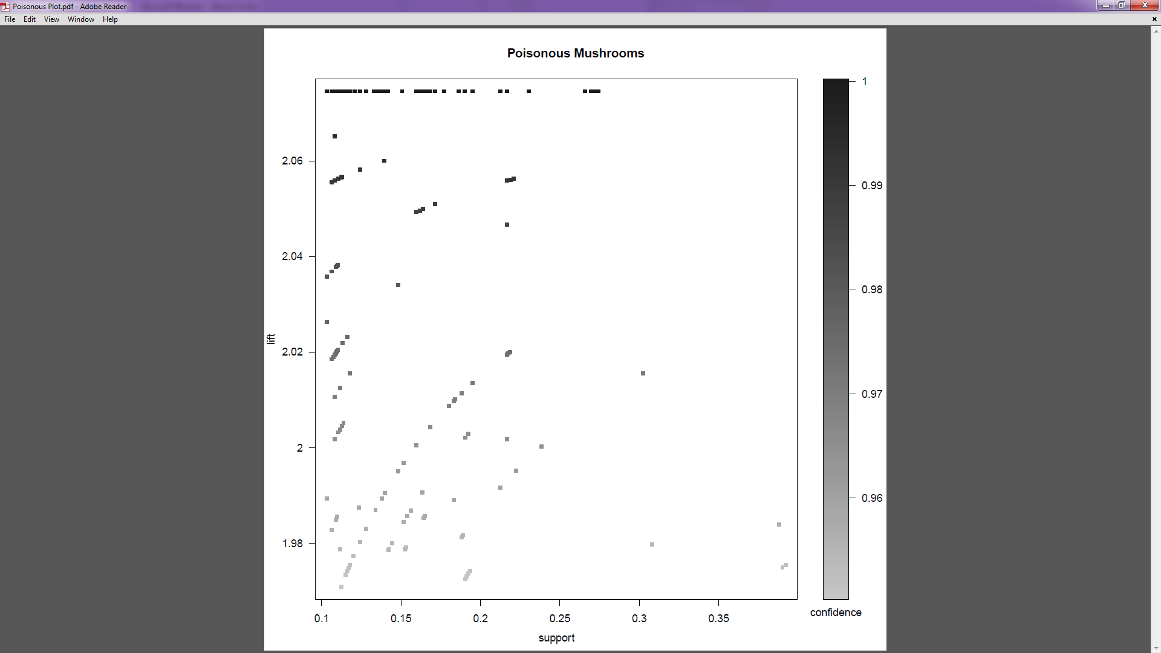
Fig. 1. Scatterplot of rules for poisonious mushrooms
plot(rulesedible.sorted,measure=c("support","lift"),shading="confidence",control=list(main="Nonpoisonous Mushrooms"))
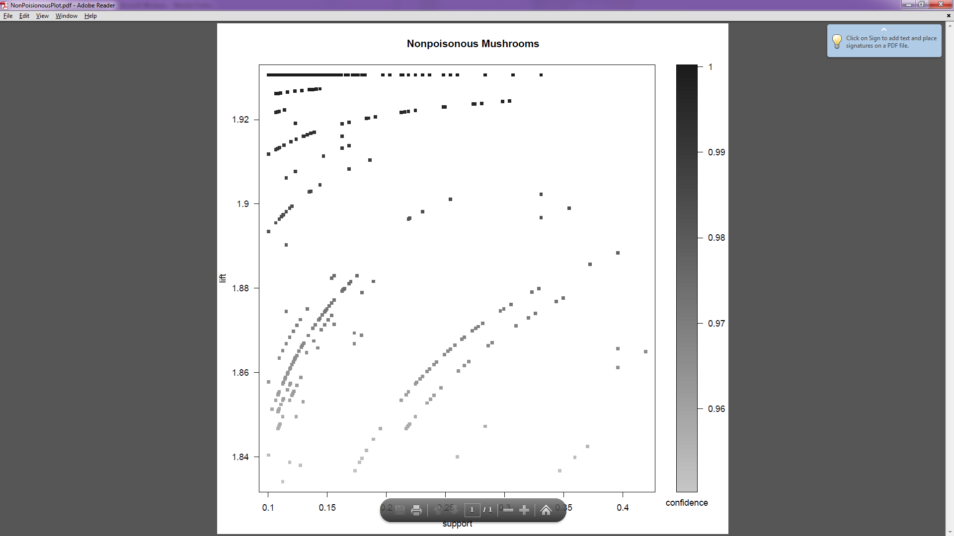
Fig. 2. Scatterplot of rules for nonpoisonous mushrooms
By examining these 2 plots we see that there are quite a few rules that should be taken into consideration when eating wild mushrooms. The higher the lift, confidence, and support the more likely it is that the rule is true.

By running inspect(head(rules)) and inspect(head(rulesedible)) the following occurred:
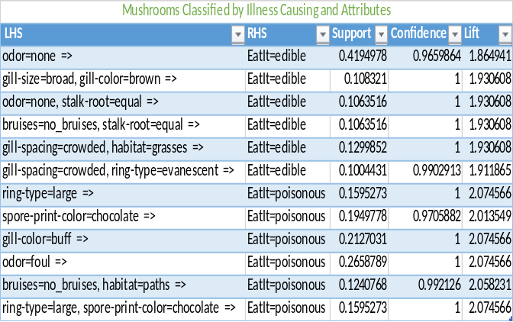
Fig. 3. Inspection of rules generated for poisonous and nonpoisonous mushrooms
Based on my analysis of the data I have found that if a mushroom stinks, you should avoid it. I have 100% confidence in that statement. However, if it doesn’t stink I’m only 96% certain it will not kill you. If the mushroom is not odorous and the stalk-root is equal you should be fine to eat this type of mushroom because of my confidence being 100% and support being 12.9% and lift being 1.93. If you are trying to make yourself ill however, I’d go with a foul smelling mushroom due to the support being 26.5%, confidence being 100% and lift being 2.074.

conclusion
It was found that there is indeed a correlation between physical attributes of a mushroom and its ability to harm a human or not as shown in Fig. 1. This correlation relies on the values for support, confidence and lift. The higher the three the more likely the rule is plausible. The most important parameter value being lift. This measure is the ratio between the rules confidence and support.
While utilizing the apiori algorithm, it was observed that the lower parameter values used (support, confidence) returned a much larger dataset so large that a fatal error occurred on my server with 128 GB of ram. Thus, having to limit the set by using higher values for the parameters. By doing this limitation I do not have the ability to see all of the rules associated with the set, even those of which I shouldn’t care about but would have liked to see.
Future work includes, utilizing the other algorithms to compare result sets to see if one is more accurate than the next by doing field tests. I will not be eating the mushrooms however, we can have them tested for certain chemicals that make them poisonous after I use these rules to pick them. We will than know how these algorithms stand up against one another.

