Thank you for giving us valuable feedback. GluConv is the model of time series forecasting designed for glucose monitoring. It is an honor to submit our work to ICASSP 2026. Our implementation is available at URL:
For comments from two reviewers, we respond to them respectively.

For Reviewer 57FF:
Comment 1.1: Why GluConv performs much worse when applied on the Dubosson dataset than on others?
Response: We suspect that the performance is attributed to data distribution of Dubosson. Dubosson has the smallest time steps of 8056 among the five datasets as shown in Table R1. In statistical analysis, an insufficient sample size is more prone to deviations from the behavior predicted by the Law of Large Numbers and the Central Limit Theorem. Accordingly, we hypothesize that the Dubosson distribution does not strictly follow a right-skewed pattern, which in turn contributes to its suboptimal performance. The glucose level distributions of the selected datasets are illustrated in Fig. R1.

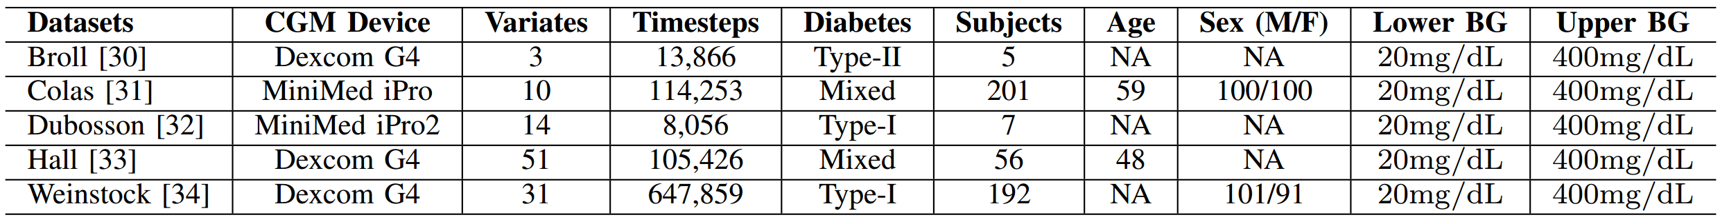
Table R1. The heterogeneous nature of the processed datasets

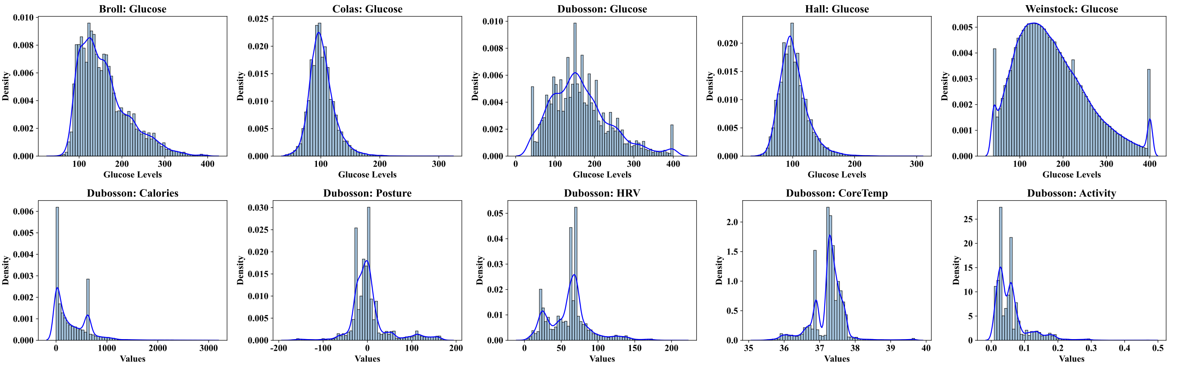
Fig R1. The glucose level distributions for the 5 datasets, along with the distributions of the remaining 5 features in the Dubosson. The feature distributions of Dubosson exhibit clear multi-modality and heavy tails.
Comment 1.2: Why the training time of XGBoost on the Weinstock dataset appears much larger than any other case?
Response: We are sorry that we mistakenly write the unit of Training Time Per Epoch in Fig. 2 as "/s". Actually the right unit is "/ms".
We launch the experiment of XGBoost on the Weinstock and record the training time. The average training time is about 3500 ms, which is 6–10 times that of other models. The log of experiment can be seen in our GitHub.

Comment 1.3: Some of the acronyms are used without claiming, e.g., CNN/RNN/UNet, etc.
Response: Thank you for pointing this out. We revise the manuscript to define all acronyms at their first occurrence, including CNN (Convolutional Neural Network), RNN (Recurrent Neural Network), and U-Net.

For Reviewer 24D2, we have sufficient evidence to doubt the comments are unfair:

Comment 2.1: Scope relevance is marginal
Response: As introduced at the beginning, GluConv belongs to the field of signal processing and time series forecasting, which is fully aligned with the scope we selected.

Comment 2.2: Minor writing issues such as a comma
Response: We note a potential inconsistency between the comment and the rating for Q8. The reviewer indicated minor writing issues, while Q8 represents serious structural and language issues. We think Q8 is unreasonable and wonder why there is a paradox. Regarding the writing quality, we have carefully revised the comma issue and conducted thorough proofreading of the entire paper to further improve readability.

Comment 2.3: No link of code can be found
Response: Our code is released on URL:

Comment 2.4: The model architecture is overly simple and lacks novelty
Response: GluConv integrates U-Net with the Mixer module, which is designed considering the characteristics of the glucose dataset. The motivation for adopting the Mixer lies in mitigating the high memory consumption of U-Net. As a result, the architecture represents a trade-off between complexity and efficiency. The whole structure of GluConv is not simple.

Comment 2.5: The experimental validation lacks in some respect; The technical contribution is insufficient
Response: We disagree with this comment. Given the 5-page limit for the main paper, we tried providing a comprehensive yet concise experimental evaluation. The accuracy, likelihood and calibration are measured in our main experiment. We also measure training time and memory cost in Fig. 2.

Comment 2.6: Some of the references are of limited relevance
Response: We disagree with this comment. We cite a total of 23 references, all of which were carefully selected to ensure their relevance to the scope of this study.

Comment 2.7: The connection between the method and the experiments is unclear, and the writing is disorganized. For example, why is the uncertainty for your proposed method shown as "–" in Table 1?
Response: We have already clarified "–" in the caption of Table 1 that "–" represents there is no such measurement on models. Uncertainty measurements cannot be applied in the machine learning-based methods in this study.
Overall, the connection between the proposed method and the experimental evaluation is explicitly described in the methodology and experimental sections.

In conclusion, we sincerely thank Reviewer 57FF for the constructive comments, which have helped us improve the clarity and quality of the manuscript.
Regarding the concerns raised by Reviewer 24D2, we have carefully addressed each point and provided detailed clarifications and supporting evidence to explain why we believe these concerns are based on misunderstandings. We hope that our responses adequately clarify these issues and demonstrate the validity of our work.

