Jon Powers Lab 4—Analysis Document

Usage

Lab4Main input_file [output_prefix] [verbose]

input_file: The file containing the integers to be sorted.
output_prefix: Optional. A prefix to be prepended to all output files. Default is “output”. Files
will be saved into the directory ./output, which must exist before the program
is run.
verbose: Optional. If “verbose” (without quotes) is provided as an argument to the
program, timing statistics for the sort will be printed to the console. Timing
statistics are not included in the output file, so this is the only way to obtain
them when running the primary program. As discussed in more detail below,
some auxiliary tools are included for testing and benchmarking purposes.

General Overview

This program has two primary components: the Sorter class and the HeapSorter class, which implement a QuickSort and a Heap Sort, respectively. The Sorter class provides both a recursive QuickSort via its qSort() method as well as an interative implementation of QuickSort via its iSort() method. Regardless of whether the iterative or recursive implementation of QuickSort is used, the Sorter class contains the internal getPivot() helper method, which provides a variety of options for pivot selection. The available pivots are to use the first, middle, or last item in the (sub)array being sorted, to use a random item from the (sub)array being sorted, or to use the median of the first, middle, and last elements in the (sub)array. Finally, the Sorter class contains a simple Insertion Sort implementation via iSort(), which can optionally be used to do final sorting on small subarrays.

The Heap Sort is implemented by the sort() method of the HeapSorter class, which uses an array-based min-heap to sort an input. When called, it creates an array with a length equal to the input array and pushes the input items, one by one, onto the heap. Heapifying procedures are called on the added element to ensure that it is placed in the correct position on the heap. Once the full heap is built, items are popped off the heap and placed into successive positions in the array. After an item is removed from the heap, the last item in the heap is placed at the top and then heapified so that it ends up in the correct position within the heap. After all items are popped off the heap, the contents of the input array are fully sorted.

The Lab4Main class provides a driver for the Sorter and HeapSorter classes, and allows the user to select from a variety of sorts and options. Together these classes and their dependencies are intended to provide the functionality set forth in the lab requirements.

To assist with generating output files, a SortFileGenerator class is included, which will generate input files to be sorted. On any given run, it will create sorted, reverse sorted, randomized, and randomized files with duplicate entries. The details of how many files will be created are hard-coded into the SortFileGenerator, though an obvious improvement would be to allow these parameters to be set via the comman line. The sorted files are created by starting a zero and adding a random number between 1 and 5 to that number a fixed number of times. This provides an ordered file that is guaranteed not to have any duplicates. Reverse sorted files are created using essentially the same process except that the generated sequence is pushed onto a stack and then written out by popping each element to a file, which reverses their order. Again, these files are guaranteed not to have any duplicates. Randomized files are created using the java.util.Random.nextInt() method within a calculated range. To prevent duplicate entries, an array of flags is maintained indicating whether a value has been used already. For example, with the value 4 is generated, flagArray[4] is set to 1; if 4 is generated on a later cycle, the program sees that the flag is marked in the flagArray, and that value will be thrown away.

To assist with the sort-performance analysis, a Benchmarker class is used. The role of the Benchmarker is to repeatedly run sorts under different parameters on a group of input files. In addition to the input files and the type of sort to be run, there are 3 key inputs to the Benchmarker. First, to limit variance in the timing numbers, the Benchmarker will do multiple runs of the same sort and record the average time of those runs. This way, system resource issues or other things that might cause glitchy data issues will be minimized. Second, the Benchmarker will run QuickSort with variable stopping case values (referred to herein as k-values). This allows us to get a more granular view of what happens as k-values change. Finally, the Benchmarker will run the QuickSort tests using various pivot selection methods. This allows us to getting better visibility into the performance of different type of pivots. Results from Benchmarker runs are output as CSV files with filenames reflecting the parameters used.

Last, to assist with understanding the Benchmarker’s output data, python is used along with several data-related libraries to visualize the data. The python script plots.py in the plots folder uses Matplotlib to generate a number of graphs showing various test results. This allows us to take the large amounts of data generated by the Benchmarker and present it in a digestible manner. The graphs presented below are based on a set of 440 input files of sizes between 50 and 22,000 were uses, with sorts averaged over 10 runs; in the case of QuickSort tests, k-values of 0 to 500 were used in increments of 50. A larger run with file sizes ranging up to 200,000 did not complete in time for inclusion in this analysis, though I expect that they would confirm the trends and conclusions found in and drawn from this 440-file analysis.

Input and Output Files; Formatting

Lab4Main is designed to accept any files containing integers separated by non-integers as input. Non-integers other than newline characters are treated as whitespace, and the integer groups are extracted as whole numbers. The lab requirements indicated that files were to consist of one integer per line with no blank likes and no leading whitespace. It was unclear from the lab requirements whether we were to restrict and reject input files that do not conform to this definition. In the interest of accepting as many reasonable files as possible, I settled on a design that will accept integers that are separated by any non-integers.

The output of Lab4Main, however, does confirm to the one-integer-per-line rule, with no leading spaces and no blank lines in the output file. These restrictions also mean that timing statistics for the sort are not included in the output file. Because of this limitation, a verbose argument may be passed at the command line, which will result in timing statistics being printed to the console.

Iterative Versus Recursive Quicksort

The Sorter class contains both iterative and recurisve implementations of Quicksort, although its API only provides access to the recursive QuickSort. I had initially written a recursive QuickSort implementation because it made the most intuitive sense and seemed like it would short and elegant. Although it was short and was clear to read, the recursion became so deep on large worst-case sorts that it would cause a StackOverFlowError to be thrown. I encountered this when attempting to run a first-item pivot on a n=20,000 file in reverse-sorted order. Rather than attempting to work around this limitation, it seemed like an easier solution would be to simply simulate recursion in a iterative implementation.

Recursive QuickSort works by repeatedly calling itself on different portions of the array being sorted. It does this by partitioning the array, and then using the pivot’s position to determine the next portions of the subarray to sort. The only thing that changes on the various recursive calls to QuickSort are the startIndex and endIndex parameters. So rather than rely on recurisve calls (and the associated call stack overhead), we can simply track the startIndex and endIndex values that would have been used on recursive calls. The obvious choice for how to do this is to use a stack so that we can pop off the next subarray information from the stack and then push new information onto the stack after it’s partitioned. By doing this, we effectively simulate the recursion, and there is no functional difference between this and a recursive implementation.

The stopping case, whether in the recursive implementation or the iterative one, is handled by testing endIndex – startIndex at the beginning of each cycle. If that value falls below the stopping-case threshold, then we divert the program flow to run Insertion Sort on that subarray rather than continuing to apply QuickSort. In the iterative version, we take the subarray indices off the stack without putting anything new back on; and in the recursive implementation, we test this condition at the beginning of the method and divert to Insertion Sort rather than partitioning the data and making further recursive calls.

Data Structures Used; Complexity

The only data structure used heavily in this program is a min-heap, which is the basis for the Heap Sort sorting algorithm. It is essentially a binary tree that is maintained in a complete or almost complete state with particular ordering characteristics such that no child is greater than the value of its parent. The tree used in this heap implementation is stored in an array, which gives us quick random access to any part of the tree we need. In addition, because the tree is complete or almost complete at all times, the maximum depth of the tree is equal to where is the number of items on the heap. As a result, when we place an item onto the heap, we will have to move it a maximum of times to get it to its correct position within the heap. A similar process is followed when removing an item from the heap, which also ensures a maximum of moves to restore the order of the heap. Because we have to do the add or remove operation for each item being sorted, we will have a complexity of for the Heap Sort.

The only data structure of note used in the Quick Sort implementation is a stack that is used in the iterative Quick Sort. The iterative Quick Sort simulates recursion by tracking the startIndex and endIndex values that would be used in the recursive calls. These are tracked by pushing them onto a stack and popping them off when needed. Specifically, we seed the stack with 0 and array.length-1 and then repeatedly (a) partition the data until reaching a stopping case; (b) push the startIndex and endIndex of the left partition onto the stack; and (c) push the startIndex and endIndex of the right partition onto the stack. This is process is repeated on the startIndex and endIndex at the top of the stack, which is essentially the same process that is used on the call stack in a recursive implementation.

Performance Results –Heap Sort

The Heap Sort performance was generally good, but it struggles badly with duplicate values within the input array. While the other types of input showed performance that is competitive with the best Quick Sort cases, the times on the randomized file with duplicates were slower by a factor of more than 10,000.

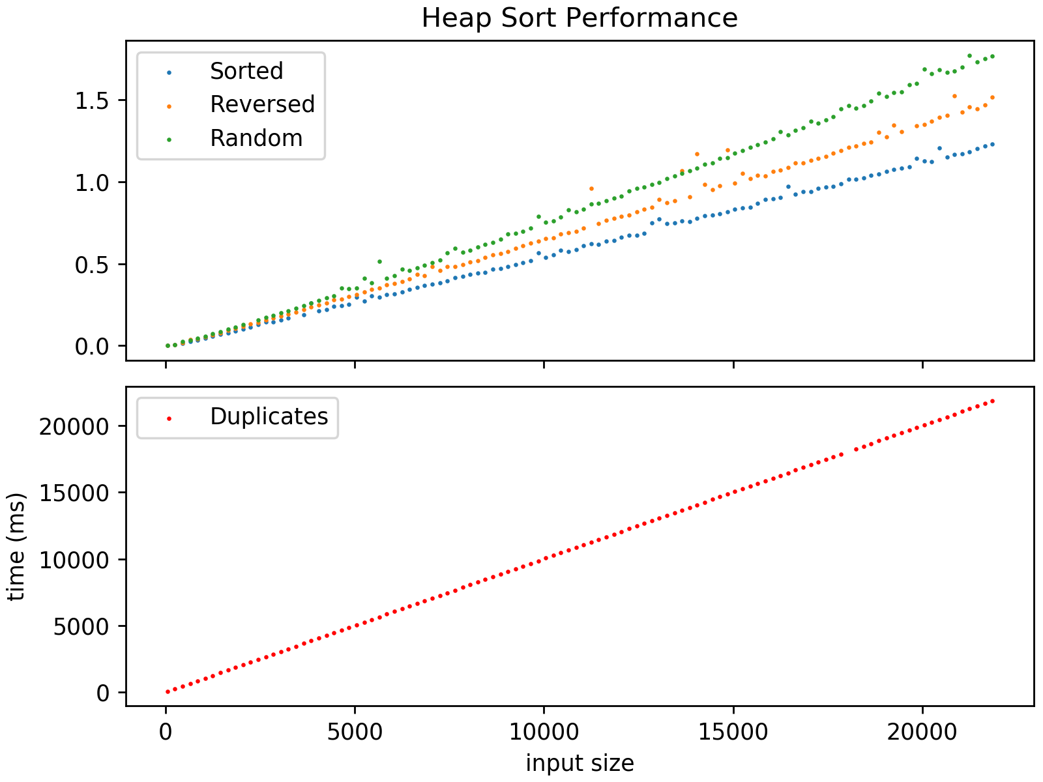

Notably, these plots appear to show an approximately linear growth rate, whereas in theory we should see logarithmic growth as the size of the input increases. It’s possible that the input sizes used here are simply too small to see the “big picture” and that further benchmarking would reveal the growth rate to be what we expect.
Performance Results—QuickSort; Effect of Pivot Selection on Performance

To analyze the effect on sort performance due to the choice of pivot, I used a straight QuickSort (no Insertion Sort to finish sorting). The interaction between pivot selection, type of input file, and k-values is explored in detail below. The first observation, which is a recurring theme throughout this analysis, is that the QuickSort performance falls into two groups. In this base case of straight QuickSort performance, the sorted and reverse-sorted input performance is generally similar:
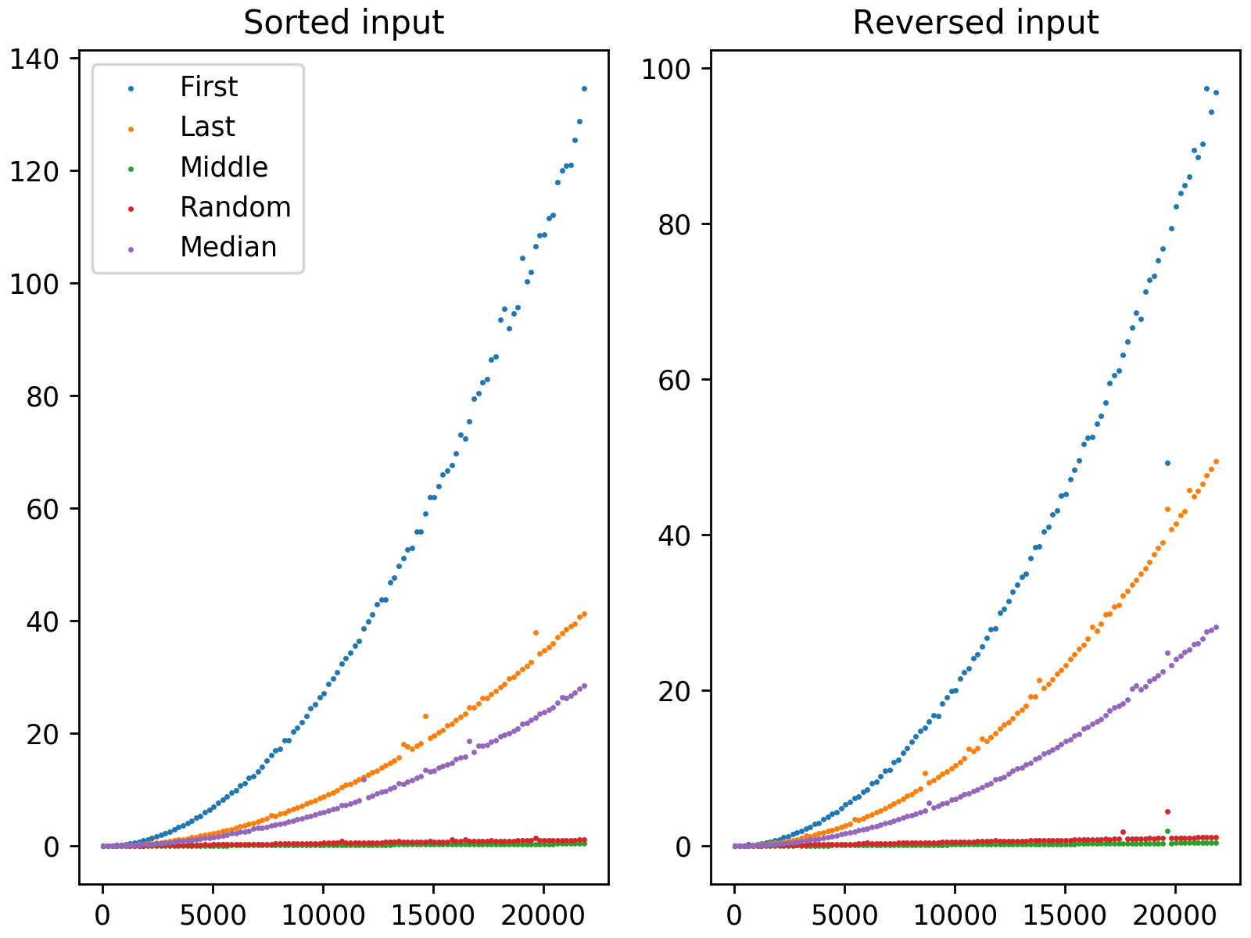

We can see that the performance of the first-item and last-item pivot selection methods is quadratic, as we would expect with this worst-case input. Since the input is ordered, selecting the first or last item as the pivot is gauranteed to produce one partition of size one and one of size n-1. As a result, we diverge as far as it’s possible to be from the ideal partition that splits the data evenly in half. One interesting result is that the last-item pivot selection seems to outperform the first-item pivot, which I would not have predicted since this same structural problem exists for the last-item pivot as it does for the first-item pivot. It also appears that the median-of-3 pivot has a quadratic performance on this type of input, although its coefficient is less than the first and last pivot-selection methods. I would have expected this to exhibit more traditional performance, since it should pick the middle element each time. Another unusual feature of this data is that the performance of the first-item pivot on sorted data seems to be about 40% worse than on the reverse sorted data as the input size becomes large.

The middle-item pivot and the random pivot selection vastly outperform all three of these other pivot-selection methods. In fact, at the scale where we can see the performance of those three methods’ performance, the middle-item and random pivot selections appear flat and approximately zero. To get a better view of how they do, we have to isolate them and zoom in:

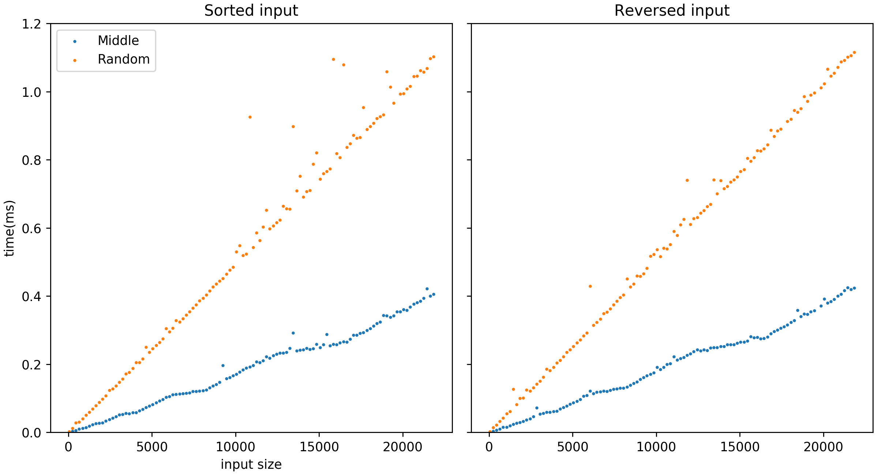

The random pivot appears to provide approximately linear performance, and the middle-item performance provides the best performance of all on the sorted and reverse-sorted data sets. It also appear to have approximately linear performance, but with a much lower coefficient than the random pivot.

With the randomized input and the randomized input with duplicates, the performance of all the pivot selection methods are broadly similar:
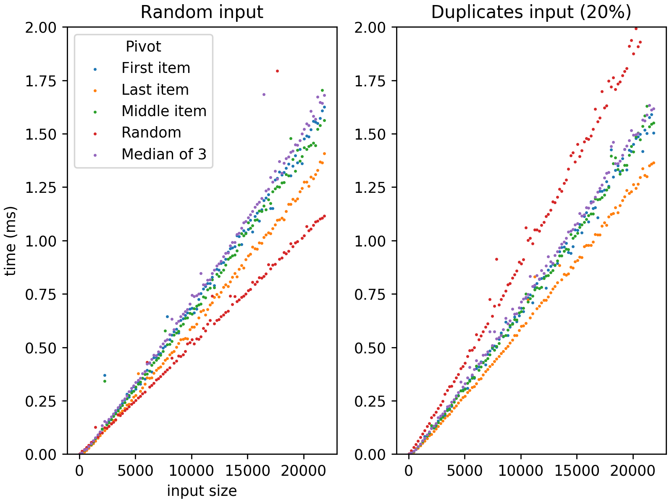

We can see that the first-item, middle-item, and median of 3 pivots are essentially the same in terms of performance. The last-item pivot seems to be clearly ahead of these in terms of performance, and the random pivot selection is the best of them all. This is somewhat surprising since with a randomized input, the pivot selected should also be random regardless of how it’s selected. For this reason, these differences in performance must be the result of my implementation (or of how the random numbers are generated by the JVM). When duplicate values are introduced, the random pivot selection becomes the worst performer of the group, and the last-item pivot takes the lead. The first-, middle- and median-of-3 pivots take the middle of the pack. But overall, the performances are about the same, and there is no major difference in overall performance when duplicates are introduced.

Effect of Using Insertion Sort to Finish Sorting

A number of benchmarks were performed to evaluate whether performance improves by using Insertion Sort to complete sorting once the subarrays become small. Generally speaking, there is nearly always some improvement when using this technique, though the exact amount depends on the type and size of the input data. For example, when the size of the input data is small, then for any significant value of k, the entire sort will be done with Insertion Sort:

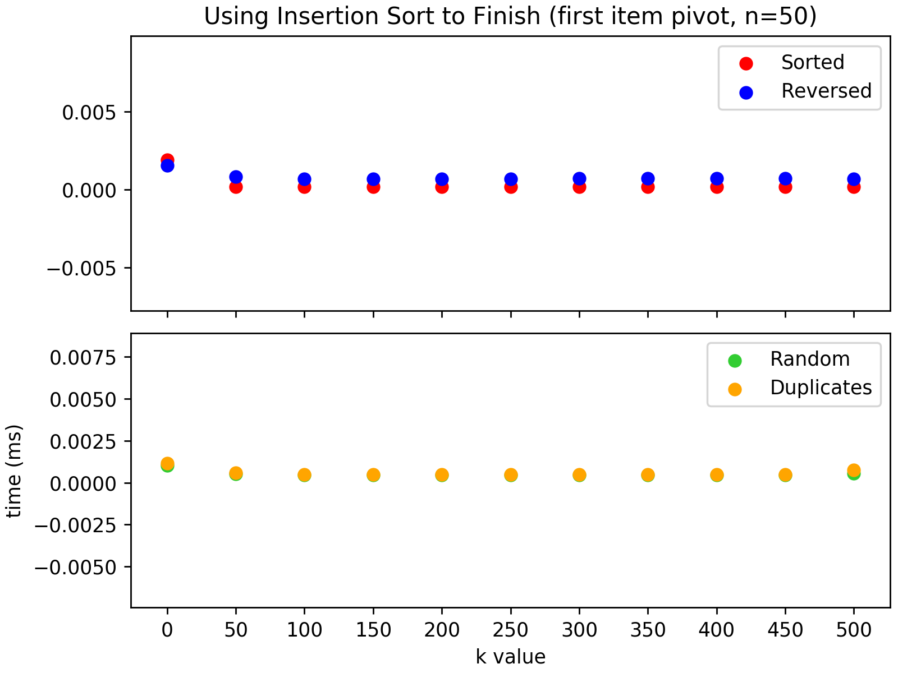

For the first data point, k=0 and the sort is a pure QuickSort. On the next data point, k=50; and because n=50, the entire sort is performed using Insertion Sort. The same is true for all higher values of k tested on this data set, which is why performance is flat for all higher values of k. Although the above graph shows results using the first item as a pivot, the same general results occurred with all the pivot-selection options.

The effect of different k values becomes more clear when using larger input sizes. Consider the following results when using an input size of 5,050 sorted integers: 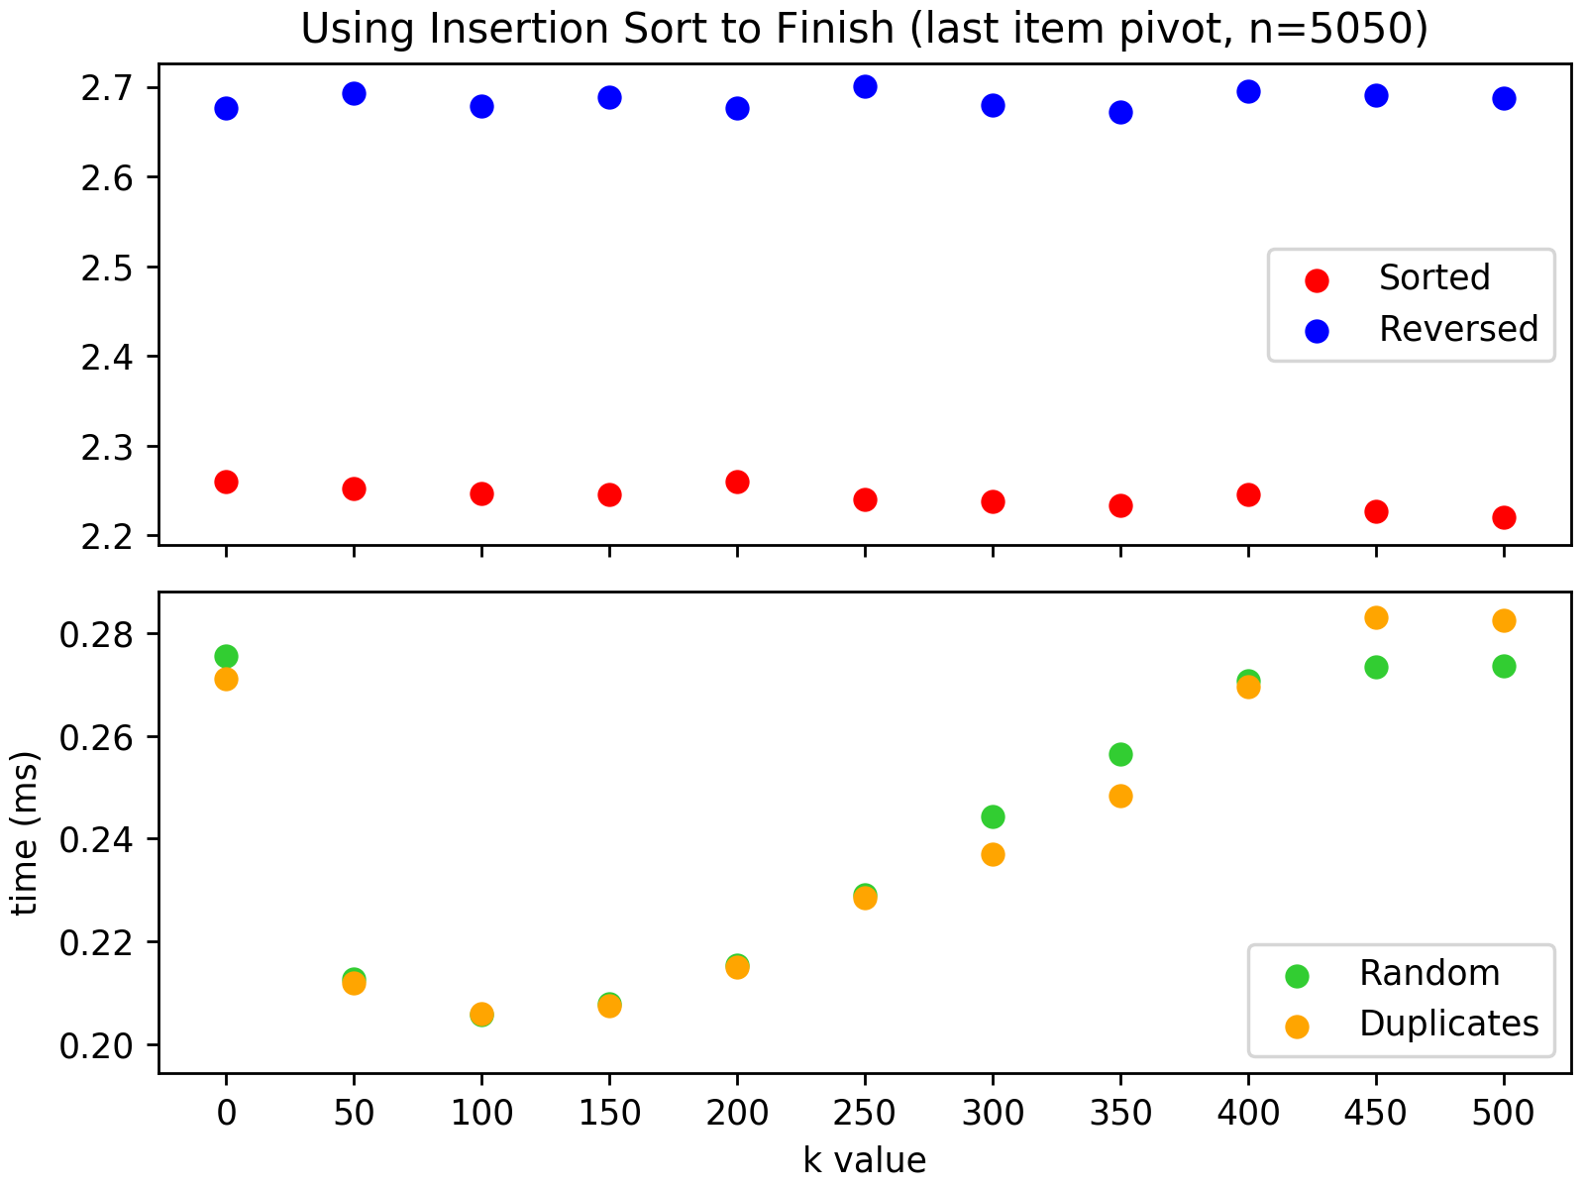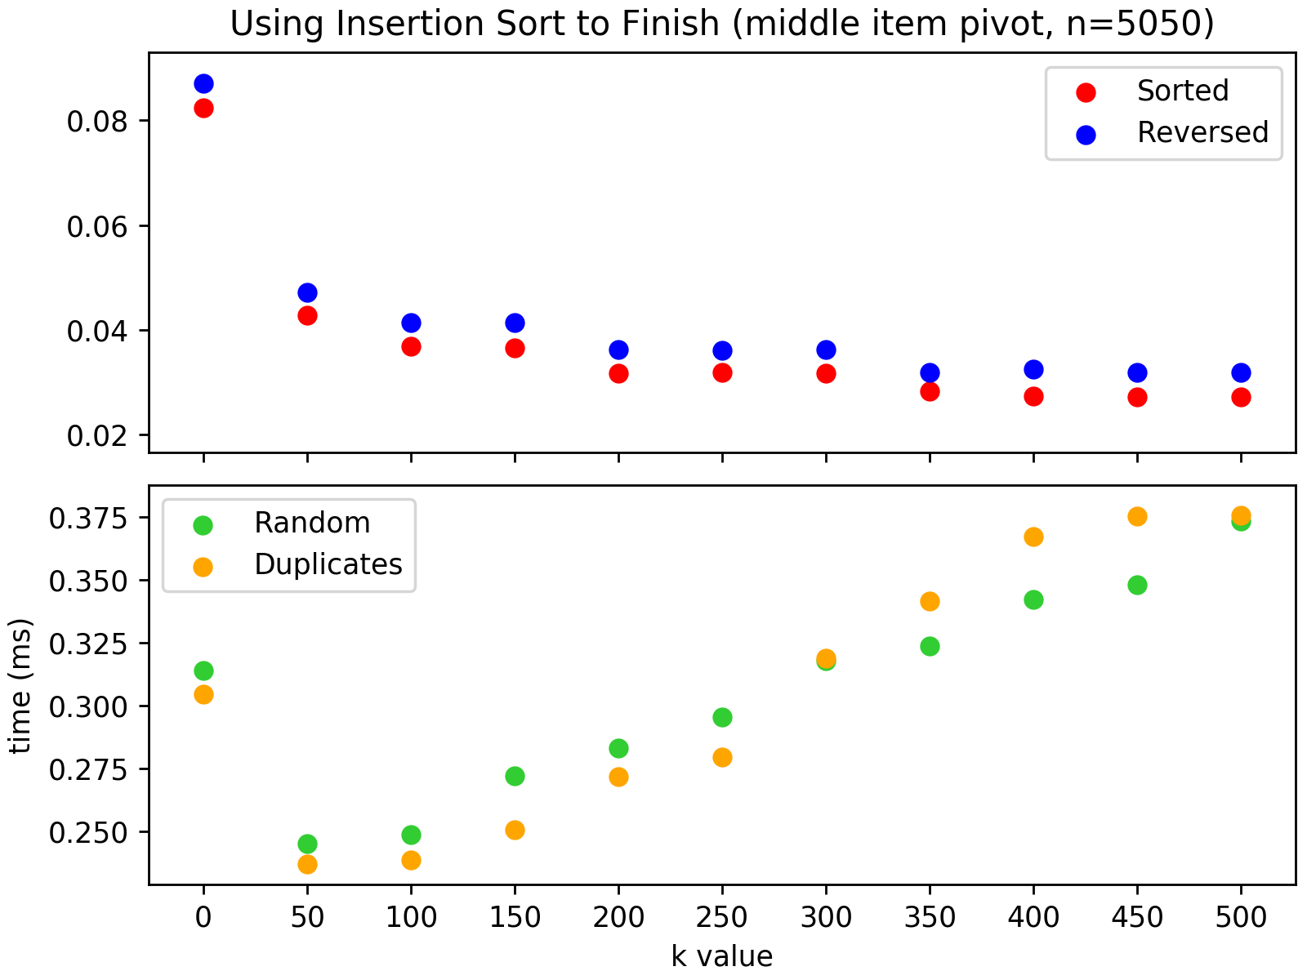

In the plot on the left, the pivot is the first item in the subarray being sorted. When this pivot choice is combined with a sorted or reverse sorted input, the partitioning process creates one subarray of size 1 and another of size n-1. InsertionSort can be of no help sorting a subarray of size 1 (it’s alredy trivially sorted), and it will not be utilized on the other subarray until the entire array being sorted has been whittled down to a subarray of size k, at which point InsertionSort will be called exactly once. In the top plot on the left, none of the tested values for k are large enough to trigger InsertionSort, so we see a flat plot of pure QuickSort performances. But when the input is random—with or without duplicates—a big change occurs. Aside from the drastic performance improvement for pure QuickSort, we a parabolic curve where performance improves rapidly until k=100 at which point it starts to climb back to the pure QuickSort performance. As we’ll see below, using increasingly large k values can cause performance to degrade to worst than a pure QuickSort.

When we change the pivot, the same general behavior on randomized inputs remains the same. (Note that we can see here an example of where the performance for high values of k actually produce worst results than a pure QuickSort.) But with sorted and reverse sorted data, we see that the flat performance is replaced with a steadily improving timing curve. It seems that the larger the value of k, the better the performance of the sort on these types of input data. We see a similar effect, though with a different curve contour, on the median-of-3 pivot:

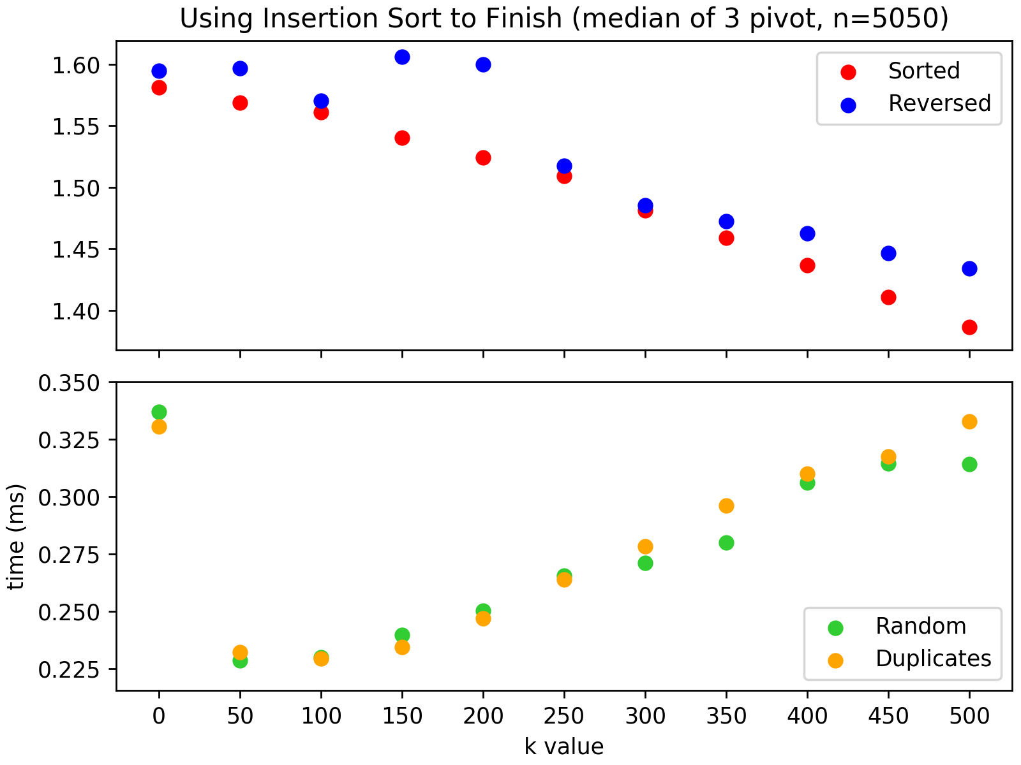

When examining these same plots for other input sizes, we find that the same patterns appear:

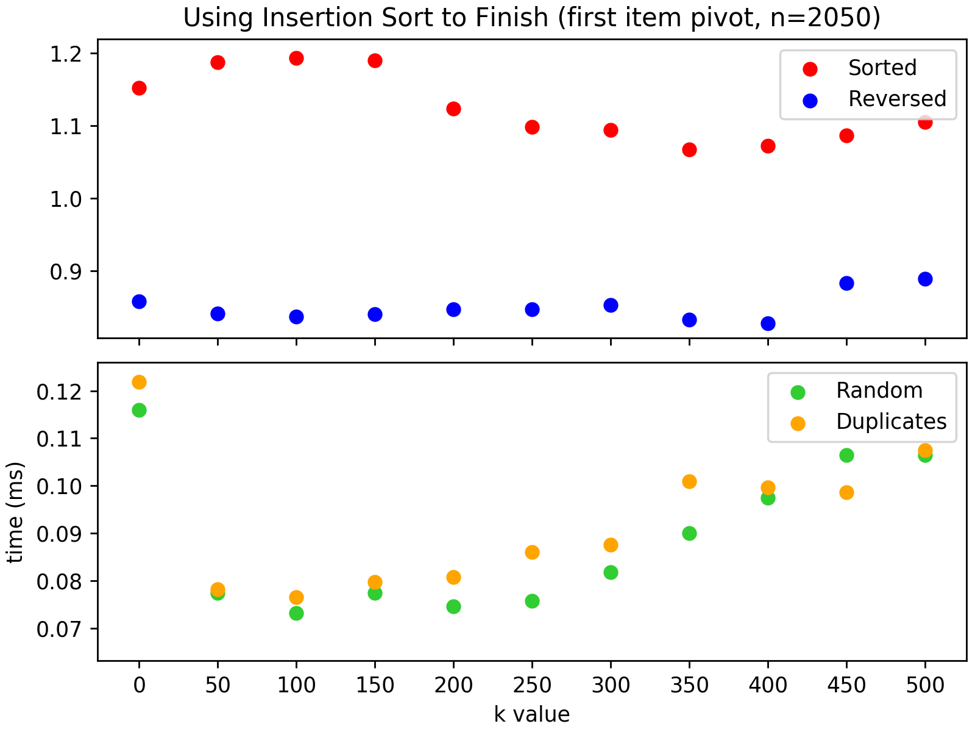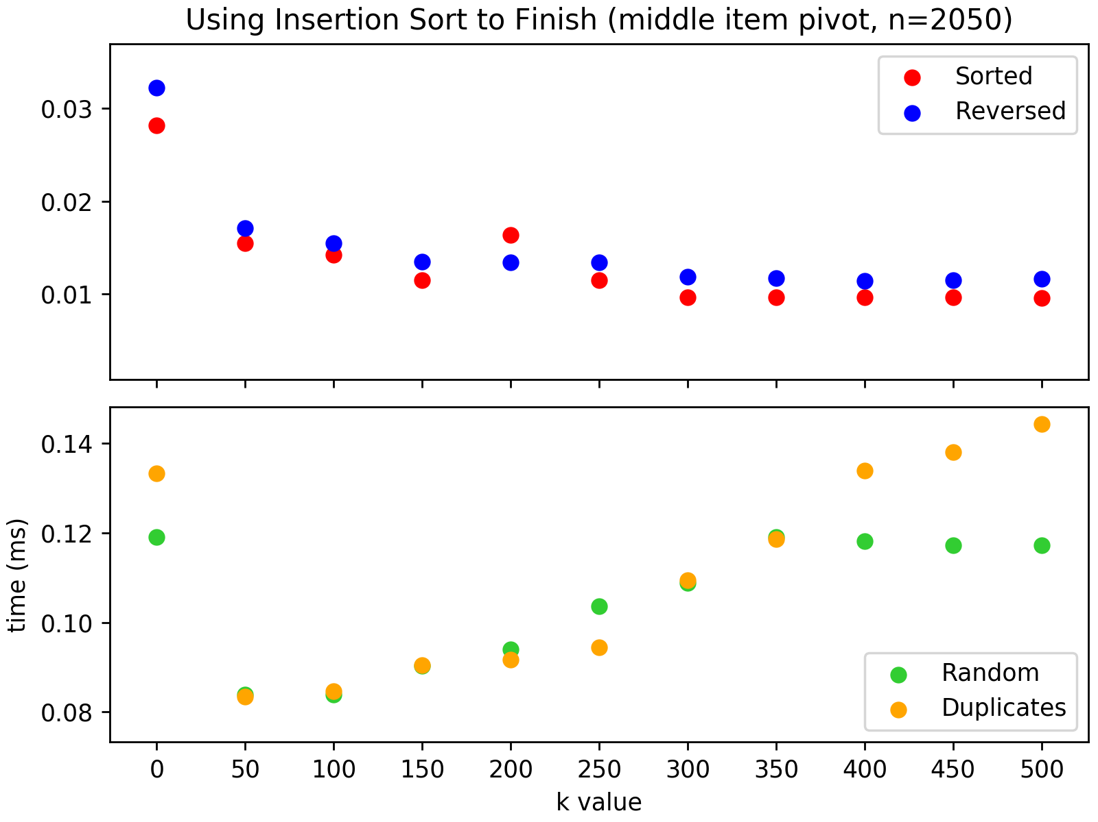

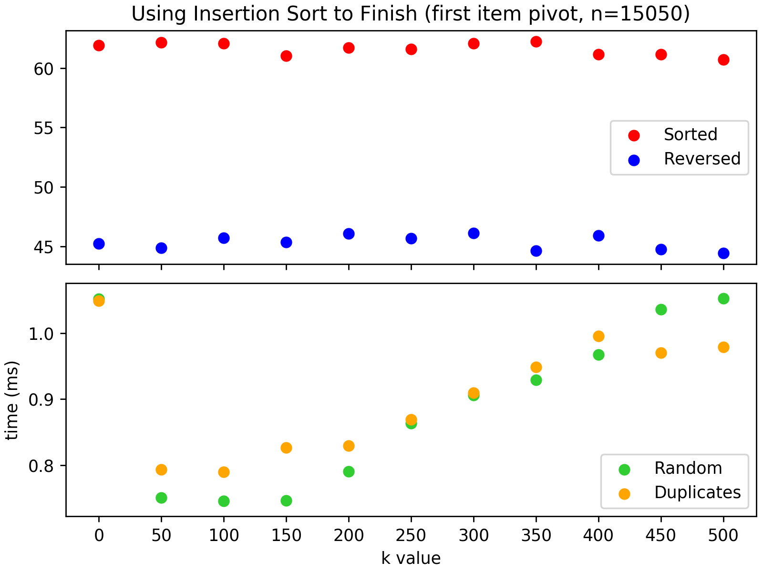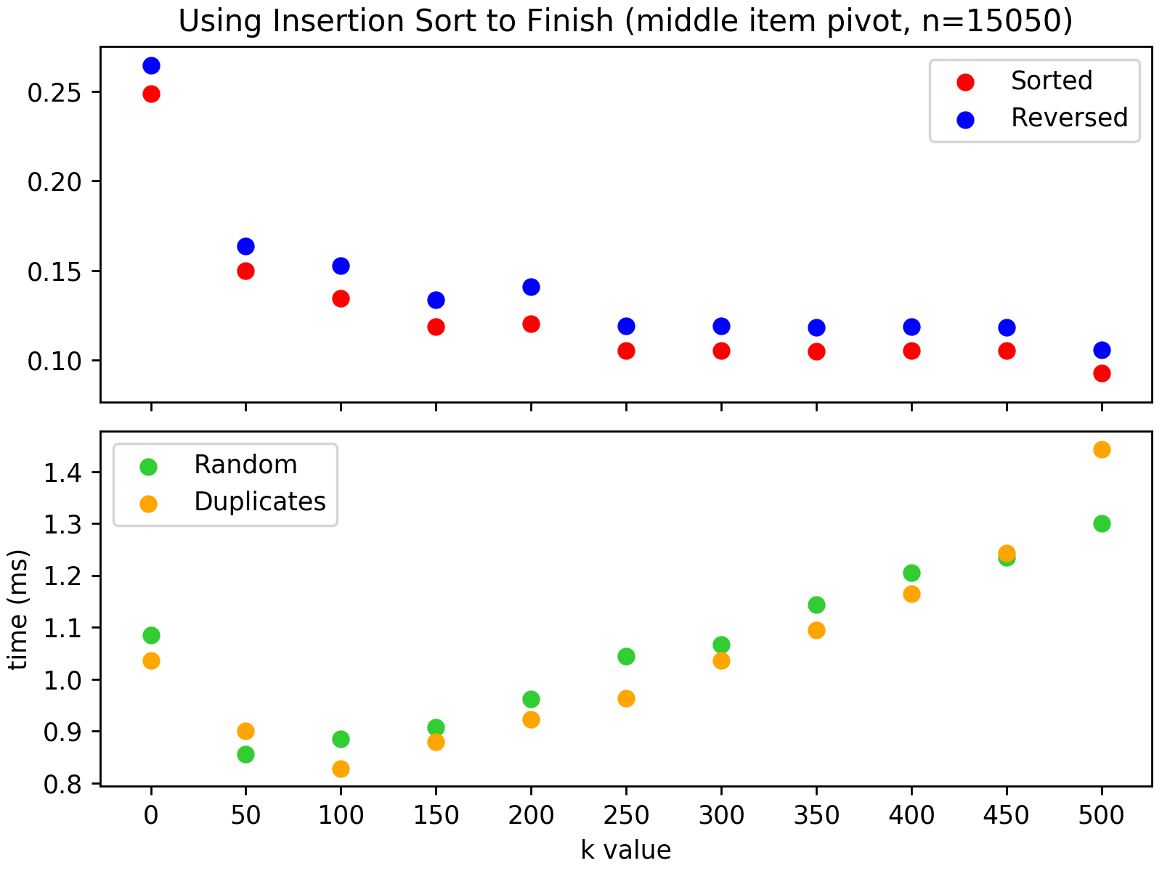

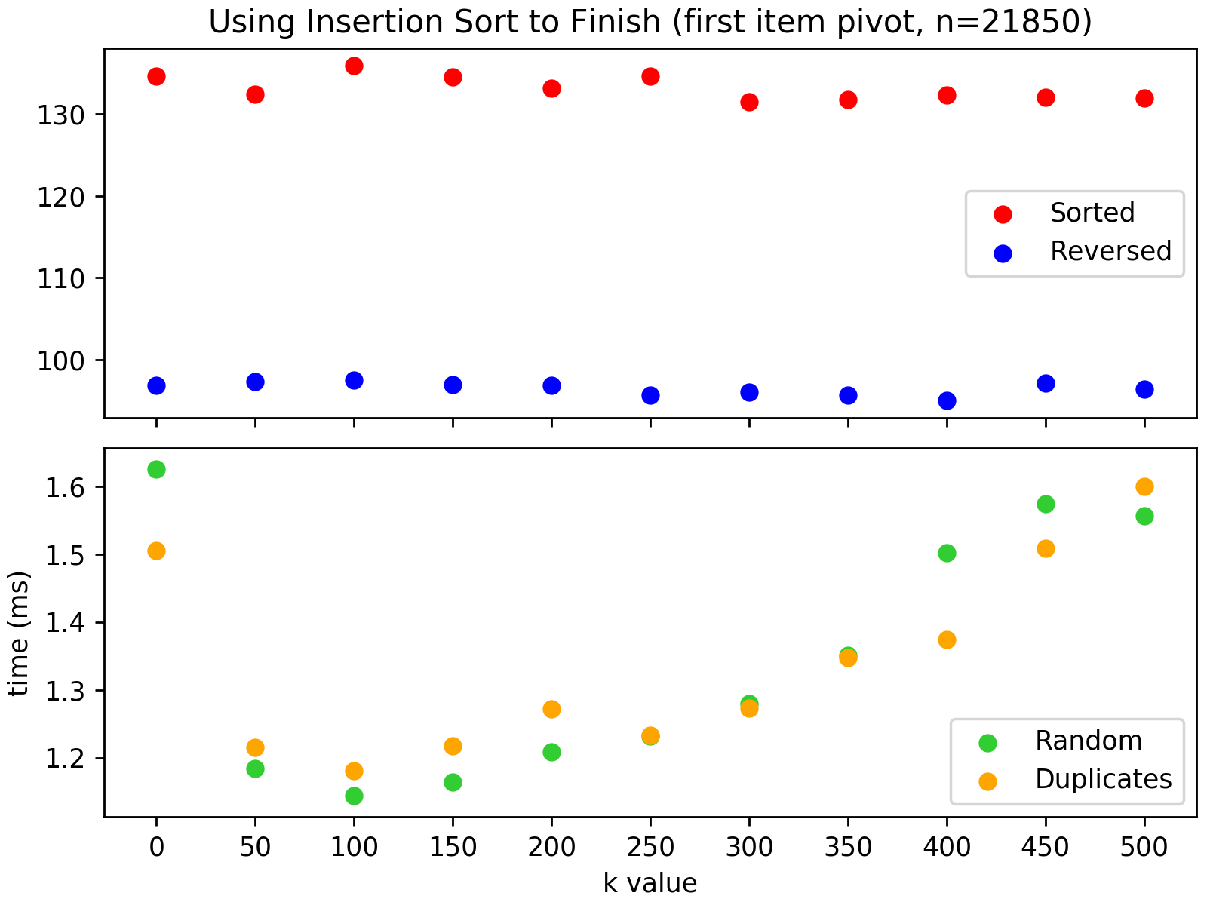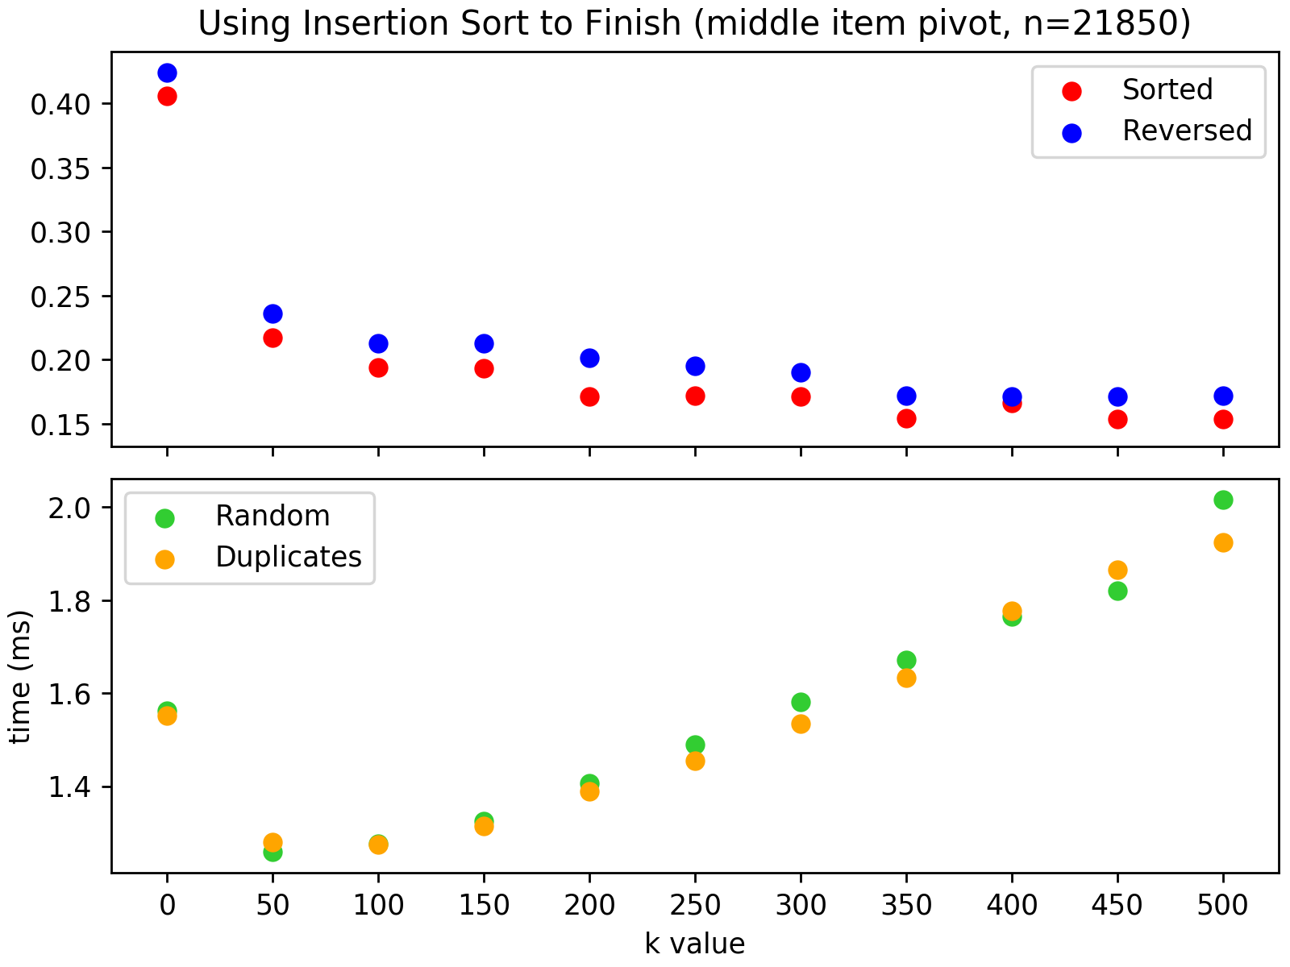

It would be helpful if, rather than looking at plots for different input sizes, we could generalize the effects of our k-value selection in a way that was not specific for the input size. If we think about the value of k in terms of a percentage of the input size, then the specific values of a particular test case are not relevant and we can directly compare performance effects over arbitrary input sizes and k values. And rather than considering the absolute speed improvement for a particular sort, we can think about it in terms of the percent improvement over a pure QuickSort. This way we can look at an improvement from 1000 ms to 600 ms in the same way as an improvement from 100 ms to 60 ms. These obviously would involve different input sizes, but we may be able to find patterns by looking at the k-to-input-size ratio and how much improvement is achieved.

Applying this concept, we can look at the various combinations of input types (sorted, randomized, etc.) and pivot-selection strategies. Consider first combinations based on a sorted input:

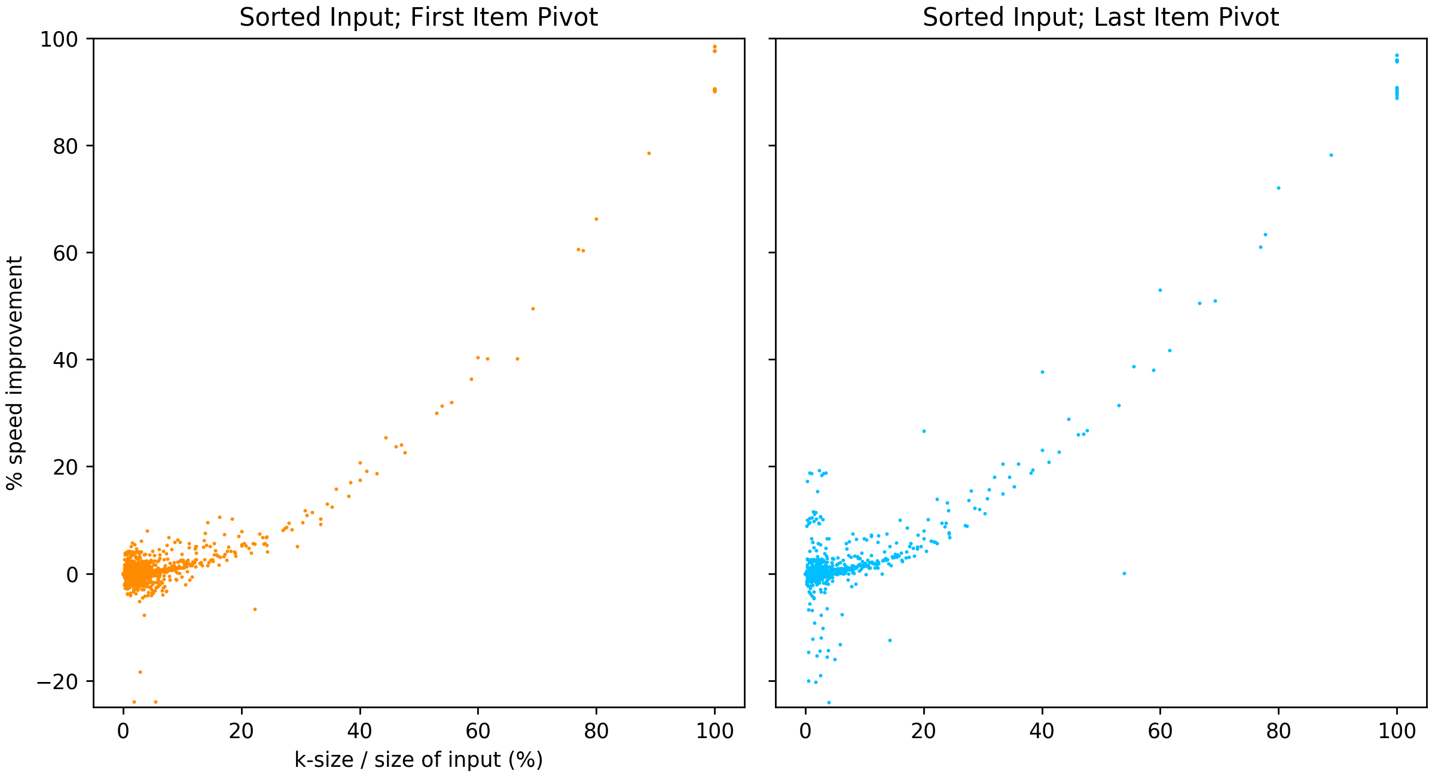

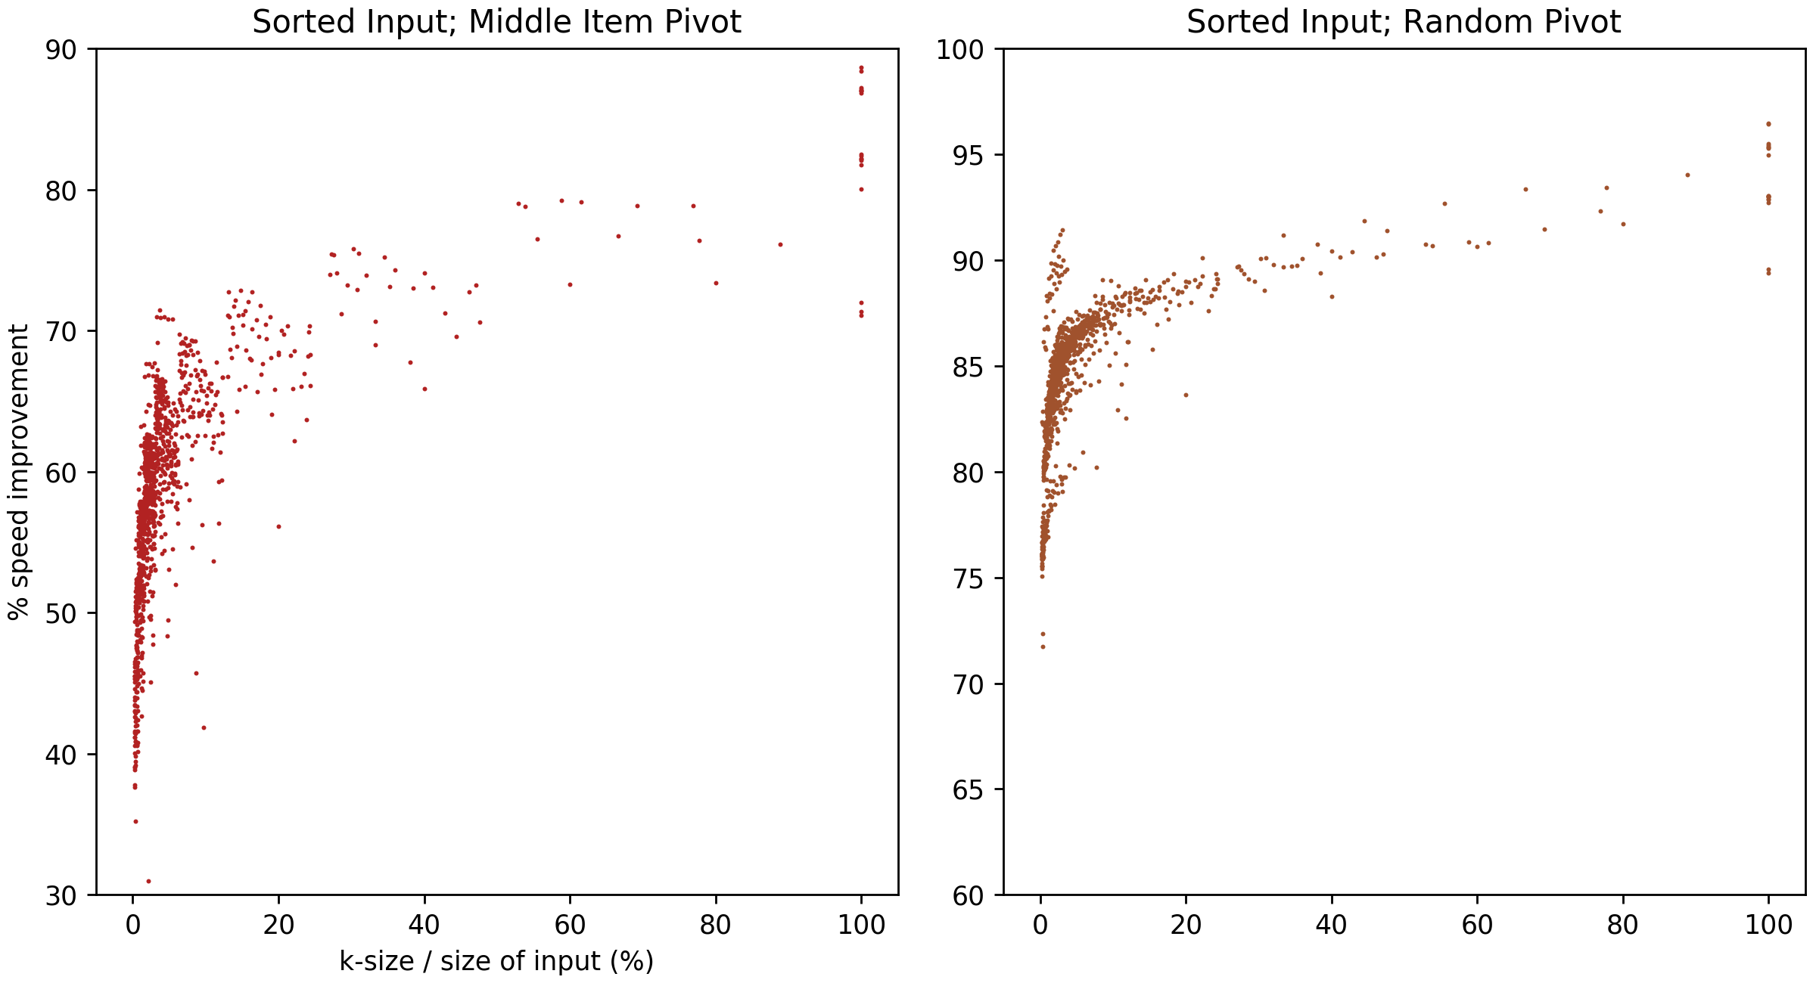
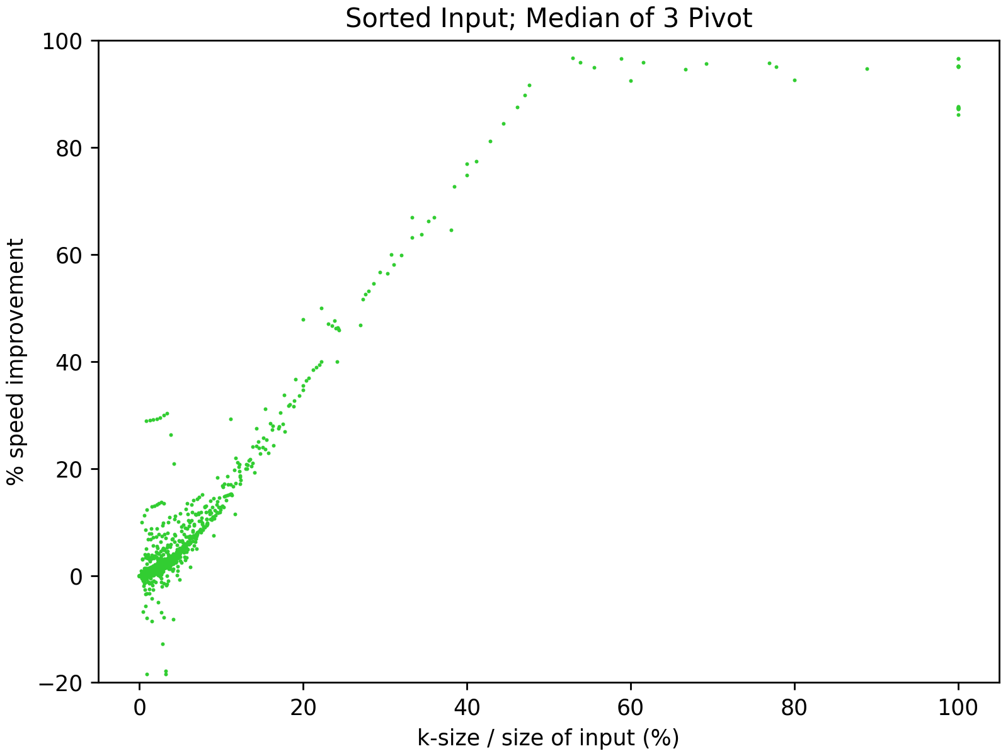

These plots were generated from a tests of 440 input files and k values ranging from 0 to 500. The size of the input files ranges from 50 to about 22,000, which is why the data points are sparse for higher k-to-input-size ratios. Even with these limitations, some clear patterns emerge from these sorts on sorted data. First, the pivot matters—a lot. The ideal k value seems to be 100% for first- and last-item pivots on sorted data. But this shouldn’t be a huge surprise because these are the worst-case parameters for QuickSort, and it seems that pure InsertionSort is simply better than QuickSort or a hybrid approach under these conditions. That said, a hybrid approach would be beneficial since it does show steady improvement over all values of k.

For the middle-item and random pivots, there is a sharp increase in performance for very small k-value ratios. While the performance improvement continues to increase over all values of k, the vast majority of that improvements occurs within k-value ratios of just a few percent. For this particular instance, a cap on the k-value ratio of around 5% would get almost all the benefit available from adding InsertionSort into the mix. For the median-of-three pivot, the improvement in performance is not as sharp and is approximately linear until around 50% at which point the curve goes flat. Under these circumstances, a 50/50 hybrid approach works just as well as a pure InsertionSort.

It’s worth noting that, unlike some of the scenarios below, the performance when adding InsertionSort with sorted data never gets worse than a pure Quicksort. The plots for reverse-sorted data are largely the same as for sorted data.
Next, we consider randomized data:
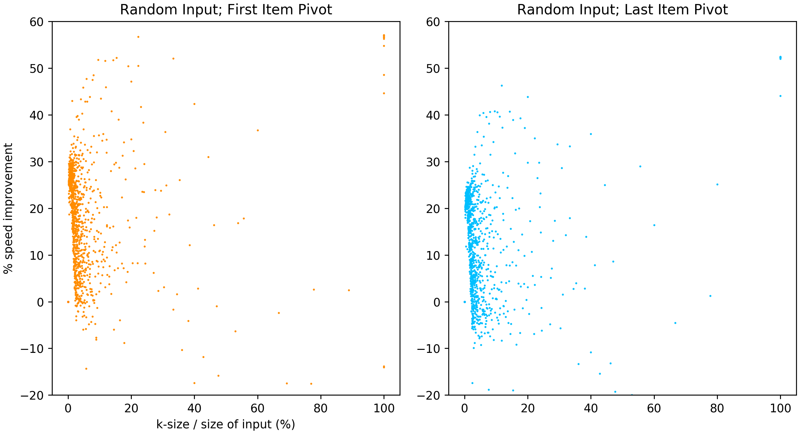
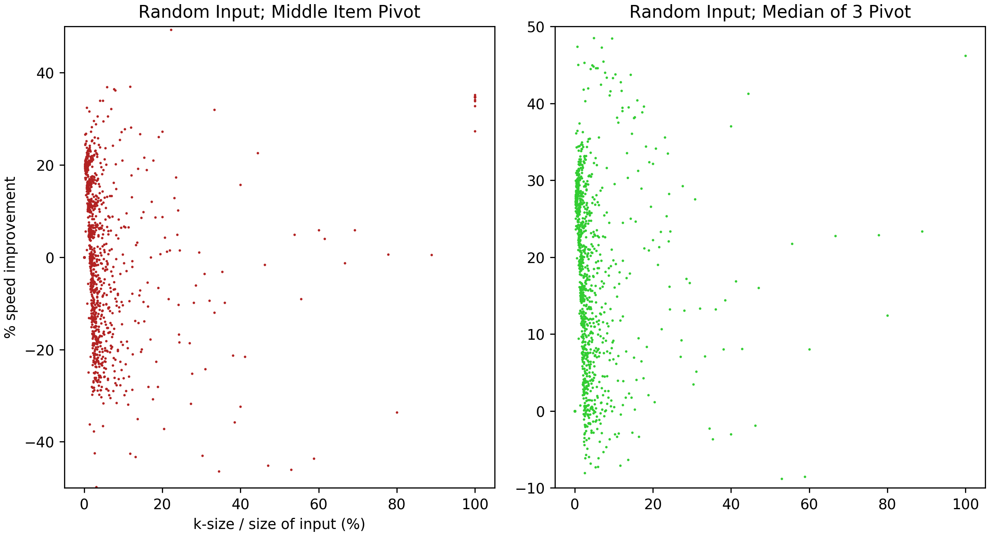
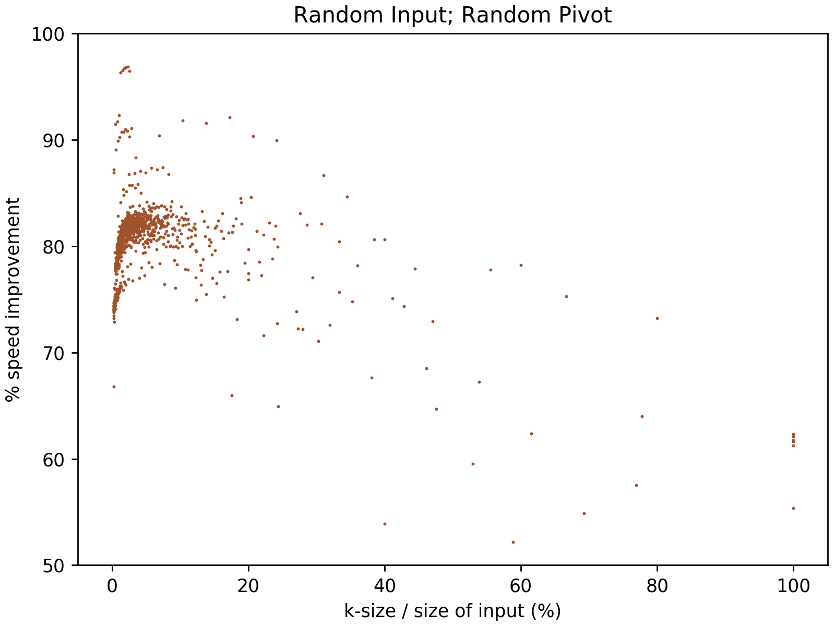
When looking at the k-value ratios with randomized data, the pivot selection matters far less than with sorted data. In fact, the first-item, last-item, and median-of-3 pivots all have essentially the same performance. The peak performance improvement occurs rapidly over k-value ratios of less than onepercent, after which it degrades steeply to about 10% worse than a pure QuickSort by the time the k-value ratio reaches 2%. The shape of the curve is the same for a middle-item pivot except that it has less upside potential, and the downside risk reaches to about 30% worse than a pure QuickSort. This is more clear when zooming in:
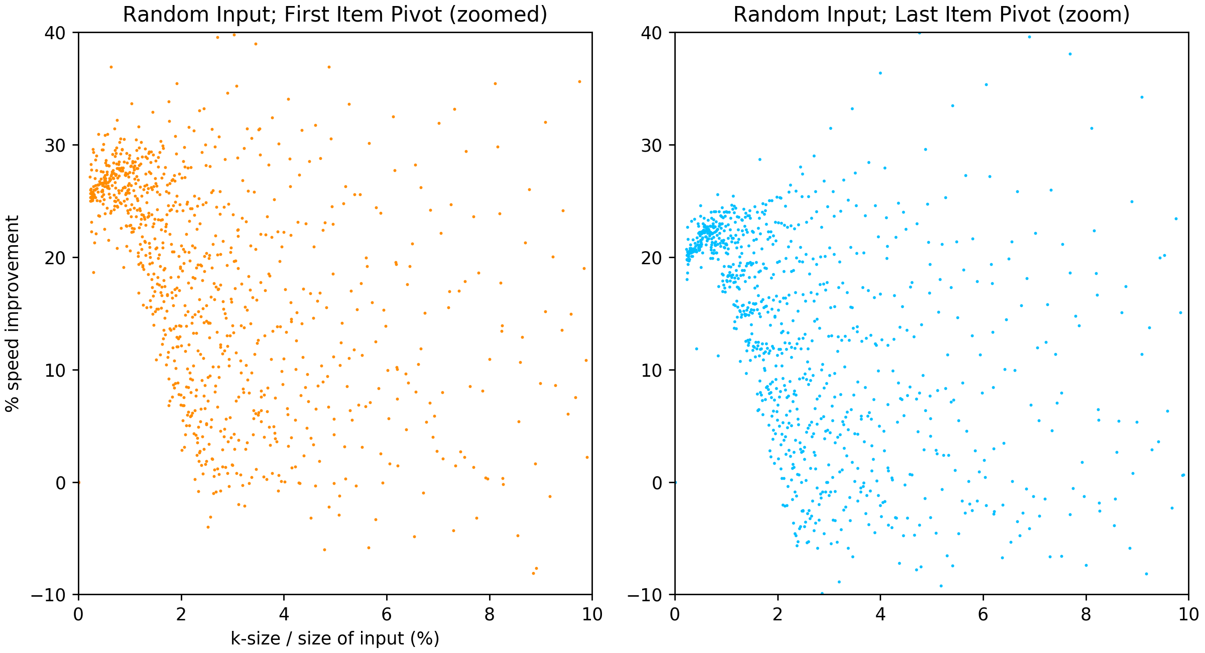

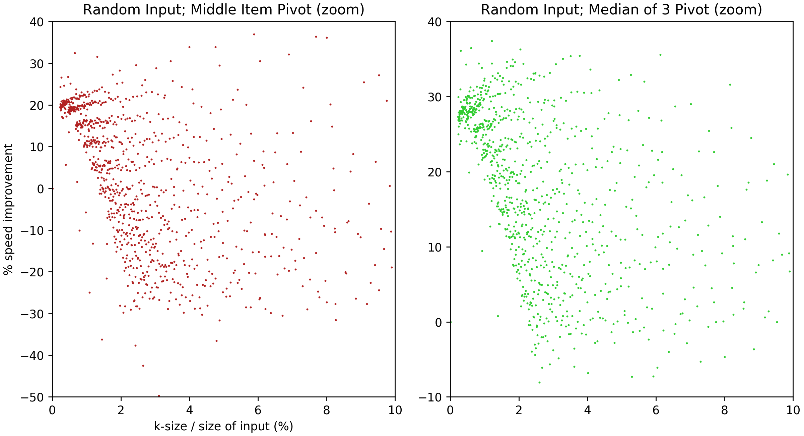

The performance curve for the random pivot on a randomized input data is distinctly different than the others. This shows a fast rise in performance over the first 2-3% that then goes flat or possibly degrades slightly. Unlike the other pivot-selection methods, the random pivot performance does not drop back down to the level of a pure QuickSort or lower—you generally get to keep the performance gains regardless of how high the k-value gets. And these are major improvements: an 80-85% improvement with k-value ratios of 1-3%.

