Introduction 3
Description of Modular Structure System 3
System Design Flowcharts 4
Educational Tools 5
Algorithm Editing 5
Hierarchy Charts 6
Structure Chart 6
Design Data Dictionary 7
OriginalImage 7
TemporaryImage 7
EditedImage 7
RGBvalue 7
Redvalue 7
Bluevalue 7
Greenvalue 8
Record: RedTolerance 8
RedTolerance.min 8
RedTolerance.max 8
EdgeTolerance 8
FunctionRequired 8
NeighbourMean 9
NeighbourMedian 9
Description of record structure (not applicable) 9
Validation Required 9
File organisation and processing 9
Name and Purpose 9
Structure 9
Sample of planned SQL queries (not applicable) 10
Identification of storage media 10
Pseudocode 10
Sobel Edge Detection 10
Laplacian Edge Detection 11
Smoothing 11
Noise Reduction 11
Grey-Scaling 12
Red Eye Reduction 12
General Algorithm 12
Graphic User Interface Design 12
Prototyping 12
Main Program 13
Usability 14
Colour Scheme 14
Input/output devices 14
Error messages, feedback and dialogue boxes 15
Exits and actions 15
Test Plan 15

Design

Introduction
For the purposes of this project I decided that it would be a good idea to make the system in three separate parts: Graphic User Interface (GUI), Logic, and Data Access. The GUI will deal with the basic processing of the user input (making sure it is the correct format, making it easy for the user to do what they want), and pass it on to the logic part of the system. The logic section will pass data back to the GUI, which will output this data to the user. The logic section will be the actual workings of the program; in this case handling bitmaps and pixel data, applying algorithms, etc. data will be passed between the Logic section and the GUI, and between the Logic section and Data Access section. The Data access section manages communications with the Data Storage, separating out the Data Handling from the Program Logic. There is no direct connection between Data Access and GUI sections of the system.
This way of breaking down the program into its constituent parts is known as the 3 box model as there are 3 separate parts of the system.

Description of Modular Structure System
The System Can be broken down as follows:
- The Implementation of the Required Image Manipulation algorithms
- The Educational tools (Explaining how the algorithms work)
- The ability for the user to edit the algorithms (to an extent)
To a large extent the educational tools will be built into the other systems (i.e. information on the algorithms will be displayed when the algorithms are applied), however some information will be accessible without actually having to do any image editing for reference.
These general processes can be described using a series of system flowcharts. The key for these flowcharts is shown below:
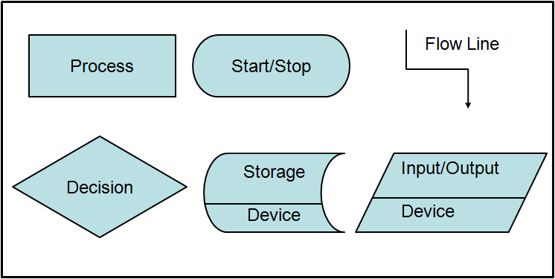

System Design Flowcharts
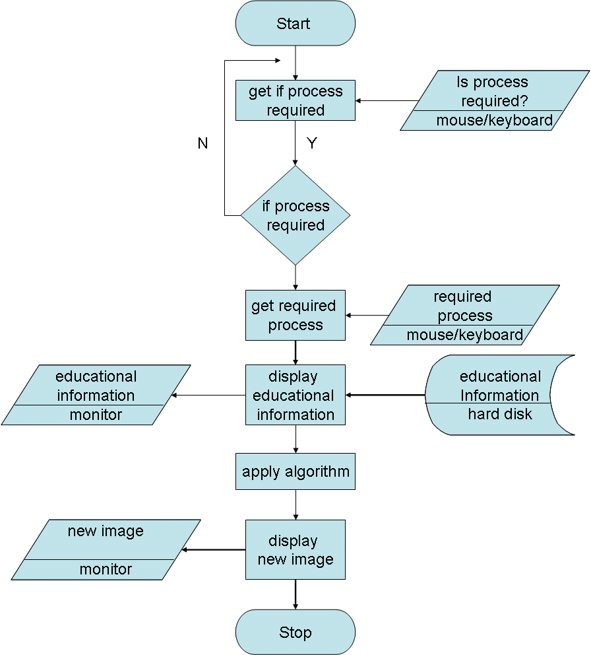

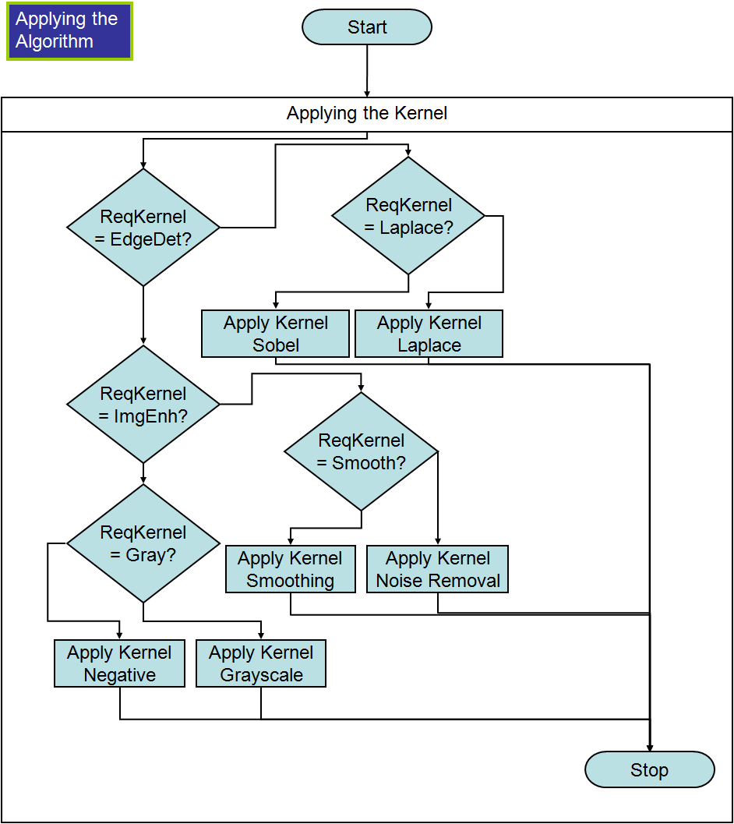
The apply algorithm function is triggered when the user wants to edit the image, and gets the required operation, and carries it out on the image which has already been inputted prior by the user, having displayed information on how the algorithm works to the user. The nested loop statement

Educational Tools
The tools will be fairly simplistic, as in an electronic-textbook style resource, as well as being integrated into the other parts of the system. As such I believe it would be unnecessary to provide flowcharts for this part of the system.

Algorithm Editing
The System must be able to allow the user to edit the algorithm so that students can see how changing the algorithm changes the outputs. In terms of the algorithms used this mainly involves editing the tolerances of the red eye algorithm, but also the sobel algorithm if it is included in the final system. This is a simple selection process so if feel no system flowchart is required.

Hierarchy Charts
Hierarchy charts are used here to show how the system functions link together; how each module is connected to others
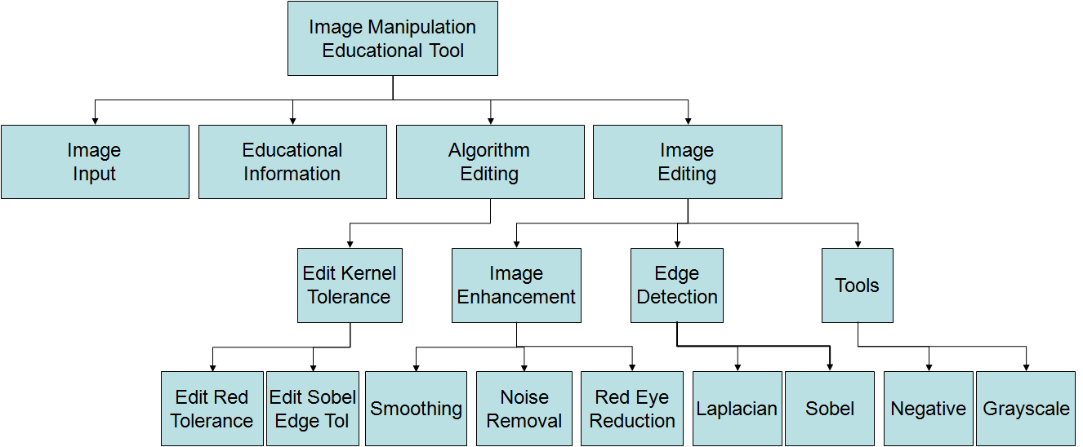
Structure Chart
The Structure chart is an extension of the Hierarchy Chart that also shows the flow of data between the modules
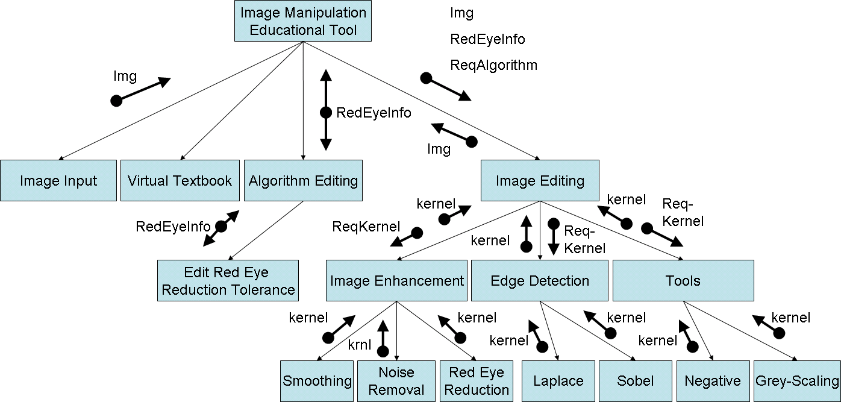

Design Data Dictionary

OriginalImage
Description | The Original Image inputted by the user (a copy will be made for editing by the program)
Validation | Must be a bitmap image with a not yet defined size boundary (<x by <y pixels)

TemporaryImage
Description | Because Kernels are applied to the original image a Temporary Image must be created by the program before the finished edited image is saved
Validation | Must be a bitmap image with a not yet defined size boundary (<x by <y pixels)

EditedImage
Description | The Copy of the Image Created by the program for editing
Validation | Must be a bitmap image with a not yet defined size boundary (<x by <y pixels)

RGBvalue
Description | The data contained in a pixel (the RGB value)
Validation | Must be a Integer of a certain length depending on the nº of bits per pixel (8 bit, 16 bit, 32bit, 64 bit)

Redvalue
Description | The Part of RGBvalue which represents red extracted from it.
Validation | Must be an Integer of a certain length depending on the nº of bits per pixel (8 bit, 16 bit, 32bit, 64 bit) where a certain number of those bits represent red.

Bluevalue
Description | The Part of RGBvalue which represents blue extracted from it.
Validation | Must be an Integer of a certain length depending on the nº of bits per pixel (8 bit, 16 bit, 32bit, 64 bit) where a certain number of those bits represent blue.

Greenvalue
Description | The Part of RGBvalue which represents green extracted from it.
Validation | Must be an Integer of a certain length depending on the nº of bits per pixel (8 bit, 16 bit, 32bit, 64 bit) where a certain number of those bits represent green.

Record: RedTolerance
Description | A record containing both the minimum and maximum value for which a pixel is said to be red
Validation | n/a

RedTolerance.min
Description | An Integer containing the minimum and minimum value for which a pixel is said to be red
Validation | Must be a Hex Integer of size corresponding to that of the Hex data contained in each pixel of the image being edited

RedTolerance.max
Description | A Hex Integer containing the minimum and maximum value for which a pixel is said to be red
Validation | Must be a Hex Integer of size corresponding to that of the Hex data contained in each pixel of the image being edited

EdgeTolerance
Description | An integer value for which an Edge in one direction is said to be found if the value of a pixel after the sobel algorithm has been carried out
Validation | Must be an Integer between certain as yet undefined values (x<EdgeTolerance<y)

FunctionRequired
Description | Each function will have an integer value assigned to it so it can be identified as the required process
Validation | A m Integer within a certain range (considering this will be a constant, this is not really appropriate)

NeighbourMean
Description | The Mean of all the neighbours of a pixel as well as the pixel itself (used in the smoothing function )
Validation | An Integer Value within a certain range depending on the number of bits per pixel

NeighbourMedian
Description | The Median of all the neighbours of a pixel as well as the pixel itself (used in the Noise Removal function )
Validation | An Integer Value within a certain range depending on the number of bits per pixel

Description of record structure (not applicable)
The proposed system will have a simple save structure not linked to a database so this part of the design would not be appropriate.

Validation Required
Detailed information about validation of variables is included in the Design data Dictionary so this section is not really useful.

File organisation and processing
Due to the nature of the system most of the information will be stored on the portable media it is being run on, but it should also be possible to copy the entire program file structure to the user’s computer for more rapid program execution.

Name and Purpose | Structure
ImageManipulationEducationalTool_1.0  Contains executable | ----ImageManipulationEducationalTool_1.0  | ImgTool_1.0.exe
Docs  Help Information and a plain pdf version of the Image Manipulation virtual textbook | |----Docs  | IMET_Readme.txt  | IMWT_Help.pdf  | IMET_textbook.pdf
SampleImages  Sample Images which are useful for showing students the effects of each image editing technique without them requiring their own images | |----SampleImages  | Sample1.bmp  | Sample2.bmp  | Sample3.bmp

Sample of planned SQL queries (not applicable)
There are no SQL queries in this solution as it is not based on a relational
Database.

Identification of storage media
The program folder containing the executable and other data will be stored on a USB drive but will also be distributed via optical disks. The program must either be run direct from the USB or the program folder must be copied to the computer, and then executed from there. Temporary images will be stored inside the program folders, but the user will have to save permanent images to their own computer

Pseudocode
For all of the algorithms below, unless stated otherwise, the pixels must be broken down into their separate colours before any kernel is applied

Sobel Edge Detection
The Sobel algorithm uses 2 3x3 kernels, one for the y-direction one for the x-direction. They i described by http://www.pages.drexel.edu/~weg22/edge.html , which cites each one in turn.

/* 3x3 GX Sobel mask. Ref: www.cee.hw.ac.uk/hipr/html/sobel.html */
GX[0][0] = -1; GX[0][1] = 0; GX[0][2] = 1;
GX[1][0] = -2; GX[1][1] = 0; GX[1][2] = 2;
GX[2][0] = -1; GX[2][1] = 0; GX[2][2] = 1;

/* 3x3 GY Sobel mask. Ref: www.cee.hw.ac.uk/hipr/html/sobel.html */
GY[0][0] = 1; GY[0][1] = 2; GY[0][2] = 1;
GY[1][0] = 0; GY[1][1] = 0; GY[1][2] = 0;
GY[2][0] = -1; GY[2][1] = -2; GY[2][2] = -1;

As shown in here the pixels are ‘scanned’ left to right, then bottom to top. The best way to implement a kernel based system is to store the grid positions of each pixel so that it is easy to carry out the operations using the surrounding pixels.

Laplacian Edge Detection
The single 3x3 Laplacian kernel is described below
G[0,0] =-1 G[0,1] =-1 G[0,2] =-1
G[1,0] =-1 G[1,1] =8 G[1,2] =-1
G[2,0] =-1 G[2,1] =-1 G[2,2] =-1

This kernel will be applied to the image in the same way as the Sobel algorithm except with only one kernel being applied once, not one kernel for each direction with both kernels being applied separately and “collated”.

Smoothing
The basic algorithm is this:
G[1,1] ← (G[0,0] + G[0,1] + G[0,2] + G[1,0] + G[1,1] + G[1,2] + G[2,0] + G[2,1] + G[2,2]) div 9

Though not technically a kernel, this algorithm works like one as it is ‘sild’ over each pixel in turn like one.

Noise Reduction
The basic algorithm is this:
G[1,1] ← median(G[0,0] + G[0,1] + G[0,2] + G[1,0] + G[1,1] + G[1,2] + G[2,0] + G[2,1] + G[2,2])

Though not technically a kernel, this algorithm works like one as it is ‘sild’ over each pixel in turn like one just like Smoothing, and these algorithms have very similar effects as they both rely on taking an average. In order to take a median the pixels must first be sorted however. The sort I wish to use is the insertion sort:
for i ←to length(kernelarray-1)
begin
value ← A[i]
j ← i - 1
done ← false
repeat
if A[j] > value then
begin
A[j + 1] ← A[j]
j ← j - 1
if j < 0 then
done ← true
end
else
done ← true
until done
A[j + 1] ← value
end
end

this is a standard algorithm and as such I have edited a version from wikipedia.

Grey-Scaling
Red ← PixelColor.Red
Green← PixelColor.Green
Blue ← PixelColor.Blue
Gray ← Round(0.3 * Red + 0.6 * Green + 0.1 * Blue)

In the grayscaling algorithm there is no kernel, instead each pixel must have its individual colour values extracted, multiplied by constants which represent how important each colour of light is to the human eye, and then the resulting weighted “average” of the 3 colour values describes the shade of gray that pixel must become.

Red Eye Reduction
if RedEyeTolerance.min < RGBvalue < RedEyeTolerance.max then RGB value := 777777

General Algorithm
For Gx ← 1 to xlength-1
For Gy ←1 to ylength-1
Begin
ApplyKernel[Gx,Gy]
End

This algorithm goes through the image applying the kernel to each column of 3x3 pixel blocks in turn. In this version it omits the outer edge of pixels as 3x3 kernels do not work on edges so they must be removed afterwards. For the Red Eye, Grayscale and Negative functions this will not be necessary as they do not use kernels.

Graphic User Interface Design

Prototyping
I have made prototype forms for each section of the GUI:

Main Program
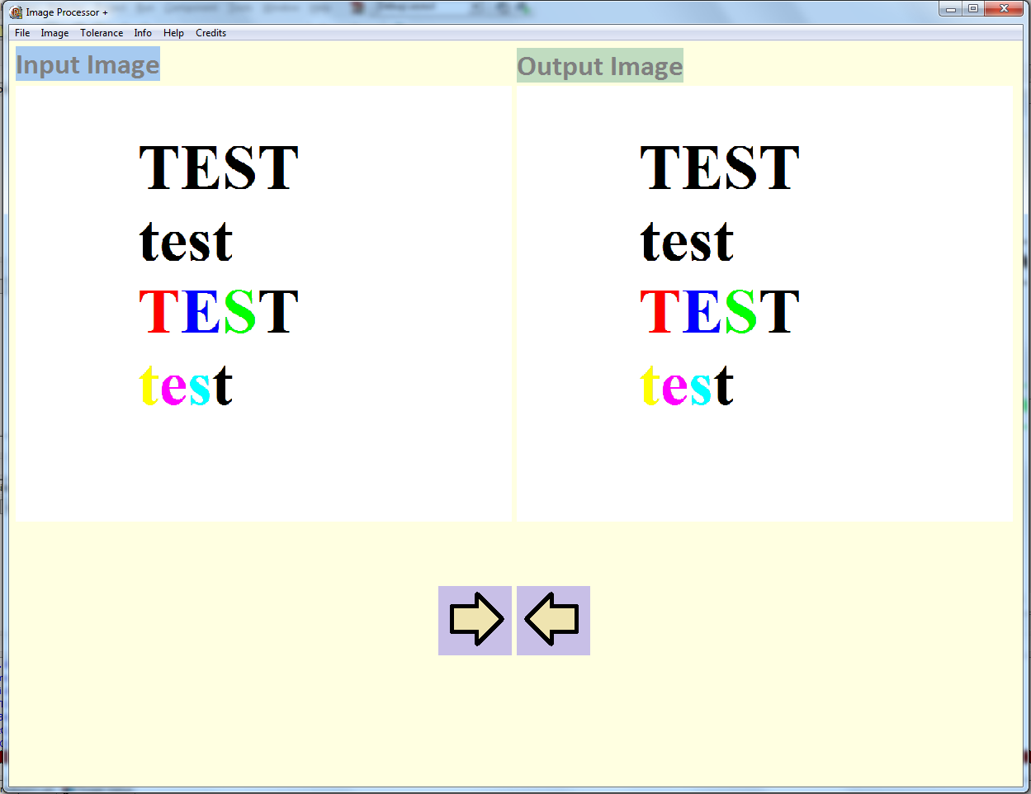
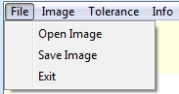
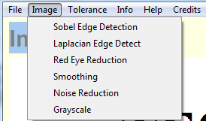
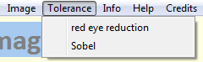

Red Eye Reduction Tolerance Editor
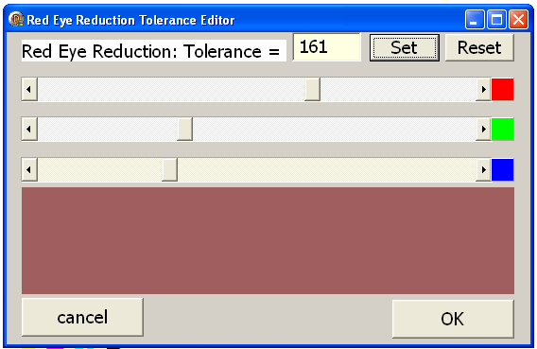

Educational Information Display
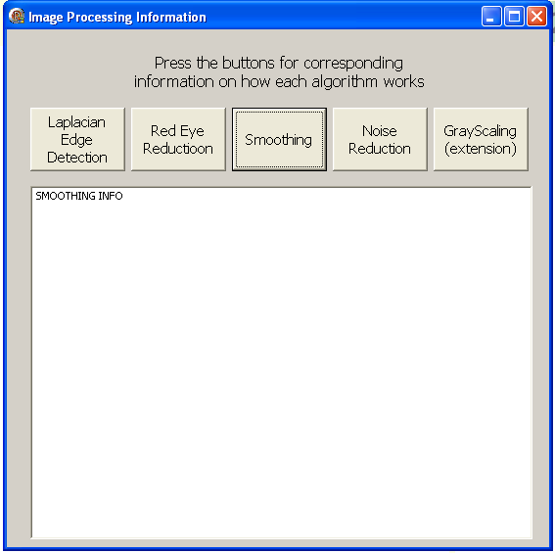

Usability
The best way to present the system to make it easy to use would likely be drop down menus, the structure of which would be thus:
- File
  - Open Image
  - Save Image
  - Exit
- Edit
  - Undo (only one temporary image will be saved at a time so can only be carried out once)
  - Redo (only one temporary image will be saved at a time so can only be carried out once)
- Image
  - Sobel Edge Detection
  - Laplacian Edge Detection
  - Smoothing
  - Noise Removal
  - Red Eye Reduction
  - Grayscaling
  - Negative
- Tolerances
  - Sobel
  - Red Eye Reduction
- Info (will display Educational Information)
- Help
- Credits

There should then be a display of the original image and the edited image in the form below. Quick buttons for undo, redo, and help may be useful; however I have not included them in my prototype. I have however included a left and right button at the bottom of the page for setting the input image to the output image and vice versa on the main form. N.B. Open Image will always open to Input image and Save Image always saves the Output Image.
The tolerance editor for red eye reduction consists of three bars for editing each colour and a preview box displaying the chosen tolerance. The SET button previews the colour and enables the OK button after checking inputs are in range.
The “Virtual Textbook” will display written information about each of the relevant anlgorithms when prompted by button presses.

Colour Scheme
Being an educational program the scheme should be fairly sober, and should follow usual text on background rules where text is dark on light and no similar colours are used for text and background. There is currently no need for high contrast support for the visually impaired.

Input/output devices
The only user inputs and outputs supported by the program will be the computer monitor, keyboard and mouse. Due to the nature of the program there is no need for any other peripherals (n.b. It may be desirable for a print procedure to be included, but this is not essential, so I have currently omitted it).

Error messages, feedback and dialogue boxes
Basic error messages such as “error: invalid input” and “error: file to large” should suffice for the system planned, as there are no complex inputs for the user to have to deal with. It must be necessary to inform the user if the image file they are attempting to open is not supported by the program, however It has not yet been decided which file types will be supported. However error messages for when there is a problem with the system must also be devised, which may include error codes which the user can reference against a help for example.

Exits and actions
To prevent unwanted loss of data, “are you sure you want to overwrite this file”, “do you want to save changes before exiting” and “are you sure you want to exit” type error messages may be useful.

Description of measures for planned system security
Because I have no plans to sell my system as a product I will not be adding any licensing keys into the product or any other systems for stopping duplication of the system. I also see no need to protect the source code as it may be useful for advanced users to analyse it, and as such I may include a copy of the source code with my program so that interested users can analyse it. There will also be no sensitive data used in the program so I see no reason to add any data encryption into the system especially as it does not involve communicating data from one device to another. To these ends I feel there are few security measures I will need to include within the program

Test Plan
n.b. currently included in testing section but requires some reformatting before transferral

