Action: reformat according to JECH manuscript structure and requirements

Abstract

Action: write abstract

Key message: The implication of this is that excess male mortality may not be inevitable, and that it was not evident in the USA before before 1960, except during the end of both World Wars.

Sex differences in life expectancy: not a thing of the past

Introduction

It is widely accepted that women, on average, live longer than men. At various stages over the life-course, women now have the edge (1-8). Male infant mortality rates are thought to have always been higher than female infant mortality rates (4), but until childbirth became safer more women than men usually died in their twenties and perhaps earlier (9).

Action:[work in that for Cuban/SAmerican mothers in USA=>exception to infant mortality sex difference, maybe further down (Matthews and MacDorman 2013)]

Today coming of age, reaching adulthood and leaving the protection (or confines) of parents or carers, confers more of an additional mortality risk for males than for females (10, 11, subsection). Males now 'age' both sooner and faster than females (subsection). Until recently in all of the world women were at a greater risk of death during child-rearing ages than men (9). Now there are only a handful of countries where women die, on average, earlier than men, but maternal mortality remains a major, if declining, killer worldwide (12).

Action: Add a subsection showing how males ‘age’ faster than females

If trends over the last century are ignored it is easy to think of current sex differences in mortality as simply a product of innate biological differences. This paper aims to challenge that perspective, by showing that age-specific mortality differences between males and females have varied across time, and between countries. Although it is true that everywhere males tend to have higher mortality risks than females at infancy, at early adulthood, and in older years, there have been substantial variations in the magnitude of these differences over time and between nations.

Other recent work has referred to these differences and some attempts have been made to explain them.

Researchers from the Wittgenstein Centre for Demography and Global Human Capital and the Vienna Institute of Demography reported in 2013 in the journal Gerontology that the excess male mortality seems to result from high mortality among subpopulations, more common among men, who experience higher mortality than women and thereby bring down overall life expectancy for all men compared to women. They conclude that these differences are not natural differences but that they result from socioeconomic conditions that could ameliorated (13).

In other animals, there is evidence that males live shorter lives than females though we found no studies that claimed to be able to say definitively whether this was a natural difference or a risk-based difference, or a difference due to other causes. In other animals, the idea that the difference varies has also been explored. For example, it has been observed in populations of birds that sex-biased adult mortality predicts adult sex ratio—which affects various social processes, including male aggression, courtship behaviour and whether males or females look after the young (14).

In humans, the gap in life expectancy between men and women seems to be closing. As life expectancy rises overall, and at the same time women make fewer gains relative to men, it may be that this is because women's risk profiles now are more similar to mens..  However, this convergence is only apparent after 1980. Men took up smoking much earlier than women and so it may well be a temporary effect of women being more free to smoke in the 1960s and 1970s. Now that smoking rates for both men and women have fallen the convergence may not continue.

These trends have been reflected somewhat in public policy in Europe. In 2012 the European Union ruled it unethical and illegal to require men to pay higher rates than women for life insurance, on the basis that this amounts to unfair sex discrimination against men (15), in spite of differences in mortality risk resulting in higher mortality rates among men at most points across the life course.

The changing nature of inequality in life expectancy between men and women is rarely discussed among health inequalities researchers, presumably because it has not been considered to be an inequality resulting from unfair practices or processes. We wanted to find out whether new methods of visualizing data collected across the last 60 years could illuminate the issue: is there evidence that this is a natural difference, or is there evidence that this is a risk-based difference, or something else?

We hypothesised that this sex difference is a natural / biological difference and sought to test our hypothesis by observing trends over time: have the differences increased, decreased, or remained static over time? In this paper we ‘fly a series of kites’ none of which can yet easily be tested statistically without making heroic assumption about “all else being equal”. Instead of doing that we try to suggest what the most fruitful future lines of inquiry might be given what we can see today and using new methods of seeing the data.

Methods

In order to see how sex mortality inequalities have varied over time, we used population count and death count data from the Human Mortality Database (HMD). The HMD contains these data for 37 separate countries, separately for males and females. HMD data are available at a 1 year by 1 year resolution, i.e. population count data and death count data are available for each year of age from newborns up to the age of 110 years, and for largely continuous ranges of years. Within the HMD, Sweden has the longest duration of records, with records dating back to 1751. France, Denmark, Iceland, Belgium, Norway and England & Wales then have the next oldest available records, stretching back to the first half of the nineteenth century; and the Netherlands, Scotland, Italy, Switzerland, Finland and Scotland have records that data to the second half of the nineteenth century. These datasets allow changes in sex mortality differences to be tracked for more than six generations, and provide some longer term historical context to more recent changes. The focus within this paper will, however, be on changes that have occurred within the previous fifty years, around two generations, as records from more countries are available over this period (16).

In order to see how sex mortality inequalities have changed over time, the ratios of male to female crude mortality rates were calculated for each country, age and year combination, i.e.

Where the superscripts, m or f, indicate male or female, D indicates death count, P indicates population count, and the subscripts indicate a particular combination of country, age, and year respectively.

For each country, the mortality rate ratios were arranged into a tabular configuration known as a Lexis surface, with each row representing a different age and each column representing year. [REFERENCES] The Lexis surfaces were visualised as shaded contour maps as described in Minton, Vanderbloemen and Dorling (2013), Minton (2013), and Minton (2014). Contour maps borrow conceptually from orienteering, showing how the height of a surface varies over space. Each contour is individually labelled with its particular value, and traces out a path along the surface where the height does not vary; the presence of many contour lines close together indicates a section of the surface where height varies steeply, and contour lines further apart indicate a more gradual variation over the surface.

Because the Lexis surface is of ratios, such the value 5/4 should be thought of as equal in magnitude but opposite in effect to 4/5, shades are coloured red if the ratios are below 1, indicating a higher female than male mortality rate, and coloured blue if the ratios are above 1, indicating higher rates of male than female mortality. The darkness of the shade is determined by the magnitude of the logarithm of the ratios, so that 4/5 will be as dark but red as 5/4 is dark but blue. The addition of shade to the contours makes it easier to distinguish between high and low sections of the surface at a glance, although perceptual distortions due to people interpreting shades in relative rather than absolute terms mean that it should be interpreted alongside the labelled contours. Before being re-discovered by Minton and colleagues (2013, 2013b, 2014) they were used extensively by Vaupel and colleagues in the late 1980s and early 1990s (Vaupel refs). The origins of using either shading or contours to visualise demographic data are much older. (Kermack etc)

All calculations were performed using the statistical programming language R. (Version 3.1.0). The lattice package (REF Sanyar) was used to produce the contour plots.

Action: Make sure I (Jon) do as I’ve just promised to do above! I’ll post you a lego jet for your desk if you do : )

Metrics are of differences in log mortality - can 'slice' the mortality surface in any of three ways:

age - differences at time periods (vertical slice)

time period - controlling for age (horizontal slice)

cohort - historic (diagonal slice) ; synthetic (reverts to vertical slice)

If differences between age-specific mortality rates have not changed over time then we will see a long series of horizontal age.

If year is what matters most then we will see a lot of vertical years

If a combination then we will see neither just vertical or just horizontal lines.

3. Stata / Bathtub curves in R: Odds ratios [odds of mortality for 20 year old men compared to 20 year old women with 20 year old men in 1900 as reference group, compare to 1920, 1940, 1960, 1980, 2000)?

Jon: I think another series of graphs - bathtub curves - will be useful as well as/instead of ORs

How concerned should we be about statistical significance given that we're dealing with whole populations?

Results

Using mortality data from the United States across a period of 60 years, we observe evidence that sex differences in life expectancy have not remained static over time. One obvious feature in the diagram below is the “smoking cloud” of very high excess deaths of older men centered around the year 1970. Several decades earlier most (then younger) men smoked and far fewer women did. This “cloud: is well known. The “cliff” in the reduction of mortality inequality by sex at younger ages in the years before 2000 has not been commented on before, or necessarily observed as clearly as we can see it in these diagrams

fig 1 USA

The difference began to increase around 1943 in the United States and intensified for the 15-25 year old age band across the 20th century, most notably around 1975 and 1990.

Another increase in excess male mortality that appears may be a Vietnam war ‘plume,’ i.e the triangle of excess male mortality for men between 1963 and 1998. This could have been due to excess deaths among men because of the Vietnam war, and persisting effects to the health and mental health of men affected by the war.

Alternatively, this excess in male mortality could also have been affected by AIDS deaths, which were more common among men than women during part of this period (17).

Since the age band affected in the plume is most apparent for 25 to 45 year olds, there is support for both of these hypotheses, and similarly to previous findings (10,11) perhaps a particularly difficult time in history for men is characterised by not just one major threat to health, but by multiple threats. Between 1963 and 1998, men in the USA faced both the Vietnam war and the Gulf War, HIV/AIDS and multiple economic recessions which damaged their traditional role as “breadwinner.” (early 1970s, 1980s and early 1990s recessions)

Excess mortality for men was trimmed dramatically around 1995, perhaps indicating better times for men, or worse times for women, or both simultaneously.

fig 2 USA + Canada

Looking at a comparable contour plot for Canada, there is support for these ideas. Canadian men would have been similarly affected by AIDS but not as much by the World Wars, the Vietnam war (there is less of a triangular plume of excess mortality reaching into the 25-40 year old age bands in the Canadian data). Or is that just because the data for Canada are till 2000 and the plume doesn’t show?

While excess male mortality drops off for most men after 1998, the excess male mortality continued for men who were 49 years old in 2005. This is evident by observing the continuation of the orange ‘plume' for 49 year olds on the USA contour map. These men would have been born in 1956, the year after the US began its involvement in the war (although the main involvement was frm 1965 to 1973). (18).

Looking at those men who were 19 (the average of participants in the Vietnam war) in 1965, there is evidence of male excess mortality during the war...

Beginning around the end of the 1940s, a mortality difference among boys and young men (15-25 years old) appears and persists across the period of available data (2010). A possibility is that this increased difference in the USA among 15-25 year olds is due to road traffic accidents, as car ownership became widespread and historically men were driving far more than women, and the 20 year old age groups were likely the highest risk groups.  (Ref, CDC chartbook 2010, death rate from motor vehicle accidents 5x higher among men compared to women, check by age.)

Did we find parallels or contrasts in other countries?

fig 2: four other countries, maybe?

1. England / Wales

2. Scotland

3. Denmark / Germany / Netherlands

4. France

Conclusions: war, tobacco, traffic, emerging infections/immune disease and economics

During the period from 1943 to 2010 differences in male versus female life expectancy emerged, most notably among younger men ages 15-25, but also among older men who were born around 1918 and 1961.

There are at least 5 possible hypotheses that could explain this excess male mortality.

1. This work and previous work hints at a war effect (in line with Barker effect but more specific to wars = Minton effect :) affecting both those born during a major conflict and those who participate, not only during the conflict but also across their lives.

new combat stress story (Marmar 2014): http://www.nytimes.com/2014/08/08/us/combat-stress-found-to-persist-since-vietnam.html?_r=0 claims those w PTSD 2x likely to have died by retirement age compare to those wo

2. The increased difference among 60 year olds which appears around 1950 could have been due to smoking behaviour, more common among men until around 1970.

3. When car ownership became widespread in the USA, men were more likely to drive than women, and also to have fatal traffic accidents. This may have changed by 1995 when young women were as likely to drive as young men, and nearly as likely to have fatal accidents as men, perhaps indicating that seat belt laws and airbag technology have prevented deaths in spite of traffic accidents.

4. Emerging infections during the 1980s such as HIV, and the human response to them in the form of immune disease followed almost always by death may have contributed to the excess male mortality during the 1980s and early 1990s, when infection was more common among men and protective therapy against the development of the immune disease was not yet widely available.

5. Unemployment – especially effecting young men (doubls mortality chance).

To our knowledge this is the first study of historical trends in the sex differences in life expectancy in the USA, but our observations are consistent with other recent studies.

Mayhew and Smith reported in 2014 that there is evidence that the difference between men and women is lessening in England and Wales, suggesting that the difference is not a natural or biological difference.

...

Limitations

What else could explain what we found?

1. changes in reporting

(refinement in age of death reporting differentially refined more for women over time.

but how would this bias the result? perhaps this would have simply resulted in rounded estimates for women that became more exact, and that wouldn’t have resulted in the findings we see here)...

2. Or, there could still be a ‘natural / biological’ longevity advantage for women. If that were true then it could be that the period before the second World War was ‘unnatural’ for women; that is, if women do have a natural longevity edge over men, then perhaps the pre-war period when women in the USA had far fewer rights relative to men was the high-risk period for women, negating their natural edge. Once equal rights had been better established, the natural advantage for women re-emerged.

Implications

If it is a real result the peaks in excess male compared to female mortality may represent points or periods in history when men experienced differential stress or threats to well-being, for example economic recessions within the context of male dominated economies.

First we should establish whether it is true that sex differences in mortality are natural or not. This paper suggests that they are not natural differences but that they are the result of historical societal trends where men and women were differentially protected or stressed compared to each other. ?

Second we should establish whether, if sex differences in mortality were truly a result of human activities and societal structures (or something else) rather than biology, or interacting with biology, whether this inequality in health between men and women can be lessened and what activities would lead to longer healthy lives for men as well as for women.

Since there is evidence that women may be beginning to experience increased mortality due to less healthy behaviours such as smoking so that their mortality looks more similar to that of men, it is important to understand the baseline situation: is the difference a natural one or not? If it is a natural difference, then what caused men and women to have similar life expectancy before the World Wars? If it is not a natural difference, then what threats to healthy lives need to be identified to prevent this excess mortality in the future?

References

1. Matthews TJ, MacDorman MF. Infant mortality statistics from the 2010 period linked birth/infant death data set. Natl Vital Stat Rep. 2013 Dec 18;62(8):1-26.

2. Person MK(1), Esposito DH, Holman RC, Mehal JM, Stoll BJ. Risk Factors for Infectious Disease Death among Infants in the United States. Pediatr Infect Dis J. 2014 May 21. [Epub ahead of print]

3. Duong HH(1), Mirea L(2), Shah PS(3), Yang J(4), Lee SK(5), Sankaran K(1). Pneumothorax in neonates: Trends, predictors and outcomes. J Neonatal Perinatal Med. 2014;7(1):29-38. doi: 10.3233/NPM-1473813.

4. Muenchhoff M(1), Goulder PJ(2). Sex differences in pediatric infectious diseases.J Infect Dis. 2014 Jul 15;209 Suppl 3:S120-6. doi: 10.1093/infdis/jiu232.

5. Rochelle TL(1), Yeung DK, Bond MH, Li LM. Predictors of the gender gap in life expectancy across 54 nations. Psychol Health Med. 2014 Jul 8:1-10. [Epub ahead of print]

6. Thakkar JP(1), McCarthy BJ, Villano JL. Age-specific cancer incidence rates increase through the oldest age groups. Am J Med Sci. 2014 Jul;348(1):65-70. doi: 10.1097/MAJ.0000000000000281.

7. Van Oyen H(1), Berger N, Nusselder W, Charafeddine R, Jagger C, Cambois E, Robine

JM, Demarest S.The effect of smoking on the duration of life with and without disability, Belgium 1997-2011. BMC Public Health. 2014 Jul 15;14:723. doi: 10.1186/1471-2458-14-723.

8. Arias E. National Vital Statistics Reports: United States Life Tables, 2009. Centers for Disease Control and Prevention, National Centre for Health Statistics, National and Vital Statistics System Volume 62, Number 7. 6 January 2014.

9. Loudon I. Maternal mortality in the past and its relevance to developing countries today. Am J Clin Nutr 2000;72(suppl):241S–6S.

10. Minton J, Vanderbloemen L, Dorling D. Visualising Europe's Demographic Scars with coplots and contour plots. International Journal of Epidemiology, 42 (4): 1164-1176. doi: 10.1093/ije/dyt115. 04 August 2013.

11. Minton J 2014 SSTE article

12. World Health Organisation. Trends in Maternal Mortality: 1990 to 2013: Estimates by WHO, UNICEF, UNFPA, The World Bank and the United Nations Population Division. WHO 2014.

13. Luy M, Gast K. Do women live longer or do men die earlier? Reflections on the causes of sex differences in life expectancy. Gerontology. 2014;60(2):143-53. doi: 10.1159/000355310. Epub 2013 Nov 28.

14. Székely T, Liker A, Freckleton RP, Fichtel C, Kappeler PM. Sex-biased survival predicts adult sex ratio variation in wild birds. *Proc. R. Soc. B* 2014 281, 20140342, published 25 June 2014

15. European Court of Justice. Gender Neutral Pricing of Life Insurance. 20/12/2012. Available at: <http://europa.eu/rapid/press-release_IP-12-1430_en.htm>

16. Human Mortality Database. University of California, Berkeley (USA), and Max Plank Institute for Demographic Research (Germany). 2011. Available at [www.mortality.org](http://www.mortality.org/)

17. National Center for Health Statistics. Health, United States, 2010: With Special Feature on Death and Dying. Hyattsville, MD. 2011.

18. BBC (2005) Vietnam War History [online] Available at:  http://news.bbc.co.uk/1/shared/spl/hi/asia_pac/05/vietnam_war/html/introduction.stm [Accessed 5 August 2014].

x. Mayhew L and Smith D. Gender convergence in human survival and the postponement of death. North American Journal of Actuarial Sciences, 2013. Available at: http://www.cass.city.ac.uk/__data/assets/pdf_file/0008/141578/Les-Mayhew.pdf [ this is the link to the slides presentation]

y. Rigby JE, Dorling D. Mortality in relation to sex in the affluent world. J Epidemiol Commun Health 2007;61:159-64.

z. Marmar 2014 (forthcoming)

a. Groenendijk J(1), Hajek F(2), Johnson PJ(3), Macdonald DW(3), Calvimontes J(4),Staib E(5), Schenck C(5). Demography of the Giant Otter (Pteronura brasiliensis) in Manu National Park, South-Eastern Peru: Implications for Conservation.PLoS One. 2014 Aug 27;9(8):e106202. doi: 10.1371/journal.pone.0106202.eCollection 2014.

b. Tarín JJ, Gómez-Piquer V, García-Palomares S, García-Pérez MA, Cano A. Absence of long-term effects of reproduction on longevity in the mouse model. Reprod Biol Endocrinol. 2014 Aug 25;12(1):84. [Epub ahead of print]

Figures

Action: Add captions to all figures.

Figure 1: USA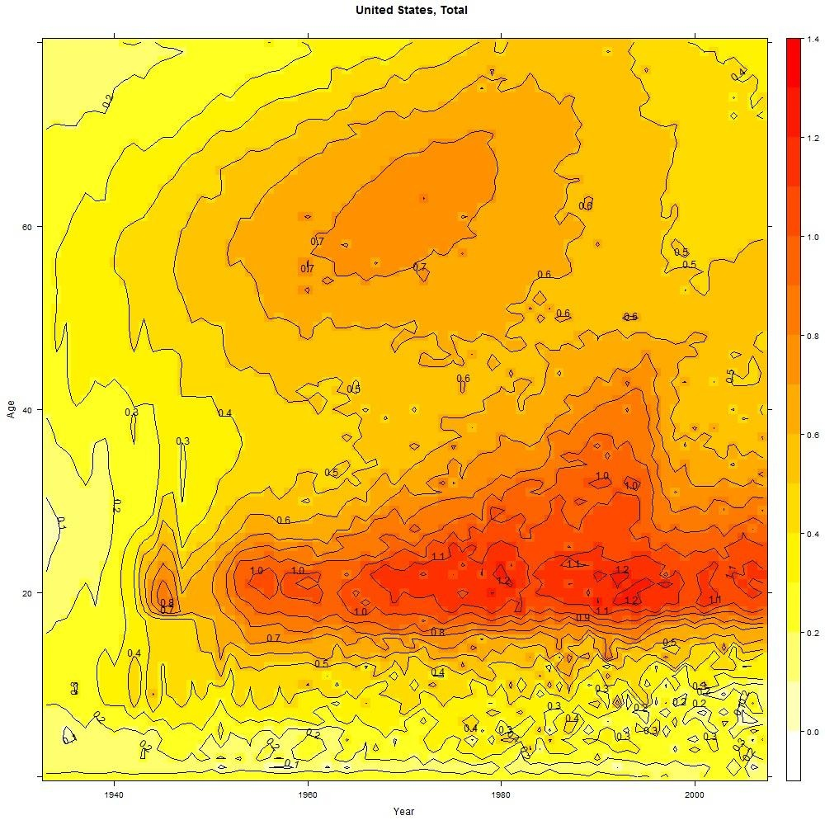

Figure 2: USA + Canada

|  |  |
| --- | --- |
|  |  |
|  |  |

Figure 3: 4 other countries to compare (England + Wales, Scotland, Germany/Denmark/Netherlands, France?)

|  |  |
| --- | --- |
|  |  |
|  |  |
|  |  |