Figures

Figure 1: Excess male mortality compared to female mortality, USA 1933 - 2010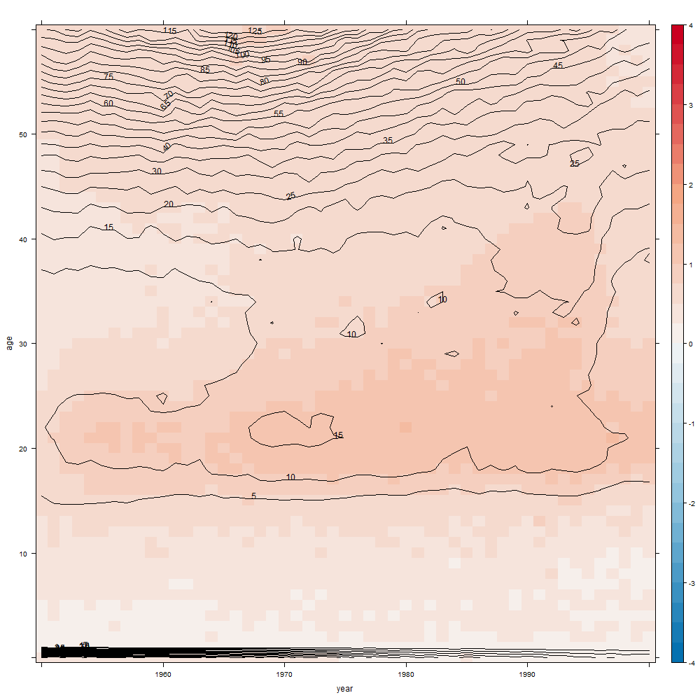

Figure 2: Vertical slices, male and female mortality by age, USA, 1933 and 2010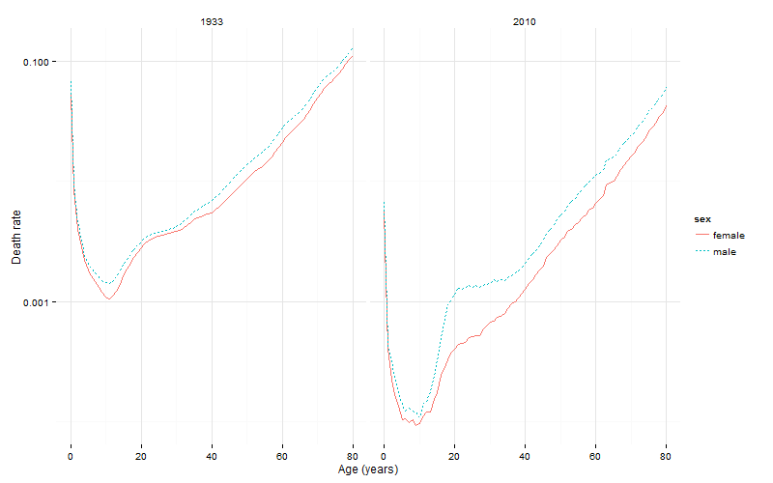

Figure 3a: Excess male mortality compared to female mortality, Canada, 1933 to 2010

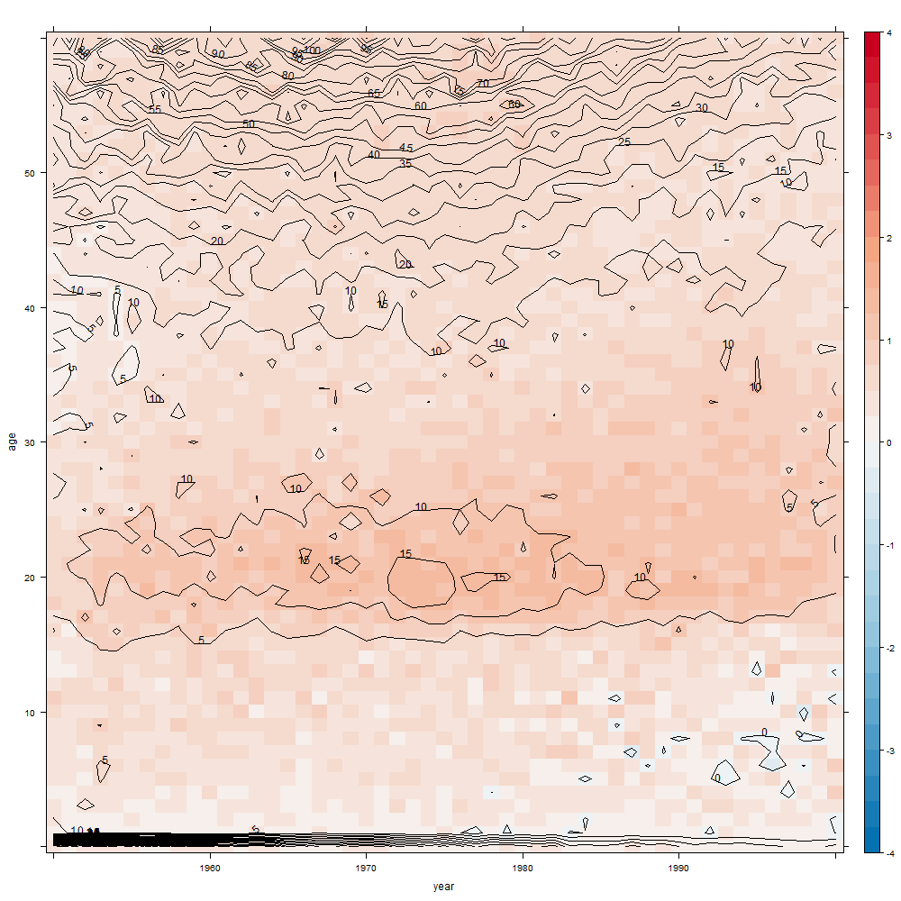

Figure 3a: Excess male mortality compared to female mortality, England and Wales, 1933 to 2010

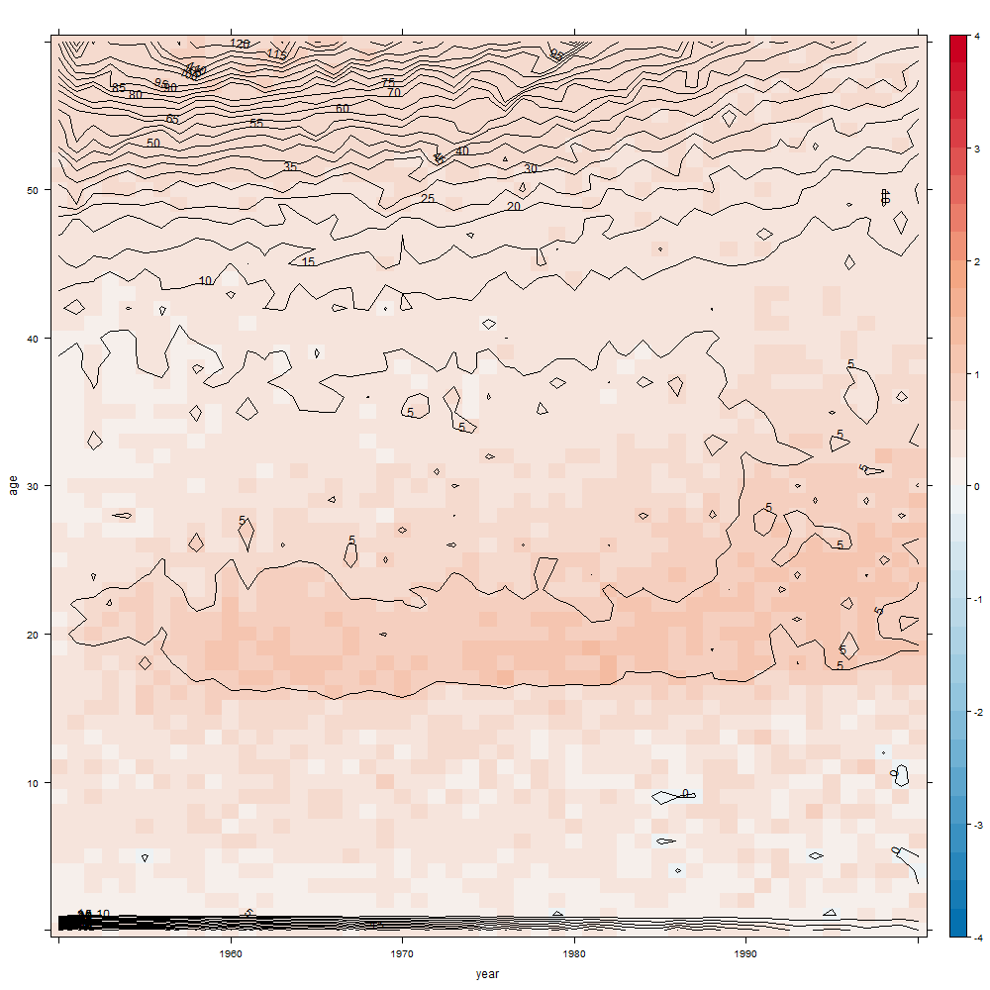

Figure 3c: Excess male mortality compared to female mortality, Japan, 1933 to 2010

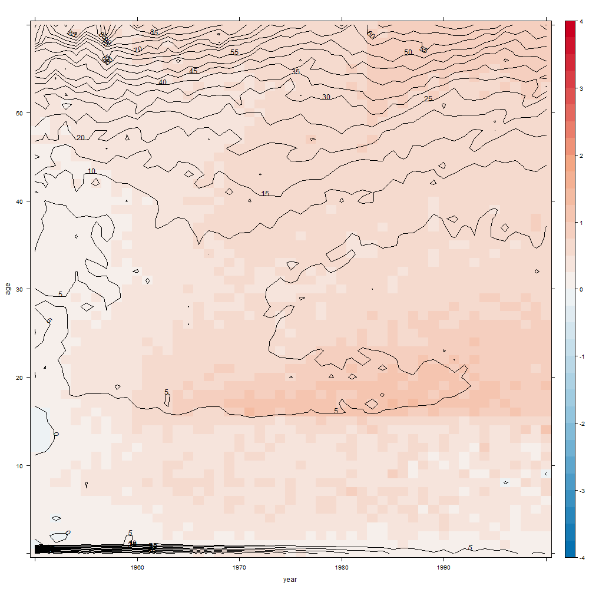

Figure 3d: Excess male mortality compared to female mortality, the Netherlands, 1933 to 2010

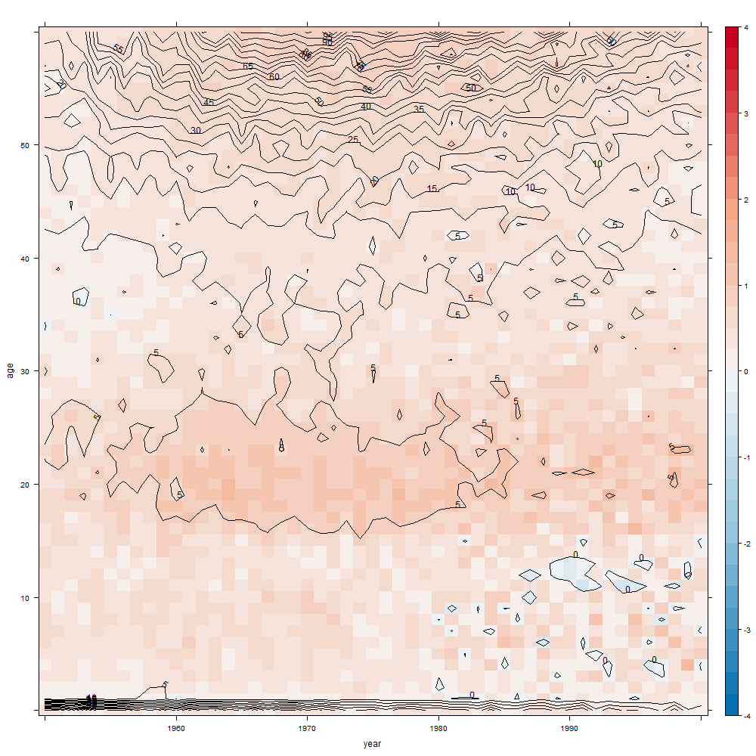

Figure 3e: Excess male mortality compared to female mortality, France, 1933 to 2010

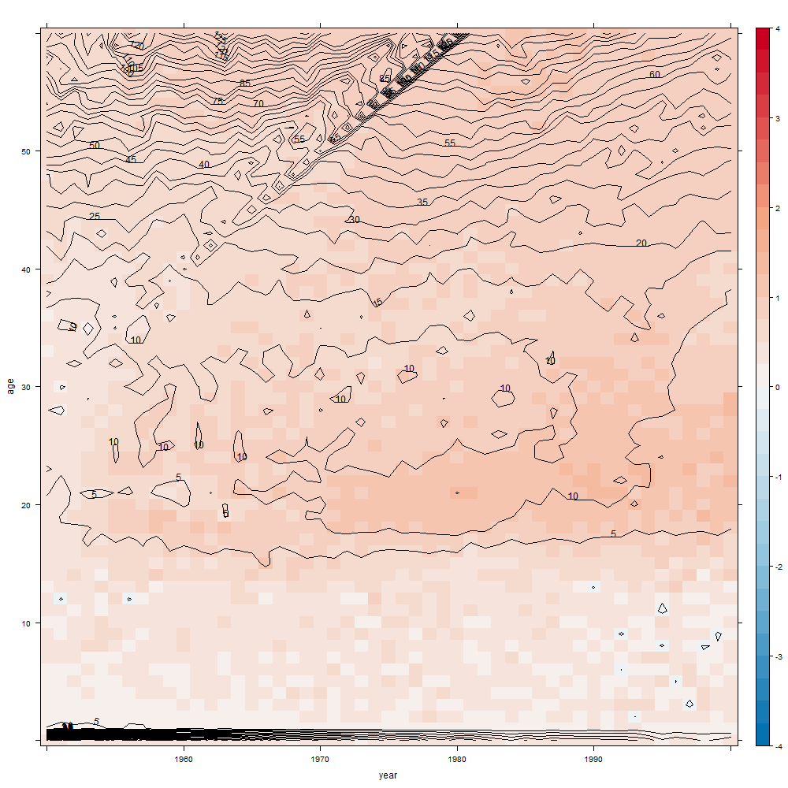

Figure 3f: Excess male mortality compared to female mortality, Sweden, 1933 to 2010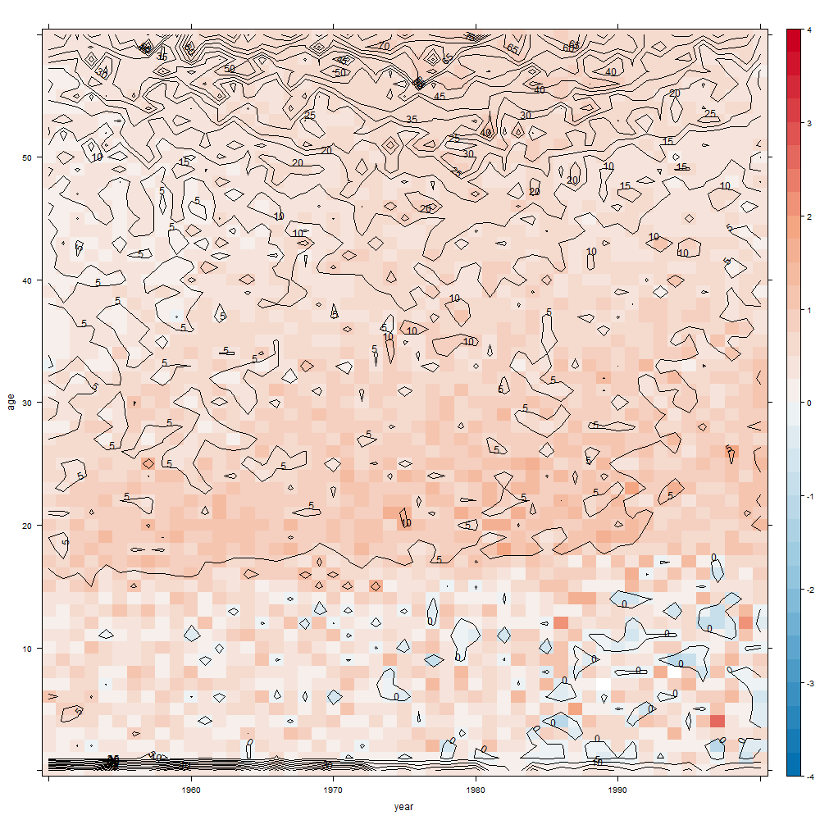

Figure 3g: Excess male mortality compared to female mortality, West Germany, 1933 to 2010

