# Structure

## Introduction

When building economic models we may need to produce a large number of estimates for the utility associated with being in a more severe health state compared with that of being in a less severe health state as part of probabilistic sensitivity analysis (PSA). Within the PSA, although we need to represent uncertainty about the true mean utility value associated with both states, we also need to represent broader clinical beliefs that there is a monotonic relationship between the mean utility values associated with the health states, so that the more severe health state will have on average a lower utility than the more severe state. This effectively means that, for each and every iteration of the PSA, the utility estimate for the more severe state should be lower than the corresponding utility for the less severe state. Often, however, we only have access to basic summary statistics about the utility associated with each health state.

In this paper we discuss ten different approaches to creating PSA estimates based on summary information about two health states we believe to be monotonically related. We have produced simulated individual patient data for the utility values associated with each patient in a moderate disease severity state (U1) and a severe disease severity state (U2). From this simulated individual level data, we produced summary statistics giving the mean and standard error of the utility value associated with each health state. It is the summary rather than individual level data which are typically available to the modellers, and so are used as the inputs for each of our approaches. We produce a list of a range of desirable and essential conditions which our methods should satisfy, and using the simulated data illustrate how well each of the approaches satisfies each of the conditions. We conclude with recommendations for practice.

## Method

### Simulated Data

Our data is of thirty hypothetical patients who progress from a moderate disease state (Stage 1) to a more severe disease state (Stage 2). The individual patient data are shown in Table 1, and the corresponding scatter plot for these data are shown in Figure 1 below. As modellers are typically interested in representing uncertainty in mean values rather than the values themselves, uncertainty in the mean scores were estimated using a bootstrapping procedure, in which the IPD were resampled with replacement 1000 times, and the corresponding mean values of U1 and U2 were extracted. This is shown in Figure 2, and represents the ‘gold standard’ against which the output of the ten methods will be compared.

|  |  |  |
| --- | --- | --- |
| Patient number | U1 | U2 |
| 1 | 0.73624 | 0.72501 |
| 2 | 0.69819 | 0.62577 |
| 3 | 0.75643 | 0.71941 |
| 4 | 0.63822 | 0.59433 |
| 5 | 0.64629 | 0.56543 |
| 6 | 0.61907 | 0.56542 |
| 7 | 0.80013 | 0.77922 |
| 8 | 0.41191 | 0.36400 |
| 9 | 0.66461 | 0.54031 |
| 10 | 0.51380 | 0.50906 |
| 11 | 0.59403 | 0.53216 |
| 12 | 0.37144 | 0.33756 |
| 13 | 0.60832 | 0.57257 |
| 14 | 0.52807 | 0.42046 |
| 15 | 0.82390 | 0.77916 |
| 16 | 0.68240 | 0.66897 |
| 17 | 0.46268 | 0.45757 |
| 18 | 0.57651 | 0.51728 |
| 19 | 0.57256 | 0.49599 |
| 20 | 0.60720 | 0.56142 |
| 21 | 0.54251 | 0.48132 |
| 22 | 0.62520 | 0.61098 |
| 23 | 0.69423 | 0.60328 |
| 24 | 0.51200 | 0.46383 |
| 25 | 0.59166 | 0.55184 |
| 26 | 0.55963 | 0.54106 |
| 27 | 0.58825 | 0.55057 |
| 28 | 0.76697 | 0.64782 |
| 29 | 0.55125 | 0.49158 |
| 30 | 0.25630 | 0.22664 |

Table 1 Hypothetical individual patient data

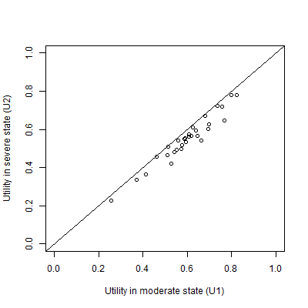

Figure 1 A plot of the simulated individual patient data

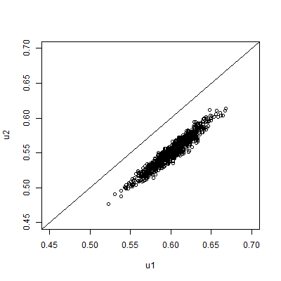

Figure 2 Scatterplot of 1000 PSA draws of the joint means of U1 and U2 produced by bootstrapping the IPD in table 1

In our hypothetical example, the modeller will not have access to the IPD, but only to the summary information shown in Table 2. This summary information, together with the knowledge that U2 should be less than U1, is the only information used in each of the ten approaches described below.

|  |  |  |
| --- | --- | --- |
|  | **U1** | **U2** |
| Mean | 0.60 | 0.55 |
| 95% confidence interval of mean | 0.555 to 0.644 | 0.506 to 0.594 |

Table 2 The assumed available summary data. This is assumed to be the only information available to the modeller

### The Montonicity Assumption

When modellers are generating multiple estimates for using within probabilistic sensitivity analyses (PSA) using these summary data, the key monotonicity condition that must hold is that an estimate of U2 should always be equal to or lower than a corresponding estimate for U1. More formally, if there are M runs within the PSA, and the subscript i defines predicted values from the ith run, then U1i ≥ U2i for all i $∈N_{1}^{M}$; where M is the total number of PSA samples. If monotonicity were violated then some of the estimated values of U1-U2 produced from the PSA would be negative.

### The Ten Approaches

The long list of ten approaches considered for handling the U2 < U1 monotonicity relationship are described in Table 2 below. Approaches 1-6 are simpler approaches, and approaches 7-10 are more complex.

|  |  |  |
| --- | --- | --- |
| **Method Number** | **Name** | **Method Description** |
| 1 | Independent Sampling | For each of the M PSA runs, take one draw from U1 and one draw from U2 independently (i.e. assume no covariance between U1 and U2) |
| 2 | Quantile Matching/  Number Seed Recycling | For each of the M PSA runs, use the same random number seed when drawing a sample from U2 and U1. (This is equivalent to selecting the same quantile from both distributions.) |
| 3 | Upward Replacement | For each of the M PSA runs:  Stage 1: draw a sample from U2  Stage 2: draw a sample from U1  Stage 3: Check if the value of U1 drawn is less than the corresponding value of U2 drawn. If it is, then replace the value of U1 with the U2 value. |
| 4 | Downward Replacement | For each of the M PSA runs:  Stage 1: draw a sample from U1  Stage 2: draw a sample from U2.  Stage 3: Check if the value of U2 drawn is greater than the corresponding value of U1 drawn. If it is, then replace the value of U2 with the U1 value. |
| 5 | Upward Resampling | For each of the M PSA runs:  Stage 1: draw first from U1.  Stage 2: draw from U2.  Stage 3: Check if the value of U1 is less than U2. If it is, then go back to Stage 2 (i.e. resample). If not, then stop. |
| 6 | Downward Resampling | For each of the M PSA runs:  Stage 1: draw first from U2.  Stage 2: draw from U1.  Stage 3: Check if the value of U2 is greater than U1. If it is, then go back to Stage 2 (i.e. resample). If not, then stop. |
| 7 | AIVM Covariance | Assume that the covariance between U1 and U2 is equal to the average of the individual variances of the means (AIVM) of U1 and U2.  If assuming this covariance implies that the correlation between U1 and U2 is greater than 1, then instead select the covariance between U1 and U2 which implies a correlation of 1 between U1 and U2. |
| 8 | Lower bounded Covariance Retrofitting | Select the minimum value of a covariance between U1 and U2 such that the two following conditions are met:  Condition 1: U1 – U2 > 0 for all PSA runs.  Condition 2: The covariance between U1 and U2 is greater than AIVM.  If this implies that the correlation between U1 and U2 is greater than 1, then instead use the covariance value associated with a correlation of 1. |
| 9 | Upper Bounded Retrofitting | Methodology 8 but where the second condition is that the covariance between U1 and U2 is less than AIVM. |
| 10 | Beta Distribution Difference Modelling | Use a derived distribution of U1, called U1(*), rather than U1 itself.  U1(*) is defined as equal to U2 + Δ, where Δ is drawn from a Beta distribution. The parameters of the Beta distribution are selected so as to minimise the differences between U1(*) and U1. |

Table 3 Summary of the ten approaches considered

### Simpler Approaches

Approaches one to six are all fairly simple, simulation based approaches. Approach one is the simplest and most naïve. Approach two is broadly equivalent to pairing the quantiles from the estimated distributions of U1 and U2 within PSA runs, matching the lowest estimate of U1 with the lowest estimate of U2, the second lowest estimate of U1 with the second lowest estimate of U2, and so on. For this reason, quantile-pairing was not considered as a separate strategy at this stage. The appendix presents additional analysis suggesting conditions where it may be appropriate to adopt this strategy, despite this being one of the more naïve strategies.

### Covariance and impossible correlations

Approaches seven to nine each involve selecting covariances on the basis either of the variances presented in the summary statistics for U1 and U2, or on whether monotonicity is maintained on all runs of the PSA. However, all covariances are also constrained by their associated correlations, such that the covariance between the variables cannot imply a correlation greater than one. The correlation of two random variables X and Y is defined as follows:

$$ρ_{XY}∶= \frac{Cov (X, Y)}{σ_{X}σ_{Y}}$$

For this reason, the upper limit of the covariance must be $σ_{X}σ_{Y}$. For approach seven, this effectively states that the covariance selected is:

$$Cov \left(X, Y\right)=Min \left\{\begin{matrix}σ_{X}σ_{Y} & , & \frac{{σ_{X}}^{2}+{σ_{Y}}^{2}}{2}\end{matrix}\right\}$$

This constraint also applies to approaches eight and nine.

### Selection of covariance for methods eight and nine

The covariances for methods eight and nine were selected using a computer algorithm which used a brute force approach to identifying correlation estimates. For both approaches the effective upper bound of the covariance which may be selected is the covariance which implies a correlation of 1, i.e. the product of the two standard errors. For approach eight the lower bound was set to the value used in approach seven; for approach nine the lower bound was set to zero. This algorithm is presented in the appendix.

### Beta Distribution Difference Modelling

Method 10 involves producing estimates for U1 through a two stage process. Firstly, independent estimates of U1 and U2 using the summary data are produced, then a Beta distribution, Δ, is parameterised with values chosen such that the sum of squares of the differences between U1 and U2 + Δ is minimised. These parameters were selected using a numerical optimisation routine using simulated annealing, using code written in the R programming language. This code is presented in the appendix.

### Comparison of PSA produced by different methods

In addition to producing estimates which do not violate the monotonicity assumption, an appropriate method for producing PSA estimates should, ideally, be able to produce joint estimates of the means of U1 and U2 which are very similar to that would be identified given the IPD. This means that scatterplots of 1,000 PSA runs comparing estimates of the mean of U1 with the mean of U2 should look similar to those seen in Figure 2. Dissimilarities in the scatterplots produced can indicate that the method may be biased. For example, they may introduce biases into the central estimates, or into estimates of the differences between values U1 – U2.

For some of the methods, it is analytically impossible for monotonicity to be violated, and so they must satisfy the monotonicity condition. These methods are 3, 4, 5, 6 and 10. For methods 7, 8 and 9, which use algorithms to select covariances between parameters, it is possible that for some runs U2 values will occasionally exceed corresponding U1 values, although this may be a rare occurrence. Where violation of monotonicity is possible, modellers should be able to specify what level of monotonicity violation is tolerable. For example, monotonicity violation may be acceptable, so long as it occurs with a frequency of less than 1/10,000. For brevity, methods 3,4, 5, 6, and 10 will be described as satisfying ‘strict monotonicity’; whereas methods 7, 8 and 9 will be described as satisfying ‘relaxed monotonicity’.

## Results: What did we find?

### Parameterisation of methods 7-9

For method 7, the variance associated with the standard errors of both U1 and U2 are 0.000504 to three significant figures, and so the AIVM is also 0.000504. The product of the standard errors of U1 and U2 is also 0.00504 to this many significant figures. This product defines the covariance which implies a correlation of 1, and so the upper bound of the covariance that can be set. This means that method 7 is simply equivalent to setting the correlation between the means of U1 and U2 to 1.

For method 8, which forces a covariance of 0.00504, implying a correlation of 1, was also identified, as method 8 uses the covariance value from method 7 as its upper bound, and as this value already implies a correlation of 1 it cannot be any higher. For method 9, however, which uses a covariance of 0 as its lower bound, a covariance of 0.00038, implying a correlation of 0.754, was identified.

### Parameterisation of method 10

The method was able to produce a Δ value such that the difference between U1 and U2 + Δ is small. This methodology involves substitution all PSA draws of U1 with PSA draws U2 + Δ, which is referred to as Beta simulated U1 in the figure. Figure 3 below shows that the density U1 and Beta simulated U1have a very similar mean and distribution of estimates. Because Δ is a draw from a Beta distribution, it is analytically impossible for any value of Beta simulated U1 to be less than the corresponding value of U2. The function used to optimise the parameters for the Beta distribution in this case was given starting values of Beta(6, 100), and from this produced Beta(8.148 and 193.921).

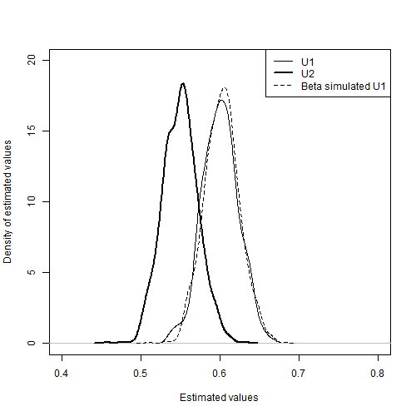

Figure 3 Comparison between Beta simulated U1 values, U1 values, and U2 values

### Scatterplots

Figures xxx present the scatter of the PSA produced by each of the methods 1-10. Figure X shows the corresponding scatter produced from the bootstrapped PSA. The diagonal line indicates parity between corresponding draws of U1 and U2. Scatter above this diagonal line shows that some proportion of the draws produced by the method violate the monotonicity assumption. A good method should be able to produce a similar pattern of scatter given the aggregate data as the bootstrapped method is able to produce using the IPD.

We can see that method 1 includes some scatter above the diagonal line, showing that some proportion of the draws violates the monotonicity assumption, highlighting the inadequacy of the approach. All other approaches appear to produce no estimates which violate the monotonicity assumption.

Methods 3, 4, 5, and 6 all show nonlinearities in the scatter, with no values above the diagonal line but relatively high densities of values just below the diagonal line. These discontinuities suggest that the methods of ensuring monotonicity may also be liable to produce biases in the estimated mean values.

The majority of the approaches appear to produce patterns of variance in the scatter which are qualitatively dissimilar to the bootstrapped scatter. Methods 1, 3, 4, 5, and 6 all produce uncorrelated scatter that is too wide, indicating the correlation of the PSA estimates is too low. By contrast, methods 2, 7, 8 all produce scatter which is too narrow, indicating the correlation estimates are too high.

We see from the scatter that method 10 (fig XX) and method 9 (fig XX) are both closest in appearance to the bootstrapped scatter, with method 10 exhibiting closer values than method 9.

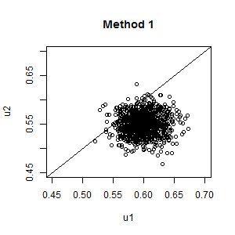

Figure PSA Scatterplot: Independent sampling

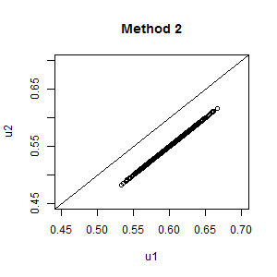

Figure PSA scatterplot: Same random number seed

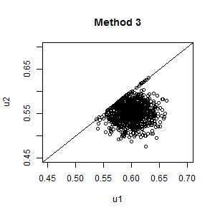

Figure Upward Replacement

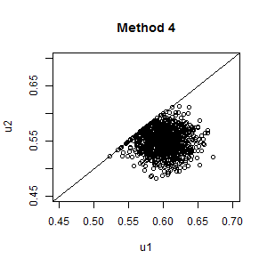

Figure Downward Replacement

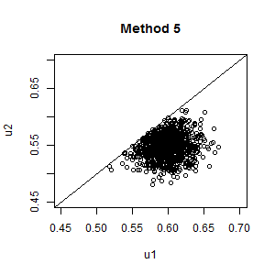

Figure Upward Resampling

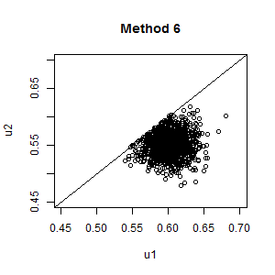

Figure Downwards Resampling

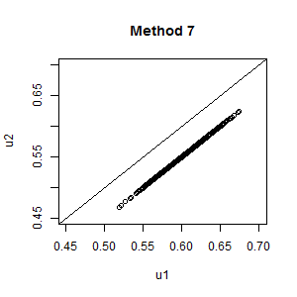

Figure Setting covariance to AIVM

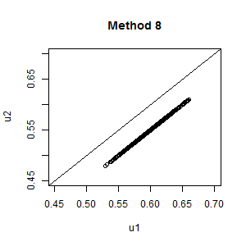

Figure Upper bounded covariance fitting

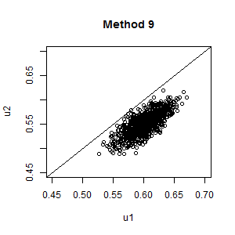

Figure Lower bounded covariance fitting

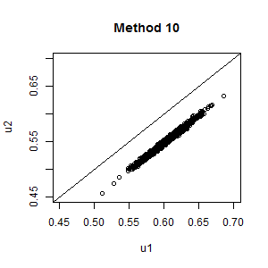

Figure Beta difference modelling

### Monotonicity violation

The two replacement methods (3 and 4), the two resampling methods (5 and 6), and the Beta method (method 10) are all designed such that it is analytically impossible for them to violate the principle of monotonicity. As such we know they must satisfy the monotonicity criterion in both its strict and more relaxed form. The other methods could all potentially violate monotonicity, in that U2 values are not analytically constrained to be less than U1 values, or U1 values all analytically constrained to be greater than the U2 values. In this example, the only approach where monotonicity is violated in the 1000 PSA samples being compared is method 1, independent sampling, where 53 out of the 1000 PSA samples violate montonicity.

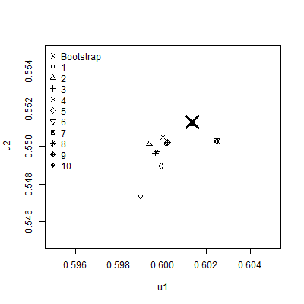

Figure 14 Mean value of U2 and U1 for each of the 10 methods, compared with bootstrapped estimates derived from IPD (large cross)

### F:\Google Drive\Monotonicity\Code\R\SDScatter.png

Figure 15 Standard deviations of U2 and U1 for each of the ten methods, compared with Bootstrapped estimates derived from IPD (large cross)

|  |  |  |  |  |  |  |
| --- | --- | --- | --- | --- | --- | --- |
| Method | U1 | | | U2 | | |
| Mean | Lower | Upper | Mean | Lower | Upper |
| 1 | 0.5997 | 0.5982 | 0.6009 | 0.5493 | 0.5478 | 0.5505 |
| 2 | 0.5997 | 0.5983 | 0.6011 | 0.5497 | 0.5482 | 0.5511 |
| 3 | 0.6000 | 0.5987 | 0.6012 | 0.5505 | 0.5491 | 0.5518 |
| 4 | 0.5999 | 0.5984 | 0.6013 | 0.5490 | 0.5477 | 0.5504 |
| 5 | 0.5990 | 0.5977 | 0.6002 | 0.5473 | 0.5461 | 0.5487 |
| 6 | 0.6013 | 0.6001 | 0.6026 | 0.5512 | 0.5499 | 0.5524 |
| 7 | 0.5997 | 0.5981 | 0.6012 | 0.5497 | 0.5483 | 0.5510 |
| 8 | 0.6002 | 0.5988 | 0.6016 | 0.5502 | 0.5489 | 0.5516 |
| 9 | 0.6001 | 0.5988 | 0.6015 | 0.5501 | 0.5488 | 0.5515 |
| 10 | 0.6025 | 0.6010 | 0.6039 | 0.5503 | 0.5489 | 0.5516 |

Other tables:

Correlation used (selected methods only)

Differences U1 – U2

Given the summary data available, it is known that, as the mean value of U1 is 0.60, and the mean value of U2 is 0.55, the mean difference between the two values should be 0.05. If a methodology produces a set of predicted values for this difference between U2 and U1 which has a mean value significantly different to 0.05, then this indicates the methodology produces biased estimates of the distributions, and so should be rejected as an appropriate method for this reason. The estimated differences produced by 1000 bootstraps of the ten methods is shown in Figure 2 below. It is seen that the methodologies which artificially adjust either U1 or U2 (methodologies 3 to 6) introduce bias by inflating the expected differences.

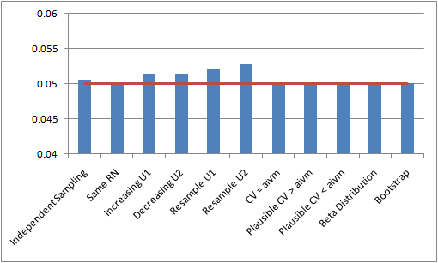Figure 16 The estimated mean differences between U1 and U2 according to the ten methodologies

|  |  |  |  |
| --- | --- | --- | --- |
|  | Monotonicity | Unbiased Mean | Unbiased Variance |
| 1 | No. | Yes | Yes |
| 2 | Relaxed monotonicity. Depends on values of U1 and U2 | Yes | No/sometimes. Depends on U1 and U2. |
| 3 | Strict | No. Produces biased estimates. | ??? |
| 4 | Strict | No. Produces biased estimates. | ??? |
| 5 | Strict | No. Produces biased estimates. | ??? |
| 6 | Strict | No. Produces biased estimates. | ??? |
| 7 | Relaxed. Depends on U1 and U2 | Yes. | ??? |
| 8 | Yes, relaxed, until covariance cannot be increased further due to implying correlations > 1 | Yes. | ???? |
| 9 | As with 8 | Yes. | ???? |
| 10 | Always. | Yes. | ???? |

### Para 2

A second condition that the methodologies should satisfy is that they should not misrepresent uncertainty about the variation of the differences between U1 and U2. This is a distinct issue to under-reporting the variance associated with either U1 or U2 independently as, in principle, the distributions U1 and U2 could each have equal variance. One could then simply define U2 as U1 plus the mean value of the difference between U2 and U2 (in this case 0.05). Although from this it might appear that variability has not been underreported, the strong assumption involved in defining U2 in this way, such that all values within U2 move in lock step with corresponding values of U1, means that the representation of uncertainty used within the PSA is unrealistic, reducing the validity of the estimates produced by the economic model.

### Para 3

Figure 3 below reports the mean estimated differences between U1 and U2 produced by each of the ten candidate methodologies. Where the minimum of these differences is below zero, it is demonstrated that monotonicity has been violated on some occasions as some estimates for U2 are greater than corresponding estimates for U1. Where the differences between the mean, minimum and maximum estimated differences are minimal or non-existent, then the appropriateness of the methodology should be doubted due to the lock-step issue mentioned above. It is seen that using the same random number or setting a CV value equal to AIVM does not allow the uncertainty to be captured in the Monte Carlo sampling. Methods 3-6, which were shown to produce a bias mean estimate of the difference, also provided a greatly inflated estimate of the uncertainty.

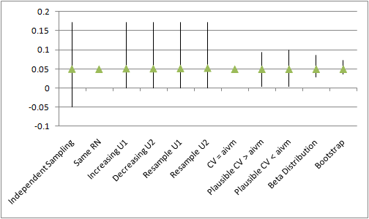

Figure 17 The mean, maximum and minimum differences between U1 and U2

### Para 4

Based on the above analyses, all but three approaches were contingently rejected due to either violating monotonicity (method 1), producing biased estimates of mean differences (methods 3,4, 5, and 6), or misrepresenting the difference between U1 and U2 as zero (methods 2 and 7). The three approaches judged assessing further within stage two were thus methods 8, 9 and 10.

### Para 5

The differences in the non-rejected methods were further explored with the addition of a third health state (mild disease – U0) to the dummy data set. The value for U0 was greater than for U1. The summary data for U0 was a mean of 0.65 and a 95% confidence interval of 0.603 – 0.697. The three retained methods were adapted to the three-variable condition as follows:

* 8) Using independent Beta distributions to describe the difference between U0 and U1 and U1 and U2. Both Beta distributions were assumed to be (1,19).
* 9) Using a Beta distribution to describe the difference between U0 and U2, (assumed to be 16,144) and a second Beta distribution (assumed to be 70,70) to indicate where the value of U1 was estimated to lie within this range.
* 10) Selecting co-variance parameters (U0-U1; U0-U2; and U0-U3). Three different sets of parameters were chosen to provide a positive correlation between U0-U1 and U1 to U2, a negative correlation and a small correlation.

The values chosen to populate these models are illustrative only and assumed to be reasonable representations of the differences between U0, U1 and U2.

Particular attention was paid to the potential for correlations between the values in each methodology. The suitability of each method for incorporating clinical belief, such as that if the difference between U0 and U1 were larger than average, the difference between U1 and U2 was also likely to be larger (or would be smaller) than average, was assessed.

### Para 7

## Discussion:

### Para 1: Summary of what found

The analyses presented here confirm the rationale for performing the analyses: simply drawing estimates for parameters that are known to be monotonically paired from independent distributions is liable to produce paired estimates for these parameters that violate the monotonicity assumption, and so producing a series of scenarios within probabilistic sensitivity analyses which lack clinical face validity. Trying to correct these monotonicity violations by simply resampling from the distributions, or forcing a predicted value which violates the monotonicity assumption, can however produced biased estimates of the mean value of the parameters, and so should also not be done. Approaches involving fixing paired estimates, within a given PSA draw, of one parameter so as to be equal to a paired value of another draw plus or minus an increment analytically determined to be positive, appears to be the type of solution required. However, the correct way to do this remains to be determined. A very naïve approach would be simple add on the mean difference of the two distributions onto one distribution. However, doing this would lead to some of the information available to the modeller being disregarded, and as the point of acknowledging monotonicity is to incorporate one additional piece of information in our models this approach thus appears counterproductive, as well as misleading in terms of how it represents the relationship between parameters and our degree of knowledge or ignorance of this. Drawing parameters for both distributions jointly in a way that assumes nonzero covariance between variables necessarily leads to a reduction in the degree of monotonicity reported. However doing this requires imposing another assumption about the relationship between variables for which clear clinical or epidemiological evidence may be lacking. At the limit, this approach converges upon the lock-step approach described and dismissed previously.

[Found that most approaches considered had disadvantages.

Assuming independence produces violations of monotoncitiy

Selective resampling produces bias

Same random number seed produces underestimate of differences (but contingent results)

Appropriate approaches involve setting correlation either explicitly var-covar matrix) or implicitly (beta distributions). However these require greater clinical input and/or more technical expertise, and involve adding new assumptions which are difficult to verify.]

Those methods that were not rejected [at stage 1] involved judiciously selecting a co-variance parameter or expressing a belief in the difference in the utilities via a statistical distribution (in this case a Beta distribution). Both of these approaches would need the input of a clinical expert in order to produce a confidence interval around the difference that would be seen as plausible.

It is seen that a number of methods that have been used in economic evaluations are not appropriate when monotonicity must be upheld.

Those methodologies that provide a bias expectation in the difference will also provide a biased estimation of the incremental cost-effectiveness ratio and should thus be avoided.

Those methods which are known to under (or over) estimate the uncertainty will produce answers from value of information analyses that are incorrect, in addition to providing the decision maker with inappropriate certainty in the adoption decision.

Two broad methodologies were not rejected. The parameters for the co-variances and the parameters for the Beta distribution were selected through a trial and error process (prior to the results of the bootstrapped analysis being known). Ideally a Bayesian approach should be undertaken where a clinical expert would provide certain characteristics that a distribution would demonstrate, with the analyst attempting to replicate this.

Where only two variables were considered there was little difference between the recommended methods. However, where there were three variables and a prior belief that there would be correlation between these the co-variance method was observed to have an advantage in replicating clinical reality.

### Para 2: Shortcomings

[Implications of research dependent on assumed validity of simulation approach. Have already addressed this shortcoming through stage three.]

[Within research particular approach to parameterising distribution was informal, and so difficult to justify externally]

### Para 3: How relates to other findings

[Not sure… ask Matt/Nick…]

### Para 4: Implications for Research

It is critical, when the amount of information available to modellers about input distributions is already limited, not to discard useful and usable information where possible. In effect, when the modeller knows that two variables are monotonically linked in a particular way, but nonetheless chooses to draw the two distributions independently within the PSA runs, the modeller is doing just this, because they are not incorporating this information into the model. However, as the results above have shown attempting to incorporate this knowledge in an inappropriate way can itself be problematic. For example, simply discarding draws which violate the monotonicity assumption can produce biases in the estimated results, disregarding and contradicting the modellers’ knowledge about the true mean sample values of a parameter. Likewise, other approaches can indirectly disregard other knowledge about the range of estimated differences between two or more distributions, by forcing predicted values to move in lock-step. In effect this can result in predictions disregarding one form of information – that of the variance of each separate distribution – in order to incorporate another source of information (that the variables are monotonically associated).

[Good method should avoid throwing away relevant information about the relationship parameters. This includes both formal information such as reported SE and mean values, and also implicit information such as knowledge that values are correlated.]

[Example of this: throwing away SE estimates when estimating 2nd value]

The follow-up simulation indicated that a fairly simple approach, using the same random number seed; or equivalently taking equal numbers of independent samples from each distribution, then matching them by quantile, can produce estimates with satisfactory properties when particular conditions hold. However, in the equal or near equal variance situation they do not. It remains a matter of modeller judgement whether the drop in …

### Para 5: Implications for practice

[Depends how much of an issue one considers violation of monotonicity assumption to be.

Less of an issue when not looking at expected values.]

[Make sure to test whether monotonicity is a problem in practice if not in theory.

[Where SEs are small relative to differences between means of distributions, even a naïve approach assuming distributions are independent could produce no violation of monotonicity on average within 1000 PSA runs]

[Need to be sure that the monotonicity assumption is valid in the particular context considered.

For example, although perhaps one can assume increasing disease severity should definitely be associated with decreased patient utility, it might not make as much sense to assume costs are also monotonic. It may be that the most severe stages of a disease are cheaper to treat than less severe stages, as fewer effective treatment options exist.

[It could also be that many clinicians assume two formally defined disease states are actually very similar, and so it would not be contrary to their expectations if the utility value of a ‘more severe’ state were actually about the same or higher on average than that of the ‘less severe’ state.

[Also far less likely to always be true when considering predicted rather than expected values, as it’s very probable that on some occasions at least some patients with a more severe disease will have higher utility than at least some patients with a less severe condition.]

When presented with summary data and with a belief that monotonicity must apply, a judicious selection of the covariance parameters or of the distributions for the differences appears appropriate. The former strategy is likely to be preferential if there are more than two parameters and there is some belief of correlation between the variables.

### Para 6

# Appendices

## Conditions in which it may be OK to use the same random number seed

After reviewing the results presented above, it was noted by one author that the decision to reject approach 3, use of the same number seed, may be contingent on the type of simulated data used, which may not be generalisable to other forms of summary data. This was because the simulated dataset made the assumption that the confidence intervals of the standard errors of the two distributions were approximately equal. In cases where the standard errors were not equal, it was considered that this finding may not hold. In order to test this concept more comprehensively, a follow-up simulation was created, whereby two normal distributions were generated a fixed difference (one unit) apart, and the ratio of the variances of the two distributions was varied systematically. For each of these variance ratios, the effect of quantile matching (effectively the same as using the same random number stream for both distributions) on two metrics was estimated, by comparing quantile-matched with independently sampling from the two distributions. These two metrics are: the proportion of draws where monotonicity was violated, shown in Figure 7, and the estimated variance of the difference between the two component distributions, shown in Figure 8.

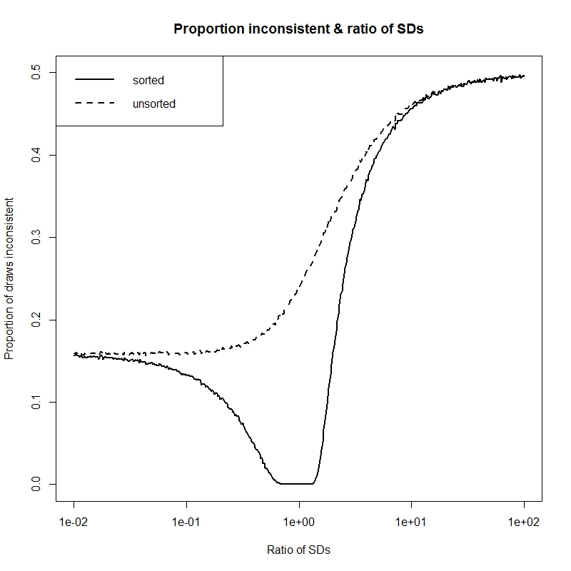

Figure 18 Proportion of inconsistent draws (violating monotonicity) as a function of ratio of SDs of distributions

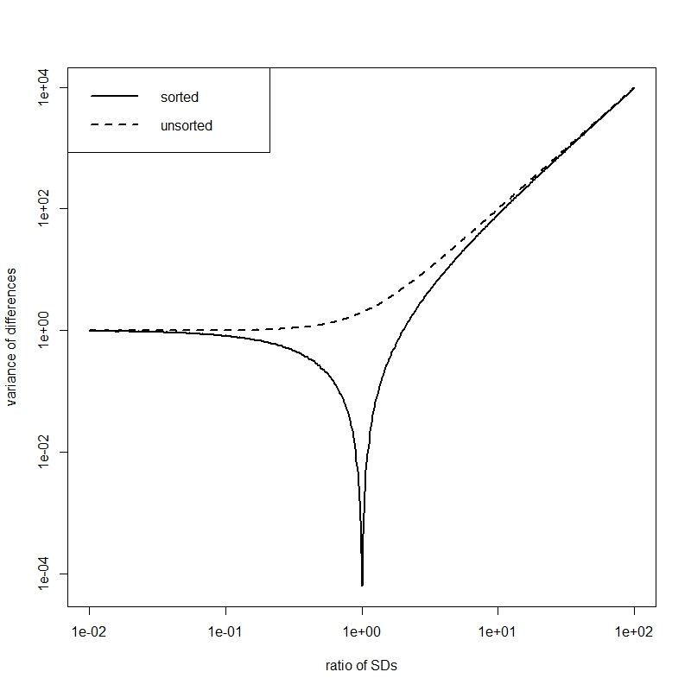

Figure 19 Variance of differences between distributions as a function of ratio of SDs of distributions

It is seen that there is only zero predicted variance of the difference between U1 and U2 in cases where the variance of both U1 and U2 are assumed to be equal, as was the case for the hypothetical distribution used to assess the ten methodologies described above. In cases where the variances of the two component distributions are unequal, as summarised by the ratio of the variances, the ratio of the predicted differences between the two distributions increases rapidly. However, for all variance ratios, the range of predicted differences between the distributions is significantly less than for the base case where the two distributions are drawn independently and not paired with each other. A trade-off in conditions appears to exist, such that larger predicted variances of differences exist as the ratio of the variances moves away from unity, but as this happens so the proportion of paired draws that violate the monotonicity assumption increases as well. There appears to be a small but potentially usable ‘sweet spot’, a series of ranges of ratios of variance, where both non-zero predicted variance of difference exists, and where there is also no violation of monotonicity. Where summary statistics for two monotonically paired distributions suggest that the ratio of variances is likely to be within this acceptable range, then this simpler approach could be considered.

## R code for methods

### Method 1

### Method 2

### Method 3

### Method 4

### Method 5

### Method 6

### Method 7

### Method 8

### Method 9

### Method 10

The Beta method was implemented in the R programming language. The stages were as follows:

1) Use summary values for U1 and U2 to construct a large number (1000) of PSA samples

2) Use a function which generates a large number of draws Delta, where Delta ~ Beta (Param1, Param2).

3) Constuct a derived parameter U1* := U1 + Delta

4) Compare the density of draws from the derived parameter U1* with those of U1, where different values of Param1 and Param2 are assumed.

5) When Param1 and Param2 values have been found which lead to a U1* distribution which appears similar to the U1 distribution, then use these as initial values Param1_init and Param2_init for an optimisation algorithm, which attempts to choose new parameter values Param1_optimised and Param2_optimised which lead to a closer fit between U1* and U1.

The calibration function compares the sum of squares of the differences between U1* and U1, and selects new Param1 and Param2 values if they lead to a reduced difference.

The optimisation algorithm used is a metropolis-hastings style simulated annealing algorithm in the optim() function in R. This is slower than many of the other algorithms available in optim() but is less likely to get stuck on a local maxima, and so more likely to find the global maxima. Other algorithms available in R could be used.

# Notes

* Each paragraph should start with a clear message (a ‘topic sentence’)
* Try to do each sentence in one go (for consistency)

|  |  |
| --- | --- |
| R Code | Comments |
| rm(list=ls())  Data.2D <- data.frame(  U1=  c(  0.6981868, 0.7564343, 0.6382204, 0.6462851, 0.6190710, 0.8001344, 0.4119082, 0.6646116, 0.5137965, 0.5940299, 0.3714398, 0.6083170, 0.5280737, 0.8239041, 0.6823991, 0.4626827, 0.5765112, 0.5725570, 0.6071968, 0.5425066, 0.6251989, 0.6942350, 0.5120049, 0.5916603, 0.5596280, 0.5882450, 0.7669716, 0.5512535, 0.2562950  ),  U2=  c(  0.6257671, 0.7194083, 0.5943290, 0.5654279, 0.5654237, 0.7792152, 0.3639981, 0.5403120, 0.5090605, 0.5321613, 0.3375571, 0.5725718, 0.4204609, 0.7791617, 0.6689688, 0.4575665, 0.5172808, 0.4959917, 0.5614181, 0.4813226, 0.6109787, 0.6032772, 0.4638334, 0.5518375, 0.5410590, 0.5505654, 0.6478170, 0.4915789, 0.2266444  )  )  require(MASS)  plot(U2 ~ U1, data=Data.2D, xlim=c(0,1), ylim=c(0,1), xlab="Utility in moderate state (U1)", ylab="Utility in severe state (U2)")  abline(0,1)  cov(Data.2D)  cor(Data.2D)  U1.summary <- list(mu=0.60, sd=(0.644 - 0.600)/1.96)  U2.summary <- list(mu=0.55, sd=(0.594 - 0.550)/1.96) | Clear the R workspace  Load the data  Load a required library  Plot the data  Create a y=x line  Identifying the true variance-covariance of the scatter  Identifying the true correlation  The summary data for U1 and U2. This is the only data typically available to a modeller, and the only data used by the methods evaluated below. |
| **Methods** | |
| n.PSA <- 1000 | Set the number of PSA runs to use |
| ***Method 1: Independent Sampling*** | |
| PSA.method01 <- data.frame(u1=rnorm(n.PSA, mean=U1.summary$mu, sd=U1.summary$sd),  u2=rnorm(n.PSA, mean=U2.summary$mu, sd=U2.summary$sd)) | Creates a dataframe containing 1000 draws of U1 and 1000 draws of U2, independently sampled |
| ***Method 2: Same Random Number Seed*** | |
| seed.value <- 20  set.seed(seed.value)  u1 <- rnorm(n.PSA, mean=U1.summary$mu, sd=U1.summary$sd)  set.seed(seed.value)  u2 <- rnorm(n.PSA, mean=U2.summary$mu, sd=U2.summary$sd)  PSA.method02 <- data.frame(u1=u1, u2=u2)  rm(u1, u2) | Set the value to use for the random number seed  Set the random number seed to use the seed value  Run the rnorm function using this seed value and u1 summaries  Re-set the random number seed back to 20  Run the rnorm function using this seed value and u2 summaries  Create a dataframe with the PSA values  Remove u1 and u2 objects stored outside the dataframe |
| ***Method 3: Upward Replacement*** | |
| u1 <- rnorm(n.PSA, mean=U1.summary$mu, sd=U1.summary$sd)  u2 <- rnorm(n.PSA, mean=U2.summary$mu, sd=U2.summary$sd)  u1[u1 < u2] <- u2[u1 < u2]  PSA.method03 <- data.frame(u1=u1, u2=u2)  rm(u1, u2) | Create values independently for U1 and U2 as per method 1  Identify the vector of values where monotonicity has been valued and replace the violating u1 values with corresponding u2 values  Create a dataframe with the PSA values and remove local copy of u1 and u2 |
| ***Method 4: Downward Replacement*** | |
| u1 <- rnorm(n.PSA, mean=U1.summary$mu, sd=U1.summary$sd)  u2 <- rnorm(n.PSA, mean=U2.summary$mu, sd=U2.summary$sd)  u2[u2 > u1] <- u1[u2 > u1]  PSA.method04 <- data.frame(u1=u1, u2=u2)  rm(u1, u2) | Create values independently for U1 and U2 as per method 1  Identify the vector of values where monotonicity has been valued and replace the violating u2 values with corresponding u1 values  Create a dataframe with the PSA values and remove local copy of u1 and u2 |
| ***Method 5: Upwards Resampling*** | |
| u1 <- rnorm(n.PSA, mean=U1.summary$mu, sd=U1.summary$sd)  u2 <- rep(NA, n.PSA)  for (i in 1:n.PSA){  continue <- F  while(continue==F){  this.u2 <- rnorm(1, mean=U2.summary$mu, sd=U2.summary$sd)  if (this.u2 < u1[i]){  u2[i] <- this.u2  continue <- T  }  }  }  PSA.method05 <- data.frame(u1=u1, u2=u2)  rm(u1, u2) | Sample the U1 values in the usual way.  Create an empty vector of the same length as the u1 vector to hold u2 estimates generated  A short routine that, for each element in the initially empty u2 vector, keeps resampling from the independent u2 distribution until a value is found which is less than the corresponding u1 value.  Package u1 and u2 estimates in a data frame then deletes local copies of the u1 and u2 objects |
| ***Method 6: Downwards Resampling*** | |
| u1 <- rep(NA, n.PSA)  u2 <- rnorm(n.PSA, mean=U2.summary$mu, sd=U2.summary$sd)  for (i in 1:n.PSA){  continue <- F  while(continue==F){  this.u1 <- rnorm(1, mean=U1.summary$mu, sd=U1.summary$sd)  if (this.u1 > u2[i]){  u1[i] <- this.u1  continue <- T  }  }  }  PSA.method06 <- data.frame(u1=u1, u2=u2)  rm(u1, u2) | Create an empty u1 vector  Sample u2 values in the usual way.  A short routine that, for each element in the initially empty u1 vector, keeps resampling from the independent u1 distribution until a value is found which is less than the corresponding u2 value.  Package u1 and u2 estimates in a data frame then deletes local copies of the u1 and u2 objects |
| ***Method 7: Setting covariance to AIVM*** | |
| MakeAIVMCov.2d <- function(mu.X, sd.X, mu.Y, sd.Y, n.psa=n.PSA){  require(MASS)  varX <- sd.X^2  varY <- sd.Y^2    aivm <- min(  mean(  c(varX, varY)  ),  sd.X * sd.Y)    sig <- matrix(data=c(varX, aivm, aivm, varY), nrow=2, byrow=T)    aivm.samples <- mvrnorm(n=n.psa, mu=c(mu.X, mu.Y), Sigma=sig )  colnames(aivm.samples) <- c("X.sampled", "Y.sampled")  aivm.samples <- as.data.frame(aivm.samples)    return(aivm.samples)  }  PSA.method07 <- MakeAIVMCov.2d(  mu.X=U1.summary$mu,  sd.X=U1.summary$sd,  mu.Y=U2.summary$mu,  sd.Y=U2.summary$sd  )  names(PSA.method07) <- c("u1", "u2") | Creates a short function which produces U1 and U2 values jointly which are correlated. The correlation is that associated with AIVM unless this would imply a correlation greater than 1, in which case a correlation of 1 is used instead.  The function takes five inputs: the means and standard deviations of the two variables, and the number of PSA runs.  Checks whether a library of functions has been loaded, this includes the function mvrnorm, which is required later.  Calculates variances given the standard deviations  Produces a variable, called aivm, which is the minimum of the average individual variances of the means, or the covariance which would imply a correlation of 1.  Produces a 2x2 covariance matrix using aivm as the off-diagonal values.  Produce correlated samples of the two variables  Formats aivm.samples to be consistent with those produced elsewhere.  Returns the labelled and formatted output as the function output  Uses the function created above with the summary values identified  Renames the variables in the data frame created in the above line for consistency |
| ***# METHOD 8: Lower Bounded Covariance Retrofitting***  ***# METHOD 9: Upper Bounded Covariance Retrofitting*** | |
| MakeBCVR.2d <- function(mu.X, sd.X, mu.Y, sd.Y, n.psa=n.PSA, incBy=0.00001, upper=T){  require(MASS)      varX <- sd.X^2  varY <- sd.Y^2  if(upper==T){  lowerbound <- 0  } else {  lowerbound <- mean(varX, varY)  }    upperbound <- min(sd.X * sd.Y,  mean(varX, varY)  ) # upper bounds are the minimum of the AIVM or the cov which implies a cor > 1    this.cov <- lowerbound  cat(varX, varY, lowerbound, upperbound, this.cov, "\n")  mus <- c(mu.X, mu.Y)  search <- T    if(this.cov==upperbound){ # if the maximum value's been reached already    cat("Upperbound already reached\n")  search <- F # if the upper limit's already been reached, go no further  testsig <- matrix(c(varX, this.cov, this.cov, varY), nrow=2, byrow=T)  testsamples <- mvrnorm(n.psa, mu=mus, Sigma=testsig)  } else {  cat("Upperbound not yet reached\n")  this.cov <- lowerbound  cat("This covariance: ", this.cov, "\n", sep="")  testsig <- matrix(c(varX, this.cov, this.cov, varY), nrow=2, byrow=T)  testsamples <- mvrnorm(n.psa, mu=mus, Sigma=testsig)  }    while(search==T){  cat("trying ", this.cov, "\n")  testsig <- matrix(c(varX, this.cov, this.cov, varY), nrow=2, byrow=T)  try.testsamples <- try(mvrnorm(n.psa, mu=mus, Sigma=testsig))  if(class(try.testsamples)=="try-error"){ # if mvrnorm has been passed impossible values  search <- F  cat("Error picked up\n")    } else {  cat("No error in mvrnorm args\n")  testsamples <- try.testsamples # if the attempted values are correct, use them  if (any(testsamples[,1] < testsamples[,2])){  cat("Violation with ", this.cov, "\n")  this.cov <- this.cov + incBy # increment the values by a little bit  cat("Trying ", this.cov, "\n")  } else {  cat("Found ", this.cov, "\n")  search <- F  }  }  }  return(list(cov=this.cov, samples=testsamples))  }  tmp <- MakeBCVR.2d(  mu.X=U1.summary$mu,  sd.X=U1.summary$sd,  mu.Y=U2.summary$mu,  sd.Y=U2.summary$sd,  upper=F  )  method08.cov <- tmp$cov  PSA.method08 <-data.frame(tmp$samples)  names(PSA.method08) <- c("u1", "u2")  tmp <- MakeBCVR.2d(  mu.X=U1.summary$mu,  sd.X=U1.summary$sd,  mu.Y=U2.summary$mu,  sd.Y=U2.summary$sd  )  method09.cov <- tmp$cov  PSA.method09 <- data.frame(tmp$samples)  names(PSA.method09) <- c("u1", "u2")  plot(u2 ~ u1, data=PSA.method08)  plot(u2 ~ u1, data=PSA.method09) | Another function, this time with seven inputs. These are the five inputs to the MakeAIVMCov.2d() function above, and the following two arguments:  incBy : the size of the increment in each guess for the appropriate covariance  upper: whether method 8 or method 9 should be calculated. Upper=T is method 9, and upper=F is method 8.  Both incBy and upper have default values, which will be used if other values have not been specified.  Calculates variances for each variables as in previous function  Set a value called lowerbound to 0 if method 9 is used (upper=T), oe the AIVM if method 8 is used (upper=F) |
| ***Method 10: Beta distribution difference fitting*** | |
| ShowImps <- function(U1, U2, shape1, shape2){  plot(density(U1), xlim=c(0,1))  lines(density(U2), lty="dashed")    increment <- rbeta(n.PSA, shape1, shape2)    lines(density(U2 + increment), lty="dashed", lwd=2)  return(sum((U1 - (U2 + increment))^2))  }  SumSquaredFinder <- function(real.values, predicted.values){  squared.errors <- (real.values - predicted.values)^2  return(sum(squared.errors))  }  FitCompare <- function(par, PSA.X, PSA.Y){  shape1 <- exp(par[1])  shape2 <- exp(par[2])  n.psa <- length(PSA.X)    additional <- rbeta(n.psa, shape1, shape2)  # cat(head(additional), "\n")  # cat(shape1, shape2, "\n")    Sims.Y <- PSA.X + additional  sumSquared <- SumSquaredFinder(real.values=PSA.Y, predicted.values=Sims.Y)  # cat("sumSquared=", sumSquared, "\n")  # browser()    return(sumSquared)  }  OptimFitFinder <- function(PSA.X, PSA.Y, initial.shape1, initial.shape2){  n.psa <- length(PSA.X)  optim.out <- optim(par=c(log(initial.shape1), log(initial.shape2)), FitCompare, PSA.X=PSA.X, PSA.Y=PSA.Y,  method="SANN", hessian=T, control=list(trace=10))  return(optim.out)  }  sims.U1 <- rnorm(n.PSA, mean=U1.summary$mu, sd=U1.summary$sd)  sims.U2 <- rnorm(n.PSA, mean=U2.summary$mu, sd=U2.summary$sd)  optimOutput <- OptimFitFinder(sims.U2, sims.U1, 6, 100)  optim.shape1 <- exp(optimOutput$par[1])  optim.shape2 <- exp(optimOutput$par[2])    plot(density(sims.U1), main="", xlim=c(0.4, 0.8), xlab="Estimated values", ylim=c(0, 20), ylab="Density of estimated values")  lines(density(sims.U2), lwd=2)  lines(density(sims.U2 + rbeta(n.PSA, optim.shape1, optim.shape2)), lty="dashed")  legend("topright", lty=c("solid", "solid", "dashed"), lwd=c(1,2,1), legend=c("U1", "U2", "Beta simulated U1"))  #ShowImps(sims.U1, sims.U2, optim.shape1, optim.shape2)  PSA.method10 <- data.frame(u1 = sims.U2 + rbeta(n.PSA, optim.shape1, optim.shape2), u2=sims.U2) | # Some functions borrowed from myself  # Use ShowImps to guess a decent enough initial value  # Find the sum of squares |
| Bootstrapped estimates for comparison | |
| methodBoot.PSA <- matrix(NA, ncol=2, nrow=n.PSA)  for (i in 1:n.PSA){  draws <- 1: dim(Data.2D)[1]  size=dim(Data.2D)[1]  tmp <- Data.2D[sample(draws, size, T),]  methodBoot.PSA[i,] <- c(mean(tmp[,1]), mean(tmp[,2]))  }  methodBoot.PSA <- data.frame(methodBoot.PSA)  names(methodBoot.PSA) <- c("u1","u2") | # want bootstrapped estimates of means to compare |
| Packaging results together | |
| MethodsBlock <- list(  methodboot=methodBoot.PSA,  method01=PSA.method01,  method02=PSA.method02,  method03=PSA.method03,  method04=PSA.method04,  method05=PSA.method05,  method06=PSA.method06,  method07=PSA.method07,  method08=PSA.method08,  method09=PSA.method09,  method10=PSA.method10) | # packaging results together in list to make them easier to automate |