A small health disadvantage could cause a big employment disadvantage in a competitive labour market

# Introduction

## Para 1: Despite working age health improving in the UK, rates of working age inactivity due to ill health have increased.

Despite general working age health improving in the UK, and most other nations, the rates of working age inactivity attributed to ill health have increased. In the UK, a range of working age sickness benefits have existed. These include…. All of these benefits have required that people show that they are in poor health through state commissioned testing. By international standards, the UK is considered to have some of the toughest eligibility criteria in the developed world. Despite this, rates of IB/IVB rose during the 1980s/1990s, rising fastest between X and Y, then starting to plateau by … with the replacement of IVB with IB. The replacement of IB by ESA in… marked further developments in the eligibility criteria. As not all economic inactivity due to ill health will lead to a benefit, as for example IB was a contributory benefit, the true level of economic inactivity due to this cause is likely to be even higher.

## Para 2: Explanations as to why this has occurred have been very politicised.

Explanations for the rise in economic inactivity have been heavily politicised. X has suggested that the rise is due to a ‘dependency culture’. Related to this people have said that people have become less stoical, and so feel themselves unable to work when their level of health falls below a threshold that works of previous generations would have struggled through. X has suggested that political ‘gaming’ of national statistics have been a significant reason for the increase in IVB numbers in the early 1990s, as benefits agencies were pressured centrally to shift older workers, especially formers miners, from unemployment benefits to invalidity benefits to make the recession look less bad. Other commentators have suggested that much of the cause could be due to the workplace becoming increasingly stressful, leading to increases in rates of mental ill health. Many government initiatives in recent years have identified the rises in economic inactivity in working age people as a social problem in need of government intervention. Interventions aimed at addressing the problem include [pathways] + ½ others.

# Methods

## Para 1: We developed a simple mathematical model that indicates how this could have occurred due to labour markets becoming more competitive.

We developed a simple mathematical model which indicates how the patterns observed could have done so because labour markets became more competitive. Mathematical models are commonly used in health technology assessments to help NICE and other health based decision making organisations make coherent, evidence-based decisions. The role of this model is more as tool for exploring the logical consequences of making a series of assumptions about job selection processes. One of the classic applications of this sort of modelling approach is Thomas Schelling’s Racial Segregation model, which showed that even a slight preference towards one’s own racial or cultural group could lead to high levels of neighbourhood segregation. The advantage of formalising assumptions in this way is that it indicates when the macrobehavior of a system composed out of many elements whose micromotives are known are not intuitively knowable. In the case of working age economic inactivity, we can see that there has been a large increase in the individual level ill health we might expect to be the cause of this. This model shows how a combination of a number of factors could contribute to these changes.

## Para 2: The model formalises a number of assumptions and shows what they imply if combined

The model formalises a number of assumptions about labour market selection and health to show why they logically imply. These assumptions are: 1) that getting a job is essentially a winter-takes-all process; 2) that health is one of a number of factors that influences how ‘fit’ a candidate is likely to be for a job; 3) that people have ‘good days’ and ‘bad days, variation in performance, but that this variation is around a central level; 4) that people in poorer health have on average a lower level of job fitness than otherwise similar people in good health. Additionally, as small number of technical assumptions needed to be made in order to operationalize the model in practice. The assumption was also made in interpreting these result’s that if someone’s probability of getting a job following an interview was below a certain threshold then they would effectively become ‘unemployable’ and so more likely to be economically inactive rather than continue jobseeking. These assumptions will now be discussed in more detail.

## Para 3: There is the assumption that getting a job is basically a winner-takes-all process

There is the assumption that getting a job is essentially a winter-takes-all process. Through it sounds obvious, an implication of this is that if on candidate’s performance in the selection process is 95% as good as another candidates, then this candidate will not receive 95% of the ‘reward’ for this performance. An implication of this assumption is that the relationship between inputs and outputs can be nonlinear, meaning that small differences in fitness could, in some situations, lead to large differences in outcomes. Although it may be argued that there are exceptions to this assumption, and ways in which the assumption represents a gross simplification of the selection process, this should be recognised as the usual situation. Possible exceptions are cases where the performance of all candidates are so bad that the employer chooses not to offer the position to anyone, or conversely cases were two or more candidates for a single position are so good that, if discretion allows, more than one candidates is appointed. It is also common that getting a job as more a kin to a triathlon than a single race, involving multiple stages of selection each testing slightly different kinds of aptitude.

## Para 4: There is the assumption that people have an average level of fitness and there is some variation between these levels.

There is the assumption that people have an average level of fitness and some level of variation around this. This is to say people have ‘good days’ and ‘bad days’, and so a candidate could make a very good impression with an employer when they are performing near their peak but a very bad impression on other occasions. Although there may be factors which systematically affect how someone performance, such as the time of day, establishment or otherwise of a sense of rapport in the first minute of the candidate-employer encounter, personal issues prior to the interview and so on, such factors are considered completely random at the level of abstraction of this model.

## Para 5: There is the assumption that if a person’s employment level is below a certain level they are effectively ‘unemployable’ and it may be rational for them to ‘choose’ economic inactivity over job seeking

There is the assumption that if a person’s employability falls below a certain threshold then they effectively become ‘unemployable. This should not be considered a strong assumption amongst older working age people as there may only be a few years of working age remaining, and seeking employment takes some of this limited time up. If, for example, a 62 year old has specialised for the previous 40 years in a particular occupation, and there are currently only 10 new opportunities in that field per year, and the candidates needs on average to apply for 100 positions to be offered one job then it will take that person on average to years to get a job. If the retirement age is 65 then that person is effectively ‘unemployable’ as the could expect employment *after* they are due to retire, and so due to move beyond working age. Among younger people, the causes of potential ‘unemployability’ are likely to be somewhat different, and relate more to psychological and rational economic factors. If job seeking is an activity requiring ‘resilience’, and this is essentially a finite psychological resource, then enough rejections may put the candidate off job seeking enough that they feel more content not seeking employment any more. At the level of abstraction of this model, the different causes of employability are not relevant, and nor are differences between types of candidate. Instead, there is simply assumed to be a d single threshold at which people become ‘unemployable’

## Para 6: There is the assumption that there are just two types of people in the labour market: ‘healthy’ people and ‘sick people.

There is the assumption that there are just two types of people in the labour market: ‘healthy’ people and ‘health impaired’ people. Further to this it is assumed that ‘health impaired people’ have, as a result of their health impairment, a lower level of job fitness on average than healthy people. Again, this represents a simplification reality in a number of ways. : job fitness depends on a range of actors, such as qualifications, experience, demographic characteristics and so on. However, as the purpose of this model is to consider the effect of lower health on fitness when most other factors have been held constant, this added layer of complexity is not modelled. Additionally, the type of ill health and the type of job can be expected to interact: poor physical health is likely to affect people’s capacity to perform manual labour than non-manual labour, for example, and mental health deficits perhaps more likely to impair someone’s capacity to perform some sorts of non-manual labour. Again, at the level of abstraction of this model, such additional levels of complexity are disregarded, although the potential for developing the model to incorporate such factors will be discussed later in this paper.

## Para 7: The model takes the following form

The way the model is implemented id described briefly as follows: a job selection process is represented by selecting from a series of candidates who each demonstrate a given level of performance of that position. The performance that each candidate demonstrated on that occasion is represented by a random draw from that particular candidate’s ‘performance distribution’. The ‘healthy’ candidates are all represented by the same performance distribution, and the health impaired candidates by this same distribution by shifted down by a given amount, d. The model simulates the proportion of trials where a health impaired candidate ‘wins’ a job over one or more healthy candidates. A number of variations of this model are run, for a wide range of permutations of k, the number of healthy candidate the health impaired candidate completes against, and d, the degree of job fitness disadvantage due to ill health that the health impaired candidate has. In order to operationalise the model, the Normal distribution was used to represent variation in candidates’ performance, and the results are likely to be somewhat contingent this choice of distribution. The R code used to perform the simulations is presented on the appendix. The process is shown graphically in Figure 1 below. Although an analytic solution to the problem is possible when using this distribution, the simulation approach has the advantage of being relatively easy to produce and follow, so of course being readily adaptable to the other distributions and the incorporation of different assumptions and layers of simulation complexity.

**Employer’s appraisal of candidate’s job fitness**

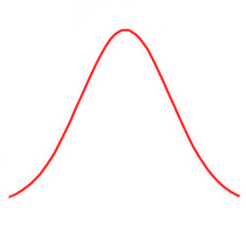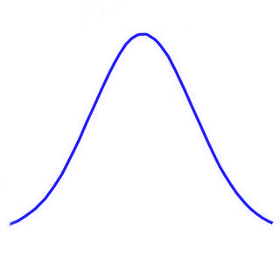

B

A

*d*

***Job 1***

***Job 2***

***Job 3***

***Job 4***

*Worse*

*Better*

Figure Stylised job selection model

# Results

## Para 1: The relationship between p(job) and d is as follows

The relationship between the probability of winning a job and the degree of health-related employability disadvantage is shown in figure X below. The results below are where k =1, i.e. there is one competitor in average health against one health disadvantaged candidate. We see that the probability of the disadvantaged candidate presenting as the better candidate than the other candidate in average health decreases monotonically with the degree of disadvantage, d. In the case presented here this result is analytically solvable and deducible, as it simply relates to the degree of overlap between two normal distributions, one with mean N(0, 1) and the other with N(0d, 1). The analytic solution in this simple case therefore is ….. This availability of ana analytic solution means the validity of the simulation results can be assessed in this instance, and are shown to be accurate. The advantage of the simulation approach is that it can be applied relatively simply to more complex of intractable variations, allowing researchers to concentrating on formalising and exploring the implications about social epidemiological processes, rather than on understanding probabilistic theory and calculus. This is demonstrated later.

## Para 2: The relationship between p(job) and k is as follows

The relationship between the probability of a helaht impaired candidate winning a job and the number of competitors for that job is shown in figure X below. Here a fixed level of disadvantage (d =0.5) is assumed in all cases, but the number of competitors is varied between k = 1 and k=15. If is see that as the number of competitors increases the probability of winning a job by the health impaired candidate decreases. Of course this pattern would be the case even where the candidate of interest had the average level of health, due to the winner-takes-all nature of the selection process. Because if the initial disadvantage, however, the probability of getting the job is lower than what would be expected of a nonimpaired candidates irrespective of the number of candidates. The bootstrapped 95% confidence intervals are shown as well. Again, these findings are largely intuitive and demonstrate that the model appears to be working properly.

## Para 3: The relationship between p(job) and (d, k) jointly is as follows

The way that the number of competitors k and degree of disadvantage d jointly affects the probability of getting a job is shown in figure X below. Figure Y presents the same relationship using the equivalent measure, expected number of applications necessary to get a job. It is see that the effect of increasing the number of competitors for a job, as would be expected as a result of the labour market becoming more competitive, is to reduce the probability of getting a job irrespective of the degree of disadvantage. In terms of the guiding focus behind this work, understanding how increased labour competition could render a small level of ill health disadvantage into a substantial employability disadvantage, it is seen that someone with a given level of health disadvantage will face an increasing challenge to their getting a job as the number of competitors per place increases. It is further noted that this relationship is nonlinear, such that both d and k have to be specified in order to identify what the effect on employability is. As has been stated previously, the precise values predicted have not been calibrated empirically, and just exist to show how this nonlinear relationship could emerge as a result of modelling a series of relatively innocuous assumptions about social and economic factors which could mediate health factors.

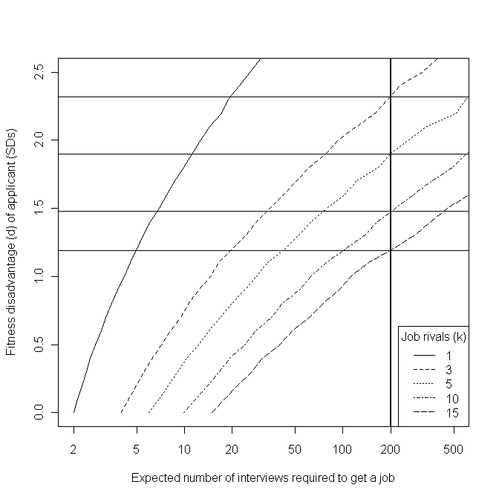

## Para 4: Unemployability as a threshold

In order to see how the relationships presented so far indicate how increases in economic inactivity due to ill health could increase despite there being no decrease in the health level of the working age, it is helpful to assume there exists a threshold at which a person effectively becomes ‘unemployable’. As discussed previously, this threshold could be different for different groups, and it could exist for a range of reasons. It is thought of here as relating to a level of unemployability so low that it is no longer in an individual’s interest to pursue employment opportunities any further, and instead some form of economic inactivity becomes preferable. There are many people of working age who have health problems that make them eligible to receive employment and support allowance, or previously IB or IVB. Not all of those who could claim the benefit and associated economically inactive category will do so. For example, many people of poor health will be working , albeit struggling to in many cases. Amongst these people it will not generally appear preferable to claim ESA, as employment generally pays better and has social standing. If that same person becomes unemployed, however, and as a result of a combination of their poor health and competition for jobs has a very low probability of getting another job, then it may be preferable for them to choose economic inactivity over jobseeking. The threshold at which this switch occurs is broadly what is meant here by ‘unemployability’.

## Para 6: How an increasing proportion of the working age population could become unemployable due to ill health even without worsening of population health

For example, if we assume that someone who requires on the average 200 applications to receive one job offer is at the ‘unemployability’ threshold, then we can observe how increased competition for jobs (increased k) will push an increasing proportion of the working age population into the ‘unemployable’ category. The threshold in this example is equivalent to the probability of employment of 0.005. With just one competitor per job, people remain ‘employable’ even where these health related disadvantage is X. With two competitors in full health, a d of X starts to render someone ‘unemployable’. With three candidates without impairment per job, someone with a d of X becomes ‘unemployable’. This relationship continues with each addition competitor. In the example presented, with 15 unimpaired competitors per place, a person becomes ‘unemployable’ when their d level is only X. Note that d refers only to the degree of disadvantage relative to the average ,and does not imply the proportion of the population with that level of d. A further nonlinear relationship between k, d, and the proportion of the population affected may be assumed, in that if the ‘unemploybaility’ threshold reaches a d level that is relatively common in the working age population, then a large rise in economic inactivity may emerge.

# Discussion

## Summary of what found

Found that more competitive labour markets can be expected to lead to more working age inactivity relating to ill health despite no worsening in population ill health

## Shortcomings

The lack of empirical ‘calibration’ Assumption about Normal stochastic term. Assumption of equal variance in populations. Not incorporating ‘staying power’ issues (well enough one day to get a job, mot enough every day to keep a job). Discrete/categorical issues/handing

## How relates to other findings

Beatty & Fothergill

Mine

Two/three others.

## Implications for research

Adding complexity and empirical calibration

Survey research on number of jobs applied for per success

Survey into possible class disparities in health of women of working age who don’t work

Application of approach to other forms of disadvantage 9e.g. employment, qualifications

## Implications for practice

Recognition that once someone of poor health becomes unemployed it may be very difficult for them to get a job again.

Consideration of sheltered employment schemes to keep people in labour market

Recognition that efficient and accessible labour markets may be mutually incompatible.