Lynda’s Short Report

# Preamble/notes

Lynda noticed an important finding in NRS data on Age-Standardised Mortality Rates in Scotland by deprivation quintile. This is that, after the ‘breakpoint’, inequalities in ASMR by deprivation quintile increased as overall ASMR improvements stalled, especially for women.

The aim of this document is to produce a first draft of these findings within the 1500 word limit of a JECH short report.

## JECH Short Report Spec

### Short report

Manuscripts reporting initial results of innovative research that deserve immediate dissemination before finalisation. The section must not be used to present a poorly elaborated research report. Short Reports should follow the IMRaD style (Introduction, Methods, Results and Discussion) and should have a structured abstract (Background, Methods, Results and Conclusion).

All research on human subjects must have been approved by the appropriate ethics committee and must have conformed to the principles embodied in the Declaration of Helsinki (see Ethics Approval for more guidelines). A statement to this effect must be included in the methods section of the paper.

Manuscripts should include a box offering a thumbnail sketch of what is already known and what your paper adds to the literature (see Research Reports).

* *Word count*: up to 1500 words
* *Structured Abstract*: up to 200 words
* *Tables/Illustrations* : up to 2
* *References*: up to 20

# Structured Abstract

## Background

* Life expectancies have been stalling in Scotland, as well as in many other rich world nations, since around 2010. However, the relationship between stalling mortality improvements and socioeconomic inequalities in health in not yet known.

## Methods

* We calculate the percentage improvement in age-standardised mortality rates (ASMR) in Scotland overall, by gender, and by SIMD deprivation quintile and gender, for two periods: 2004-2010, and 2011-2017. We then calculate the socioeconomic gradients in improvements for both periods and each gender.

## Results

* Between 2004 to 2010, ASMRs fell by 12.8% (11.5% in females and 14.9% in males), but between 2011 to 2017 ASMRs only fell by 1.8% (0.9% in females and 3.5% in males). The socioeconomic gradient in ASMR improvement more than doubled, from 1.0% per quintile in 2004-2010 (1.3% in females, 0.3% in males) to 2.2% (2.8% in females, 1.3% in males). Within the most deprived quintile, ASMRs fell in the 2004-2010 period (10.4% overall, 8.1% in females and 13.2% in males), but rose in the 2011-2017 period (by 3.6% overall, 5.8% in females and 0.4% in males).

## Conclusion

* As trends towards falling mortality risks in Scotland stalled from 2011-2017 compared with 2004-2010, socioeconomic gradients in mortality widened, especially in females, and mortality risks increased in the most socioeconomically deprived fifth of the population.

# Report

## Introduction

* As in many other countries, life expectancy improvements have stalled in Scotland.
* The stall in Scotland may be more severe than in most comparable nations, with an absolute fall (rather than slowing down) in life expectancy from 2015 to 2016. (?)
* The association between stalling improvements in life expectancy, and health inequalities by socioeconomic gradient, is unclear.
* Longevity in Scotland is lower than comparator nations for both genders, but more so in relative terms for females than males.
* European age-standardised mortality rates (ASMRs) are a way of comparing mortality risks between populations between and within countries in a way that controls for population structure. The NRS have published ASMRs by population quintile, as measured by SIMD, for Scottish populations from 2001 to 2017.
* We use this recently published data to explore how health inequalities in longevity by socioeconomic gradient and gender have changed in Scotland in a recent six year period of stalling life expectancies (from 2011 to 2017) compared with the previous six year period (2004 to 2010).

## Methods

* ASMRs from the NRS by SIMD quintile were extracted from the NRS website. ASMRs were used because life expectancy estimates for the latter period have not yet been released.
* The trends in ASMRs for each year from 2001 to 2017 inclusive by gender, overall and by SIMD quintile, were plotted.
* The percentage changes in ASMRs from 2004 to 2010 (period 1), and from 2011 to 2017 (period 2), were calculated by gender, for the whole of Scotland, and by SIMD quintile were calculated. These periods were selected because they cover the same number of years, and because the latter period includes years where life expectancy in Scotland has either fallen or improved very slowly.
* The socioeconomic gradient in percentage improvement was calculated for both periods, and by gender, by regressing percentage improvement aginst SIMD quintile using standard linear regression. Model fits were assessed with the R-squared statistic, and the intercept (predicted percentage improvements in most deprived quintile) and gradients (average increase in percentage improvement associated with move up one quintile category) were calculated and presented in tabular format.

## Results

* Figure 1A shows the change in ASMR per 100 000 population from 2001 to 2017. The thick black line shows the ASMR for Scotland overall, and thinner dashed lines indicate ASMRs for SIMD quintile groups. The two six year periods (2004-2010 and 2011-2017) are labelled and separated with vertical dashed lines. This figure shows that ASMRs improved throughout the period 2004-2010, but not in the period 2011-2017, for both genders. The falls in ASMR by deprivation quintile in the 2004-2010 period largely appear to run in parallel, suggesting that absolute (though not necessarily relative) inequalities in longevity did not increase during this period, except perhaps for females in the most deprived quintile.

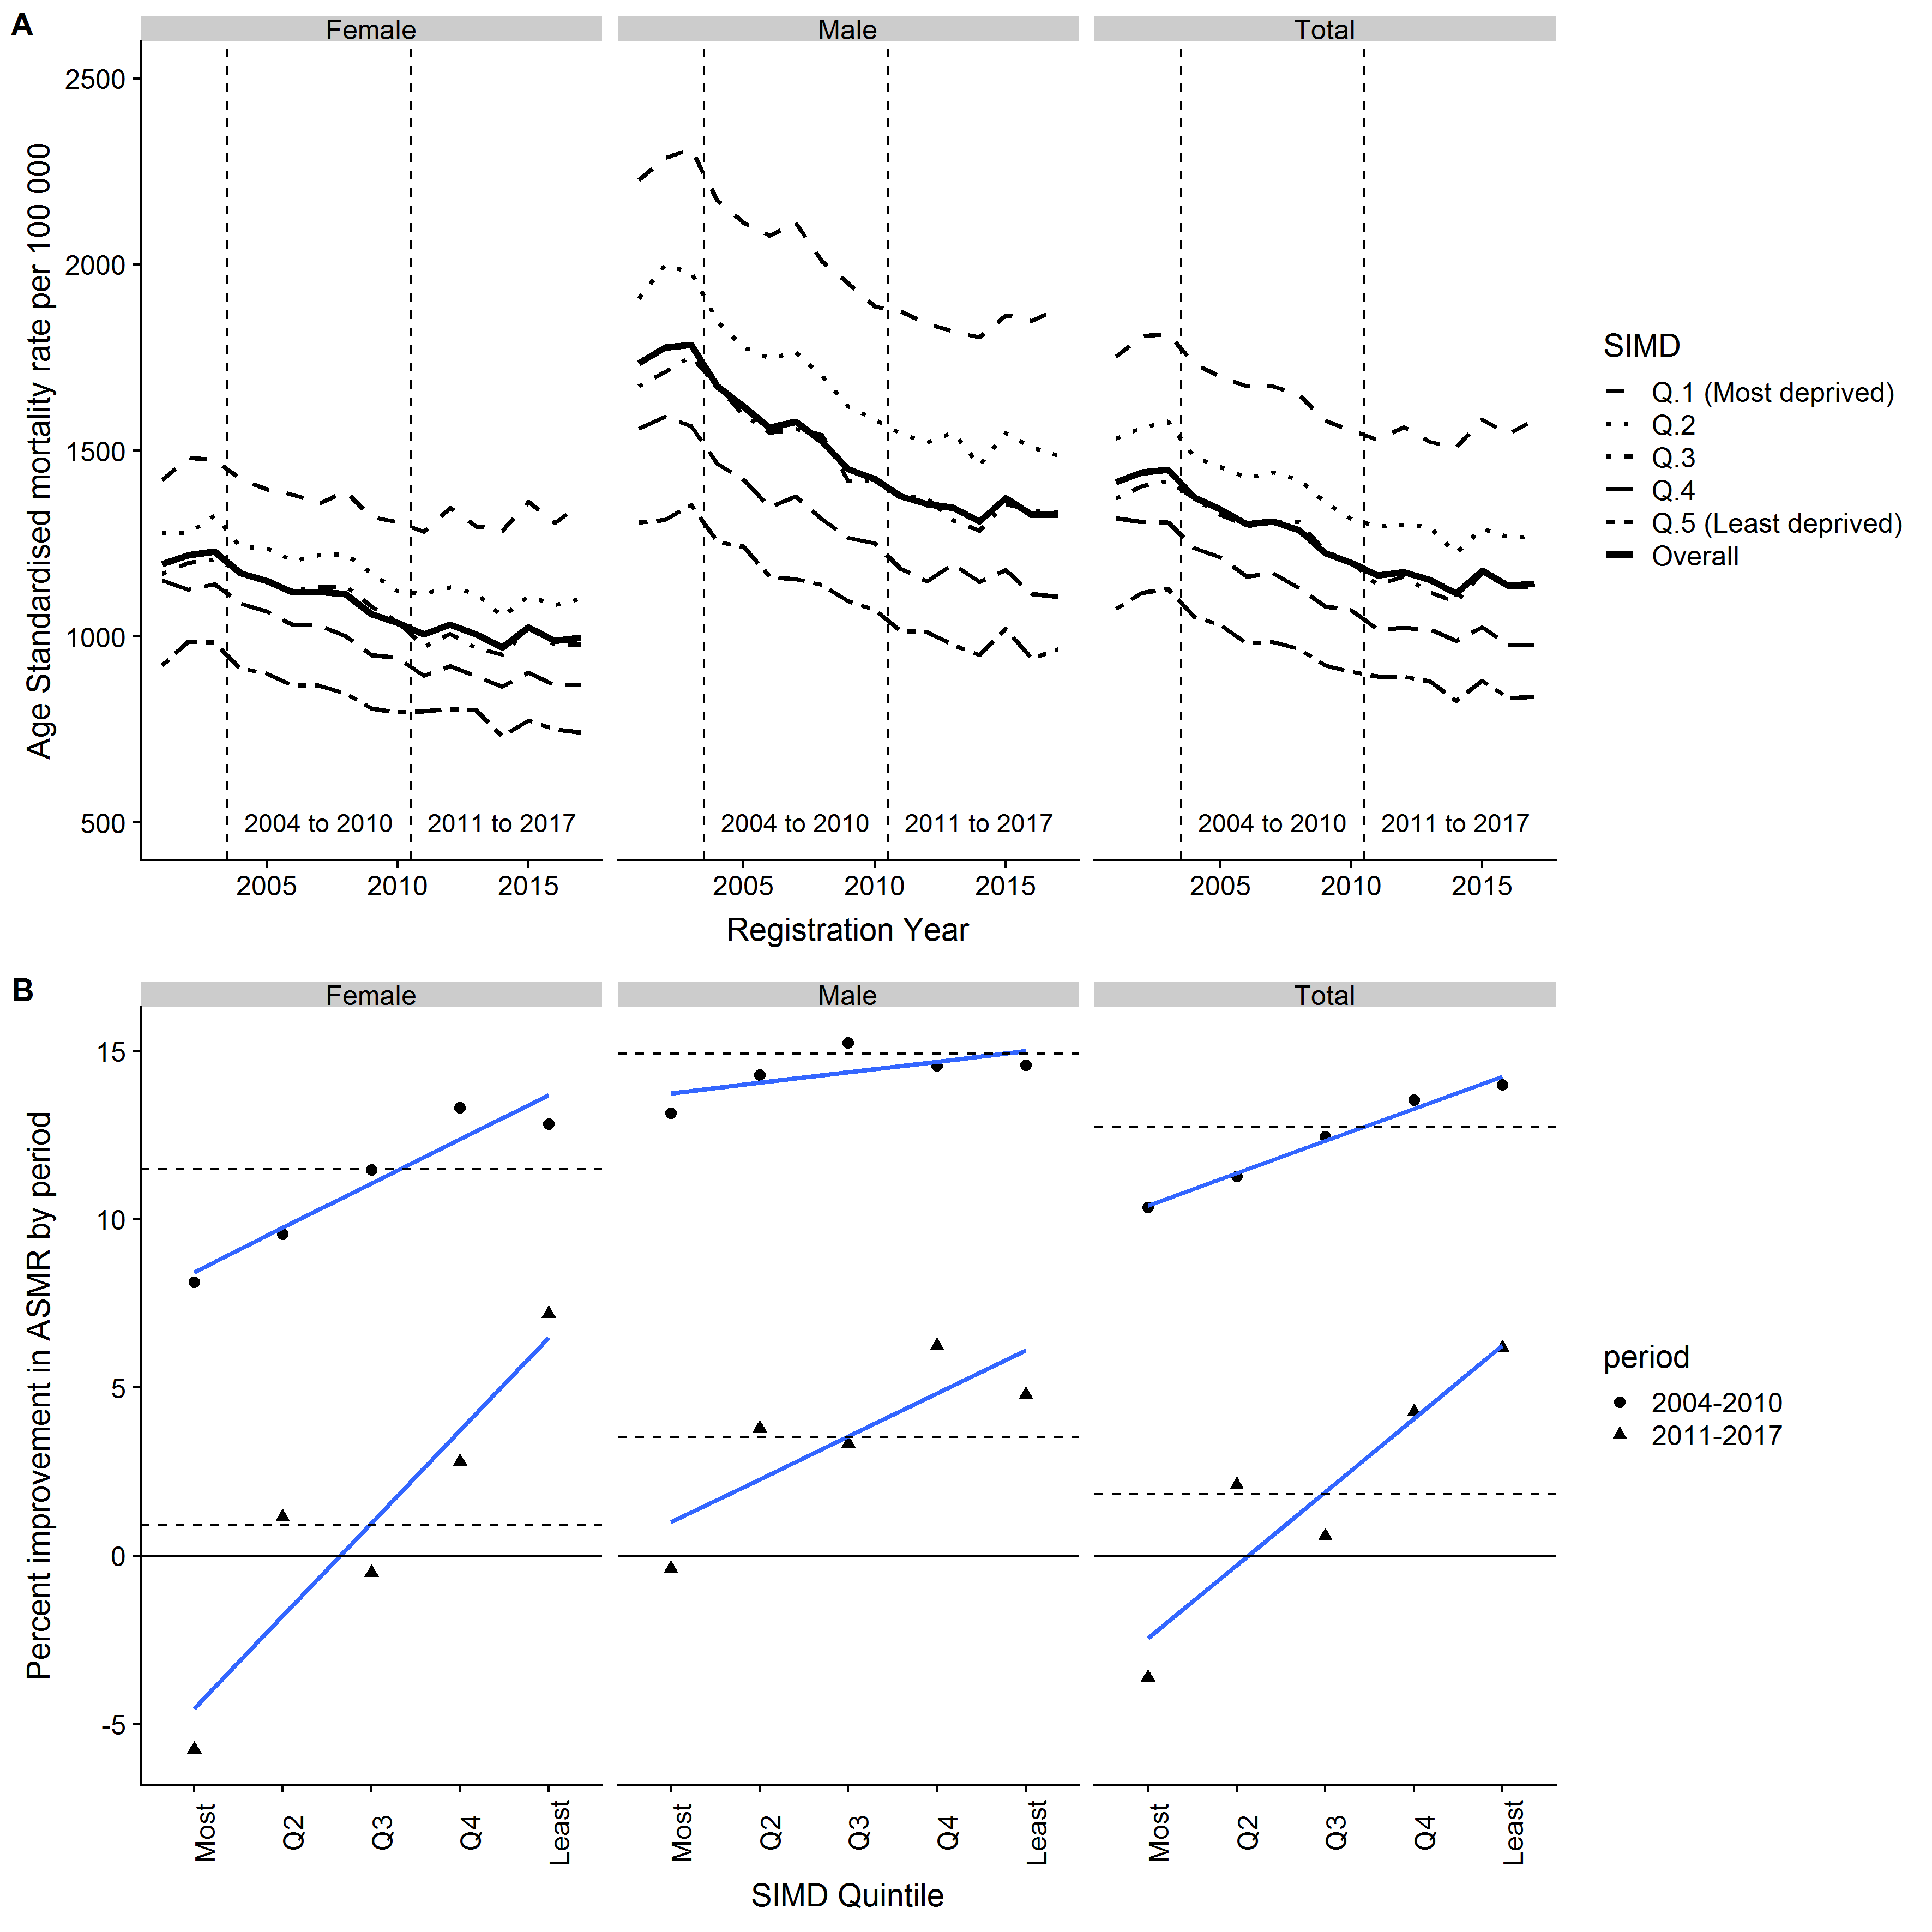

Figure the combined figure referred to in the results section

* Figure 1B shows how the percentage improvement in ASMR from the start to the end of the two periods changed by SIMD quintile. Circles are used to indicate values in the 2004-2010 period, and triangles used to indicate the 2011-2017 period. The horizontal dashed lines indicate the overall percent improvement within the period, and the diagonal lines show the socioeconomic gradients. Table 1 provides the same information in tabular form.

Table Table as formatted appropriately

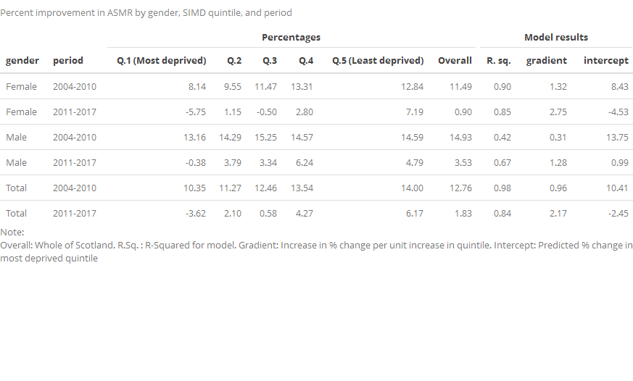

Table Table 1, not correctly formatted but modifiable

|  |  |  |  |  |  |  |  |  |  |  |
| --- | --- | --- | --- | --- | --- | --- | --- | --- | --- | --- |
| gender | period | Q.1 (Most deprived) | Q.2 | Q.3 | Q.4 | Q.5 (Least deprived) | Overall | R. sq. | gradient | intercept |
| Female | 2004-2010 | 8.14 | 9.55 | 11.47 | 13.31 | 12.84 | 11.49 | 0.90 | 1.32 | 8.43 |
| Female | 2011-2017 | -5.75 | 1.15 | -0.50 | 2.80 | 7.19 | 0.90 | 0.85 | 2.75 | -4.53 |
| Male | 2004-2010 | 13.16 | 14.29 | 15.25 | 14.57 | 14.59 | 14.93 | 0.42 | 0.31 | 13.75 |
| Male | 2011-2017 | -0.38 | 3.79 | 3.34 | 6.24 | 4.79 | 3.53 | 0.67 | 1.28 | 0.99 |
| Total | 2004-2010 | 10.35 | 11.27 | 12.46 | 13.54 | 14.00 | 12.76 | 0.98 | 0.96 | 10.41 |
| Total | 2011-2017 | -3.62 | 2.10 | 0.58 | 4.27 | 6.17 | 1.83 | 0.84 | 2.17 | -2.45 |

* In the 2004-2010 period (circles in Figure 1B), ASMRs improved by 12.76% overall (11.49% for females and 14.93% for males). By constrast, in the 2011-2017 period (triangles in Figure 1B), ASMRs improved by only 1.83% overall (0.90% for females and 3.53% for males). A clear socioeconomic gradient was observed in these improvements for both periods, with larger improvements in higher SIMD groups. The linearity of the socioeconomic gradient appeared to fall somewhat from the earlier to the latter period, as suggested by a near-perfect R-Squared value (0.98) in the 2004-2010 period, and a slightly lower fit (0.84) in the 2011-2017 period. This declining fit is largely driven by the gradient in females (R-Squared 0.90 to 0.85), with the fit in males increasing slightly (0.42 to 0.67). However, while the linearity of the fit has declined, the gradient of the fit, which can be considered a measure of the importance of socioeconomic gradient to health inequalities, has increased markedly, from 0.96% per quintile in the 2004-2010 period to 2.17% per quintile in the 2011-2017 period; a ratio of gradients of 2.3, and difference in gradients of 1.2%. The change in ratio of gradients was steeper for males (4.1 compared with 2.08 for females), though the difference in gradients was greater for females (2.1%) than for males (1.0%).
* The column marked ‘intercept’ is the percentage improvement in quintile 1 (the most deprived quintile) predicted by the linear models. This can be compared with the actual percentages for quintile 1 in the third column of table 1 (as well as the corresponding points in Figure 1B). In the 2004-2010 period, the predicted values for the lowest quintile were close to the observed values, whereas for the 2011-2017 values the model predictions substantially underestimated the observed values, being 1.2% lower than predicted overall (3.62% compared with 2.45%). As Figure 1B also shows, the linear fits also under-predict improvements in quintile 2, as well as over-predicting improvements in quintile 1.

## Discussion

* *Summary*: This paper has shown that, as improvements in mortality have stalled in Scotland, socioeconomic gradients in mortality have increased, especially for women. In the most socioeconomically deprived fifth of areas in Scotland, improvements have gone into reverse, with ASMRs increasing by 3.6% from 2011 to 2017.
* *Limitations*: This paper has not looked at life expectancies, as these have not been published for 2017. However ASMR and life expectancy trends are closely linked. The paper has also not looked at age-specific mortality rates, rather than age-standardised rates, and there may be important differences in gradients by age group.
* *Implications for Practice*: To do
* *Implications for Research*: To do

# Other notes from Lynda

# Paper framework – Mortality trends item 5: mortality trends by deprivation in Scotland

Overall aim

How do recent adverse mortality trends (all-age, all-cause) in Scotland vary by socioeconomic deprivation, and to what extent any differences in mortality trend are underlying the overall population trajectory?

Background

1. Life expectancy improvements have stalled in Scotland; most recent NRS data showed a fall for men and women; the scale of this trend is marked historically and in comparison with other countries.
2. Age-standardised mortality rates (all age, all cause) changed trend from steady decline to a rate of slower or no improvement in the year ending 2012 Q4 for men and the year ending 2014 Q2 for women (paper 1, segmented regression, 2 break model, best estimates).
3. Mortality inequalities are increasing in Scotland:
   1. Long-term monitoring report (HLE, premature mortality SII&RII)
   2. NRS life expectancy by SIMD
4. Several published analyses explore the contribution of deaths by age and cause to overall mortality inequality, and some have repeated this at different time points to explore how the constituents of inequality have changed.
5. Analyses of overall mortality trends have tended to explore the age, cause and geographical variation in this (by decomposition or age/cause specific trends).
6. Bringing together analyses on overall population mortality and mortality inequality is an important step in understanding to what extent
7. Change in fundamentals --> widening health inequalities in longevity

Questions

1. Are increasing inequalities having a marked impact on overall population mortality trends?

Method

Data source

NRS published:

Life expectancy by SIMD 2012 (2001/03-2011/13) <https://www.nrscotland.gov.uk/statistics-and-data/statistics/statistics-by-theme/life-expectancy/life-expectancy-in-scottish-areas/time-series-data>

Life expectancy by SIMD 2016 (2014/15-2-15/17) – expected shortly

Age-standardised mortality rate by SIMD 2016 quintile 2001-2017

<https://www.nrscotland.gov.uk/statistics-and-data/statistics/statistics-by-theme/vital-events/deaths/age-standardised-death-rates-calculated-using-the-esp>

ASMR – NRS 2001-2017 SIMD 2016 Quintile

1. Trend
2. Before & after breakpoint (2011)
3. Overall measures of inequality before and after (SII/RII)
4. Gender differences

Results

1. Trend
2. Before & after breakpoint (2011)
3. Overall measures of inequality before and after (SII/RII)
4. Gender differences

Discussion

Limitations

Implications for practice

Implications for research

Questions to be addressed

Key literature/existing analyses

1. **Trends in mortality inequality Scotland**
2. Taulbut M, Agbato D, McCartney NHS Health Scotland G. Working and hurting? Monitoring the health and health inequalities impacts of the economic downturn and changes to the social security system [Internet]. 2018 [cited 2018 Sep 25]. Available from: <http://www.healthscotland.scot/media/2147/working-and-hurting-sep-2018-english.pdf>

* Working age mortality (15-64 years) SIMD 2012, 2001-2015: RII, SII
* All-cause mortality (ASMR) by SIMD quintile 1996-2016 (various SIMD applied)

1. Long-term monitoring report <https://www.gov.scot/publications/long-term-monitoring-health-inequalities-december-2017/>

* Inequality in HLE
* Premature mortality (<75) RII, SII

1. Mesalles-Naranjo O, Grant I, Wyper GMA, Stockton D, Dobbie R, McFadden M, et al. Trends and inequalities in the burden of mortality in Scotland 2000–2015. Devleesschauwer B, editor. PLoS One [Internet]. 2018 Aug 1 [cited 2018 Dec 5];13(8):e0196906. Available from: <https://dx.plos.org/10.1371/journal.pone.0196906>

* SII for years of life lost by cause to 2015

1. **Assessing age/cause contributions to health inequality**

**Scotland**:

Seaman R, Leyland A, Popham F. OP05 Which ages and causes of death explain the widening lifespan variation gap in scotland? a population based study using routine data. J Epidemiol Community Heal [Internet]. 2017 Sep 1 [cited 2018 Aug 29];71(Suppl 1):A3–4. Available from: <https://jech.bmj.com/content/71/Suppl_1/A3.2>

* Lifespan variation, Carstairs 1981-2011, decomposition of age/cause contributors to lifespan gap in 1981 and 2011
* Increased contribution of working age deaths and deaths due to external causes ton inequality

**England**:

1. PHE report: <https://www.gov.uk/government/publications/health-profile-for-england-2018/chapter-5-inequalities-in-health#contribution-of-age-groups-and-causes-of-death-to-the-gap-in-life-expectancy>

* LE and HLE inequality 2014/16 SII
* Age/cause decomposition of LE gap (most-least deprived decile) 2014/16

1. Bennett JE, Pearson-Stuttard J, Kontis V, Capewell S, Wolfe I, Ezzati M. Contributions of diseases and injuries to widening life expectancy inequalities in England from 2001 to 2016: a population-based analysis of vital registration data. Lancet Public Heal [Internet]. 2018 Nov 23 [cited 2018 Dec 5];3(12):e586–97. Available from: <https://www.sciencedirect.com/science/article/pii/S2468266718302147>

**Northern Ireland**:

<https://www.health-ni.gov.uk/publications/health-inequalities-life-expectancy-decomposition-2017>

* Life expectancy decomposition 2009/11-2012/15 by age, sex, cause, rurality

1. **Health inequality in Scotland in context**

Seaman R, Seaman R, Leyland A, Popham F. Lifespan variation since 1950: How does Scotland compare to 16 other Western European countries? [Internet]. [cited 2018 Oct 1]. Available from: https://academic.oup.com/eurpub/article-abstract/24/suppl_2/cku166-019/2839783