Online Technical Appendix for Fenton, Wyper, McCartney, Minton, ’Socioeconomic inequality in recent mortality trends in Scotland

Jon Minton

# Introduction

This document describes all data, methods and code used to generate the results within the above-listed article.

All data are publically avaialble, and you are free to interrogate and use the code in your own analyses.

All data preparation, analyses, figures and tables were generated using the R programming language, with the exception of some initial data preparation done within Microsoft Excel. This data preparation only involved changing the structure of existing data within an Excel sheet, rather than the contents of such data.

# Data

The data used are from [this National Records of Scotland (NRS)) webpage](https://www.nrscotland.gov.uk/statistics-and-data/statistics/statistics-by-theme/vital-events/deaths/age-standardised-death-rates-calculated-using-the-esp). The dataset [‘Latest tables based on 2013 ESP’ (European Standardized Population) was downloaded in Excel format](https://www.nrscotland.gov.uk/files//statistics/age-standardised-death-rates-esp/2017/age-standard-death-rates-17-all%20tabs-revised.xlsx).

All analyses presented in the paper were based on table 7 of this Excel Workbook.

The contents of table 7 of the Workbook were rearranged so as to conform with data structure recommended by (Wickham, (2014) ‘Tidy Data’)[<https://www.jstatsoft.org/article/view/v059i10/v59i10.pdf>], producing a new datasheet, called flat_data, which was imported directly into R. All further processing and analyses were conducted within R.

# Workflow and results

The following code chunks perform the analyses which are presented in the paper.

Where additional information are required as to the methods, they are described adjacent to the code chunks.

## Loading the required packages

pacman::p_load(tidyverse, readxl, cowplot, kableExtra)

*Note*: pacman is an R package for managing R packages. It has to be installed once using install.packages("pacman"), but once installed will either install or load other packages as required.

## Load data

dta <- read_excel("data/ASMR_SIMD_2001_2017_indexed trends.xlsx", sheet = "flat_data")

## Tidying the data

names(dta) <- c("year", "overall", "q1", "q2", "q3", "q4", "q5", "gender")  
  
dta_tidy <- dta %>%   
 gather(key = "simd", value = "asmr", -year, -gender) %>%   
 mutate(SIMD = factor(simd,   
 levels = c("q1", "q2", "q3", "q4", "q5","overall"),  
 labels = c("Q.1 (Most deprived)",   
 "Q.2", "Q.3", "Q.4", "Q.5 (Least deprived)", "Overall")  
 )  
 )

## Visualising

This is one part of the first figure. The R package ggplot2 is used to produce this visualisation.

p1 <- dta_tidy %>%   
 ggplot(aes(x = year )) +  
  
 facet_wrap(~gender) +   
 geom_line(aes(y = asmr, group = SIMD, linetype = SIMD, size = SIMD, color = SIMD)) +   
 scale_size_manual(values = c(1, 1.2, 1, 1.2, 1, 1.4)) +   
 scale_linetype_manual(values = c(2,3,4,5, 6, 1)) +   
 scale_color_manual(values = c("black", "grey", "black", "grey", "black", "blue")) +   
 labs(x = "Year", y = "Age Standardised mortality rate per 100 000") +   
 scale_y_continuous(expand = c(0, 0), limits = c(0, 2500), minor_breaks = seq(0, 2500, by = 100)) +  
 scale_x_continuous(minor_breaks = 2001:2017) +  
 geom_vline(xintercept = 2012, linetype = "dashed") +   
 geom_vline(xintercept = 2006, linetype = "dashed") +   
 annotate("text", y = 100, x = 2006 + (2012 - 2006) / 2, label = "2006 to 2011") +   
 annotate("text", y = 100, x = 2012 + (2018 - 2012) / 2, label = "2012 to 2017") +   
 geom_ribbon(  
 aes(x = year, ymin = q5, ymax =q1),   
 alpha = 0.1, fill ="red",  
 data = dta_tidy %>% filter(simd %in% c("q1", "q5")) %>% select(-SIMD) %>% spread(simd, asmr)  
   
 ) +   
 background_grid(major = "xy", minor = "xy")  
  
  
  
p1

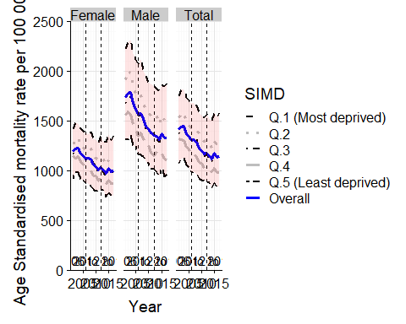

The following chunk calculates the percentage change, from the earlier to latter period, in ASMR by gender and SIMD quintile.

percent_changes <- dta_tidy %>%   
 mutate(period = case_when(  
 between(year, 2012, 2017) ~ "2012-2017",   
 between(year, 2006, 2011) ~ "2006-2011",  
 TRUE ~ NA_character_) %>% factor(levels = c("2012-2017", "2006-2011"))) %>%   
 group_by(gender, simd, period) %>%   
 filter(year == min(year) | year == max(year) ) %>%   
 filter(!is.na(period)) %>%   
 group_by(gender, SIMD, period) %>%   
 summarise(percent_change = - 100 * (1 - asmr[year == max(year)] / asmr[year == min(year)])) %>%   
 ungroup()

## Warning: Factor `period` contains implicit NA, consider using  
## `forcats::fct_explicit_na`

Note: The contents of percent_changes look as follows:

percent_changes

## # A tibble: 36 x 4  
## gender SIMD period percent_change  
## <chr> <fct> <fct> <dbl>  
## 1 Female Q.1 (Most deprived) 2012-2017 0.690  
## 2 Female Q.1 (Most deprived) 2006-2011 -7.21   
## 3 Female Q.2 2012-2017 -2.65   
## 4 Female Q.2 2006-2011 -7.37   
## 5 Female Q.3 2012-2017 -2.96   
## 6 Female Q.3 2006-2011 -13.3   
## 7 Female Q.4 2012-2017 -5.53   
## 8 Female Q.4 2006-2011 -13.2   
## 9 Female Q.5 (Least deprived) 2012-2017 -7.79   
## 10 Female Q.5 (Least deprived) 2006-2011 -7.81   
## # ... with 26 more rows

Note: The code chunk above can be readily adapted to showing absolute change (for example), as follows

dta_tidy %>%   
 mutate(period = case_when(  
 between(year, 2012, 2017) ~ "2012-2017",   
 between(year, 2006, 2011) ~ "2006-2011",  
 TRUE ~ NA_character_) %>% factor(levels = c("2012-2017", "2006-2011"))) %>%   
 group_by(gender, simd, period) %>%   
 filter(year == min(year) | year == max(year) ) %>%   
 filter(!is.na(period)) %>%   
 group_by(gender, SIMD, period) %>%   
 summarise(  
 percent_change = - 100 * (1 - asmr[year == max(year)] / asmr[year == min(year)]),  
 absolute_change = asmr[year==max(year)] - asmr[year == min(year)] # additional line  
 ) %>%   
 ungroup() %>% # indicative visualisation   
 ggplot(aes(x = SIMD, y = absolute_change)) +  
 geom_point() +   
 facet_grid(period~gender) +   
 geom_hline(yintercept = 0) +  
 theme(axis.text.x = element_text(angle = 90))

## Warning: Factor `period` contains implicit NA, consider using  
## `forcats::fct_explicit_na`

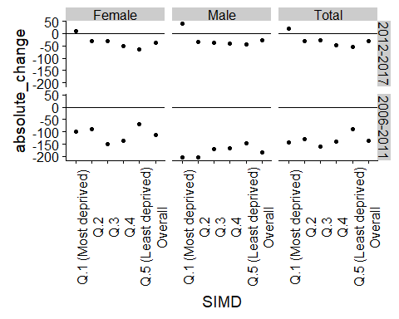

The following shows the second part of the figure in the paper

p2 <- percent_changes %>%   
 mutate(SIMD = factor(SIMD,   
 levels = c("Q.1 (Most deprived)",   
 "Q.2", "Q.3", "Q.4", "Q.5 (Least deprived)", "Overall"),  
 labels = c("Most", "Q2", "Q3", "Q4", "Least", "Overall")  
 )  
 ) %>%   
 filter(SIMD != "Overall") %>%   
 ggplot(aes(x = SIMD, y = percent_change, group = period, shape = period)) +   
 facet_wrap( ~ gender) +   
 geom_point(size = 5) +   
 stat_smooth(method = "lm", se = F) + # This produces the blue line with the regression slopes  
 geom_hline(yintercept = 0) +   
 geom_hline( # This adds the overall percent change  
 aes(yintercept = percent_change, group = period),  
 data = percent_changes %>% filter(SIMD == "Overall"),  
 linetype = "dashed"  
 ) +   
 theme(axis.text.x = element_text(angle = 90)) +   
 labs(y = "Percent change in ASMR by period", x = "SIMD Quintile") +  
 scale_shape_manual("Period", values = c(17, 16))   
   
p2

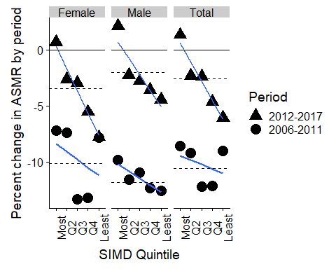

# Combined figure

The following produces the combined figure comprising the two parts shown previously. The figure is rendered as a png format image at 300dpi, and placed in the directory ‘figures’.

p_both <- plot_grid(p1, p2, labels = c("A", "B"), ncol = 1, align = "v")  
  
p_both

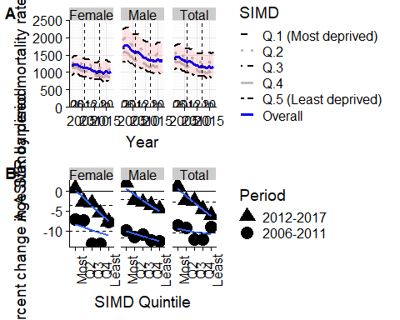

ggsave("figures/combined_figure_2012.png", dpi = 300, units = "cm", height = 30, width = 30)

## Table

The following shows how the contents of the table were produced.

These summarise a series of univariate linear regressions of SIMD quintile against precentage change in ASMR within distinct periods.

The columns intercept and gradient present summary information about point estimates and 95% confidence intervals for the intercept and gradient of the the regressions, which are then presented in the formatted table.

A functional programming approach was adopted in order to produce the same analyses consistently for different gender and period combinations, using functions within the (purrr package)[<https://purrr.tidyverse.org/>.

get_ci <- function(x){  
 tmp <- x %>% summary() %>% coefficients()  
   
 return(  
 list(  
 lower = tmp[,1] - 1.96 * tmp[,2],  
 upper = tmp[,1] + 1.96 * tmp[,2]  
 )  
 )  
   
}  
  
# Model parameters   
tbl_1 <- percent_changes %>%   
 filter(SIMD != "Overall") %>%   
 mutate(qnt = unclass(SIMD) - 1) %>% # This is so the intercept refers to the 1st quintile (not the 'zeroth' quintile)  
 select(gender, period, percent_change, qnt) %>%   
 group_by(gender, period) %>%   
 nest() %>%   
 mutate(mdl = map(data, ~lm(percent_change ~ qnt, data = .x))) %>%   
 mutate(`R. sq.` = map_dbl(mdl, ~summary(.x)["r.squared"][[1]])) %>%   
 mutate(gradient = map_dbl(mdl, ~coef(.x)["qnt"])) %>%   
 mutate(intercept = map_dbl(mdl, ~coef(.x)["(Intercept)"])) %>%   
 mutate(cis = map(mdl, get_ci)) %>%   
 mutate(  
 int_lower = map_dbl(cis, ~.[["lower"]][1]),  
 int_upper = map_dbl(cis, ~.[["upper"]][1]),  
 grd_lower = map_dbl(cis, ~.[["lower"]][2]),  
 grd_upper = map_dbl(cis, ~.[["upper"]][2])   
 ) %>%   
 select(gender, period, `R. sq.`,   
 gradient, grd_lower, grd_upper,   
 intercept, int_lower, int_upper  
 ) %>%   
 mutate(  
 gradient = paste0(  
 format(round(gradient, 2), nsmall = 2),   
 " (",   
 format(round(grd_lower, 2), nsmall = 2),   
 ", ",   
 format(round(grd_upper, 2), nsmall = 2),   
 ")"  
 )  
 ) %>%   
 mutate(  
 intercept = paste0(  
 format(round(intercept, 2), nsmall = 2),   
 " (",   
 format(round(int_lower, 2), nsmall = 2),   
 ", ",   
 format(round(int_upper, 2), nsmall = 2),  
 ")"  
 )  
 ) %>%   
 select(-grd_lower, -grd_upper, -int_lower, -int_upper)  
  
tbl_1

## # A tibble: 6 x 5  
## gender period `R. sq.` gradient intercept   
## <chr> <fct> <dbl> <chr> <chr>   
## 1 Female 2012-2017 0.960 -1.98 (-2.44, -1.53) " 0.32 ( -0.80, 1.44)"  
## 2 Female 2006-2011 0.122 -0.70 (-2.84, 1.44) " -8.38 (-13.62, -3.14)"  
## 3 Male 2012-2017 0.803 -1.44 (-2.25, -0.63) " 0.69 ( -1.29, 2.67)"  
## 4 Male 2006-2011 0.790 -0.63 (-1.00, -0.26) -10.19 (-11.09, -9.29)   
## 5 Total 2012-2017 0.928 -1.71 (-2.25, -1.17) " 0.62 ( -0.70, 1.93)"  
## 6 Total 2006-2011 0.121 -0.40 (-1.60, 0.81) " -9.44 (-12.39, -6.48)"

tbl_2 <- percent_changes %>% spread(SIMD, percent_change)  
  
tbl_both <- inner_join(tbl_2, tbl_1)

## Joining, by = c("gender", "period")

tbl_both

## # A tibble: 6 x 11  
## gender period `Q.1 (Most depr~ Q.2 Q.3 Q.4 `Q.5 (Least dep~  
## <chr> <fct> <dbl> <dbl> <dbl> <dbl> <dbl>  
## 1 Female 2012-~ 0.690 -2.65 -2.96 -5.53 -7.79  
## 2 Female 2006-~ -7.21 -7.37 -13.3 -13.2 -7.81  
## 3 Male 2012-~ 2.11 -2.27 -2.78 -3.57 -4.44  
## 4 Male 2006-~ -9.81 -11.6 -10.9 -12.4 -12.6   
## 5 Total 2012-~ 1.35 -2.32 -2.38 -4.61 -6.05  
## 6 Total 2006-~ -8.56 -9.18 -12.2 -12.2 -9.04  
## # ... with 4 more variables: Overall <dbl>, `R. sq.` <dbl>,  
## # gradient <chr>, intercept <chr>

The following converts the above table into a more neatly formatted table using the kable and kableExtra packages.

tbl_both %>%   
 mutate(period = factor(period, levels = c("2006-2011", "2012-2017"))) %>%  
 arrange(gender, period) %>%   
 knitr::kable(  
 digits = 2,   
 caption = "Percent change in ASMR by gender, SIMD quintile, and period"  
 ) %>%   
 kableExtra::kable_styling() %>%   
 kableExtra::add_header_above(c(" "," ", "Percentages" = 6, "Model results" = 3)) %>%   
 kableExtra::footnote("Overall: Whole of Scotland. R.Sq. : R-Squared for model. Gradient: Increase in % change per unit increase in quintile. Intercept: Predicted % change in most deprived quintile. For gradient and intercept, values in parentheses show lower and upper 95% confidence intervals of coefficients respectively.")

Percent change in ASMR by gender, SIMD quintile, and period

Percentages

Model results

gender

period

Q.1 (Most deprived)

Q.2

Q.3

Q.4

Q.5 (Least deprived)

Overall

R. sq.

gradient

intercept

Female

2006-2011

-7.21

-7.37

-13.34

-13.21

-7.81

-10.11

0.12

-0.70 (-2.84, 1.44)

-8.38 (-13.62, -3.14)

Female

2012-2017

0.69

-2.65

-2.96

-5.53

-7.79

-3.46

0.96

-1.98 (-2.44, -1.53)

0.32 ( -0.80, 1.44)

Male

2006-2011

-9.81

-11.57

-10.94

-12.35

-12.57

-11.82

0.79

-0.63 (-1.00, -0.26)

-10.19 (-11.09, -9.29)

Male

2012-2017

2.11

-2.27

-2.78

-3.57

-4.44

-2.00

0.80

-1.44 (-2.25, -0.63)

0.69 ( -1.29, 2.67)

Total

2006-2011

-8.56

-9.18

-12.19

-12.17

-9.04

-10.59

0.12

-0.40 (-1.60, 0.81)

-9.44 (-12.39, -6.48)

Total

2012-2017

1.35

-2.32

-2.38

-4.61

-6.05

-2.59

0.93

-1.71 (-2.25, -1.17)

0.62 ( -0.70, 1.93)

Note:

Overall: Whole of Scotland. R.Sq. : R-Squared for model. Gradient: Increase in % change per unit increase in quintile. Intercept: Predicted % change in most deprived quintile. For gradient and intercept, values in parentheses show lower and upper 95% confidence intervals of coefficients respectively.

# Approach discussed in sensitivity analysis

The sensitivity analysis to the paper showed the effect of using the fitted values for the first and last year in each of the periods, rather than the values themselves. This approach can address any concern that the first and last year within either period were in any way anomalous or uncharacteristic of change within the period as a whole.

The function broom::augment was used to extract fitted values for each year within each period, gender and SIMD combination. The fitted values, .fitted, were then used in place of the observed values, asmr, as in the main analyses.

percent_changes_pred <- dta_tidy %>%   
 mutate(period = case_when(  
 between(year, 2012, 2017) ~ "2012-2017",   
 between(year, 2006, 2011) ~ "2006-2011",  
 TRUE ~ NA_character_) %>% factor(levels = c("2012-2017", "2006-2011"))) %>%   
 group_by(gender, SIMD, simd, period) %>%   
 nest() %>%   
 mutate(mdl = map(data, ~lm(asmr ~ year, data = .x))) %>%   
 mutate(aug = map(mdl, broom::augment)) %>%   
 select(-data, -mdl) %>%   
 unnest() %>%   
 filter(!is.na(period)) %>%   
 group_by(gender, SIMD, period) %>%   
 filter(year == min(year) | year == max(year) ) %>%   
 summarise(percent_change = - 100 * (1 - .fitted[year == max(year)] / .fitted[year == min(year)])) %>%   
 ungroup()

## Warning: Factor `period` contains implicit NA, consider using  
## `forcats::fct_explicit_na`  
  
## Warning: Factor `period` contains implicit NA, consider using  
## `forcats::fct_explicit_na`

percent_changes_pred_overall <- percent_changes_pred %>%   
 group_by(gender, period) %>%   
 summarise(percent_change = mean(percent_change)) %>%   
 ungroup() %>%   
 mutate(SIMD = "Mean of quintiles") %>%   
 select(gender, SIMD, period, percent_change)  
   
percent_changes_pred <- percent_changes_pred %>%   
 bind_rows(percent_changes_pred_overall) %>%   
 mutate(SIMD = factor(SIMD,   
 levels = c("Q.1 (Most deprived)",   
 "Q.2", "Q.3", "Q.4", "Q.5 (Least deprived)", "Overall", "Mean of quintiles"),  
 labels = c("Most", "Q2", "Q3", "Q4", "Least", "Overall", "Mean of quintiles")  
 )  
 )

## Warning in bind_rows_(x, .id): binding factor and character vector,  
## coercing into character vector

## Warning in bind_rows_(x, .id): binding character and factor vector,  
## coercing into character vector

The subfigure using this alternative stratgy is therefore produced as follows:

p2a <- percent_changes_pred %>%   
 filter(!(SIMD %in% c("Overall", "Mean of quintiles"))) %>%   
 ggplot(aes(x = SIMD, y = percent_change, group = period, shape = period)) +   
 facet_wrap( ~ gender) +   
 geom_point(size = 5) +   
 stat_smooth(method = "lm", se = F) +   
 geom_hline(yintercept = 0) +   
 geom_hline(  
 aes(yintercept = percent_change, group = period),  
 data = percent_changes_pred %>% filter(SIMD == "Overall"),  
 linetype = "dashed"  
 ) +   
  
 theme(axis.text.x = element_text(angle = 90)) +   
 labs(y = "Percent change in ASMR by period", x = "SIMD Quintile") +  
 scale_shape_manual("Period", values = c(17, 16))   
   
p2a

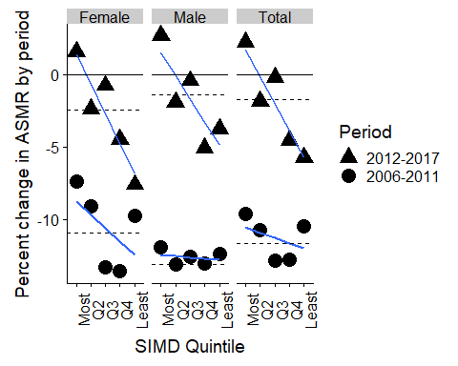

ggsave("figures/fig1a_using_alt_method_2012.png", dpi = 300, units = "cm", height = 16, width = 30)

The table of the above, using this alternative modelling strategy, is produced using the code chunks below

get_ci <- function(x){  
 tmp <- x %>% summary() %>% coefficients()  
   
 return(  
 list(  
 lower = tmp[,1] - 1.96 * tmp[,2],  
 upper = tmp[,1] + 1.96 * tmp[,2]  
 )  
 )  
   
}  
  
# Model parameters   
tbl_1a <- percent_changes_pred %>%   
 filter(!(SIMD %in% c("Overall", "Mean of quintiles"))) %>%   
 mutate(qnt = unclass(SIMD) - 1) %>% # This is so the intercept refers to the 1st quintile (not the 'zeroth' quintile)  
 select(gender, period, percent_change, qnt) %>%   
 group_by(gender, period) %>%   
 nest() %>%   
 mutate(mdl = map(data, ~lm(percent_change ~ qnt, data = .x))) %>%   
 mutate(`R. sq.` = map_dbl(mdl, ~summary(.x)["r.squared"][[1]])) %>%   
 mutate(gradient = map_dbl(mdl, ~coef(.x)["qnt"])) %>%   
 mutate(intercept = map_dbl(mdl, ~coef(.x)["(Intercept)"])) %>%   
 mutate(cis = map(mdl, get_ci)) %>%   
 mutate(  
 int_lower = map_dbl(cis, ~.[["lower"]][1]),  
 int_upper = map_dbl(cis, ~.[["upper"]][1]),  
 grd_lower = map_dbl(cis, ~.[["lower"]][2]),  
 grd_upper = map_dbl(cis, ~.[["upper"]][2])   
 ) %>%   
 select(gender, period, `R. sq.`,   
 gradient, grd_lower, grd_upper,   
 intercept, int_lower, int_upper  
 ) %>%   
 mutate(  
 gradient = paste0(  
 format(round(gradient, 2), nsmall = 2),   
 " (",   
 format(round(grd_lower, 2), nsmall = 2),   
 ", ",   
 format(round(grd_upper, 2), nsmall = 2),   
 ")"  
 )  
 ) %>%   
 mutate(  
 intercept = paste0(  
 format(round(intercept, 2), nsmall = 2),   
 " (",   
 format(round(int_lower, 2), nsmall = 2),   
 ", ",   
 format(round(int_upper, 2), nsmall = 2),  
 ")"  
 )  
 ) %>%   
 select(-grd_lower, -grd_upper, -int_lower, -int_upper)  
  
tbl_1a

## # A tibble: 6 x 5  
## gender period `R. sq.` gradient intercept   
## <chr> <fct> <dbl> <chr> <chr>   
## 1 Female 2012-2017 0.848 -2.05 (-3.03, -1.07) " 1.38 ( -1.03, 3.78)"  
## 2 Female 2006-2011 0.290 -0.93 (-2.58, 0.72) " -8.76 (-12.80, -4.72)"  
## 3 Male 2012-2017 0.705 -1.60 (-2.78, -0.43) " 1.51 ( -1.36, 4.39)"  
## 4 Male 2006-2011 0.0813 -0.09 (-0.44, 0.26) -12.44 (-13.29, -11.59)   
## 5 Total 2012-2017 0.834 -1.86 (-2.80, -0.92) " 1.70 ( -0.60, 4.01)"  
## 6 Total 2006-2011 0.162 -0.37 (-1.31, 0.58) -10.55 (-12.85, -8.24)

tbl_2a <- percent_changes_pred %>% filter(SIMD != "Mean of quintiles") %>% spread(SIMD, percent_change)  
  
tbl_both_a <- inner_join(tbl_2a, tbl_1a)

## Joining, by = c("gender", "period")

tbl_both_a

## # A tibble: 6 x 11  
## gender period Most Q2 Q3 Q4 Least Overall `R. sq.`  
## <chr> <fct> <dbl> <dbl> <dbl> <dbl> <dbl> <dbl> <dbl>  
## 1 Female 2012-~ 1.60 -2.38 -0.751 -4.50 -7.60 -2.47 0.848   
## 2 Female 2006-~ -7.35 -9.09 -13.3 -13.6 -9.76 -10.9 0.290   
## 3 Male 2012-~ 2.69 -1.92 -0.424 -5.06 -3.76 -1.40 0.705   
## 4 Male 2006-~ -11.9 -13.1 -12.6 -13.1 -12.4 -13.1 0.0813  
## 5 Total 2012-~ 2.22 -1.85 -0.190 -4.54 -5.73 -1.72 0.834   
## 6 Total 2006-~ -9.63 -10.7 -12.8 -12.8 -10.4 -11.7 0.162   
## # ... with 2 more variables: gradient <chr>, intercept <chr>

And the table using the alternative approach

tbl_both_a %>%   
 mutate(period = factor(period, levels = c("2006-2011", "2012-2017"))) %>%  
 arrange(gender, period) %>%   
 knitr::kable(  
 digits = 2,   
 caption = "Percent change in ASMR by gender, SIMD quintile, and period. (Alternative method)"  
 ) %>%   
 kableExtra::kable_styling() %>%   
 kableExtra::add_header_above(c(" "," ", "Percentages" = 6, "Model results" = 3)) %>%   
 kableExtra::footnote("Overall: Whole of Scotland. R.Sq. : R-Squared for model. Gradient: Increase in % change per unit increase in quintile. Intercept: Predicted % change in most deprived quintile. For gradient and intercept, values in parentheses show lower and upper 95% confidence intervals of coefficients respectively.")

Percent change in ASMR by gender, SIMD quintile, and period. (Alternative method)

Percentages

Model results

gender

period

Most

Q2

Q3

Q4

Least

Overall

R. sq.

gradient

intercept

Female

2006-2011

-7.35

-9.09

-13.32

-13.59

-9.76

-10.94

0.29

-0.93 (-2.58, 0.72)

-8.76 (-12.80, -4.72)

Female

2012-2017

1.60

-2.38

-0.75

-4.50

-7.60

-2.47

0.85

-2.05 (-3.03, -1.07)

1.38 ( -1.03, 3.78)

Male

2006-2011

-11.90

-13.14

-12.62

-13.06

-12.40

-13.11

0.08

-0.09 (-0.44, 0.26)

-12.44 (-13.29, -11.59)

Male

2012-2017

2.69

-1.92

-0.42

-5.06

-3.76

-1.40

0.71

-1.60 (-2.78, -0.43)

1.51 ( -1.36, 4.39)

Total

2006-2011

-9.63

-10.73

-12.82

-12.76

-10.45

-11.67

0.16

-0.37 (-1.31, 0.58)

-10.55 (-12.85, -8.24)

Total

2012-2017

2.22

-1.85

-0.19

-4.54

-5.73

-1.72

0.83

-1.86 (-2.80, -0.92)

1.70 ( -0.60, 4.01)

Note:

Overall: Whole of Scotland. R.Sq. : R-Squared for model. Gradient: Increase in % change per unit increase in quintile. Intercept: Predicted % change in most deprived quintile. For gradient and intercept, values in parentheses show lower and upper 95% confidence intervals of coefficients respectively.