# Change in life expectancy, UK and UK constituent nations

Table R2.1 and figure R2.1 show the average annual change in life expectancy in the UK and constituent nations by sex and decade. For the UK as a whole, and all constituent nations except Northern Ireland, the 2000s saw faster rates of improvement in life expectancy than the 1980s and 1990s. Rates of improvement in the UK as a whole have been higher each decade for males than for females, including in the 2010s, with annual gains of 0.31 years/year for males in the 2000s, compared with 0.24 years/year for females. For the UK and all constituent nations, rates of annual improvement were lower in the 2010s than any of the three previous decades, and lower still for females than males.

|  |  |  |  |  |  |  |  |  |
| --- | --- | --- | --- | --- | --- | --- | --- | --- |
|  | **Female** | | | | **Male** | | | |
| Population | 1980s | 1990s | 2000s | 2010s | 1980s | 1990s | 2000s | 2010s |
| United Kingdom | 0.168 | 0.170 | 0.241 | 0.080 | 0.230 | 0.232 | 0.313 | 0.131 |
| England | 0.171 | 0.168 | 0.244 | 0.081 | 0.228 | 0.239 | 0.311 | 0.133 |
| Scotland | 0.107 | 0.206 | 0.218 | 0.067 | 0.188 | 0.205 | 0.319 | 0.128 |
| Wales | 0.178 | 0.138 | 0.251 | 0.039 | 0.248 | 0.175 | 0.323 | 0.081 |
| Northern Ireland | 0.308 | 0.143 | 0.224 | 0.114 | 0.388 | 0.250 | 0.296 | 0.182 |

Table R2.1 Average annual change in life expectancy by sex and decade, UK and constituent nations. (Source: ONS)

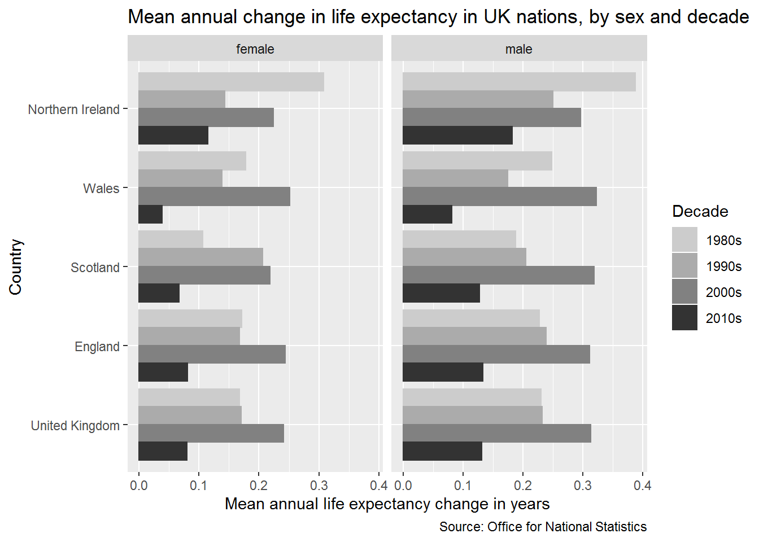

Figure R2.1 Average annual change in life expectancy in the UK and constituent nations, by sex and decade. (Source: ONS)

Webappendix R2.1A and R2.2A both provide further analyses of trends in annual life expectancy gains in the UK and constituent nations. R2.1A presents annual series in life expectancy trends in the UK and constituent nations, and R2.2A looks at how correlated the annual life expectancy series are between males and females and each UK nation (i.e. it compares the correlation since 1980s in eight series of annual life expectancy changes, males and females in each of the UK’s four nations).

The results presented in R2.1A shows that, again with the exception of Northern Ireland, the low rate of average annual improvement seen in the 2010s is not driven by any single ‘bad year’, but is part of a continuing trend towards slowdown; if this downwards trend continues it suggests the overall average annual life expectancy gain observed by the end of the 2010s will be lower rather than higher than the already-exceptionally-low rates shown here. The presentation of annual series also shows that single years in which life expectancy fell rather than rose compared with the previous year are not in themselves exceptional; rather, it is a combination of both faster falls in life expectancy in ‘bad years’ combined with lower rates of gain in ‘good years’ that seem to be driving the recent trend towards slowdown.

The results presented in R2.2A indicate that male and female trends within nations tend to be more strongly correlated with the same sex in other nations. This coupling of trends in strongest in Wales and England, weaker in Scotland, and weakest in Northern Ireland, where the between-sex correlations are weaker than between countries. However for all countries the correlations over time are above r = 0.5.

Webappendix R2.3A compares estimates of average annual change in life expectancy by decade derived from the HMD and ONS data, and finds estimates to be very similar.