# R3.A Breakpoint analysis

This appendix shows results of running breakpoint analysis on UK and constituent nation annual life expectancy change data from the ONS single year lifetables. The R package segmented was used. (1,2) One breakpoint models were fit, and the effect of using different random number seeds in fitting these models explored.

## R3.1A Breakpoint estimates and standard errors

Figure R3.1A and table R3.1A show the point estimates for the breakpoints in trends. The errors bars show two standard errors around these point estimates. For each country except Northern Ireland, a breakpoint is identified around 2009-2010. The confidence intervals tend to be wider for females than for males, and (again with the exception of Northern Ireland) for smaller compared with larger countries.

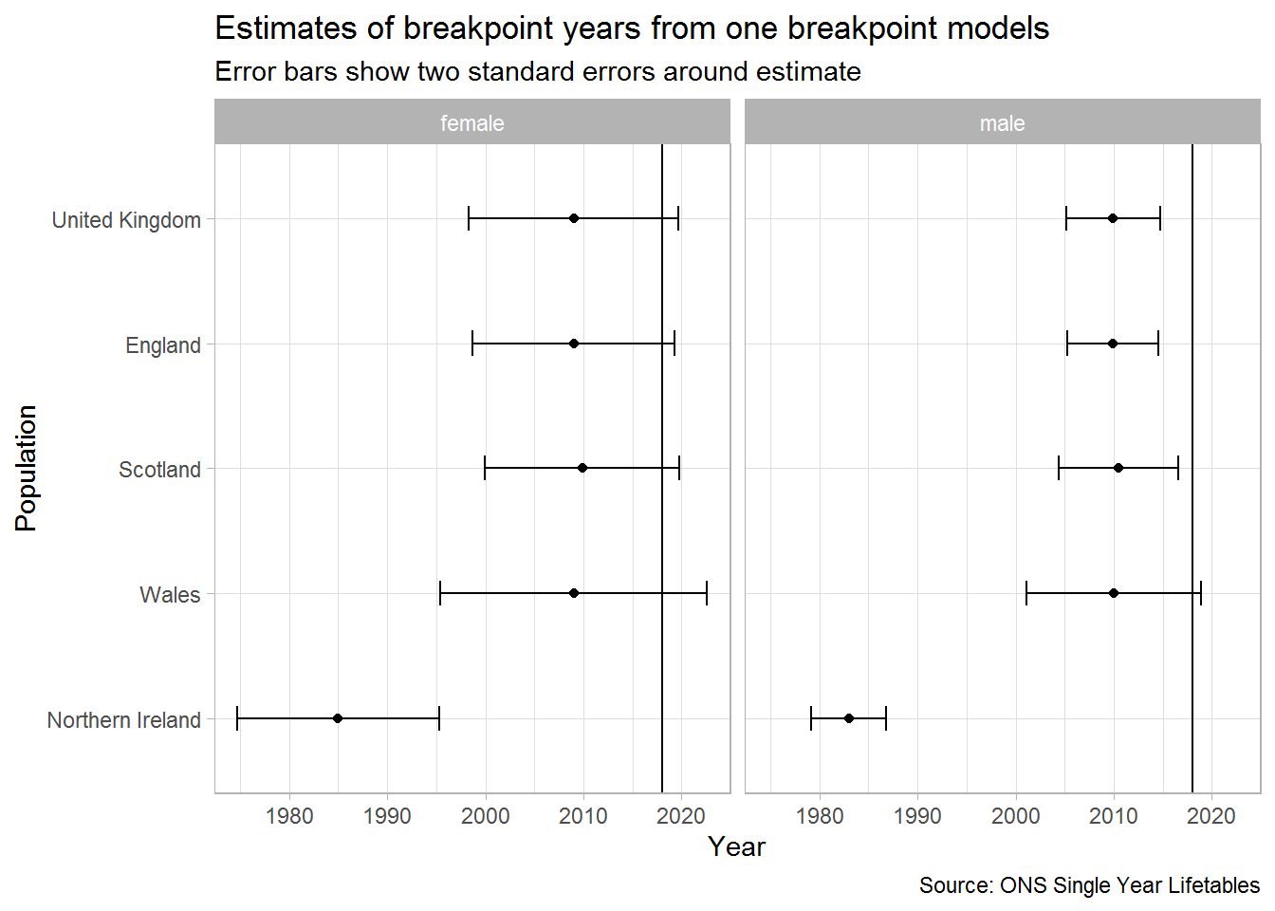

Figure R3.1A Breakpoint estimates and standard errors

|  |  |  |  |  |  |
| --- | --- | --- | --- | --- | --- |
| **Population** | **Sex** | **Breakpoint** | **Standard Error** | **Lower CI** | **Upper CI** |
| England | female | 2009.00 | 5.15 | 1998.70 | 2019.30 |
| England | male | 2009.93 | 2.34 | 2005.26 | 2014.60 |
| Northern Ireland | female | 1985.00 | 5.13 | 1974.73 | 1995.27 |
| Northern Ireland | male | 1983.00 | 1.92 | 1979.16 | 1986.84 |
| Scotland | female | 2009.87 | 4.95 | 1999.97 | 2019.77 |
| Scotland | male | 2010.45 | 3.05 | 2004.36 | 2016.54 |
| Wales | female | 2009.00 | 6.80 | 1995.40 | 2022.60 |
| Wales | male | 2010.00 | 4.43 | 2001.14 | 2018.86 |
| United Kingdom | female | 2009.00 | 5.35 | 1998.30 | 2019.70 |
| United Kingdom | male | 2009.95 | 2.39 | 2005.18 | 2014.72 |

Table R3.1A Breakpoint analyses and standard errors

## R3.2A Effect of random number seed choice on breakpoint estimate

The results can be dependent on the choice of random number seed used by the algorithm to identify the breakpoint. With some random number seeds, the algorithm may not be able to identify a breakpoint at all. Figure R3.2A shows the differences in breakpoint estimates produced by passing the first five random number seeds that identify a breakpoint estimate. (Seeds 4, 5, and 7 do not consistently identify a breakpoint for all populations. With the exception of females in Wales, the majority of random number seeds lead to very similar breakpoint estimates.

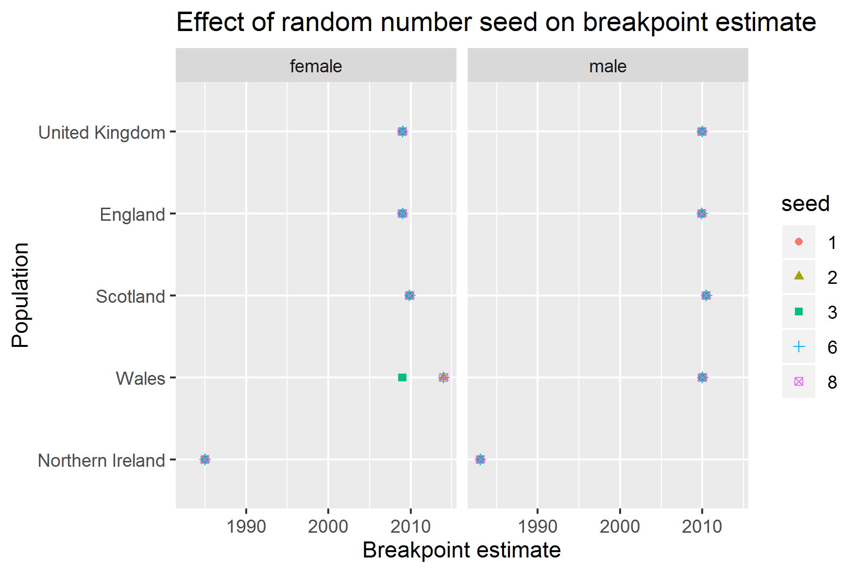

Figure R3.2A Effect of random number seed on breakpoint estimate

Bibliography

1. Muggeo VMR. Estimating regression models with unknown break-points. Stat Med. 2003 Oct 15;22(19):3055–3071.

2. Muggeo VMR. Testing with a nuisance parameter present only under the alternative: a score-based approach with application to segmented modelling. J Stat Comput Simul. 2016 Oct 12;86(15):3059–3067.