# ONS life expectancy projections

Figure R4.1 shows ONS life expectancy projections from 1971 to 2018, compared with observed life expectancy at birth in a black line. ONS life expectancies have, since 1971, tended to consistently under-predict the life expectancies that were achieved up until around 2010. After 2012, there are increasing indications that life expectancy projections may now be over-predicting life expectancy gains instead, with the most recent projections returning to around those levels assumed in projections from the early 2000s.

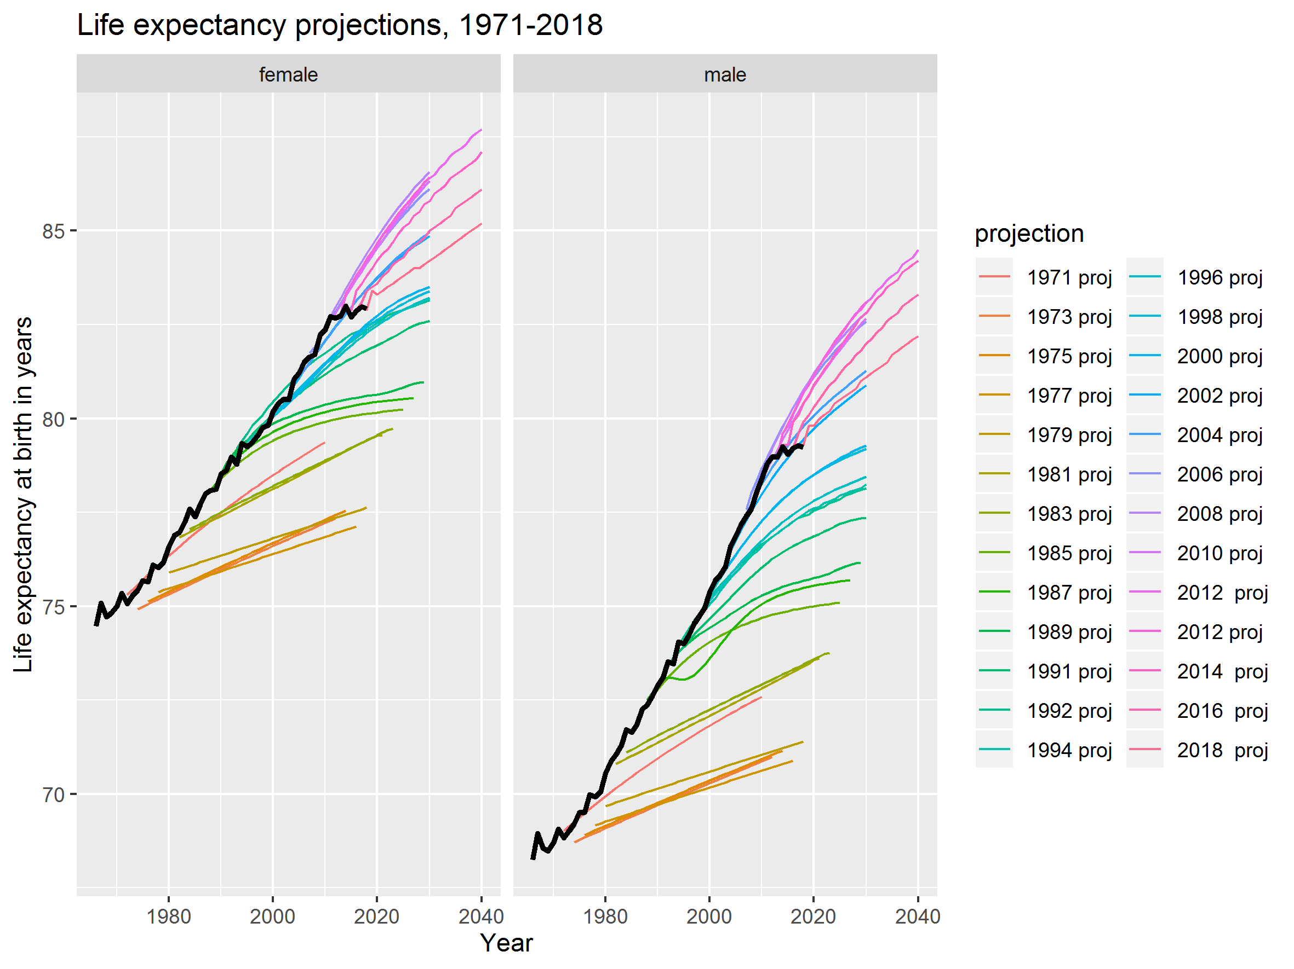

Figure ONS UK life expectancy projections compared with observed life expectancy (black line)

A less common way of representing such assumptions is in terms of projected conditional life expectancy over time, which is presented as a Lexis surface in Figure R4.2A in the web appendix, along with changes between conditional life expectancy between successive revision, as shown in Figure R4.3A as a Lexis surface in the web appendix. Figure R4.3A The ONS modifies their estimates of life expectancy every couple of years as part of their population projections exercise. For the last four projections the life expectancy projections have been downgraded. This section will show how projections have changed over time, and how they compare against observed life expectancy.

So, the projections have all assumed that the rates of improvement observed in the 2000s are not sustainable in the long term, but have been downrated by around a third from 2012 to 2018 for females, and by around a fifth from 2012 to 2018 for males. Assumed rates of improvement are around 17.5% higher than observed in the 2010s for females, and around 13% higher than observed in the 2010s for males.

To put more simply: the 2012 ONS projection assumed the rate of improvement would be the midpoint between the 1990 and 2010-11 rates, and subsequent projections have tended increasingly towards the post 2010 improvement levels. They have largely been responsive to the new and much slowed life expectancy gains.

| **sex** | **2012** | **2014** | **2016** | **2018** |
| --- | --- | --- | --- | --- |
| f | 0.137 | 0.129 | 0.115 | 0.094 |
| m | 0.148 | 0.147 | 0.134 | 0.114 |

**3.3 Summaries**

**3.3.1 Average projected improvement**

Let’s summarise this:

|  |
| --- |
|  |

**3.3.1.1 Average projected improvement - visualised**

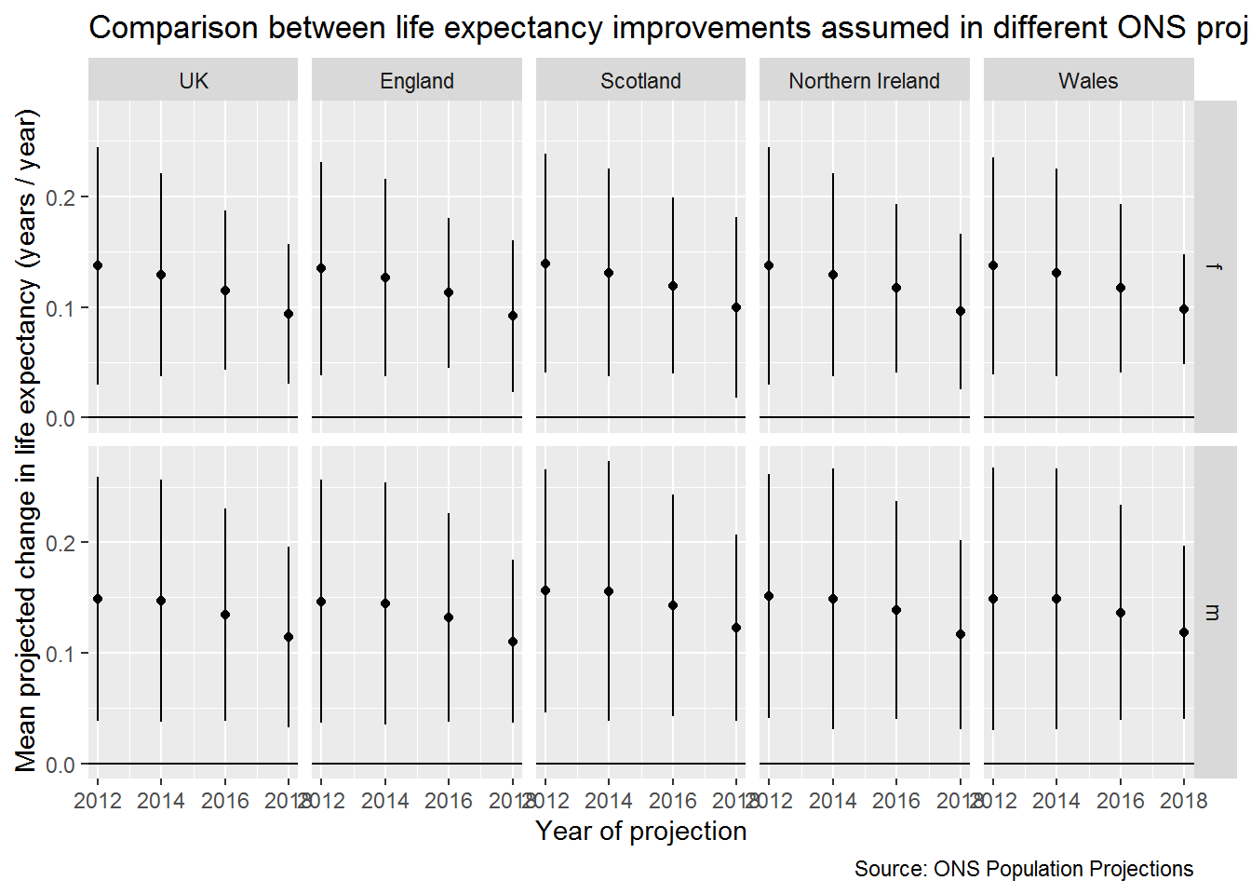

| **sex**  <chr> | **country**  <chr> | **proj_year**  <dbl> | **mean_ch_e0**  <dbl> | **sd_ch_e0**  <dbl> |
| --- | --- | --- | --- | --- |
| f | England | 2012 | 0.13488372 | 0.04822428 |
| f | England | 2014 | 0.12666667 | 0.04472136 |
| f | England | 2016 | 0.11276596 | 0.03373181 |
| f | England | 2018 | 0.09183673 | 0.03437983 |
| f | Northern Ireland | 2012 | 0.13720930 | 0.05355574 |
| f | Northern Ireland | 2014 | 0.12888889 | 0.04583678 |
| f | Northern Ireland | 2016 | 0.11702128 | 0.03798826 |
| f | Northern Ireland | 2018 | 0.09591837 | 0.03511400 |
| f | Scotland | 2012 | 0.13953488 | 0.04947118 |
| f | Scotland | 2014 | 0.13111111 | 0.04681794 |