|  |
| --- |
|  |

| **population**  <chr> | **sex**  <chr> | **after_end**  <int> | **perc**  <dbl> | **mu**  <dbl> | **ll**  <dbl> | **bayes_factor**  <dbl> | **period**  <chr> |
| --- | --- | --- | --- | --- | --- | --- | --- |
| England | female | 2011 | 1.00 | 0.194500 | 0.7173006 | 1.0000000 | 2011-11 |
| England | female | 2011 | 0.99 | 0.192555 | 0.7172876 | 0.9999870 | 2011-11 |
| England | female | 2011 | 0.98 | 0.190610 | 0.7172745 | 0.9999739 | 2011-11 |
| England | female | 2011 | 0.97 | 0.188665 | 0.7172612 | 0.9999606 | 2011-11 |
| England | female | 2011 | 0.96 | 0.186720 | 0.7172478 | 0.9999472 | 2011-11 |
| England | female | 2011 | 0.95 | 0.184775 | 0.7172342 | 0.9999336 | 2011-11 |
| England | female | 2011 | 0.94 | 0.182830 | 0.7172205 | 0.9999199 | 2011-11 |
| England | female | 2011 | 0.93 | 0.180885 | 0.7172066 | 0.9999060 | 2011-11 |
| England | female | 2011 | 0.92 | 0.178940 | 0.7171926 | 0.9998920 | 2011-11 |
| England | female | 2011 | 0.91 | 0.176995 | 0.7171785 | 0.9998779 | 2011-11 |

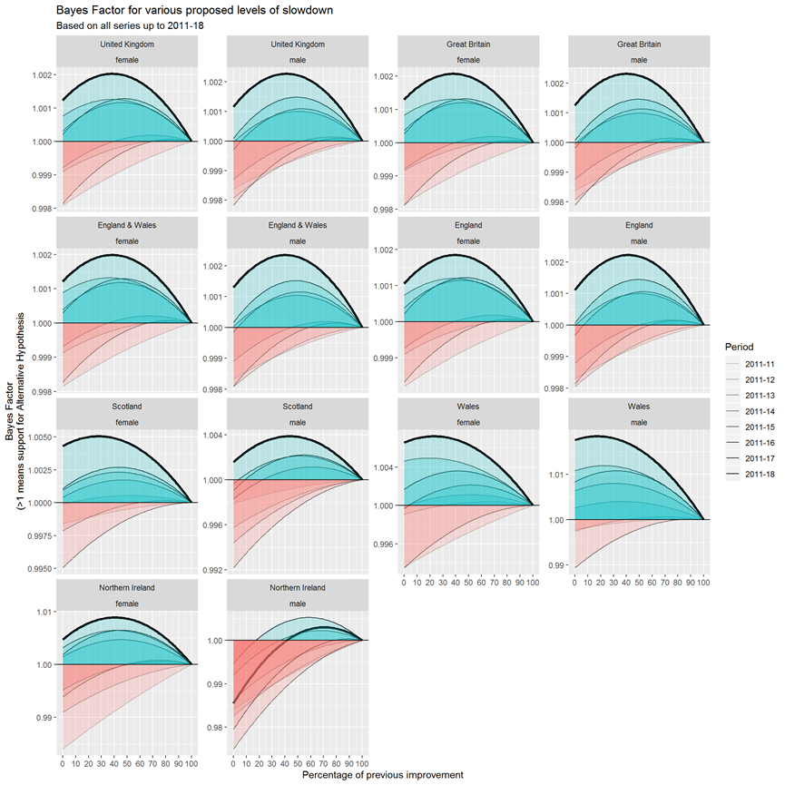

For all populations except males in Northern Ireland, the addition of the 2018 single year life expectancy data led to sizeable increases in the empirical support for the belief that there has been a slowdown in life expectancy after 2010; this is seen by noting how much higher the bold line, which incorporates the 2018 data, is than the fainter lines representing cumulative data based on shorter series of observations. For most of these populations, the peak of the bold line is to the left of peaks based on earlier series, meaning not only did the 2018 observations increase the strength of evidence supporting belief in a slowdown in life expectancy improvements, but also suggested more severe magnitudes of slowdown than the series excluding this most recent observation had indicated. For the UK as a whole, the addition of the life expectancy data for 2018 suggested an overall slowdown of around 60% was most likely, compared with a most likely magnitude of slowdown of around 50% based on data up to 2017. For each of these populations, what does the Bayes Factor maximise at?

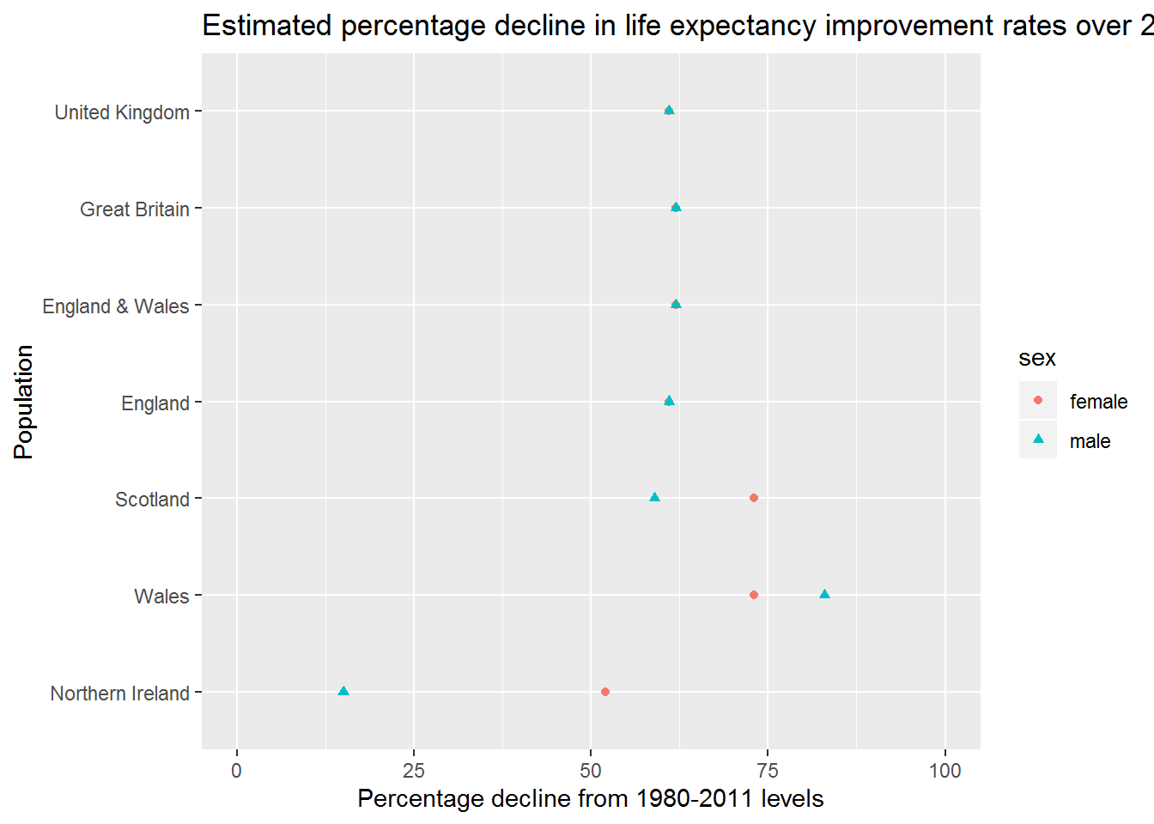

And as a table

|  |
| --- |
|  |

| **population**  <fctr> | **sex**  <chr> | **perc**  <dbl> | **bayes_factor**  <dbl> |
| --- | --- | --- | --- |
| England | female | 61 | 1.002120 |
| England | male | 61 | 1.002958 |
| England & Wales | female | 62 | 1.002173 |
| England & Wales | male | 62 | 1.003081 |
| Great Britain | female | 62 | 1.002221 |
| Great Britain | male | 62 | 1.003173 |
| Northern Ireland | female | 52 | 1.004581 |
| Northern Ireland | male | 15 | 1.000435 |
| Scotland | female | 73 | 1.003834 |
| Scotland | male | 59 | 1.005845 |

**Technical appendix**

**Likelihood and Log Likelihood of the Normal Distribution**

For computational reasons it is more common to calculate the log likelihood of a function rather than the likelihood itself. Defining X={x1,x2,...,xn}X={x1,x2,...,xn} as a series of nn observations, the Log Likelihood of the Normal Distribution is as follows:

logL(μ,σ2|X={x1,x2,...,xn})=−n2log(2π)−nlog(σ)−12σ2∑i=1n(xi−μ)2logL(μ,σ2|X={x1,x2,...,xn})=−n2log(2π)−nlog(σ)−12σ2∑i=1n(xi−μ)2

This is implemented as a function in R as follows:

get_ll <- **function**(x, mu, sig_sq){

sig <- sqrt(sig_sq)

n <- length(x)

- n * log(sig) - (n/2) * log(2 * pi) - (1 / 2 * sig_sq) * sum((x - mu)^2)

}

The Bayes Factor is defined as ratio of Likelihoods of two models. In the general case, if g(θ)g(θ) refers to a model with parameters θθ, and θnullθnull and θaltθalt to two different candidate parameters, then the Bayes Factor is

L(g(θalt)|X)L(g(θnull)|X)L(g(θalt)|X)L(g(θnull)|X)

Note that the alternative and null model specifications both contain a number of parameters in the Log likelihood that are identical. This includes n2log(2π)n2log(2π) and nlog(σ)nlog(σ) (because we are not concerned about testing proposed difference in the variance before and after). This means Bayes Factor could be calculated without including these parameters. However, they have been included for completeness.