# Bayes Factor estimation of the extent of the slowdown

The previous section showed that since 2012 life expectancy projections have tended to overestimate the improvements in life expectancy so far observed, and that forecasts have since tended to be successively downgraded with each new biennial projection. A breakpoint analysis for UK life expectancy trends was also performed (See section XX and appendix YYY) confirming a change in life expectancy improvement rates around 2010, broadly consistent with previous published research. (1) This section presents the results of a relatively simple approach for quantifying the extent to which recent life expectancy improvement rates within the UK have fallen short of pre-2010 trends, as well as the additional information produced by each successive annual life expectancy estimate produced by the ONS in informing researchers and policy makers as to the extent and persistence of the post 2010 slowdown.

The approach involves comparing the likelihood of a model which assumes life expectancies will continue to improve at the long-term pre-2010 rate, with a series of models which assume anywhere between a 1% and 100% long-term decline from this earlier rate. The most likely of this family of alternative models can then be identified, and with each new annual lifetable for the UK and constituent nations the preferred model and changing strength of evidence in support of this model can be updated. A graphical illustration showing the relative likelihood of each of these models, and how the inclusion of each new observation changes the likelihood surface, is shown in Figure R5.1A in the webappendix, along with a technical description of the approach.

For all populations except males in Northern Ireland, the addition of the 2018 single year life expectancy data led to sizeable increases in the empirical support for the belief that there has been a slowdown in life expectancy after 2010; this is seen by noting how much higher the bold line, which incorporates the 2018 data, is than the fainter lines representing cumulative data based on shorter series of observations. For most of these populations, the peak of the bold line is to the left of peaks based on earlier series, meaning not only did the 2018 observations increase the strength of evidence supporting belief in a slowdown in life expectancy improvements, but also suggested more severe magnitudes of slowdown than the series excluding this most recent observation had indicated. For the UK as a whole, the addition of the life expectancy data for 2018 suggested an overall slowdown of around 60% was most likely, compared with a most likely magnitude of slowdown of around 50% based on data up to 2017. For each of these populations, what does the Bayes Factor maximise at?

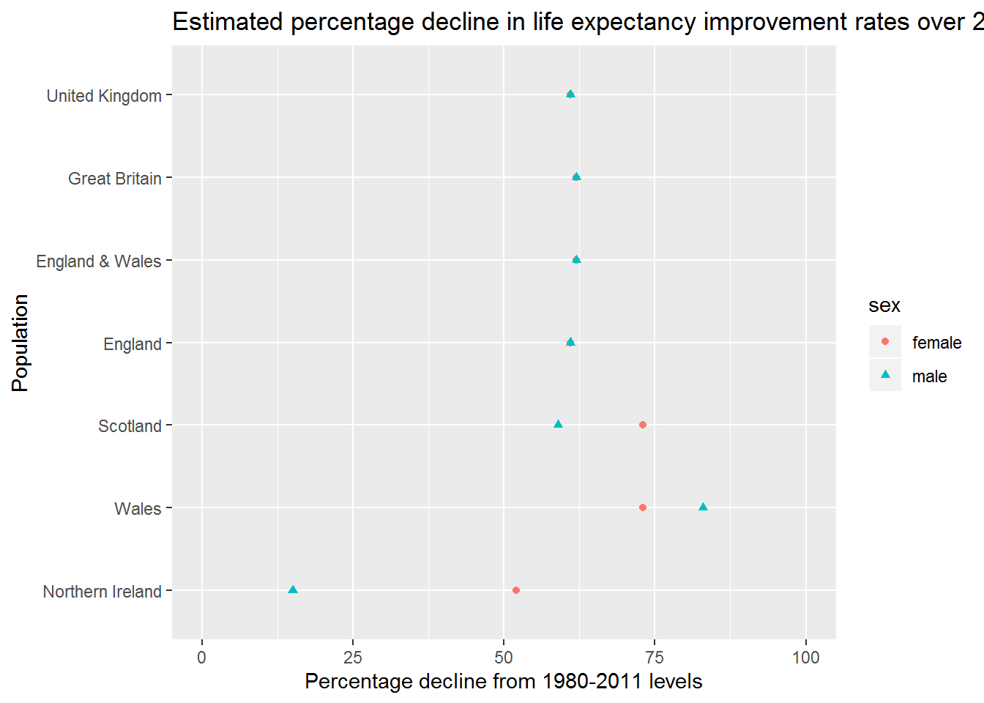

And as a table

|  |
| --- |
|  |

| **population**  <fctr> | **sex**  <chr> | **perc**  <dbl> | **bayes_factor**  <dbl> |
| --- | --- | --- | --- |
| England | female | 61 | 1.002120 |
| England | male | 61 | 1.002958 |
| England & Wales | female | 62 | 1.002173 |
| England & Wales | male | 62 | 1.003081 |
| Great Britain | female | 62 | 1.002221 |
| Great Britain | male | 62 | 1.003173 |
| Northern Ireland | female | 52 | 1.004581 |
| Northern Ireland | male | 15 | 1.000435 |
| Scotland | female | 73 | 1.003834 |
| Scotland | male | 59 | 1.005845 |

In the UK as a whole, it is most likely that life expectancy improvement rates have slowed down by 62% for females, and 59% for males. This is made up of a 60% (females) and 59% (males) slowdown in England, a 72% (females) and 56% (males) slowdown in Scotland, a 59% (females) and 29% (males) slowdown in Northern Ireland, and an estimated 77% (females) and 83% (males) slowdown in Wales. With the exception of males in Northern Ireland, rates of slowdown are therefore similar across UK nations, and generally slightly more severe for females than males.

Some important points:

* This approach means that the process of updating beliefs about the extent and evidence for a slowdown in life expectancy gains can be made formally rather than informally.
* The Bayes Factor schedules can be recalculated whenever a new data release becomes available. This means that updated schedules can be produced within minutes of the release of official statistics. The commitment to do this each each new release, and to publish updated estimates of support for slowdown, should be made before such data are released.
* The tendency within UK populations has been for the rate of slowdown to be increasing over time, rather than to shift suddenly from one rate to another. If this continues then the proposed slowdown percentage that maximises the bayes factor will continue to shift further to the left with additional years’ data, and could be maximised at a negative value (i.e. declining life expectancy rather than slowing improvement) if this tendency continues.