## Comparison between Bayes Factor and ONS projections

Finally, we will estimate the Bayes Factors implied by each of the average improvement rates implied by each of the recent ONS mortality projections, discussing how optimistic or pessimistic each of these scenarios seems to be, and how the Bayes Factor strategy can be applied to more openly update our beliefs about the persistence and extent of a life expectancy slowdown in the UK as and when the 2019 period life expectancy estimate becomes available.

Let’s now compare the values that maximise the Bayes factor against the ONS population projections:

| **Year** | **BF- female** | **BF- male** | **ONS- female** | **ONS- male** |
| --- | --- | --- | --- | --- |
| 2011-2012 | 0.161 | 0.276 | 0.137 | 0.148 |
| 2011-2014 | 0.163 | 0.218 | 0.129 | 0.147 |
| 2011-2016 | 0.088 | 0.138 | 0.115 | 0.134 |
| 2011-2018 | 0.075 | 0.108 | 0.094 | 0.114 |

And as a graph

[ADD ANNUAL VALUES FOR BF APPROACH]

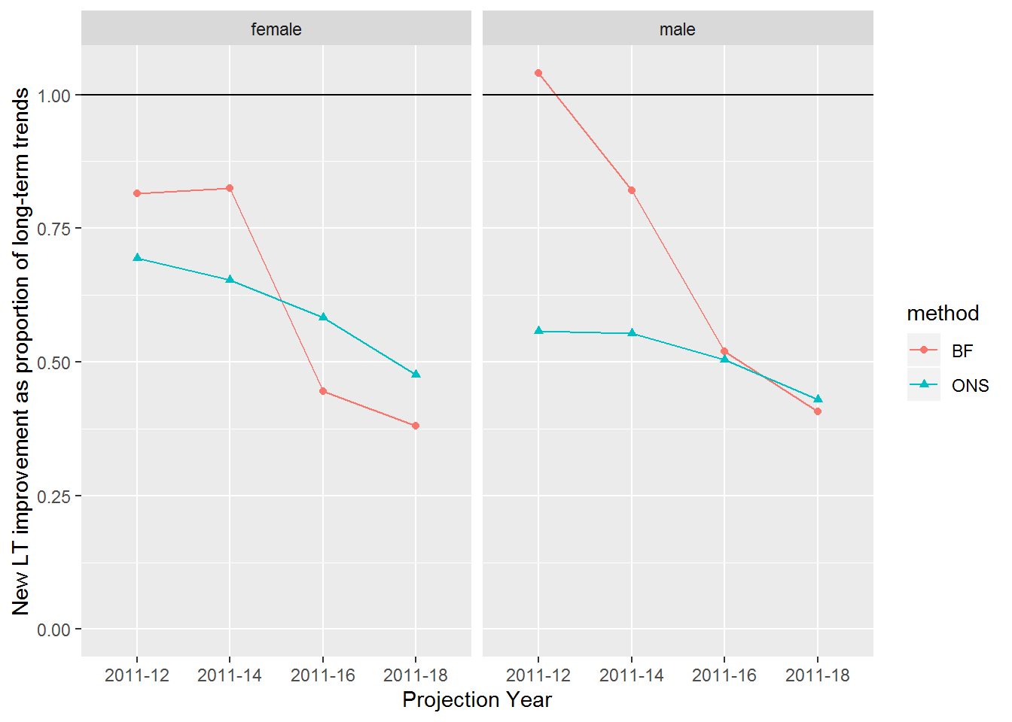

So, it appears the ONS, and the experts who advised them, believed that the long-term improvement trends were unsustainable from 2011 onwards, and projected trends that were slower than the average improvement rates seen between 1980 and 2011. However, each successive biennial update has projected a slower rate of improvement than the previous projection. The Bayes Factor approach, with the accumulated data from 2011 to 2018, suggests the ONS projections are largely in line with recent data for males, but may still be underestimating the extent of the stalling in life expectancy gains for females.